[ООП_на_Python_Учебное пособие_var7.pdf - Яндекс Документы (yandex.ru)](https://docs.yandex.ru/docs/view?tm=1700131105&tld=ru&lang=ru&name=%D0%9E%D0%9E%D0%9F_%D0%BD%D0%B0_Python_%D0%A3%D1%87%D0%B5%D0%B1%D0%BD%D0%BE%D0%B5%20%D0%BF%D0%BE%D1%81%D0%BE%D0%B1%D0%B8%D0%B5_var7.pdf&text=%D0%BE%D0%B1%D1%8A%D0%B5%D0%BA%D1%82%D0%BD%D0%BE-%D0%BF%D1%80%D0%BE%D0%B3%D1%80%D0%B0%D0%BC%D0%BC%D0%B8%D1%80%D0%BE%D0%B2%D0%B0%D0%BD%D0%B8%D0%B5%20python%20book.pdf&url=https%3A%2F%2Fcmp.phys.msu.ru%2Fsites%2Fdefault%2Ffiles%2F%25D0%259E%25D0%259E%25D0%259F_%25D0%25BD%25D0%25B0_Python_%25D0%25A3%25D1%2587%25D0%25B5%25D0%25B1%25D0%25BD%25D0%25BE%25D0%25B5%2520%25D0%25BF%25D0%25BE%25D1%2581%25D0%25BE%25D0%25B1%25D0%25B8%25D0%25B5_var7.pdf&lr=41&mime=pdf&l10n=ru&sign=c1cb546e5feb31031459bdb79a8f7272&keyno=0&nosw=1&serpParams=tm%3D1700131105%26tld%3Dru%26lang%3Dru%26name%3D%25D0%259E%25D0%259E%25D0%259F_%25D0%25BD%25D0%25B0_Python_%25D0%25A3%25D1%2587%25D0%25B5%25D0%25B1%25D0%25BD%25D0%25BE%25D0%25B5%2520%25D0%25BF%25D0%25BE%25D1%2581%25D0%25BE%25D0%25B1%25D0%25B8%25D0%25B5_var7.pdf%26text%3D%25D0%25BE%25D0%25B1%25D1%258A%25D0%25B5%25D0%25BA%25D1%2582%25D0%25BD%25D0%25BE-%25D0%25BF%25D1%2580%25D0%25BE%25D0%25B3%25D1%2580%25D0%25B0%25D0%25BC%25D0%25BC%25D0%25B8%25D1%2580%25D0%25BE%25D0%25B2%25D0%25B0%25D0%25BD%25D0%25B8%25D0%25B5%2Bpython%2Bbook.pdf%26url%3Dhttps%253A%2F%2Fcmp.phys.msu.ru%2Fsites%2Fdefault%2Ffiles%2F%2525D0%25259E%2525D0%25259E%2525D0%25259F_%2525D0%2525BD%2525D0%2525B0_Python_%2525D0%2525A3%2525D1%252587%2525D0%2525B5%2525D0%2525B1%2525D0%2525BD%2525D0%2525BE%2525D0%2525B5%252520%2525D0%2525BF%2525D0%2525BE%2525D1%252581%2525D0%2525BE%2525D0%2525B1%2525D0%2525B8%2525D0%2525B5_var7.pdf%26lr%3D41%26mime%3Dpdf%26l10n%3Dru%26sign%3Dc1cb546e5feb31031459bdb79a8f7272%26keyno%3D0%26nosw%3D1)

Вариант 1

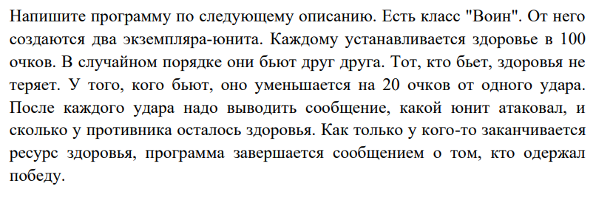

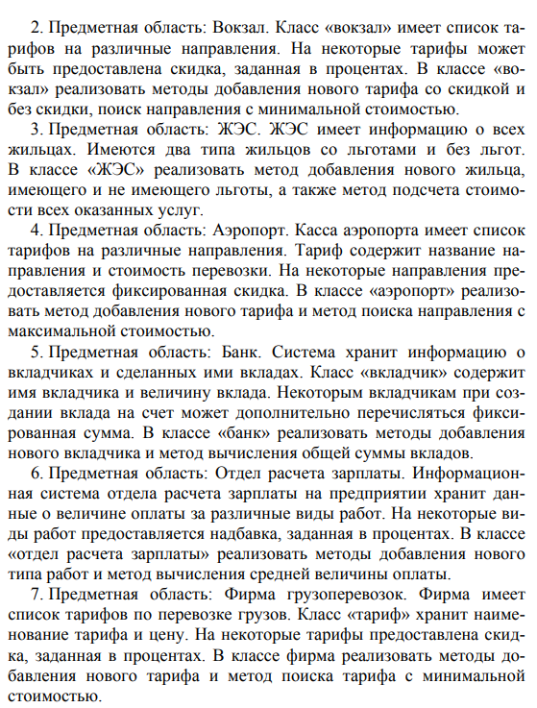

Вариант 8

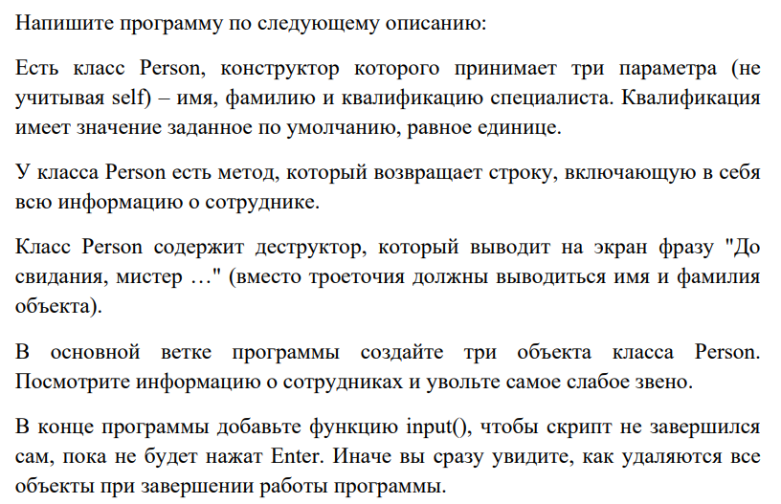

Вариант 9

