Date: 5th June 2020
John Doe
NSW Legislative Council
Parliament House, Macquarie Street
Sydney NSW 2000

Subject: Letter of Transmittal

Dear Mr Doe
This is our final deliverable for the pothole management system proposal, we have provided a detailed system description and model for our system. The aim of the overall project is to propose a new system by which the public can report on potholes to the RMS and to local councils, who then in turn can assign contractors to repair them. The system would collate all the relevant data into a discernable format, which would assist all relevant stake holders involved.
In this document we have provided a detailed analysis of all the relevant stake holders that will be involved in using the system, this includes the NSW Government, Road and Maritime Services, Local Councils, Contractors, and the General Public. We have done a thorough analysis of the interviews conducted with the stakeholders, where we asked them relevant questions that can help us build our system. Using the information provided and interpreted from the stakeholders, we created a system vision document, a work break-down structure and a Gantt chart for how the project has progressed
We have proposed a software development methodology and justified its use. Furthermore, we have provided a system scope document and feasibility study for our project. Finally, the relevant activity, use case and DMC diagrams have been presented for your consideration.

Sincerely
Keegan Naidoo – Project Manager
Kazi Swad Abdullah – Project Planner
Md Parvaze Dewan - Analyst
Matthew Munday - Analyst

Systems Description and Modelling
Presented as part of the detailed systems analysis for a ‘Pothole Management System’.
  - Keegan Naidoo (6424624)
  - Kazi Swad Abdullah (5220683)
  - Md Parvaze Dewan (6779803)
  - Matthew Munday (6486290)

  - Presented to NSW Legislative Council.
5th June 2020

Executive Summary
The purpose of this project is to develop a detailed system analysis for a “Pothole Management System”. We would use this to bid for a contract to build the new system for the NSW Government. To conduct this task, we have divided job roles amongst our team as follows.
Keegan Naidoo – Project Manager:
responsible for managing the overall scope of the project and assigning duties accordingly.
Kazi Swad Abdullah – Project Planner:
responsible for planning the course of the project and charting the progress of it as well
Md Parvaze Dewan – Analyst:
Analyzing data and organizing it into a constructive format.
Matthew Munday – Analyst
Analyzing data and organizing it into a constructive format.
In this report a thorough analysis was conducted on how pothole repairs are currently managed by RMS and councils in the state of New South Wales. Relevant stake holders were identified and investigated, the five main stake holders identified were the NSW government, Roads and Maritime services (RMS), Local Councils, Contractors, and the General Public. After analyzing the five stakeholders and by taking into consideration their concerns and problems with the current system, we were able to propose a new system that addresses those issues.
Some of the concerns that stake holders had, were the inefficiency and high cost associated with overall process, mainly due to a lack of analytical data on the pothole repair process. Another major concern was the inability of the public to report on the potholes in an efficient manner. Contractors reported issues with cumbersome paperwork and manual reporting that took up a bulk of their time. All stakeholders had concerns on creating a line of communication between the relevant parties involved.
The proposed system would create a digital line of communication between all parties involved, whereby issues can be reported, documents can be uploaded, and progress tracked. The system would generate valuable data on the pothole repair process, the costs involved, and scope and progress of the work completed. The system would provide councils and rms back end control and contractors and the public a front-end access of the collated data. The proposed pothole management system provides greater efficiency in terms of cost, price and scope compared to the contemporary system.

Table of Contents

Introduction--------------------------------------------------------------------------------------Page 5

Project Plan---------------------------------------------------------------------------------------Page 6

Stake Holder Analysis---------------------------------------------------------------------------Page 6

Interview Analysis-------------------------------------------------------------------------------Page 8

System Vision Document-----------------------------------------------------------------------Page 9

Work Break Down Structure------------------------------------------------------------------Page 11

Gantt Chart-------------------------------------------------------------------------------------Page 13

Software Methodology----------------------------------------------------------------------- Page 15

System Scope Statement----------------------------------------------------------------------Page 16

Feasibility Study--------------------------------------------------------------------------------Page 17

Requirement Analysis--------------------------------------------------------------------------Page 19

Use Case Diagram------------------------------------------------------------------------------Page 19

Activity Diagram-------------------------------------------------------------------------------Page 20

Domain Model Class Diagrams---------------------------------------------------------------Page 22

Conclusion---------------------------------------------------------------------------------------Page 23

Reference----------------------------------------------------------------------------------------Page 23

Glossary------------------------------------------------------------------------------------------Page 23

Appendix----------------------------------------------------------------------------------------Page 24

Introduction
Like most civil structures, road and highways have a defined shelf life. With heavy traffic flow and extreme weather conditions, the materials that make up the road pavement would weaken, causing dents and deformations, known as potholes. To keep the roads and highways safe and the road network trafficable, the NSW government conducts reactive maintenance on the deformations, to make sure that the section of road is roadworthy again.
The specific agency of the NSW Government that is responsible for conducting the maintenance process are the Roads and Maritime Services and the respective Councils. Councils and RMS conduct the maintenance by contracting repair servicemen from a third-party organization to go on site and do the work required. The contractors would need to provide proper documentation to get the job and to get compensated for completing the job.
Councils and RMS are informed about potholes that occur by the public, who usually phone it in, through the contact details provide on their website. This is an issue of confusion for the public as they have no way of knowing whether the road where the pothole is located fall under the jurisdiction of RMS or Council.
The current system is cumbersome, cost inefficient and time consuming. This why the NSW Government has put out a tender for respective parties to propose a solution that can solve this problem. We have decided to compete for this project and have therefore compiled a user evaluation report as part of our system analysis report for this project. The report would give the client an idea of how the system would function and how they would benefit from our proposal.
The overall aim of the proposed pothole management system would be to aid the relevant stakeholders to report, track, and fix the potholes. The back end of the system would be for councils and roads and maritime services (RMS) to operate and would include analytics on occurrences, location hotspots, and assist in the management of workflow. It would also include a front-end system for the public to interface with and for the contractors to complete and retrieve information and work processes.

Stakeholder Analysis
As part of the pothole management system analysis we have identified 5 different stakeholders that are relevant to this project, this includes the NSW government, roads, and maritime services (RMS), local councils, contractors, and the public.

NSW government (Internal/Executive)
The NSW government is an executive and internal stakeholder for the pothole management system. The government wants the system to be more productive and cost efficient compared to the old system. The NSW Government has a financial interest in the system and would like to see it save them money in the long run. The NSW Government is the financial benefactor of the process as they will be responsible for delegating funds to RMS and local councils for the repair process. They are also the primary sponsor of the contract and will be providing the funds to develop the new system. They might be able to provide more resources if necessary but would also require greater feedback on the progress of the project. They have a vital role in improving the quality of the overall project.

Roads and Maritime Services (Internal/Operational)
The RMS is an operational and internal stakeholder as they deal with most of the back-end processes that would occur within the new system. They would have operational control of the whole system. The RMS generally wants to get more accurate information of a pothole occurrences so that they can mitigate the damage and repair the pothole for efficiently. Their interest is purely operational and will be the primary users for the new system. They will be providing the most useful input when it comes to the system requirements, that is why they should be consulted regularly on how the system should function. Effort needs to be made to get them more involved as their involvement would greatly improve the quality of the project.

Local Councils (Internal/Operational)
The local councils are an operational and internal stakeholder that have a similar role to that of the RMS, however they operate only within their local jurisdiction. They also have similar interests as the RMS as they would also like to be able to manage pothole occurrences more efficiently and repair them in the shortest and most efficient way at the best price. Like RMS they will be providing the most useful input when it comes to how the system should function. They should also be consulted regularly on how the system should function and effort needs to be made to get them more involved. Different councils follow similar processes, and therefore for our analysis we have decided to look at one specific council i.e. Wollongong Council.

Contractors (External/Operational)
The contractors are an operational and external stakeholder as they were hired from outside the organization to fix the pothole. The contractors are responsible for doing the actual construction work involved in fixing the pothole. Council or RMS contact them when a pothole has been identified and they bill RMS or Council for the hours it took to fix it and the materials that were required. They have financial interests in the system, as the contracts are what brings revenue to their company. They would ideally want to see photos of the potholes so they can decide whether the job would be economically feasible for the money offered and the time required. They would have much greater interest in seeing an effective system but have very little influence in how the project should progress. It would be ideal to get them involved in the development process and get them to complete some low priority tasks. Different contractors follow similar processes, and therefore for our analysis we have decided to look at one specific contractor i.e. Global Utility Construction.

General Public (External/Operational)
The public are an operational and external stakeholder and they would be accessing the system to report on pothole occurrences and not be a part of it. The public currently have no idea that they can report on potholes or have tried to but have thought it was too much of a hassle for them. They have low interest in the success of the system, they also have low influence on how the project should progress. However their input is still required as they will be the one reporting on the potholes and as tax payer money is what will be funding the project, they should still be informed on the progress of the project on an occasional basis.

We have analyzed the influence and impact of all the stakeholders involved and have concluded that the NSW Government has the highest influence and impact and therefore needs to be included in all decision making involved. The contractors have less influence but high impact, therefore they should be included in some of the decision making involved. RMS and Council have high influence but less impact on them, therefore they need be consulted on their opinion, but including them in the decision making is less important. The public has the least impact and influence of all the stake holders involved, however it still might be important to keep them informed through newsletters and occasional emails. The stake holder map showing the influence and impact of the different stakeholders is shown below.
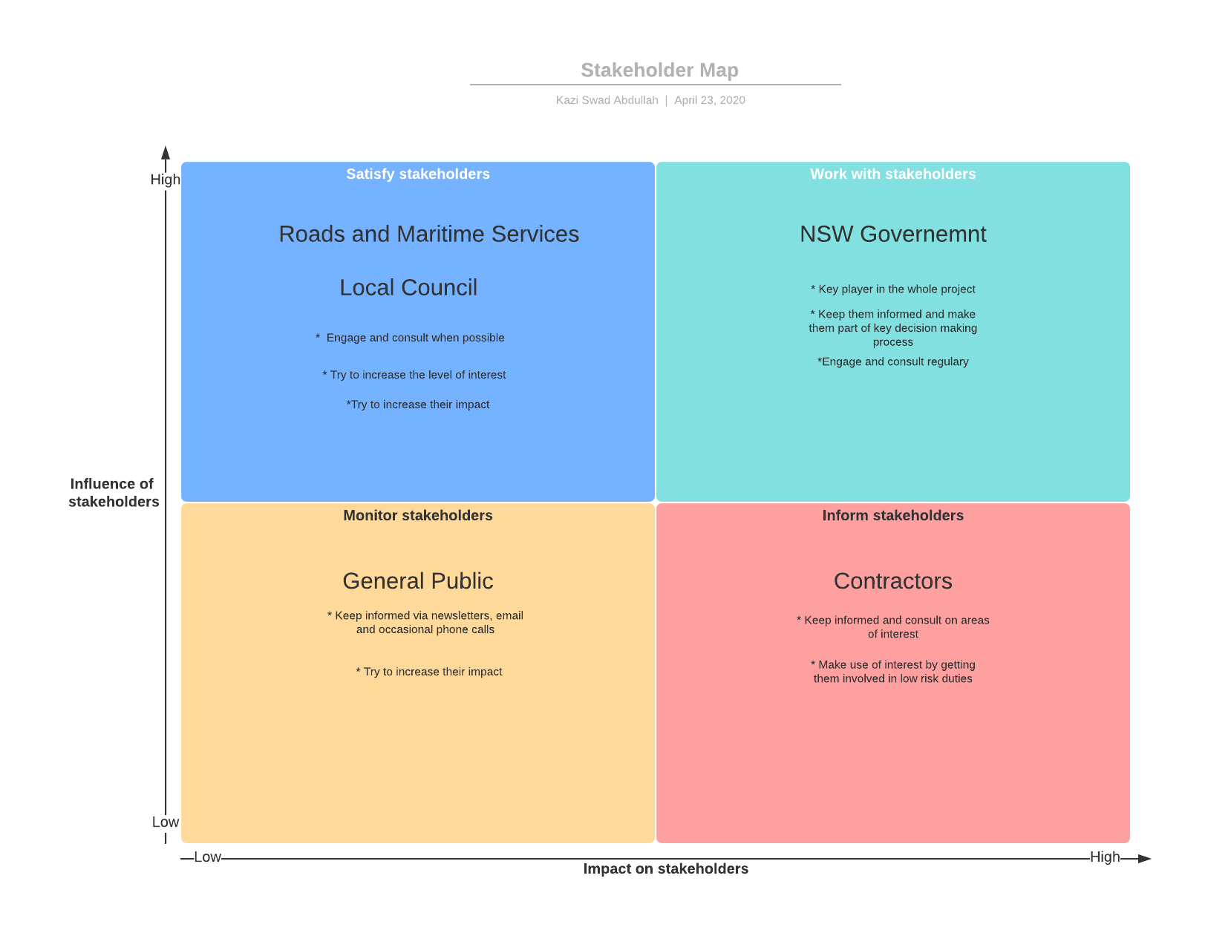 Table 1: Stakeholder Map shows the various stakeholders their relative influence and the impact they have on the project.

Interview Analysis
The pothole management system has different stakeholders with different needs for the system, we conducted individual interviews, where one of our team members visited each one of the stakeholders involved. We developed a questionnaire for each one of the stakeholders asking them relevant information regarding the requirements of the system from their end. We based our questions on the prior research that was done on the overall process. The interview structure was funnel shaped, where we asked general question first and then proceeded to more specific questions. The questions asked were largely open ended so that we could get more detail and spontaneously proceed to other avenues of questioning. After the interview was complete, we asked whether the stakeholders would be okay with a follow up interview, they all complied, however for the sake of this project, it was not required.

Based on the information we gathered, we can conclude that the NSW Government would be a typical user of the system and would not be interacting with the system regularly. The government requires an affordable and efficient system that has the ability to generate monthly reports that contain information on the number of potholes both under RMS control and under control of the local councils as well as repair costs and repair times involved with each job. They need this information so that can more readily manage their budget and allocate funds as they are required.
The local councils and the roads and maritime services would be extreme users of the system and would be interacting with the system on a regular basis. They want a system that is easy to use by the general public, able to be used on-site, so preferably a mobile app or website with mobile support, the information that is collected needs to be presented and stored in a central system. The system will need to have a place to submit pictures, location, and any additional information required. The system must then use the location submitted, to determine automatically if it is a major road or minor road and then notify the RMS or Council respectively. It should also have a way for contractors to log in and view allocated work and have a method to upload proof that the job is done, the materials used, and the hours taken.
The contractors would be an extreme user of the system and would interact with it on a regular basis. The contractor has requested a place where they can be notified of the jobs that are available and what the specifics of the job are i.e. location, type of pothole and description. They have also requested for a way to directly contact the RMS or the local council when on site. It would be ideal for the system to verify their location when on site and the length of time they were on the job. The contractor wants to upload proof before and after the work has been completed into system remotely and not be required to come into the office to make a submission.
From the interviews conducted with the public it can be concluded that they would be typical users of the system, only interacting with it when a pothole has been observed. The public have requested an easy to use system where they can report on potholes, optionally send pictures of the pothole, possibly an interactive map so the user can more accurately show where the pothole is located. Once a report is made a prompt should ask if the user would like to be notified when the pothole is fixed. Also, concerns were raised on how to use the system while driving so the system should integrated with hands free or other similar program, this way it can use the current location to automatically generate a report with minimal input from the driver.

System Vision Document
The system vision document highlights the problem that needs to be solved by the proposed system, the capabilities the system would ideally have and the benefits that it would bring to the business.

Problem Description
The current system for identifying and repairing potholes in NSW is inefficient and expensive for all parties involved in the process. Currently potholes are reported over the phone, i.e. someone rings RMS or council to provide the exact location and description of the pothole. However, the public is unaware that they can report on the issue, and if they do, they do not know who to call in order to provide the information. Furthermore, potholes are managed separately by the local councils and RMS depending on the jurisdiction that it falls under, causing further confusion for the public. From the RMS and councils’ point of view there is no way to automatically collate relevant information such as the number of pothole occurrences, repair time and cost associated with it. This information would help manage finances and scope, whilst reducing the time it takes to assign contractors to fix the potholes. From the contractor’s point of view the cumbersome paperwork and reporting that needs to be done manually through physical mediums, could be reduced by a system that creates a digital communication channel with RMS and Council.

System Capabilities
This document identifies the required system capabilities on a surface level. Later documents will specify the detailed requirements. The capabilities are:
- Generate monthly reports on the overall progress of pothole repair in NSW.
- Collect data from both rms and councils.
- Provide the number of occurrences of potholes.
- Provide the time taken for repairs.
- Provide the costs involved in repairs.
- User submission of pothole location and description.
  - Record exact location of the pothole via geo-location.
  - Take pictures of the pothole.
  - Compatible with most devices, especially mobile phones.
  - Easy to understand user interface.
  - Option to provide additional information if required.
- Analyzed user submission set up for contractor allocation
  - Detailed description of the pothole including pictures and scope
  - Easily accessible by the contractor.
  - Amount that will be paid for job stated.
  - Upload paperwork that proves that the repair has been completed.
  - Upload hours spent and materials used by the contractor.
  - Communication channel with RMS or Council if additional information is required.
- Information channel that informs all parties involved.
  - Provides notification to relevant parties regarding the progress of the repair.
  - Amount and degree of information provided to parties depends on their influence.

Business Benefits
The business benefits of these capabilities will lead to increased efficiency and reduced costs for all parties involved by connecting the public, contractors, council, and RMS through a single digital medium. The specific benefits include:
- Generating monthly reports will help RMS and councils to better analyze data, manage workflow and manage the costs involved.
- Allows for more seamless reporting of potholes by the public, thus simplifying the process and creating a more efficient way to resolve issues.
- Contractors will be able to be notified of jobs via the system, reducing time and costs associated with the process.
- Contractors can report on documentation easily over the system and therefore reduce time and increase workflow for the process.
- A lot of the documentation such as pictures of the pothole (before and after repair), geo-location of the pothole and receipts for materials bought can be directly uploaded to the system, greatly reducing time involved.
- Will lead to greater reporting of potholes as the public will find it easier to report on it when it occurs.
- Increases speed in which the pothole repairs are managed.
- Reduced cost involved for all parties involved.
- Greater satisfaction of the public, who are the primary people paying for the process.
- Increased workflow, as more work can be managed at a time by all parties involved.

Work Break Down Structure
The Work Breakdown Structure or WBS is the list of activities and tasks used to estimate the work done in a project. The task times associated with each task has also been mentioned.
The stake holder analysis and the interview analysis conducted earlier has been mentioned in the WBS. We used the information gathered from the interviews to create a system vision document that has also been mentioned in the WBS. A thorough feasibility study was conducted on the project which included a cost-benefit analysis and a risk and feasibility analysis. We went through the process of gaining approval from all the relevant stakeholders including all the members of our team for the project to go ahead.
The project environment consisted of working remotely due to the current circumstances with the corona virus. All members used their own personal computers with basic document processing software installed to develop this document. All communication was done over Facebook messenger, email and on skype. All text communication has been recorded and a record has been kept of the contribution from each member.

Project planning
Analyze the stakeholder’s interest and power…………...………………………………….………………………….1/2 Day
Create a questionnaire for the relevant stakeholder………………………….………………………………………...1 Day
Meet with NSW Government………………………………………………….……………………………………………………1 Day
Meet with RMS…………………………………………………………….………………………………………...…………………….1 Day
Meet with Council……………………………………………...……………………………………………………………………….1 Day
Meet with General Public…………………….…………………………………………………………………………………….…1 Day
Meet with Contractor………………...……………………………………………………………………………………………….1 Day
Analysis and User Evaluation Report Planning
Analyze Interviews……………………………………………………………………………………………………………………....3 Days
Create System Vision Document………………………………………………………………………………………………….1 Day
Complete WBS…………………………………………………………………………………………………………………………......1 Day
Make Gantt Chart……………………………………………………………………………………………………………………......1 Day
Complete Feasibility Study………………………………………………………………………………………………………......2 Day
Structure and Write Report…………………………………………………………………………………………………………7 Days
Adding Planning documents to report…………………………………………………………………………………………1 Day
Project Plan
Software Development Method chosen…………………………………………………………………………………..…2 Days
Justification for chosen Method………………………………………………………………………………………………….1 Day
System Scope Document………………………………………………………………………………..……………………………1 Day
Case Descriptions………………………………………………………………………………………………………………………..3 Days
Case Diagrams …………………………………………………………………………………………………………………………...3 Days
Activity Diagrams………………………………………………………………………………………………………………………..2 Days
Domain Model Class Diagrams…………………………………………………………………………………………………..4 Days
Progress Interview
Prepare for the progress interview……………………………………………………………………………………………….1 Day
Models Developed…………………………………...…………………………………………………………………………………2 Days

Note: The WBS needs to be completed before a Gantt Chart can be made. We cannot have a questionnaire for the stakeholders until we have analyzed them thoroughly. We cannot meet with the stake holders until we have a list of questions to ask them. Progress Interview cannot be completed until all aspects of the User Evaluation Report has been completed and a Project Plan has been developed for the scope of the project. The necessary diagrams cannot be drawn with the scope description and user case description.

Gantt Chart
The Gantt Chart shows the activities that need to be completed against time, precedence, and resource allocation.
We divided out our Gantt chart into 4 different sections namely project planning, analysis and user evaluation report planning, project plan and progress interview. One resource was allocated to most tasks except for the report writing task which was done by Kazi and Keegan. Regardless of the role assigned, all members shared in the analysis and reporting of the project. The order of precedence has been discussed in the Work Breakdown section of the report. The red section in our Gantt chart shows the critical path of our process, which are all the tasks that need to complete for the project to be completed on time.

Chart 1(below): Gantt chart showing the activities that need to be completed against time and in accordance to resource allocation and precedence, for a clearer view, please refer to the appendices Table 1 and Graph 2

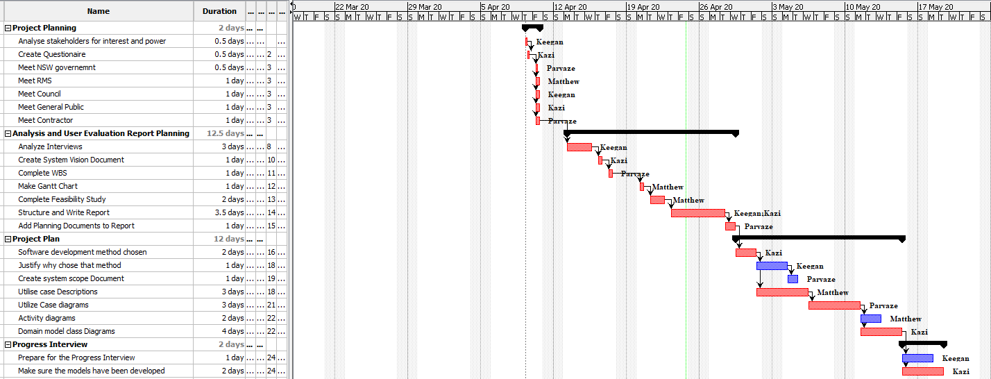

System Development Methodology
The system development methodology that we have chosen to develop our system, is the “Waterfall Development Model”. We believe that the requirements of the system that we have gathered from the planning stages, where we conducted our interview and stake holder analysis and decided on the plan for the system development, is suffice. We believe that that the project has low technical risk and can be developed according to plan. The phases that we have decided our project has to follow are shown below:
- Project Initiation
- Project Planning
- Analysis
- Design
- Implementation
- Deployment
These phases are sequential in the sense that they are non-overlapping and no iteration is required. For the sake of this document we are going to consider the first three of the phases shown above:
1) Project Initiation: This phase involves setting up our team, deciding on the hardware and software requirements, setting up the name of the team and listing the deliverables required to complete the project.
2) Project Planning: This phase involves conducting a thorough interview and stakeholder analysis, to develop the system vision document. Developing a work breakdown structure and Gantt chart for how the system development will proceed. This phase also involves deciding on the system development methodology, finalizing the systems scope, and deciding on its feasibility.
3) Analysis: This involves analyzing the requirement and deciding on how the system will function, we demonstrated this by developing use case diagrams, activity diagrams and DMC Diagrams, which shows how our system will prospectively function.

System Scope Statement
Project Scope Statement
Project Name | Pothole Management System
Project Sponsor | NSW Government
Project Manager | Keegan Naidoo
Date of Project Approval | 3rd March 2020
Last Revision date | 5th June 2020
Scope Description | In Scope:  - Generate Monthly Reports showing the number, time and cost associated with pothole repair  - User submission of pothole occurrence and relevant details about occurrence.  - Interface for council/rms to post job reports and for contractors to retrieve and complete jobs.  - Interface for contractor to submit relevant information relevant to the repair process.  Out of Scope:  -Geographic Mapping of Pothole Hotspots
Project Deliverables | - A web-based pothole management system  - A mobile interface for the PMS
Acceptance Criteria | The project will be acceptable when it is agreed by the NSW Government, Councils, and the NSW RMS. The project will also be considered a success if contractors and the public find it easy to use.
Constraints | Councils/NSW RMS are not dedicated to this project and can only provide partial support
Assumptions | All stakeholders have provided accurate and detailed information regarding their requirements.

Table 2: A system scope statement showing the revised scope after confirming details with the relevant stakeholders. These details need to be finalized, before development work can commence

Feasibility Study
To determine if the pothole system is worth doing, we must determine how feasible the project is to develop in terms of the organizational risk, technological risk, resource risk, and scheduling risk.

Organizational Risks
In terms of organization the RMS/council will need to add a new team to review the pothole reports coming in from the public, a new team to program and maintain the software and application, and a new team to market the solution. This will either cause the RMS/council to have to either hire new people or shift some of their already hired staff into new positions. If staff are shifted, they may not like the new change and hence come into work with a negative attitude which could be a net negative to the morale of the other teams within the building. New staff may also be looked down upon by co-workers, who must train them about the store's processes which could pressure someone’s mental health. However given that these are new projects, it is most likely that new staff will be hired specifically for a new department dedicated to the pothole app which would mean the only training needed would be a tour of the building. Most contractors would also be in favor of the new system as it makes their job in terms of viewing job offers easier. Overall, the new system would improve the organizational culture, as it will make the jobs for reviewing potholes and hiring contractors easier and the system won't be so complex that staff will get frustrated trying to figure it out.

Technological Risks
The team would be specifically hired to already have extensive knowledge on how to develop, maintain and market the product hence not much training on new technology would be needed. The application could easily be made and run on a standard computer running windows 10 and a programming engine, so unless a proprietary engine was being used by the council/RMS the developers would not need training on it. The application is to be designed to run on mobile so that almost anyone in the public can use it. There is not much technological risk with this system aside from the people who are hired to review the pothole reports, they may require training with the new system once it has been developed. Overall, the technological risk is not very high as the technology available to develop the application is plentiful and probably already owned by the RMS/council, i.e. computers, servers, programming software.

Resource Risks
The government is funding the upgraded Pothole management system to hopefully make it more cost beneficial in the long run, so it is mostly the money of taxpayers on the line. Otherwise resources in terms of available staff is plentiful as the market flooded with capable staff. This is a software application so most of the money will be spent on staff being paid to work on the application and marketing it. As long as the RMS/council stays within the development budget by the government there is not much resource risk as the government has a guaranteed money supply from taxpayers, hence they should have already allocated what departments within the government gets the appropriate amount of money. The Resource risk is medium as if the RMS/council go over their budget that means other fields of government will receive less funding than needed however assuming the right people are hired the cost would not be expected to exceed the whatever budget needed.

Scheduling Risks
It would be preferential that the RMS/council is able to finish the development process of the application rather quickly or within the given time otherwise the cost of the system will exceed the budget provided. The Pothole management system shouldn’t be too complicated to develop so assuming the right people were hired, and the needs were set out specifically, It would be able to be done within an appropriate time frame. Time would also need to be allowed for the team that will review reports to learn the system, and if new people are hired for software maintenance and updates, will need time to understand the code written. If staff within the RMS/council is shifted to this project it could impact the schedules of other projects. Overall though the scheduling risks for this project are quite low, with the problem being exceeding budget if the development does not go to plan, however the project could impact other project schedules depending on what position a person was in originally if they were shifted.

Use Case Diagram
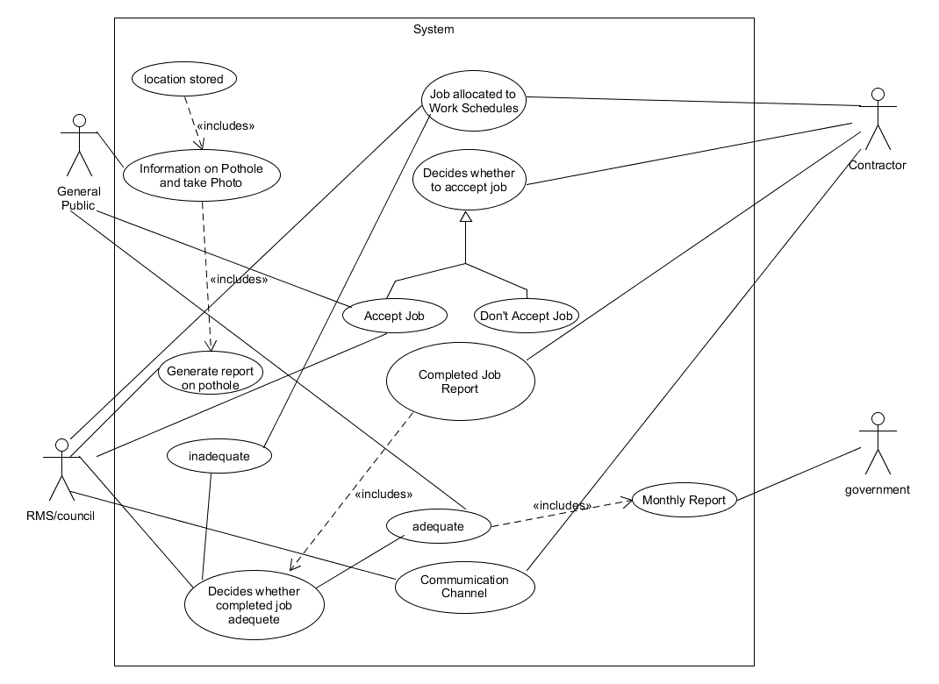
Diagram 1: Use Case Diagram for the Pothole Management Systems
Use Case | Description
Information on Pothole  and takes Photo | User takes photo of pothole and reports it to the system
Location Stored | As the user takes a photo the location is being tracked by GPS so it can quickly be reported with the photo.
Generate report on  pothole | RMS/council reviews report on pothole and decides whether it should be considered to post as a job to work schedule.
Job allocated to Work Schedules | RMS/Council posts job in work schedule with the relevant details. Contractor can view what jobs are available
Decides whether to accept job | Contractors decides based on pothole report whether the  Job is worth their time and effort
Accept job | Contractor accepts job, public is informed that work is taking place.
Don't Accept Job | Contractor declines job.
Completed Job Report | Contractor post relevant details about completed job.
Decides whether completed job adequate | RMS/council views completed job report and decides whether the job completed is adequate or not.
Adequate | If adequate all information related to the pothole repair is store and added to the monthly report.
Inadequate | Prompts contractor to complete job properly.
Monthly Report | Government receives a summarized version of the completed jobs, pothole occurrences and all other relevant information throughout the month.
Communication Channel | Establishes a communication channel between RMS/Council and the Public.

Table 3: Use Case Descriptions for the Pothole Management System

Activity Diagram

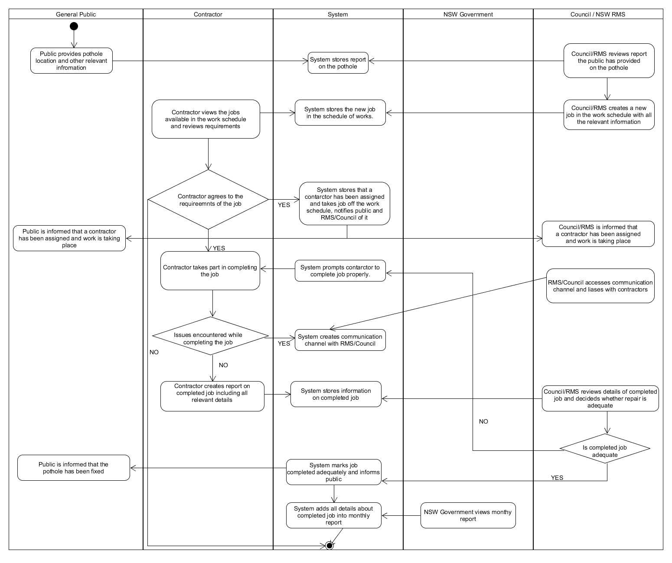
Diagram 2: Activity Diagram for the Pothole Management System

Domain Model Class Diagram

Conclusion
In conclusion, the current system for managing potholes is flawed, expensive and inefficient. The public, either has no idea how and where to report potholes or find it too inconvenient to do so. The NSW government wants the process of reporting potholes to be simplified to reduce costs, they also want a macro outlook on the entire process in the form of monthly reports. The RMS and local councils want to get notification about occurrences of potholes more readily from the public. This was achieved in our proposed system, where the public can report on potholes and attach all necessary information in a convenient way. Our system also generates custom reports on pothole occurrences, issues resolved, cost incurred and other information relevant to the process.
The Contractors want to access jobs available and evaluate the feasibility of each job through the system. The contractor also wants to upload proof of jobs completed to the system so that they can be compensated for their work. The public wants to report on holes more easily i.e. through a simple app. The RMS, Council, Contractors and General Public, all have similar interests, in that they want to make the pothole management system more efficient which lines up with the government’s goals as well.
If the contractors can choose jobs more easily, the government saves money as they can choose the cheapest contractor who does job in the best possible way. If the public can report on potholes more easily, then the councils and RMS can accurately collect data on potholes, making it easier for the everyone involved.

Glossary
- PMS: Pothole Management System
- RMS: Roads and Maritime Services
- WBS: Work Breakdown Structure
- DMC: Domain Model Class

References
- Rms.nsw.gov.au. 2020. Projects - Roads And Maritime Services. [online] Available at: <https://www.rms.nsw.gov.au/projects/index.html> [Accessed 24 April 2020].
- Ryu, Seung-Ki, Taehyeong Kim, and Young-Ro Kim. "Image-based pothole detection system for ITS service and road management system." Mathematical Problems in Engineering 2015 (2015).
- Council.wollongong.nsw.gov.au. 2020. Report It. [online] Available at: <http://council.wollongong.nsw.gov.au/customerserviceonline/reportit/Pages/default.aspx>
- [Accessed 24 April 2020].Roads and Maritime Services. 2020. Phone Contacts. [online] Available at: <https://www.rms.nsw.gov.au/contact-us/phone-contacts.html> [Accessed 25 April 2020].
- Shoalhaven.nsw.gov.au. 2020. Understanding Road Repairs. [online] Available at: <https://shoalhaven.nsw.gov.au/My-Community/Road-Safety-and-Traffic/Understanding-Road-Repairs> [Accessed 24 April 2020].
- Globaluc.com.au. 2020. GLOBAL | Utility Construction. [online] Available at: <https://globaluc.com.au/> [Accessed 24 April 2020].

Appendices
Table 1: Stakeholder Map shows the various stakeholders their relative influence and the impact they have on the project.
Chart 1: Gantt chart showing the activities that need to be completed against time and in accordance to resource allocation and precedence
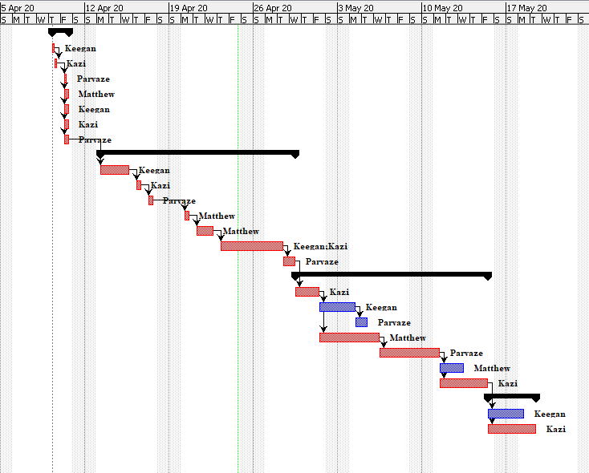
Chart 2: Gant chart on its own
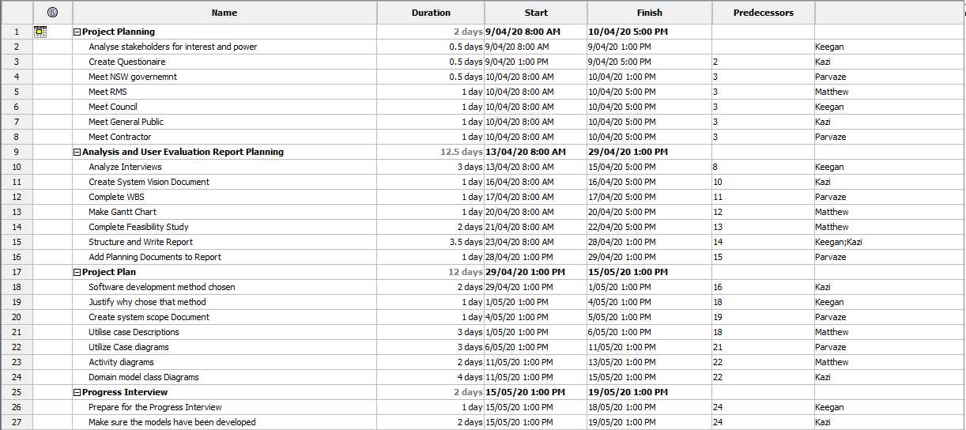
Table 1: WBS on its own showing the necessary resource allocation and precedence
Diagram 1: Use Case Diagram for the Pothole Management Systems
Diagram 2: Activity Diagram for the Pothole Management System

