A) A diagram explaining the basic of human cognitive architecture is shown below:
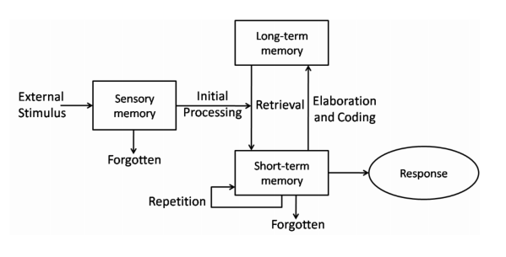
Figure1: Human Cognitive Architecture, Source: Lecture Notes
Whenever one views, hears, smells anything an external stimulus is registered in their sensory memory. If they are paying attention this new information will go into their working memory. The more attention you put into something the better the chances of remembering it later. If they do not pay attention this information will be forgotten. After initial processing, the stimulus gets stored in their short term memory. Short term memory is very limited in scope and time and if it is not remembered repeatedly it will be forgotten. To store the short term memory, it needs to be encoded and moved into ones long term memory. Long term memory has a huge capacity to store information permanently. Information from long term memory can be retrieved and moved into working memory. The information from the working memory is processed and applied by someone into their working environment.

B) Card Sorting is used to generate information about the associations and grouping of specific data items. We use low fi and high fi methods to represent card sorts. The card sorts are done in a series of individual, group exercise or both and consist of either open or closed sorts. To conduct a cord sort we write down the various data items of our system into various cards and the participant groups them into larger subject groups. In an open card sort the participants group all the cards on their own and label them as they please. In a closed card sort the participants receive only a limited number of cards and group them into prefilled labels. Hierarchical Task Analysis involves breaking tasks into subtasks and so on. These subtasks are grouped as plans which will specify how tasks will be performed. HTA focuses on physical and observable actions. Hierarchical Task Analysis can be presented in either a list format or a table format. A Hierarchical Task Analysis list and table format is shown below:
A hierarchical list task analysis to buy a DVD as a new user and a regular user:
1) Locate DVD
2) Add DVD
3) Enter Payment Details
4) Add Address
5) Confirm
Existing users do:1,2,5
New users do: 1,2,3,4,5
A Hierarchical Task Analysis table format is shown below:
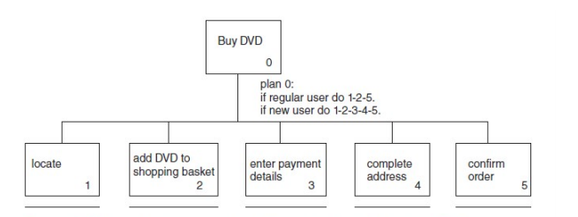
Figure2: Hierarchical Task Analysis Table Format, Source: Lecture Notes
C) Skeuomorphism is an imitation of an object intended to represent the original. In UX design Skeuomorphism is a graphical interface to create an object that mimic their real-world precedents. For example, the windows desktop represents an actual office desktop. Material Design is blend between flat design which is only the information in textual form and skeuomorphism. It consists of lighter, shapes and colors that remind the user of the objects that it represents. Example the calendar application on google.
D) Perceivable: For a web interface with video or audio content, subtitles can be provided which would make it easier for the user with hearing difficulties to understand the content.
Operable: Make sure there are no bright colors or sudden flashes in the web application and if there are, let the user know before hand, this will protect the user form seizures and physical reactions. This would protect users with specific illnesses.
Understandable: In the web interface there should be an option for the user to go back and correct mistakes if needed, this would be helpful to people with learning difficulties.
Robust: Make the user interface and application compatible with all formats suck Mac, Windows and Mobile. This would allow users with all kinds of devices to access the application.
E) Devices designed to provide people with solutions to allow them to perform typical activities that they would not have otherwise be unable to do. Two assistive technologies are alternative input devices such as braille keyboard for the visually impaired and text to speech applications for the learning impaired.
F) Two Panel Selector Design Pattern: where one area for the selectors, and one area next to it for the content of the selected thing
Tiled Pane: Various tiles on the screens representing various information.
Expanding Menus: Enables more options to be shown on the screen than is possible with a single flat menu, more flexible navigation. The ones representing the screenshot are cascading ones.
Contextual Menus: As this is a Microsoft word application contextual menu are also available which provide access to often used commands that make sense in the context of the current task.

