A)
Story Board:
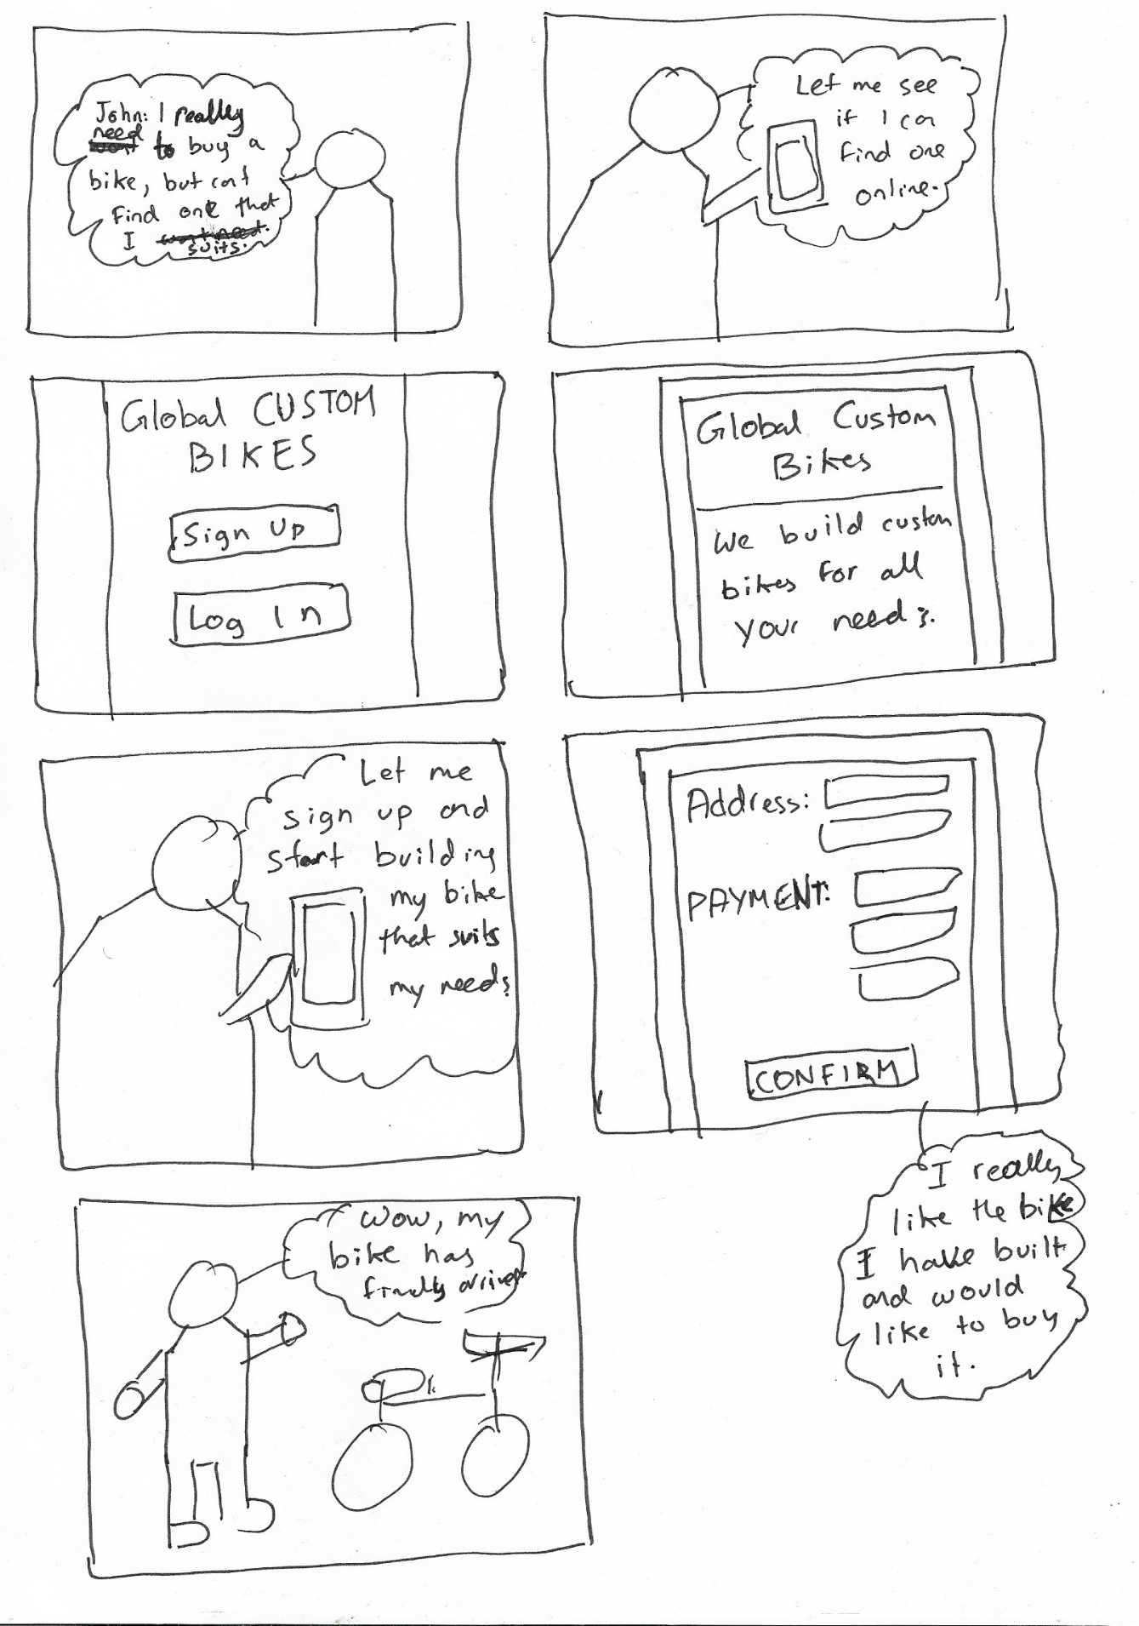

LO-FI Wireframes:
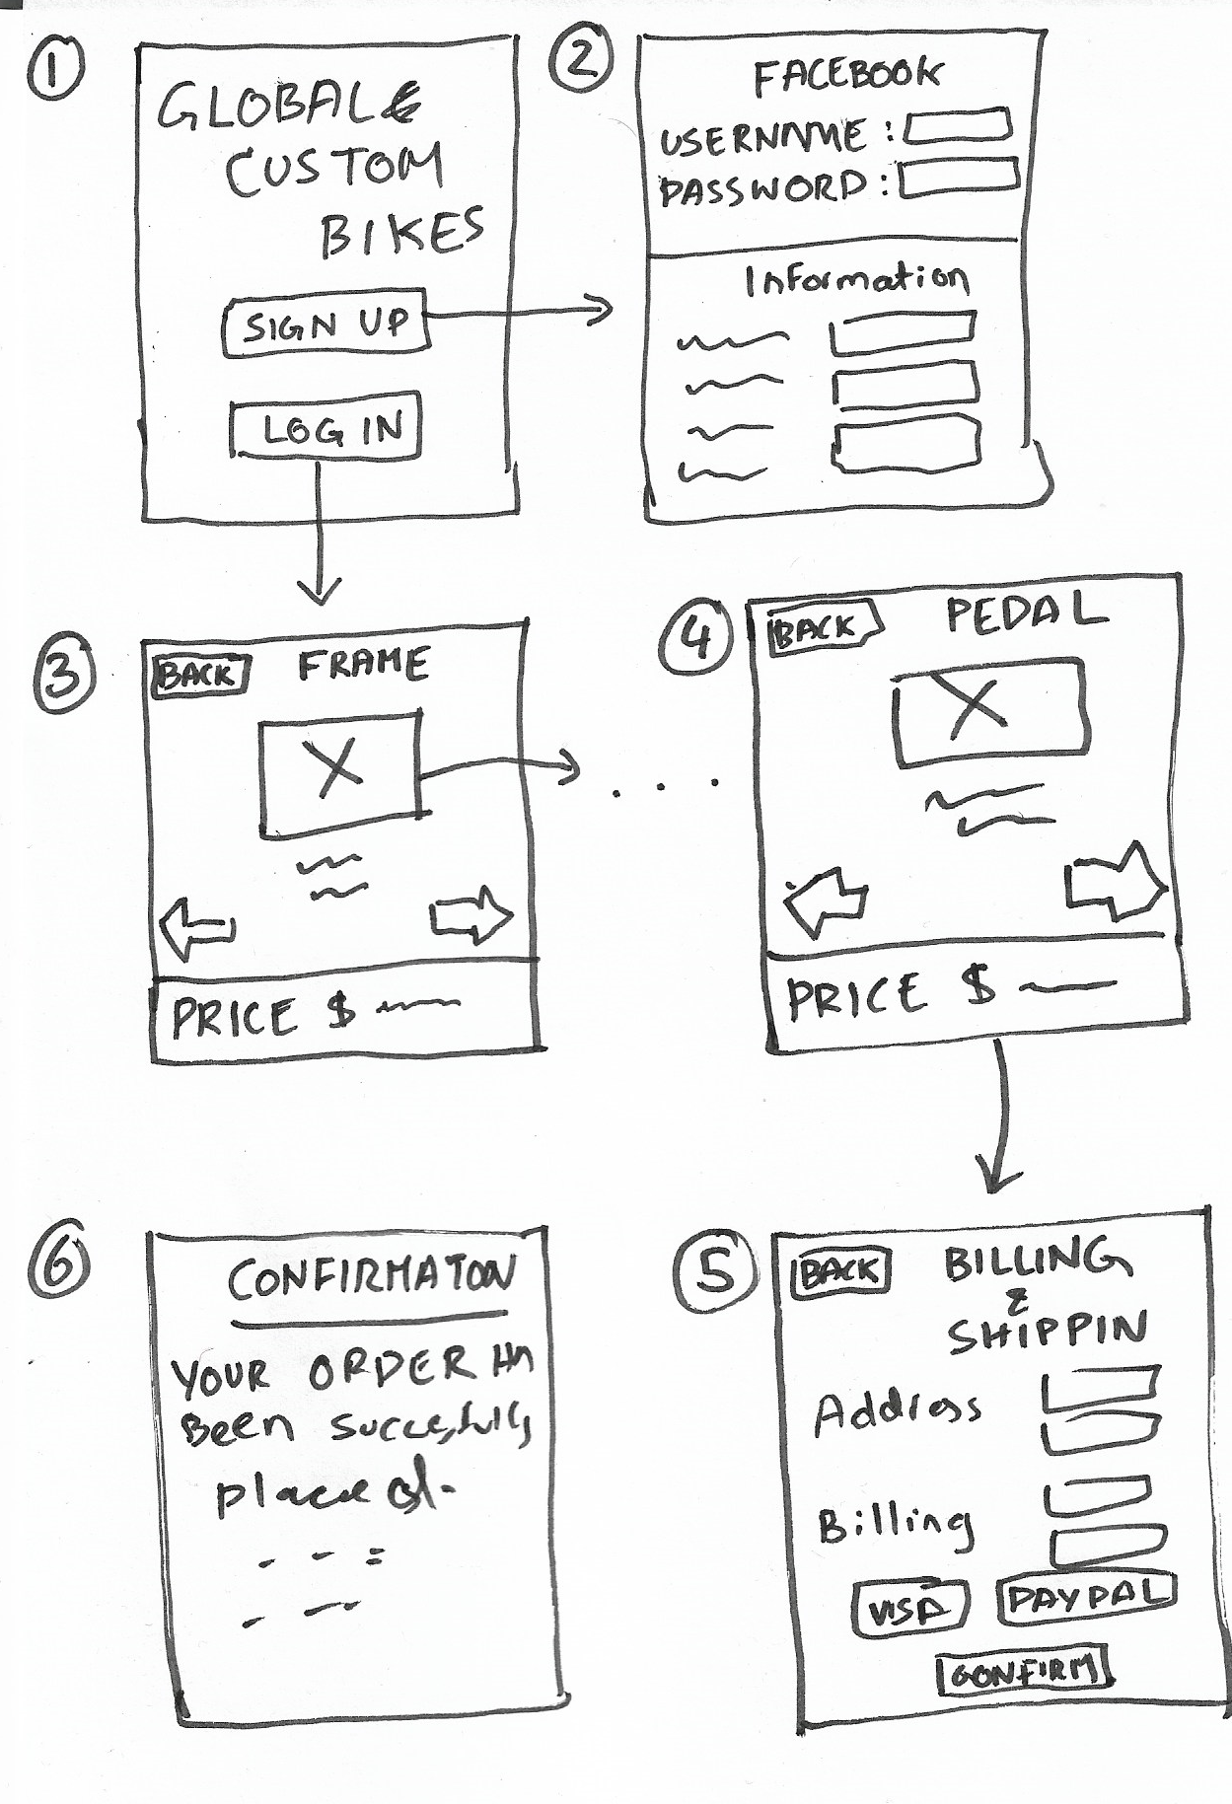
LO FI Explanation:
1) Our application is mainly a mobile application as it is the medium of choice for most people nowadays. The first page the user enter asks whether they want to log in or sign up. If the user presses sign up it take him/her to the sign up and if they press log in it logs them in with he details
2) In the signup page the user can either sign up via facebook or enter the information manually.
3) In the bike build pages the user goes through the parts frame, wheels and tyres, gears, breaks, seat and pedals in succession. When the user clicks the arrows he /she goes through all the parts and sees a picture with a description and the price at the bottom.
4) Pedals is the last part the use gets to choose after which he/she must check out.
5) At check out the user enters his/her address information and billing information ad presses confirm to confirm the purchase.
6) A confirmation page show that the order has been successfully placed and all the relevant information in regards to the order.

Scenario:
John recently moved to a new apartment in the middle of the city, which is far away from work. John is planning to commute to work each and every day, however he does not want to take his car as he lives in the middle of the city and does not want to deal with the traffic. He wants to buy a specific type of bike that is compatible to riding in the city, easy to carry and with a small frame. He tried to buy it in the store but did not find any bike that fits his specification, so he decided to buy it online. He found Global Custom Bikes online and decided to build his own bike that fits his specification. He looked up the site on his phone, registered and account easily using Facebook and started building his bike on the applications easy to use interface. After the bike was built John, check out was pressed where he was asked to input his payment details and delivery address and asked if he wanted to save this information for later. After confirming the order, the information was passed onto all relevant stakeholders.

B)
Usability Evaluation Methods can be:
User Based Evaluation: these measure the performance, the nonverbal behavior attitude, cognition stress and motivation of the users through a variety of methods including informal, usability testing and through field studies. The evaluation can be conducted in either a controlled or an uncontrolled environment. The advantages of this method is that the suers are directly involved in the process and is and important part of the user centered design process the disadvantage of this process is that it is some time cumbersome and expensive especially if the user based evaluation is being done in a controlled environment. There are also ethical and practical concerns to user based evaluations
Expert Based Evaluation: In an expert-based evaluation process expert use their knowledge of user and technology to review the software usability. It can be done in two ways through Heuristic evaluation where the experts review the system through a guided set of heuristics or by walkthrough where the experts steeped through planned scenarios make judgment along the way. The advantages of using expert based evaluation is that the experts can focus on specific issues highlighted by the developers and project managers. There are no ethical or practical concerns tot expert-based evaluations. The disadvantages are that the process might be expensive, and experts might not be that easy to find also the evaluations are based on preconceived abstract ides.
Theory Based Evaluation: Provides a way to evaluate products or design without involving users, it is less expensive that user testing, however its usefulness is limited to systems with predictable tasks. There are many theory-based evaluation process eses including GOMS, KLM, NGMOSL, CPM-GOMS. KLM is the process where we measure keystrokes to see how quickly and efficiently the user is using the system.
After reviewing all the above evaluation methods, I would recommend using theory Based Evaluation method to test the usability of the system. The theory based predictive model is easy to set up and less expensive than all the other methods and that is one of the main reasons why I am recommending this evaluation method. Also, the information that can be gained through a process like KLM is quantitative in nature and can be used as a marketing tool for the product.

