SPHERIC benchmark test case

test case title | Sloshing Wave impact problem
SPHERIC test case number
test case coordinator
  Antonio Souto-Iglesias & Elkin Botia-Vera
organisation and country |  | Model Basin Research Group (CEHINAV).  Naval Architecture Department (ETSIN).  Technical University of Madrid (UPM).  Madrid, Spain
email |  | elkinmauricio.botia@upm.es  antonio.souto@upm.es
Introduction
In this benchmark test case both lateral and roof wave impacts in a rectangular tank are considered, by providing information about the 4 first impacts which includes: time histories of the pressures recorded at specific locations, together with the corresponding roll angle history of the periodic angular motion of a sloshing tank and repeatability registers. Each experiment is accompanied by its corresponding video file. The liquids used in the experiments are fresh water and sunflower oil at 19ºC. The gas phase is air at the same temperature and atmospheric pressure. The tank is closed. Only 1X (62 mm) tank thickness is considered.

Flow phenomena
2D Incompressible Viscous flow with two different fluids, water and oil. Pressure is recorded at specific wall locations. Depending on the filling level and the fluid, the flow is considered either laminar or turbulent, thus, the phenomena which considers both water and low filling level is turbulent (Re=97546) with overturning and breaking waves due to the sloshing phenomena, however when oil is used the phenomena becomes laminar (Re=1748).
High filling level presents high fluid accelerations without breaking waves. The dynamics is similar for both water and oil.

Geometry
The tank is rectangular, built in Plexiglas. Its dimensions, in mm, together with the sensor positions can be found in Figure 1. The tank length L is 900mm. The breadth can be modified by three different plates 31, 62 and 124 mm (0.5x, 1x, 2x), but only 1x results were uploaded (for other thicknesses see reference 3). The rotation axis is at the center of the bottom line of the tank. The sensors are leveled with the tank walls. Their location can be seen in Figure 1. Sensor 1 has been used for low filling level and sensor 3 for high filling level.
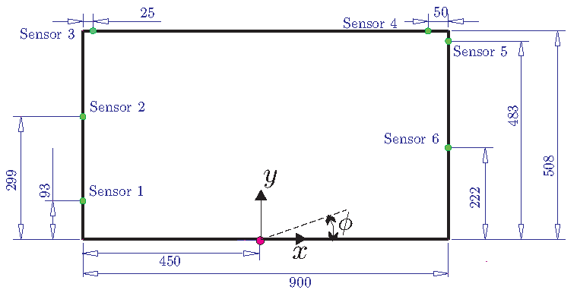
Figure 1. Tank Geometry of the wave impact problem in a sloshing flow in a rectangular tank

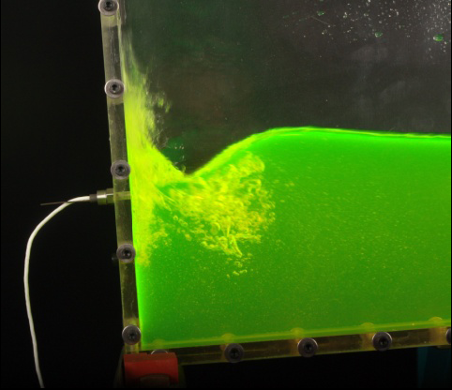
Figure 2. Sensor 1 location and lateral wave impact
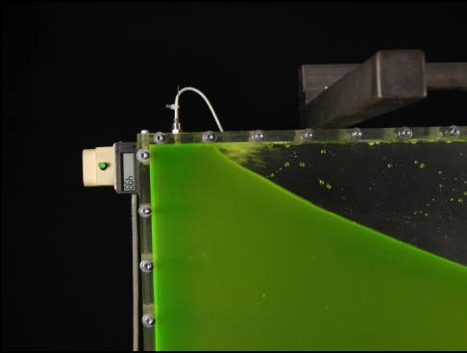
Figure 3. Sensor 3 location and roof wave impact

Boundary conditions

The liquid level H considered is the one corresponding to 18% and 70% filling tank level, i.e., 93 mm and 355.6mm respectively. For each liquid level, the first sloshing period can be obtained from the shallow water dispersion relation as:

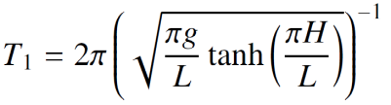

For low liquid level (H=93 mm , lateral wave impact), the period is T₁ =1.9191s.

The real time-angle curves are provided as supplementary materials. Nonetheless, in order to have a general idea of which are the oscillation periods compared to the first sloshing one, this information is provided in the next table:

Liquid | H [mm] | T₁ [s] | T/T₁
Water | 93 | 1.919 | 0.85
Oil | 93 | 1.919 | 0.80
Water | 355.3 | 1.167 | 1.00
Oil | 355.3 | 1.167 | 1.00

For water, low liquid level, the chosen period was the one for which maximum first impact was found. For oil, the period was chosen so that a flip-through impact could take place. For high filling levels the first sloshing period was found to provide interesing roof impact dynamics.
Initial conditions
At time zero the tank is initially in horizontal position.
The free surface is located at 93 mm filling level for lateral impacts and at 355.6 mm filling level for roof impacts in both water and oil. The liquids used are at 19 ºC and can be considered Newtonian with the S.I units values as shown in Table 1.

 | ρ | μ | ν | σ
Water | 998 | 8.94e-4 | 8.96e-7 | 0.0728
Oil | 990 | 0.045 | 5e-5 | 0.033
Glycerin | 1261 | 0.934 | 7.4e-4 | 0.064
Table 1. Liquids properties

Discretisation
Does not apply

Results specification
The results files contain the necessary information on pressure and position time history to launch simulations. Those files are referred to the case that has the pressure peak closest to the mean peak of all 100 experiments. Also video and repeatability files for each case are provided.

Visit http://canal.etsin.upm.es/ftp/SPHERIC_BENCHMARKS/ for a full description of all these data.

Results format
-Pressure and movement files

In the subfolder \data files are the following files:

lateral_oil_1x.txt
lateral_water_1x.txt
roof_oil_1x.txt
roof_water_1x.txt

There are 4 ASCII files with 6 columns as follows:

Column 1:Time [s]
Column 2:Pressure[mbar]
Column 3:Position_smooth_splines [deg]
Column 4:Velocity[deg\s]
Column 5:Aceleration[deg\s2]
Column 6:Position_original [deg]

- Video files

General AVI videos (30-300FPS) and sensor focused videos (300FPS) were taken for each case.
The files are in the folder \video files. There is a subfolder for each case as follows:
\lateral_oil
\lateral_water
\roof_oil
\roof_water

Every subfolder contains the video files with the following file structure:

Case_Fluid_Tank thickness_View_FPS.avi were:
Case: Lateral or roof impact
Fluid: Water or sunflower oil
Tank thickness: For each case just 1X is considered
View: Full tank or sensor focused
FPS: Frames per second

- Repeatability files

In the subfolder \case 1\Repeatability files the following files are found:
Oil_4first_peak_lateral_impact_tto_0_8_H93_B1X.xls
Oil_4first_peak_roof_impact_tto_1_H355_5_B1X.xls
Water_4first_peak_lateral_impact_tto_0_85_H93_B1X.xls
Water_4first_peak_roof_impact_tto_1_H355_5_B1X.xls

These contain information about the first four pressure peak values in mBar for 102 independent experiments. We refer to reference 3.
Benchmark results
Both lateral and roof impacts are considered for water and oil. Only results concerning 1X are presented. For additional information about the rest of the thicknesses see reference 3.
Lateral Impact Water
The period of oscillation for this experiment is 0.85 × T₁ = 1.6295s. For this filling ratio, overturning waves are generated that impact on the lateral wall of the tank, close to the still water level surface. 100 experiments were conducted, leaving 3 minutes to allow the liquid come to rest between each run. Pressure (Sensor1 Figure 1) and roll angle were registered in all these experiments. Figure 4 shows the pressure peak closest to the mean peak of all 100 experiments.
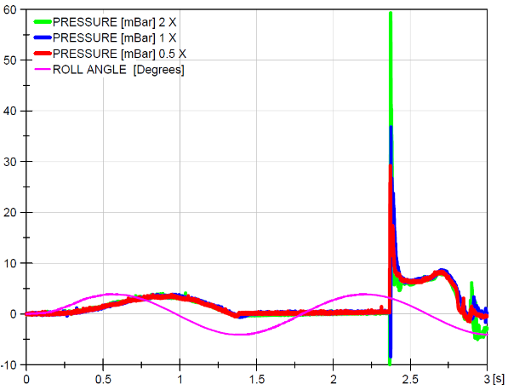
Figure 4. Lateral impact water, first peak pressure register

Lateral Impact Oil
The period of oscillation for this experiment is 0.8 × T1 = 1.5353s. The pressure registers in sensor 1 are similar to those obtained in the previous case but the dynamics differs substantially, hence the difference in peak shape as evidenced in Figure 5. Case 1X is particularly relevant because no 3D structures seem to onset which makes it a good candidate for a laminar 3D simulation. Figure 5 shows the pressure peak closest to the mean peak of all 100 experiments.

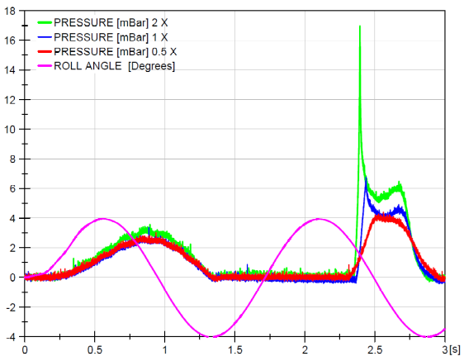
Figure 5. Lateral impact oil, first peak pressure register
The files can be found in http://canal.etsin.upm.es/ftp/SPHERIC_BENCHMARKS/

Roof Impact Water
The roof impacts are quite relevant in the industry due to the tank roof often being less reinforced. The liquid level for this set of experiments corresponds to a 70% fill ratio. The period of oscillation is the first sloshing period for this depth, i.e. T₁ = 1.1676s and roof impacts are generated in each cycle. In this configuration neither overturning nor breaking waves are generated. It seems that air is not entrapped during the impact event and this could have a substantial influence on the pressure field. This difference makes this case a distinct challenge compared to the lateral sloshing one, maybe more appropriate for monophasic models. Pressure (Sensor3 Figure 1) and roll angle were registered in all these experiments. Figure 6 shows the pressure peak closest to the mean peak of all 100 experiments.
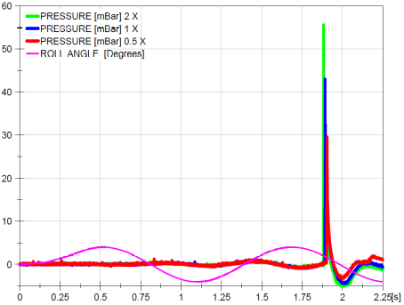
Figure 6. Roof impact water, first peak pressure register
Roof Impact Oil
The dynamics is similar to the water roof impact case because air is not entrapped during impact. This was not the case for lateral impact in which air was entrapped in the previous case. Figure 7 shows the pressure peak closest to the mean peak of all 100 experiments and it is noticeable that impact pressure does not occur in 0.5X and in 1X it occurs after two complete oscillations.
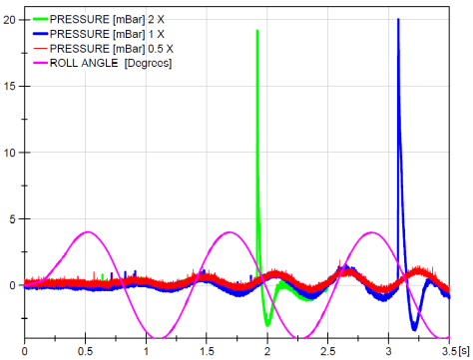
Figure 7. Roof impact oil, first peak pressure register
Future work
There is work in progress regarding this test case, that will be included in future revisions of this document. They include:
- Uncertainty assesment in impact pressure data is an open topic in the literature. In regards to the data referred in this test case, we refer the reader to references 2 and 3 for further reading on this issue.
- Regulated ullage pressure data and PIV measurements.
References
When using this test case, please cite these references.
[1] L. Delorme, A. Colagrossi, A. Souto-Iglesias, R. Zamora-Rodríguez, and E. Botia-Vera, “A set of canonical problems in sloshing. Part I: Pressure field in forced roll. Comparison between experimental results and SPH,” Ocean Engineering, vol. 36, no. 2, pp. 168–178, February 2009.

[2] A. Souto-Iglesias, E. Botia-Vera, A. Martin, and F. Pérez-Arribas, “A set of canonical problems in Sloshing. Part 0: Experimental setup and data processing,” Ocean Engineering (submitted for publication).

[3] Souto-Iglesias, A., E. Botia-Vera, and G. Bulian (2011, June). Repeatability and Two-Dimensionality of model scale sloshing impacts. In International Offshore and Polar Engineering Conference (ISOPE). The International Society of Offshore and Polar Engineers (ISOPE).

[4] Botia-Vera, E., A. Souto-Iglesias, G. Bulian, and L. Lobovský (2010). Three SPH Novel Benchmark Test Cases for free surface flows. In 5th ERCOFTAC SPHERIC workshop on SPH applications.

