PayFlow Assignment Write-Up
Project Overview
PayFlow is a simplified UPI-style wallet backend API built with Spring Boot. It supports registering users, finding users, listing users by balance, and recording simple money transfer transactions.
How to Run the Application
mvn spring-boot:run
H2 console: http://localhost:8080/h2-console
JDBC URL: jdbc:h2:mem:payflowdb
Layer Explanation
Entity layer: Contains Java classes that map to database tables. User maps to users and Transaction maps to transactions.
Repository layer: Contains interfaces that extend JpaRepository. Spring Data JPA creates the implementation automatically.
Service layer: Contains business methods used by controllers. The services call repositories directly in this simple assignment.
Controller layer: Contains REST API endpoints. Controllers receive HTTP requests, call services, and return Java objects that Spring converts to JSON.
Spring Boot Features
Embedded server: PayFlow runs on embedded Tomcat, so no separate server installation is required.
Auto-configuration: Spring Boot configures Spring Web, JPA, H2, and repository beans based on project dependencies and properties.
Production-ready defaults: Spring Boot provides sensible defaults for startup, logging, configuration, and app behavior. Actuator can be added later if needed.
Generated Database Structure
H2 creates the database tables automatically from the JPA entity classes because spring.jpa.hibernate.ddl-auto=create is configured.
Generated SQL for users
create table users (
balance float(53),
user_id bigint generated by default as identity,
name varchar(255),
phone_number varchar(255),
upi_id varchar(255) unique,
primary key (user_id)
);
Generated SQL for transactions
create table transactions (
amount float(53),
transaction_id bigint generated by default as identity,
note varchar(255),
receiver_upi_id varchar(255),
sender_upi_id varchar(255),
primary key (transaction_id)
);
Users table structure
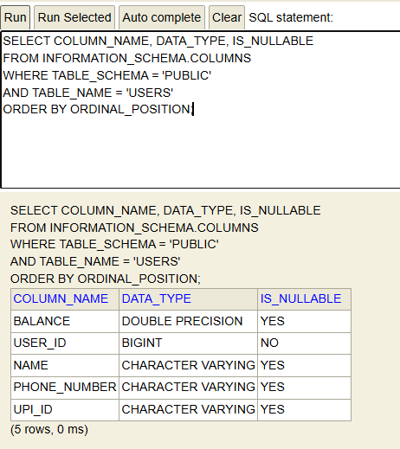
Transactions table structure
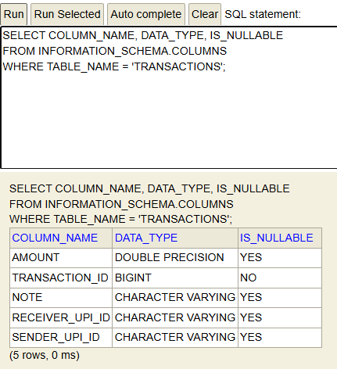
H2 Console Evidence
USERS table before data insertion
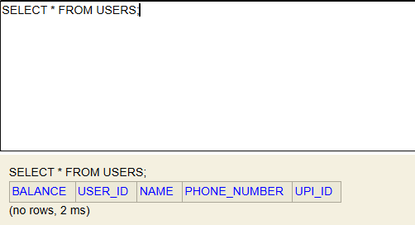
TRANSACTIONS table before data insertion
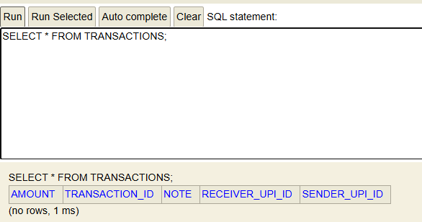
USERS table after registering two users
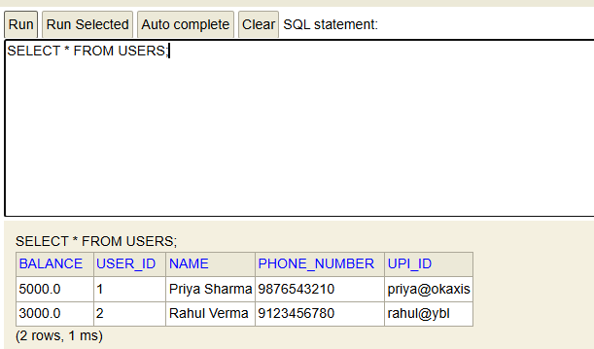
TRANSACTIONS table after sending one transaction
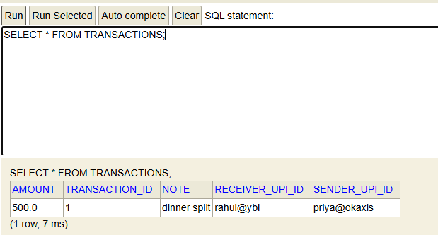
API Testing Evidence
POST http://localhost:8080/users
POST /users output for Priya
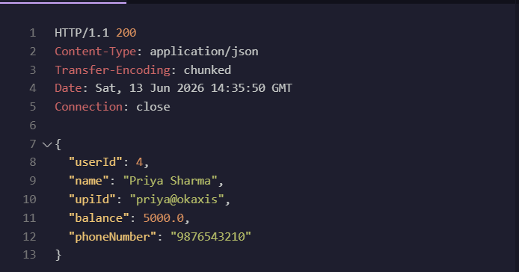
POST http://localhost:8080/users
POST /users output for Rahul
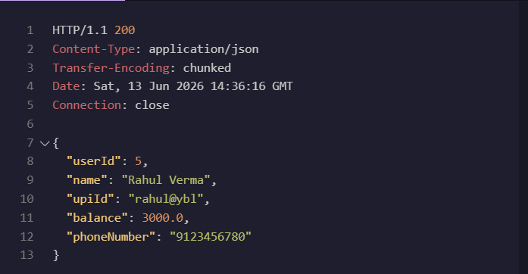
GET http://localhost:8080/users
GET /users output
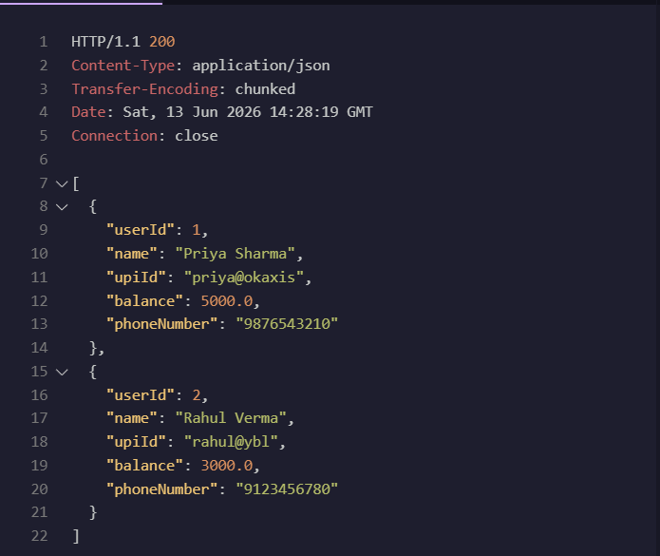
GET http://localhost:8080/users/1
GET /users/{id} output
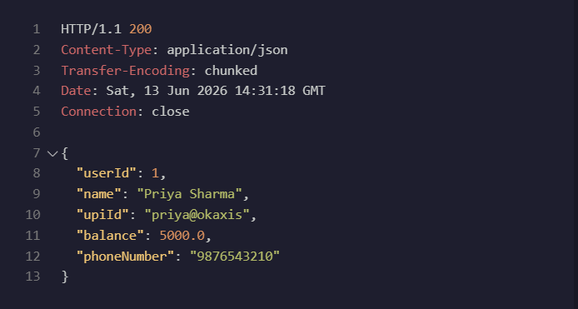
GET http://localhost:8080/users/upi/rahul@ybl
GET /users/upi/{upiId} output
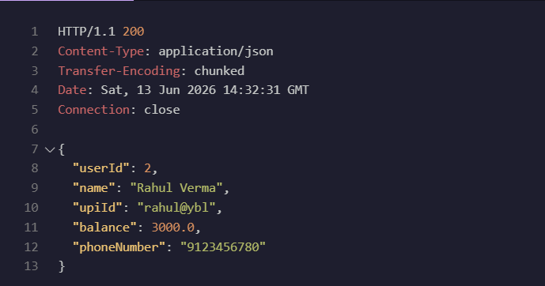
POST http://localhost:8080/transactions
POST /transactions output
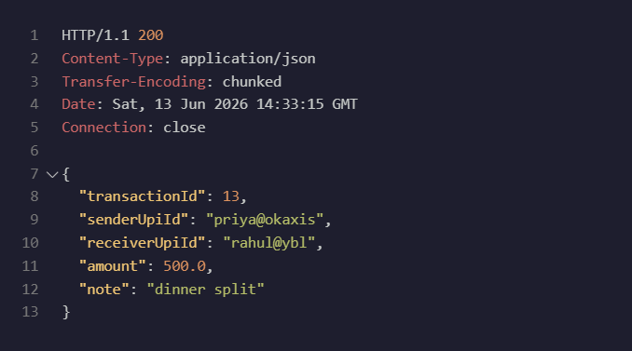
findByUpiId Generated SQL
select
u1_0.user_id,
u1_0.balance,
u1_0.name,
u1_0.phone_number,
u1_0.upi_id
from
users u1_0
where
u1_0.upi_id=?
Spring Data JPA derives this query from the repository method name findByUpiId. It reads the method name and understands that it should search using the upiId field of the User entity. The ? placeholder is where the actual UPI ID value is safely bound at runtime.
@RequestBody Demonstration
With @RequestBody
User{userId=null, name='Request Body Test', upiId='requestbody@test', balance=1000.0, phoneNumber='9000000000'}
Hibernate:
insert
into
users
(balance, name, phone_number, upi_id, user_id)
values
(?, ?, ?, ?, default)
{
"userId": 1,
"name": "Request Body Test",
"upiId": "requestbody@test",
"balance": 1000.0,
"phoneNumber": "9000000000"
}
Without @RequestBody
User{userId=null, name='null', upiId='null', balance=null, phoneNumber='null'}
Hibernate:
insert
into
users
(balance, name, phone_number, upi_id, user_id)
values
(?, ?, ?, ?, default)
{
"userId": 1,
"name": null,
"upiId": null,
"balance": null,
"phoneNumber": null
}
Without @RequestBody, Spring MVC does not ask Jackson to read the JSON request body and convert it into a Java User object. The request reaches the controller, but the object fields are not filled from the JSON payload, so they remain null. With @RequestBody, Jackson deserializes JSON keys like name, upiId, balance, and phoneNumber into the matching Java fields.
Query Approaches
Derived method names: Simple queries generated from method names, such as findByUpiId.
@Query JPQL: Custom object-based query using entity and field names, such as select u from User u where u.balance > :amount.
Native SQL: Raw database-specific SQL. It is least preferred here because it is tightly coupled to the database and less portable.
Conceptual Write-Up Answers
Request lifecycle
When a request comes to a Spring Boot REST API, it first reaches the embedded Tomcat server. Tomcat forwards it to Spring MVC's DispatcherServlet, which acts as the front controller. The DispatcherServlet finds the correct controller method using handler mappings and uses a HandlerAdapter to call that method. The returned Java object is converted to JSON and sent back as the HTTP response.
Serialisation and deserialisation
Deserialization means converting incoming JSON into a Java object, and serialization means converting a Java object back into JSON. By default, Jackson expects JSON field names to match Java property names such as upiId, not database column names such as upi_id. Hibernate may create the database column as upi_id, but the REST JSON field should still be upiId unless extra Jackson configuration is added.
Spring Boot features
Spring Boot reduces setup by providing auto-configuration, starter dependencies, and an embedded server. In this project, the web server, JPA setup, H2 database connection, and repository implementations are configured mostly from the dependencies and application.properties. This lets the project focus on entities, repositories, services, and controllers instead of long XML or server configuration.
Spring vs Spring Boot
Spring is the main framework that provides dependency injection, beans, MVC, data access support, and many other modules. Spring Boot is built on top of Spring and makes it faster to create applications with less manual configuration. For this project, Spring provides controllers, services, repositories, and dependency injection, while Spring Boot starts the app and auto-configures the common setup.
Stateless REST
A stateless REST API does not store client session data inside the server between requests. Each request should contain the information needed for that operation. This makes scaling easier because a load balancer can send request one to server A and request two to server B without depending on server memory. In PayFlow, saved data is in the database, not in a Java List stored only in one controller object.
Persistence
A Java List stores data only inside application memory, so if the server restarts, all transaction records would be lost. That is unacceptable for a payments app because payment history must be stored reliably and auditable after the request finishes. In this assignment, H2 is used as a lightweight database to practise real persistence concepts such as tables, generated IDs, SQL, and repositories. Since this project uses an in-memory H2 database, data may still reset when the app restarts, but the structure is closer to how a real payments system would use a persistent database like MySQL or PostgreSQL.

