Example 1: Simple Filter
Description:
{
"description": "Which employees were hired after 2019?"
}
Result:
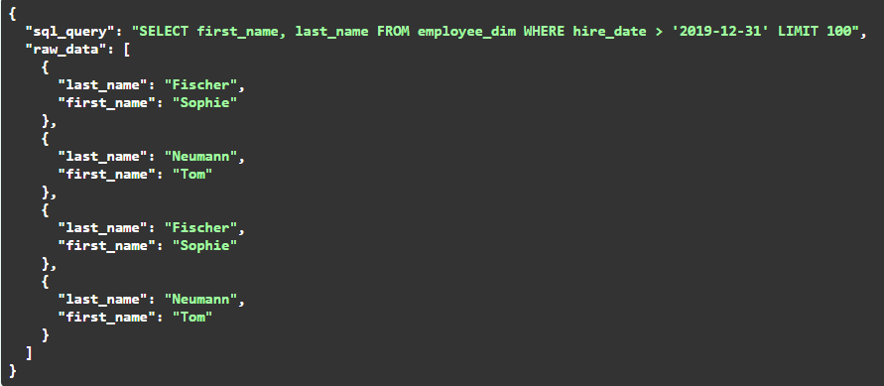

Example 2: Advanced Analytics
Description:
{
"description": "For each employee, show monthly total sales, their rank within the department, and the department average sales"
}
Result:
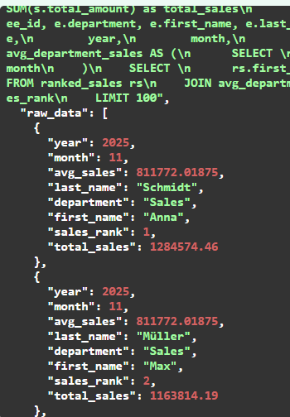

Example 3: Comparison
Description:
{
"description": "Compare the sales of employees this month compared to last month."
}
Result:
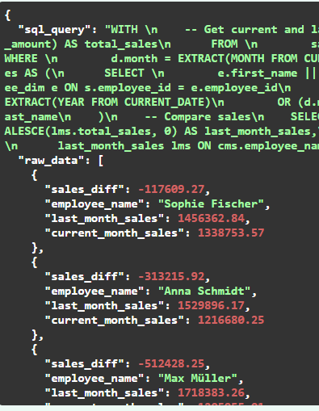

Example 4: Cumulative Analysis
Description:
{
"description": "Calculate the accumulated sales per product this month by day."
}
Result:
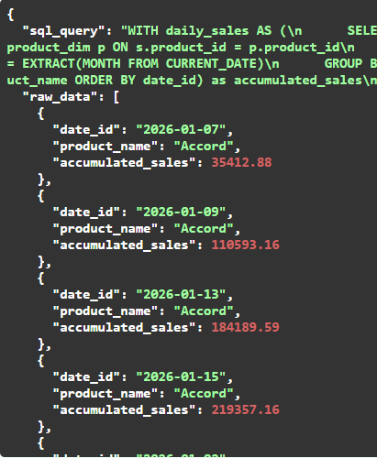

Example 5: Hierarchy Performance
Description:
{
"description": "Analyze sales performance by department, team, and employee and show percentage contribution at each level."
}
Result:
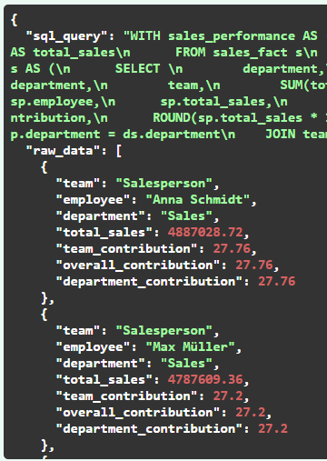

Example 6: Creative Llama
Description:
{
"description": "Tell me something creative about my data."
}
Result:
