Model Answer

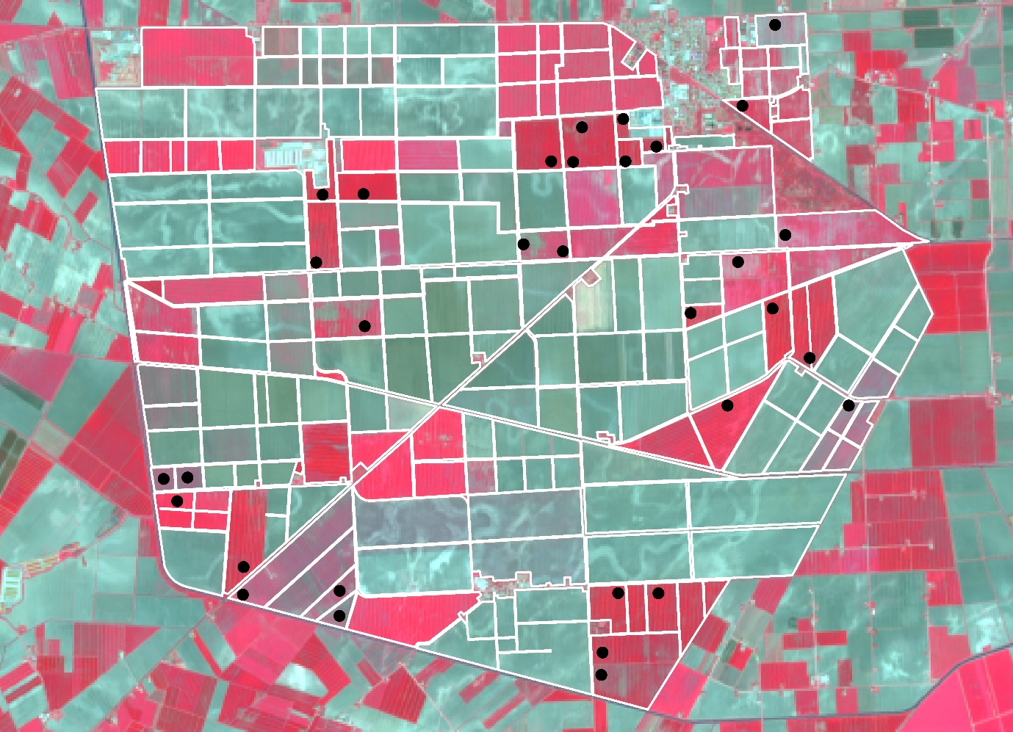

Sentinel-2 03-April-2020 (RGB = Band 8, 4, 3). This is pre-season for most of the crops on the farm, so the fields appear bluish due to the green band. The fields have not been tilled and have been fallow through the winter. They probably contain a lot of weeds. There are also some bluish buildings to the northeast, west, and south. The wheat fields are reddish due to the NIR band. Productivity (photosynthesis) and reflectance in the NIR is increasing after the winter thaw.

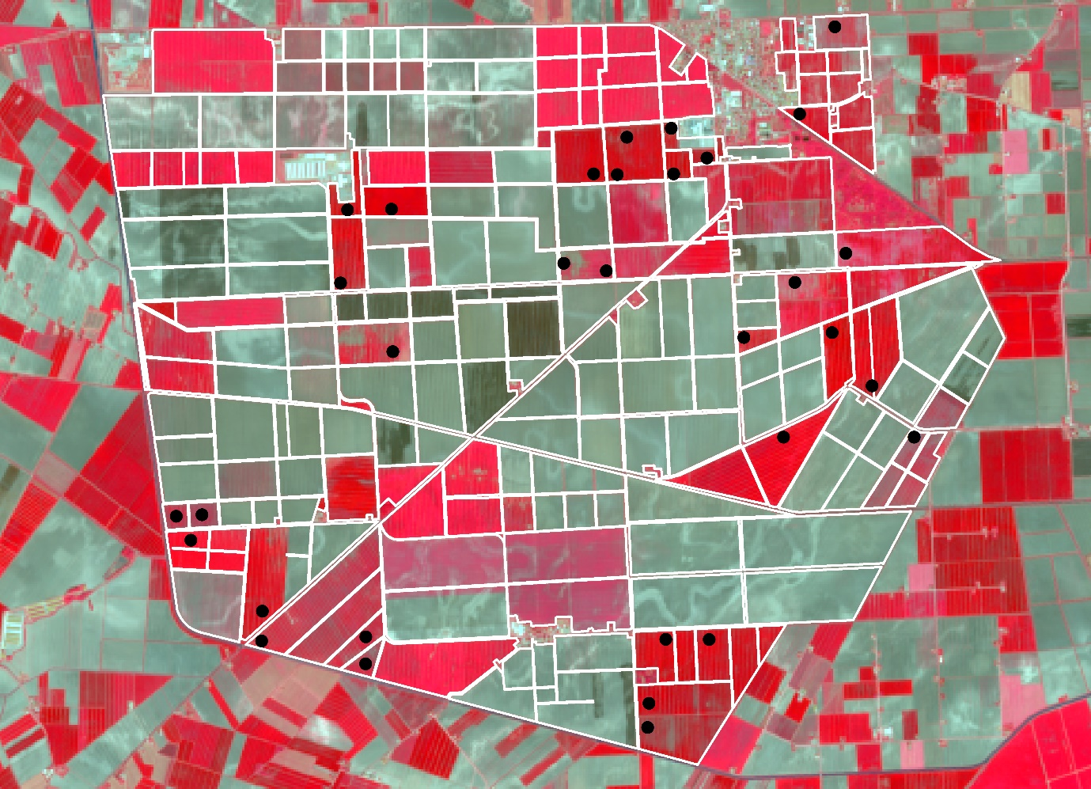

Sentinel-2 23-April-2020 (RGB = Band 8, 4, 3). Not even a month later, the wheat fields are much redder due to the NIR band. Productivity and reflectance in the NIR continue to increase. The buildings + roads remain the same color. Some of the fields appear brownish as they were recently tilled.

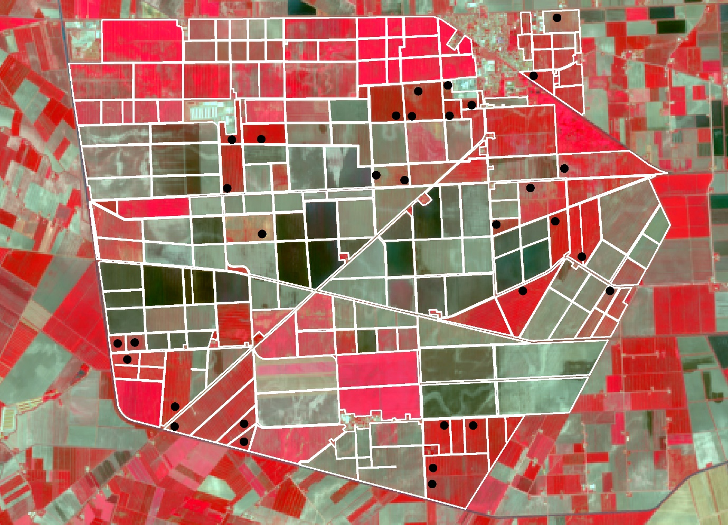

Sentinel-2 23-May-2020 (RGB = Band 8, 4, 3). The wheat fields remain reddish but a bit darker. The wheat is now well within the reproductive phase. The buildings and roads remain the same. Many of the remaining fields have been tilled and planted with summer crops (e.g., maize, soy).

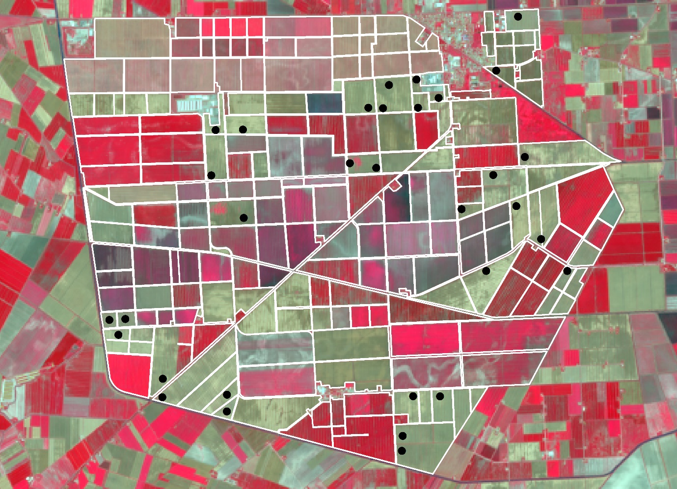

Sentinel-2 22-June-2020 (RGB = Band 8, 4, 3). This image was taken just before wheat harvest. The fields appear largely brown, as the remaining chlorophyll has been expended. The other crops are increasing in productivity and reflectance in the NIR. The buildings + roads remain the same.

The answers may vary according to the vegetation indices you looked at…I analyzed NDVI, Clre, and NDWI.

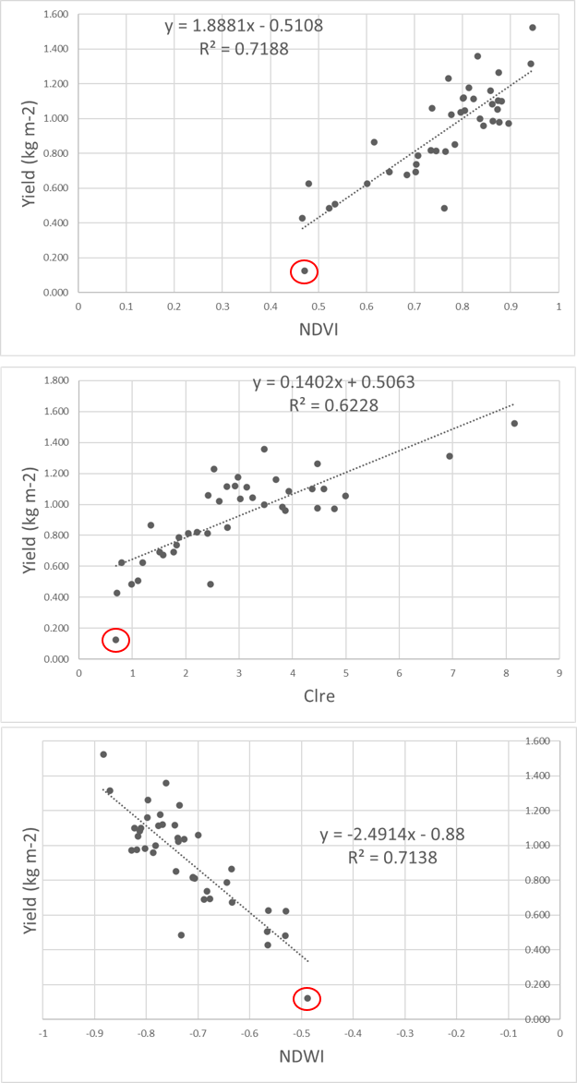

The highest performing index was NDVI in the 23 May 2020 image. This date corresponds to the reproductive phase. Many researchers identify this period as good for prediction, because reproductive organs are being formed for grain-filling and photosynthesis reaches its maximum. NDVI is particularly good, because it detects absorption due to chlorophyll and reflectance due increased canopy structure (biomass). NDWI also performs quite well for similar reasons.

The indices generally performed poorest on 22 June 2020. This is near harvest when the crop canopies are quite brown and photosynthesis has stopped. Shortwave indices tend to due better during this period, because they are more sensitive to lead/canopy water and non-pigment compounds (e.g., lignin/cellulose). However, these properties are difficult to detect with Sentinel-2.

The relationship appears linear. However, DWBNF0202 has a yield value of 0.124 kg m-2, which is quite a bit lower than the other samples. This is clearly seen in the scatterplot (circled in red) but could also be identified with a residual plot. You may consider removing upon further investigation.

The performance of the log transformed yield was lower (R2=0.6482,0.4512,0.6499 for NDVI, Clre, and NDWI respectively). This is further evidence that the relationships are linear.

The average and cumulative composites in this case performed more poorly than the single date prediction. This could be due in part to the low number of images used for the analysis (N=4). The composites may perform better with a larger number of images.

