**S3 TASK**

1. Create an S3 bucket and upload some objects to S3.

* Open aws console
* Navigate to s3
* Create a bucket with a unique name in global region
* 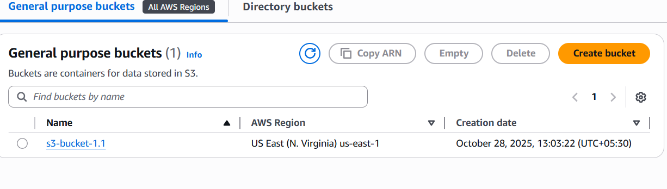
* Uploaded few objects from local through gui

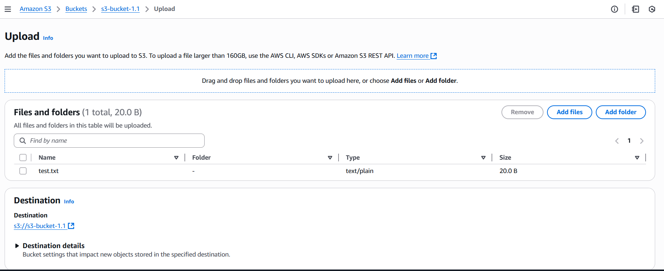

* 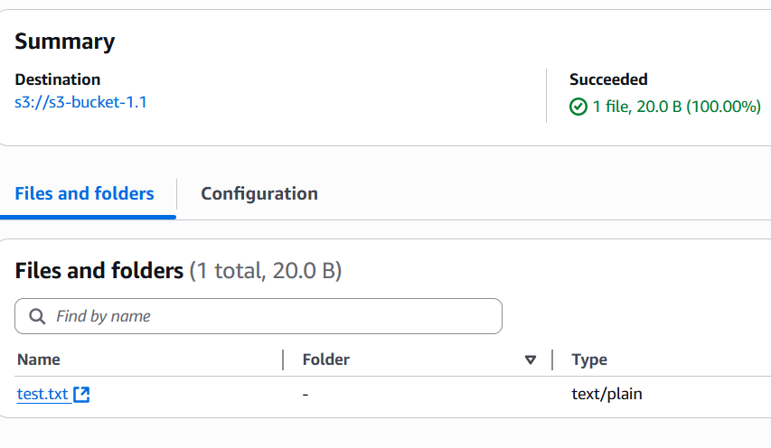

2 . Deploy a static website in the S3 bucket.

* This has to be done in bucket level
* Navigate to bucket > properties
* 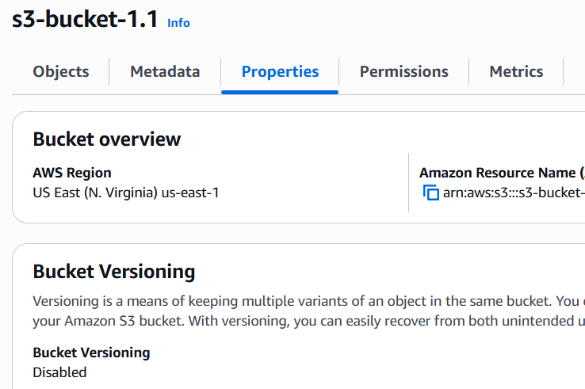
* Scroll down , can find static website hosting
* 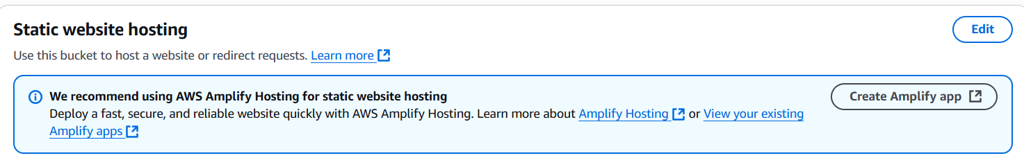
* Make it enable
* Select static website hosting
* 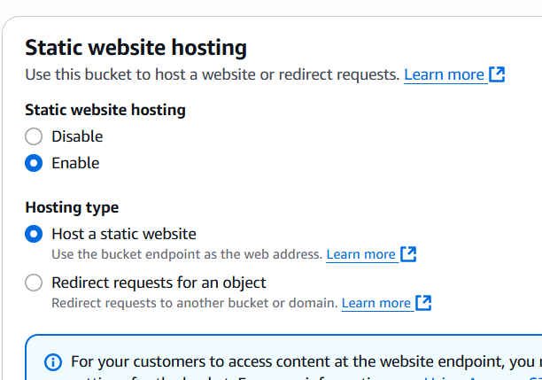
* Add name of the files eg. Index.html and error .html
* 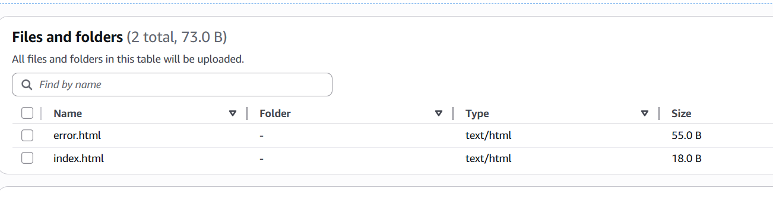
* Now go to bucket and upload those files to bucket
* Now navigate to permission and disable the block public accces
* Make it uncheck
* 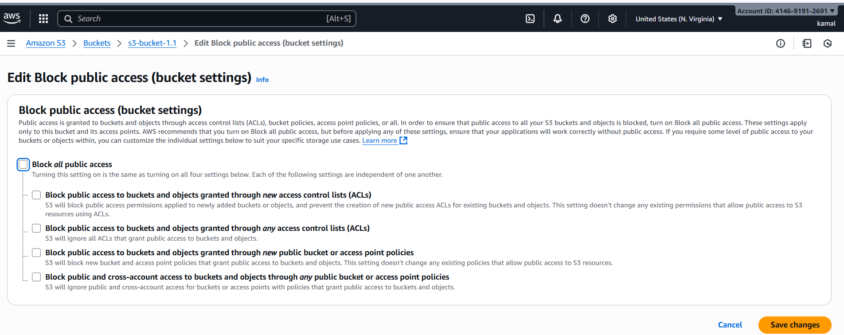
* Enable versioning in properties
* 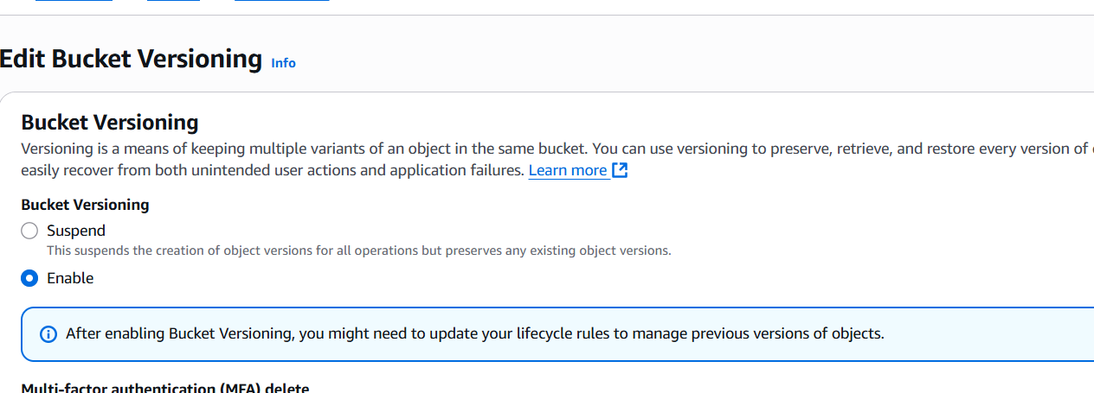
* Now go to bucket permission add json format policy
* {
* "Version": "2012-10-17",
* "Statement": [
* {
* "Sid": "PublicReadGetObject",
* "Effect": "Allow",
* "Principal": "*",
* "Action": "s3:GetObject",
* "Resource": "arn:aws:s3:::s3-bucket-1.1/*"
* }
* ]
* }
* 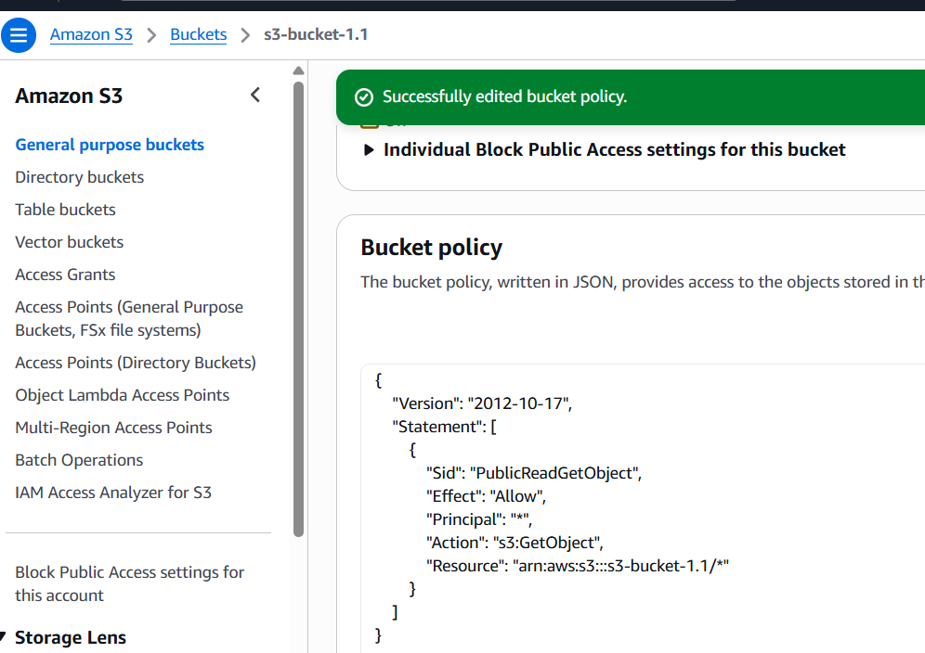
* Go to properties scroll down till the end find th e url or static website hosting
* 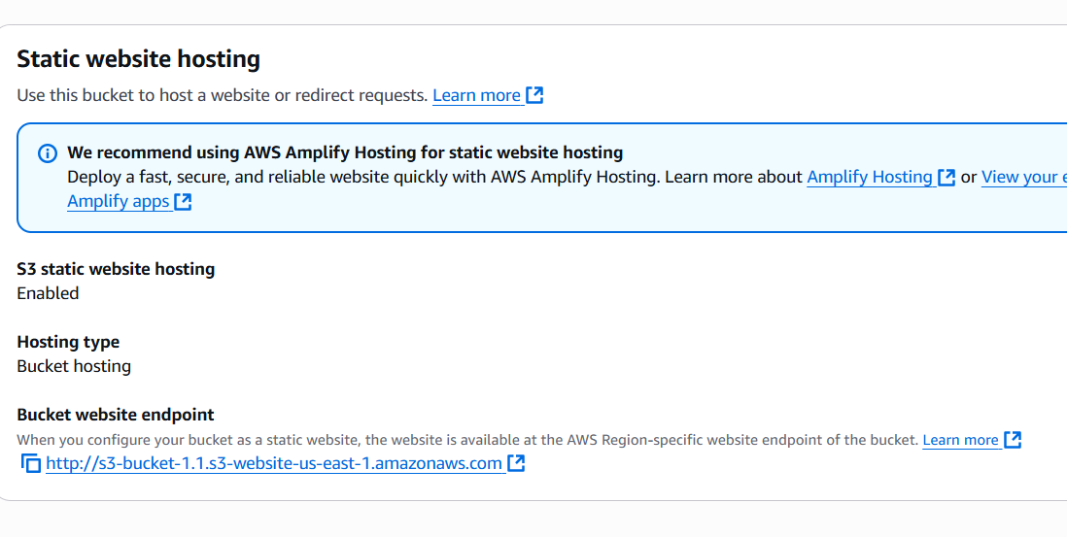
* 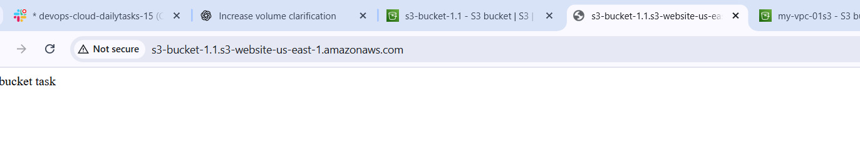

3 . Enable cross-region replication on S3 buckets.

* Create 2 buckets in 2 different regions
* 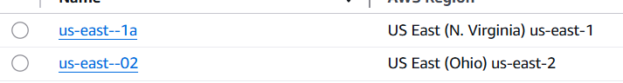
* Replication from n.virgina to ohio
* Open bucket us-east-1a and navigateto management
* Create a replication rule
* Give destination
* 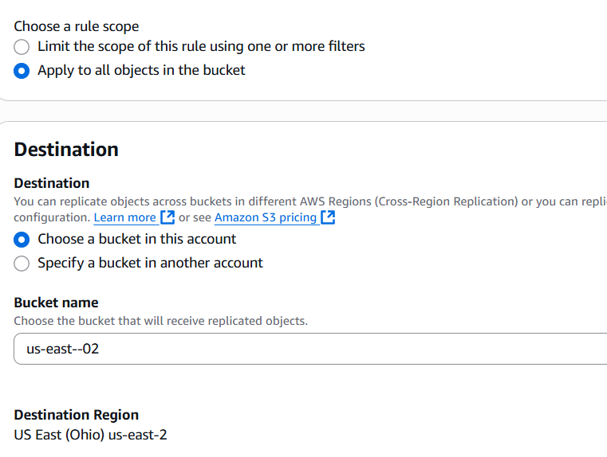
* 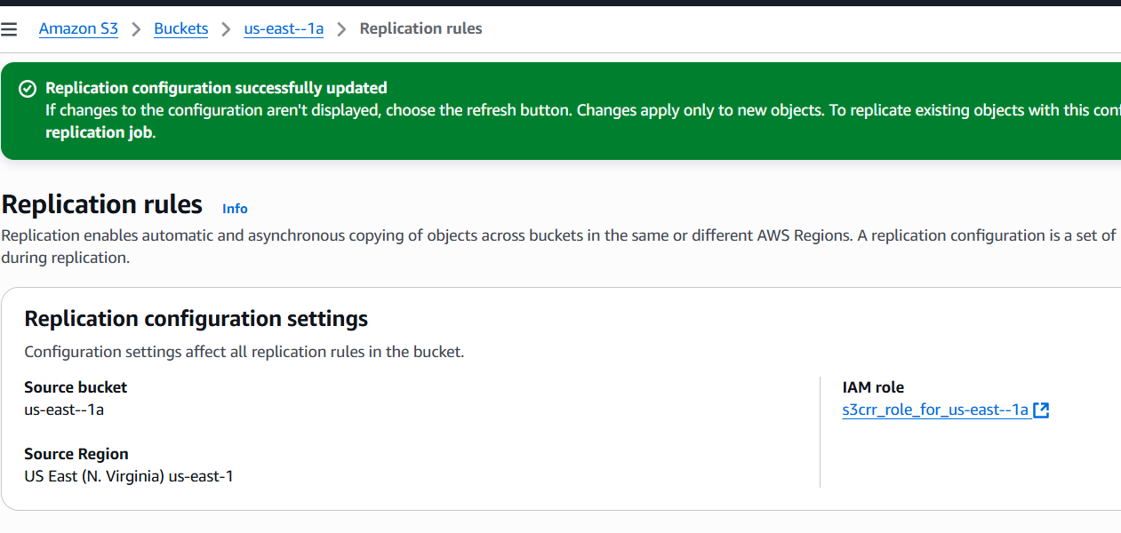
* Uploaded a file in us-east-1a bucket

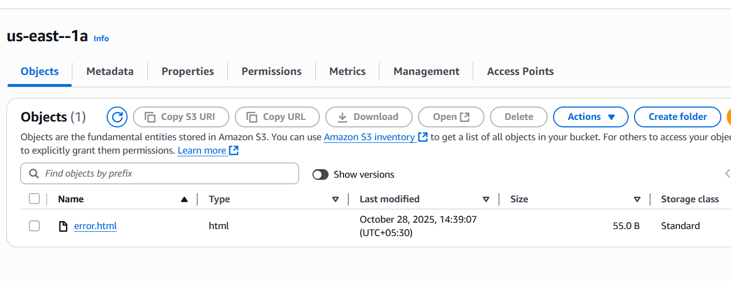

* The same file has seen in second bucket also
* 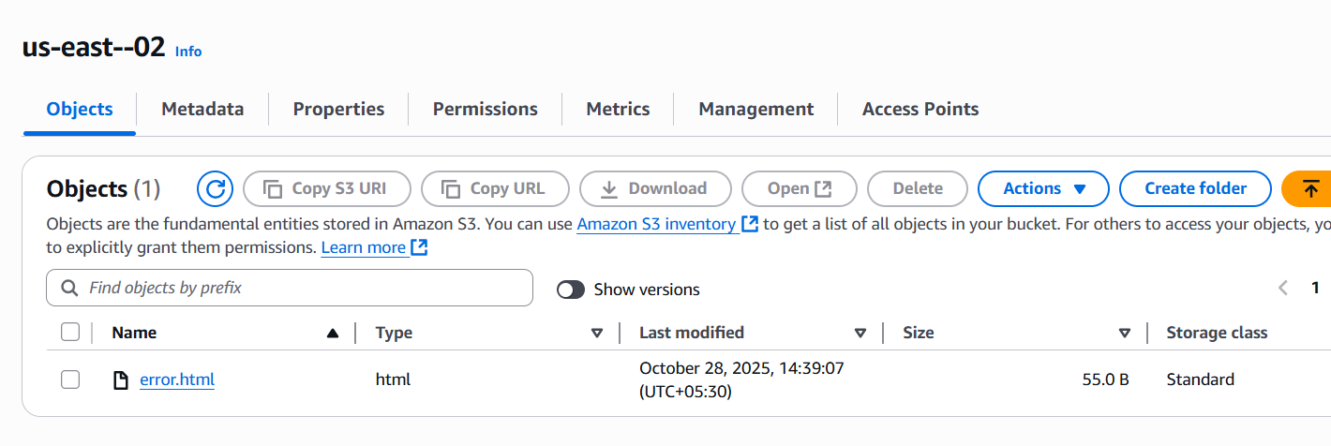

4 . Configure a bucket policy so only the Admin user can see the objects of the S3 bucket.

* 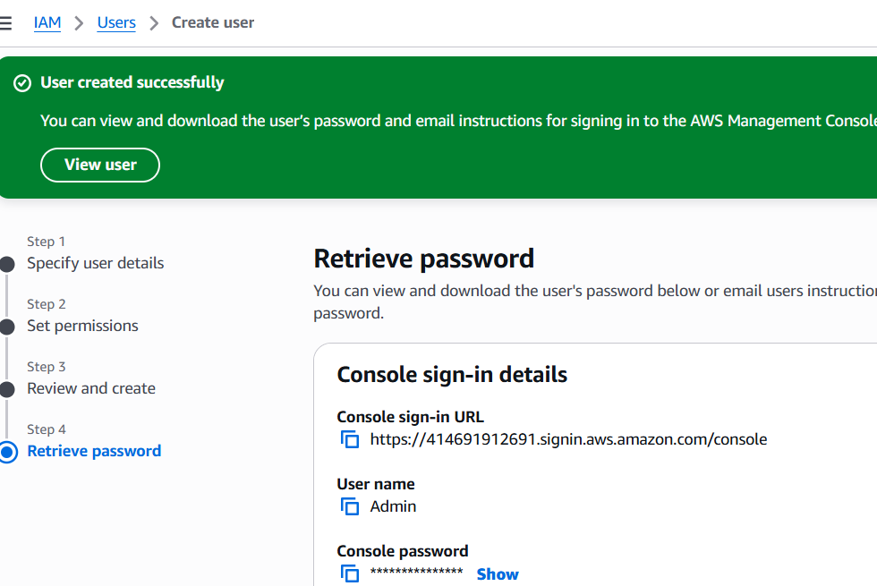
* Create user called Admin
* Attach policy directly – s3fullaccess
* Navigate to s3 bucket and > permission disable block public access
* Add Jason format policy for admin
* {
* "Version": "2012-10-17",
* "Statement": [
* {
* "Sid": "AllowAdminReadOnly",
* "Effect": "Allow",
* "Principal": {
* "AWS": "arn:aws:iam::414691912691:user/Admin"
* },
* "Action": [
* "s3:ListBucket",
* "s3:GetObject"
* ],
* "Resource": [
* "arn:aws:s3:::us-east--1a",
* "arn:aws:s3:::us-east--1a/*"
* ]
* },
* {
* "Sid": "DenyAllOthers",
* "Effect": "Deny",
* "NotPrincipal": {
* "AWS": [
* "arn:aws:iam::414691912691:user/Admin",
* "arn:aws:iam::414691912691:root"
* ]
* },
* "Action": "s3:*",
* "Resource": [
* "arn:aws:s3:::us-east--1a",
* "arn:aws:s3:::us-east--1a/*"
* ]
* }
* ]
* }
* 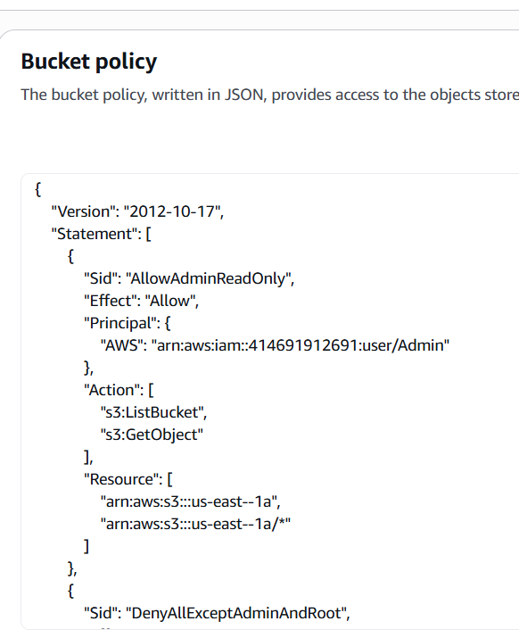
* 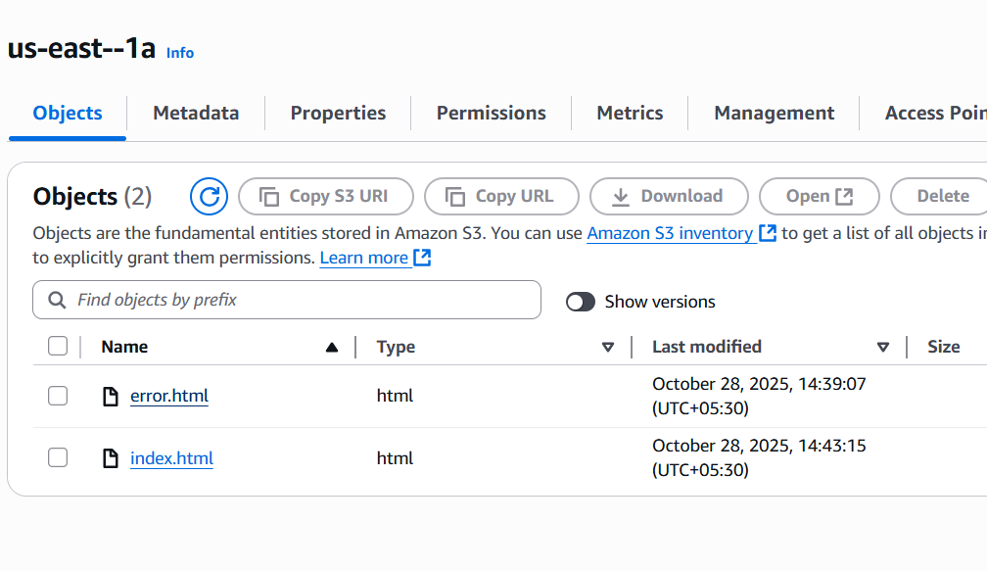

5. Set up lifecycle policies to automatically transition or delete objects based on specific criteria.

* Open bucket
* Navigate to maintance
* Create a life cycle
* Give a name
* Select the objects you want for transition from class to class or permanently delete
* Give number of dates for exisiting and then delete
* 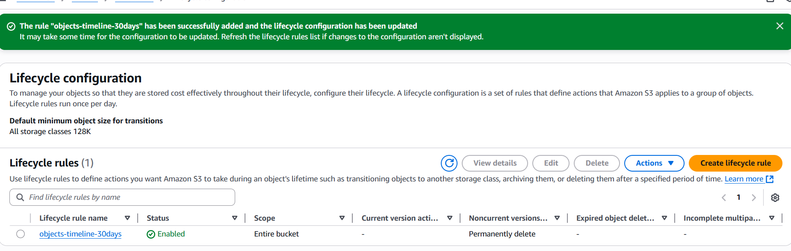

5 . Push some objects to S3 using the AWS CLI.

* Configure gui and cli
* Navigate to iam ,create iam user and give s3 full access to the user
* Now open cli
* Give command aws configure
* Give access key and secret key and location
* Now list the buckets
* Aws s3 ls
* 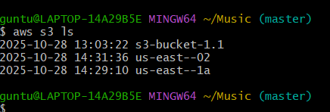
* To upload the files
* Open gitbash in location (FILES LOCATION )
* And give command
* aws s3 cp s3-test s3://s3-bucket-1.1/
* 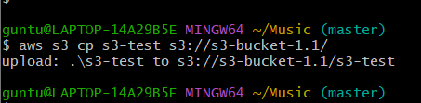
* To verify the upload
* aws s3 ls s3://s3-bucket-1.1/
* 

7. Write a Bash script to create an S3 bucket.

* Open git configure aws and cli
* Create a file
* #!/bin/bash
* # Ask for bucket name and region
* read -p "Enter the S3 bucket name: " BUCKET_NAME
* read -p "Enter AWS region (default: us-east-1): " REGION
* REGION=${REGION:-us-east-1}
* echo "Creating bucket: $BUCKET_NAME in region: $REGION ..."
* # Create the bucket based on region
* if [ "$REGION" = "us-east-1" ]; then
* aws s3api create-bucket \
* --bucket "$BUCKET_NAME" \
* --region "$REGION"
* else
* aws s3api create-bucket \
* --bucket "$BUCKET_NAME" \
* --region "$REGION" \
* --create-bucket-configuration LocationConstraint="$REGION"
* fi
* # Confirm creation
* if [ $? -eq 0 ]; then
* echo "✅ Bucket '$BUCKET_NAME' created successfully!"
* else
* echo "❌ Failed to create bucket."
* Run the script
* ./create-s3-bucket.sh
* Created successfully
* 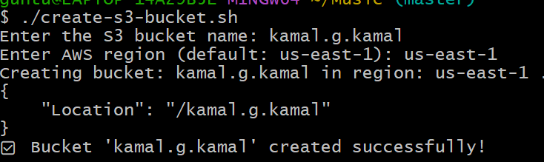
* To vcerify open gui and refresh

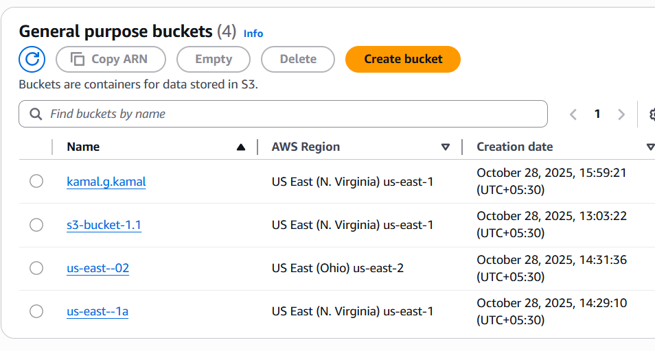

8. Upload a 1 GB file to S3 using the CLI.

* open gitbash
* configure aws through cli
* create a user and generate access key and secret key
* add it into git
* down load 1gb file by commad
* curl -k -O <https://speed.hetzner.de/1GB.bin>
* now aws s3 ls
* send file to bucket NAME (kamal.g.kama)
* aws s3 cp s3://kamal.g.kamal
* 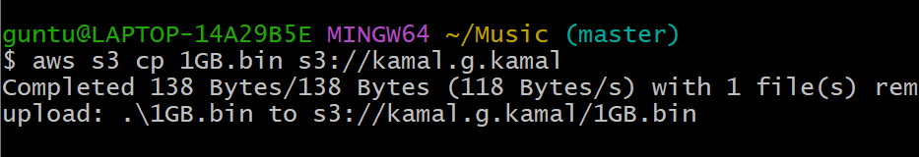
* Now to verify check aws -s3 – bucket
* Check bucket – kamal.g.kamal
* 