**--1. Identify all sales transactions for "Electronics" in the South region to evaluate regional performance for this category.**

SELECT *

FROM sales

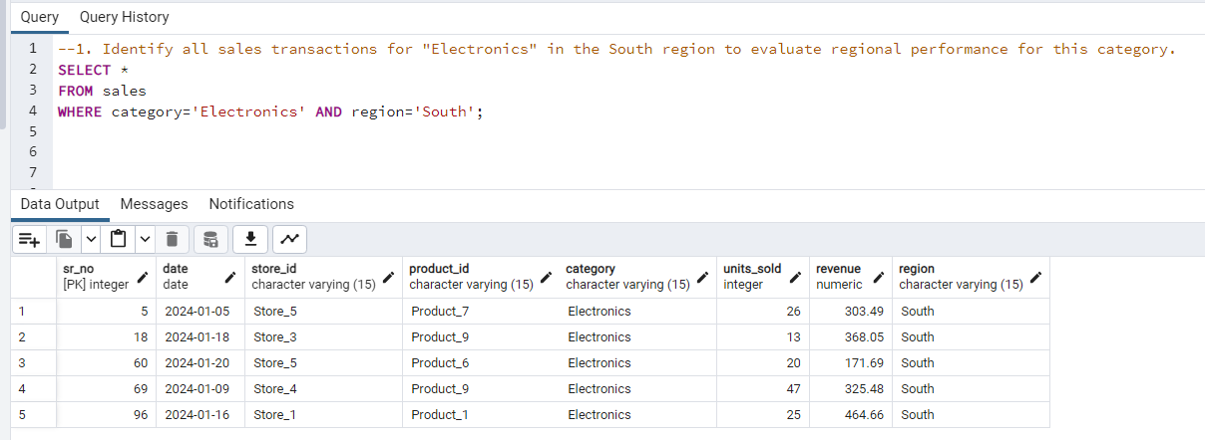WHERE category='Electronics' AND region='South';

**--2. Calculate the total revenue and units sold across all stores to measure overall business performance.**

SELECT SUM(revenue) AS total_revenue, SUM(units_sold) AS total_units_sold

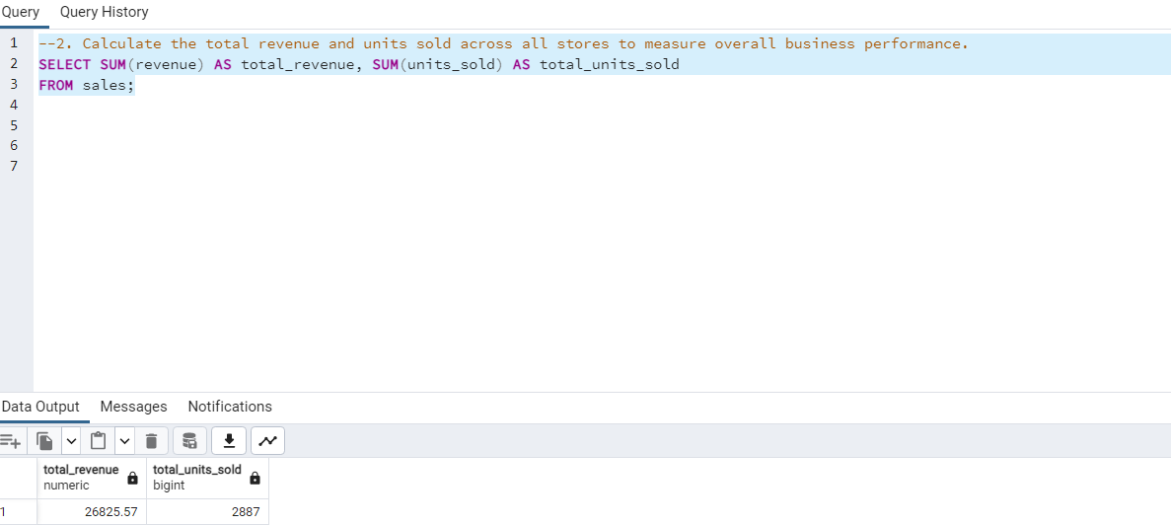FROM sales;

**--3. Determine the total revenue contribution of each product category to identify top-performing segments.**

SELECT category, SUM(revenue) AS revenue_contribution

FROM sales

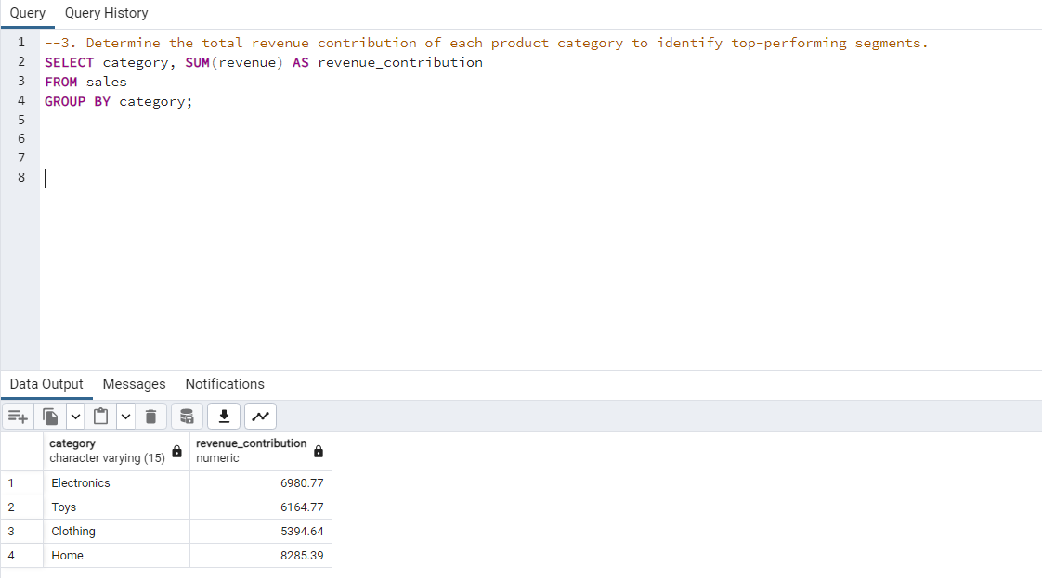GROUP BY category;

**--4. Analyze sales records for January 2024 to assess post-holiday season performance.**

WITH cte1 AS(

SELECT sr_no, store_id, product_id, category, units_sold, revenue, region, EXTRACT(MONTH FROM date) AS months

FROM sales

)

SELECT *

FROM cte1

WHERE months=1;

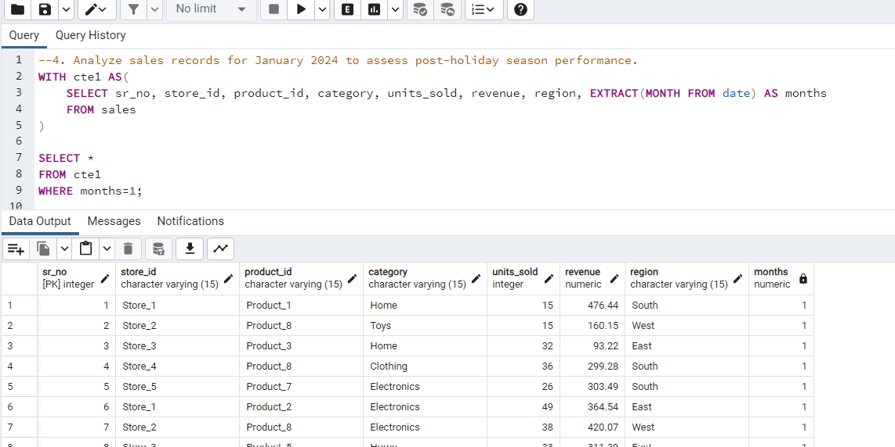

**--5. Classify sales transactions based on revenue into "High," "Moderate," and "Low" categories to prioritize product performance reviews.**

-- Figured out MIN(revenue)=50.2 and MAX(revenue)=492.58 first to get appropriate classification of categories

SELECT *,

CASE

WHEN revenue BETWEEN 0 AND 150 THEN 'Low'

WHEN revenue BETWEEN 151 AND 350 THEN 'Moderate'

ELSE 'High'

END AS product_performance

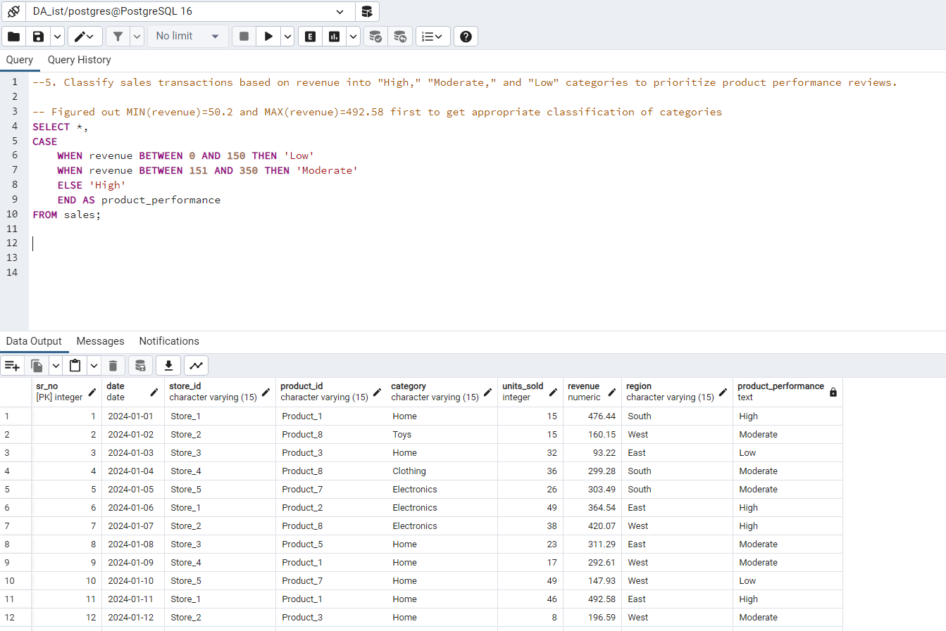FROM sales;

**--6. Identify which store generated the highest total revenue to recognize the best-performing location.**

SELECT store_id, SUM(revenue) AS total_reveue

FROM sales

GROUP BY store_id

ORDER BY SUM(revenue) DESC

LIMIT 1;

