Documentation of IL API

**Introduction:**

This is the documentation for the IL API. It includes the build and release pipeline processes. Build pipelines include Nuget-related tasks, artifact generation, etc. Once the build is successful, the release pipeline starts triggering it.

**Build and Release pipeline for IL API Services :-**

**IPERFORMECCMApiIllinois :-**

**Scope:**

* CI/CD is used because code can be easily deployed into a specific environment in a short period of time.
* Through the build pipeline, we can generate the artifacts, and through the release pipeline, we are able to deploy them in a specific location with the required changes.

**CI/CD Architecture:**

**Deployment Group:**A deployment group is a logical set of deployment target machines that have agents installed on each one.

1. Create a deployment group.

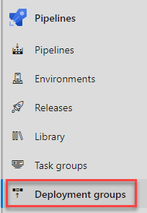

1. Select Add a deployment group.

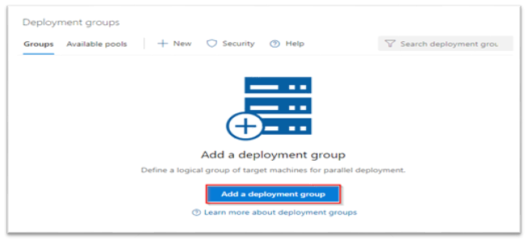

1. Enter a Deployment group name and then select Create. A registration script will be generated. Select the Type of target to register and then select Use a personal access token in the script for authentication. Finally, select Copy script to the clipboard.

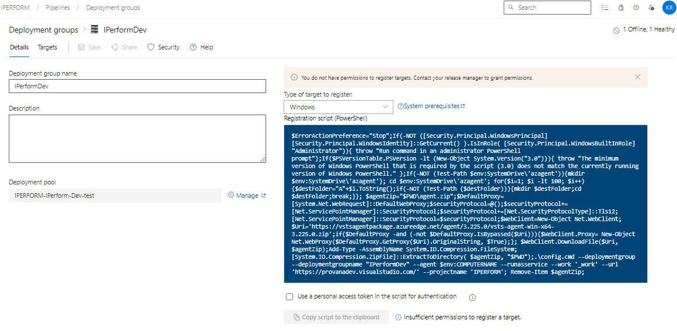

At this stage our deployment group is created but not online yet.

1. Log onto each of your target machines and run the script from an elevated PowerShell command prompt to register it as a target server. When prompted to enter tags for your agent, press *Y* and enter the tag(s) you will use to filter subsets of the servers.

At this stage, our deployment group creation gets completed and now if you go and check the status of the deployment group in the Azure DevOps, it should show as Online.

**Build Pipeline for IPERFORMECCMApiIllinois :-**

Steps:

1) Navigate the page to Pipelines and click on the “New Pipeline”.

2) Click on the Azure Repos Git as our code is in azure repository.

1. Select the repository for which we have to create build pipeline.

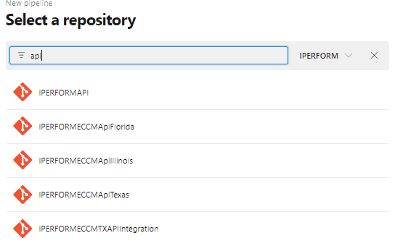

4)then configure your pipeline as per your requirements.

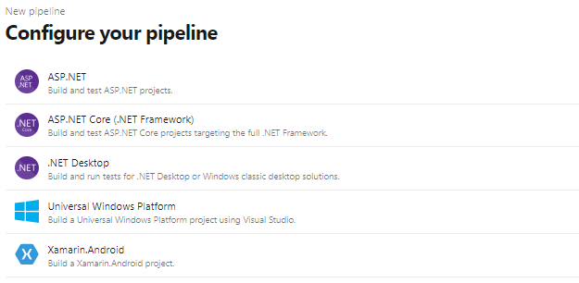

**Pipelines:**

We are using Azure pipelines (Microsoft hosted agent) as the agent pool for this pipeline. Microsoft-2019 OS version will be used in the agent.

**Variables:**

you can create variables that can be used in every step of the pipeline. For builds, you could set the username and password of an external service that you want to call. Azure DevOps already comes with a couple of predefined variables like the build configuration or platform.

|  |  |  |
| --- | --- | --- |
| Variable | Description | Used in Task |
| BuildPlatform | CPU configs | Build Solution |
| BuildConfiguration | Configuration | Build Solution |

**Tasks:**

**NuGetToolInstaller@0** - Acquires a specific version of NuGet from the internet or the tools cache and adds it to the PATH. Use this task to change the version of NuGet used in the NuGet tasks.

**NuGetCommand@2** – Use this task to restore, pack, or push NuGet packages, or run a NuGet command.

**SonarQubePrepare@4** - This task use prepare a SonarQube analysis Configuration.

**VSBuild@1** - The Visual Studio Build step builds your application using the solution file

**SonarQubePublish@4** - This Use this task to publish SonarQube's Quality Gate result on the Azure DevOps build result.

**sonar-buildbreaker@8** - This task for has better error handling and you probably want to browse to SonarQube if this task makes your build fail.

**VSTest@2** - Use this task to run unit and functional tests (Selenium, Appium, Coded UI test, etc.

**Publish Artifact**

Publish Artifact is necessary for an automated deployment. This step publishes all the files which you want to deploy later in the release pipeline.

**Git Tag –**

A simple task that tags a commit.

**Validation**

So, here “drop’ folder should include the following files:

**Release pipeline for IPERFORMECCMApiIllinois :**

**Steps:**

1. Navigate to release pipelines and click on “New“so as to create a new release pipeline which will be IPERFORMECCMApiIL in this case.

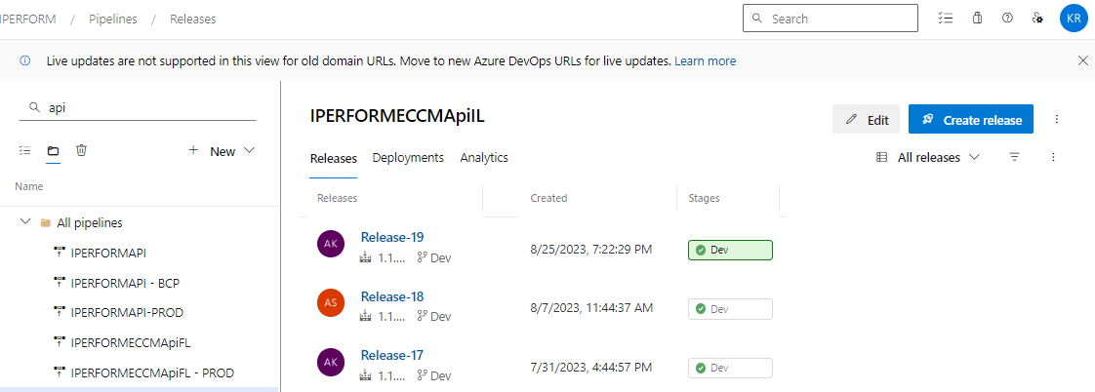

1. Select an empty job because we need to add customized jobs later which will support our project’s needs and functionality.

1. Before customizing the jobs, we will need to add the artifact that was built through our build pipeline. So, click on “Add an artifact” and then select the build pipeline which produced the artifact that is going to get used in this release pipeline.

1. As soon as the artifact is added, we must customize jobs according to the functionality of the project.

**Continuous deployment trigger:**

Continuous deployment triggers allow you to create a release every time a new build artifact is available.

Note -A release will be triggered only for a build that is from one of the branches selected here.  For example, selecting "DEV" will trigger a release for every build from the DEV branch.

**Pull request trigger**

Enabling this will create a release every time a selected artifact is available as part of a pull request workflow.

**Pre-deployment conditions :**

Pre-deployment gates ensures there are no active issues in the work item or problem management system before deploying a build to an environment.

Note –

* Triggers - Set the trigger that will start the deployment to this stage automatically. Select "Release" to deploy to the stage every time a new release is created. Use the "Stage" option to deploy after deployments to selected stages are successful. To allow only manual deployments, select "Manual".
* Artifact filters - Select artifact condition(s) to trigger a new deployment. A release will be deployed to this stage only if all artifact conditions match.

**Pre-deployment approvals** –

Select the users who can approve or reject deployments to this stage.

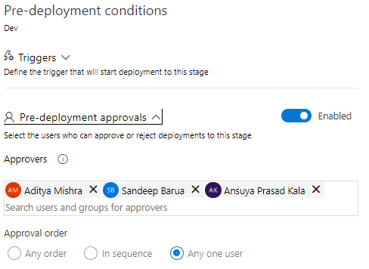

**Tasks:**

1. We must provide Stage Name, Azure subscription and App type and Name.

**Agent Job:**

A job is a logical grouping of tasks that defines the runtime target on which the tasks will execute. An agent job executes tasks on an agent in an agent pool.

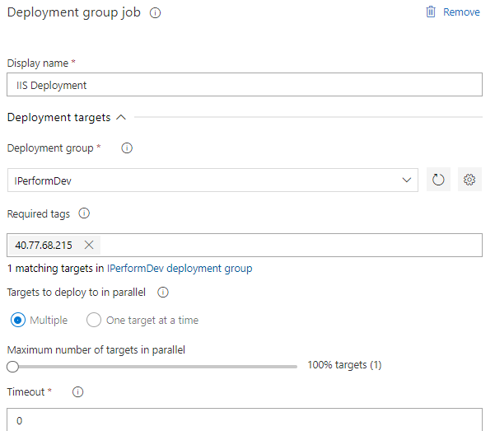

**IIS Web App Manage**  - This task use for Create or update websites, web apps, virtual directories, or application pools.

**IIS Web App Deploy**  - This task use for Deploy a website or web application using Web Deploy.

**Replace Tokens -** Replace tokens in Web.config.

Here we can see the use of replace tokens which uses ‘#’ in the web.config.

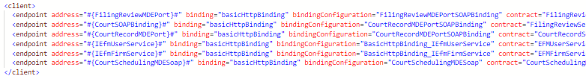

**Command Line Script  -** This task use for Run a command line script using Bash on Linux and macOS and cmd.exe on Windows.

**Variables:**

**Validation :**

Once the release is successful, We check the url with public ip working or not.

**Revision History**

|  |  |  |  |
| --- | --- | --- | --- |
| **Date** | **Version** | **Description** | **Author** |
| **30/8/2023** | 1.0 | **Draft and Initial** | **Kamal Rajput** |