**Network Task**

**Task1:**

**Get me the IP address of a particular domain (guvi.in).**

**#nslookup guvi.in**

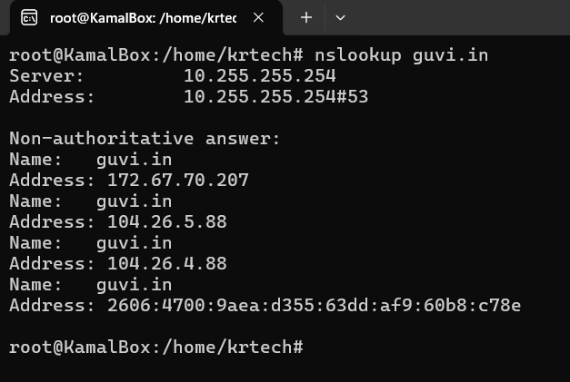

**#dig guvi.in**

**How do I find my CPU/memory usage of my server?**

**#top**

**#htop**

**#vmstat –** to check Memory utilization

**#mpstat –** to check CPC Utilization

**#free -h –** to check the free space of Memory

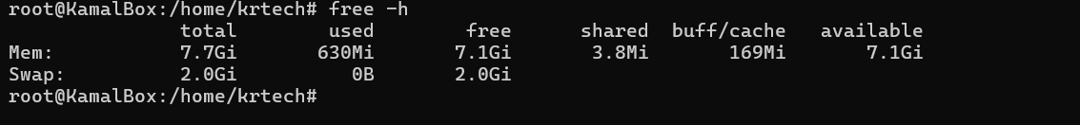

**#ps aux –sort=-%mem | head ,** to view the process sorted view of Memory and CPU

**#ps aux –sort=-%cpu | head**

**Test the connectivity between 2 nodes?**

**#ping**

**#traceroute**

**#mtr**

**#telnet (domain) (portno)**

**2. I have deployed an application in guvi.com:9000, and logs show my app is running, but I’m unable to view the page. Check whether my port is open or not ?**

**#netstat | head**

**#netstat -tuln |head**

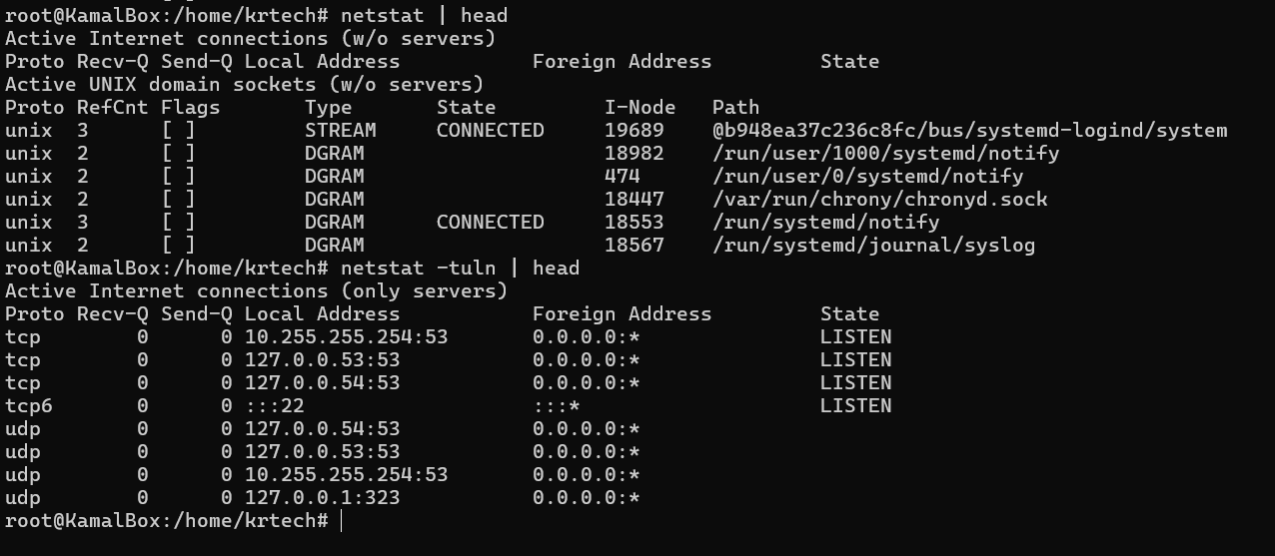

**#ss |head**

**#ss -tuln |head**

**UFW commands to view and allow/deny ports**

**#ufw status verbose –** to view the status of allow and deny ports

**# ufw allow (port no)**

**#ufw deny (port no)**

