# **Rep_Data Peer Assesment 1**

*Kamal*

Here is the Code to Load the data

library(plyr)  
dat <- read.table("./data/activity.csv",sep=",",header = T)  
##fileter out the NA values  
udat <- dat[!is.na(dat$steps),]  
##Sumation of steps  
## need plyr package  
  
dat1 <- ddply(udat,.(date),summarize, steps =sum(steps))

What is mean total number of steps taken per day?

#histogram ploting  
plot(dat1$steps, dat1$date, type = "h",xlab ="Steps", ylab="Date")

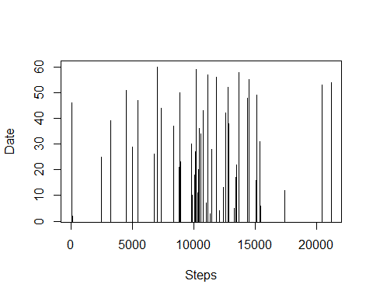

## Mean and Maidan  
mean <- ddply(udat,.(date),summarize, mean_steps =mean(steps))  
median <- ddply(udat,.(date),summarize, median_steps =median(steps))  
merge(mean, median)

## date mean_steps median_steps  
## 1 2012-10-02 0.4375 0  
## 2 2012-10-03 39.4167 0  
## 3 2012-10-04 42.0694 0  
## 4 2012-10-05 46.1597 0  
## 5 2012-10-06 53.5417 0  
## 6 2012-10-07 38.2465 0  
## 7 2012-10-09 44.4826 0  
## 8 2012-10-10 34.3750 0  
## 9 2012-10-11 35.7778 0  
## 10 2012-10-12 60.3542 0  
## 11 2012-10-13 43.1458 0  
## 12 2012-10-14 52.4236 0  
## 13 2012-10-15 35.2049 0  
## 14 2012-10-16 52.3750 0  
## 15 2012-10-17 46.7083 0  
## 16 2012-10-18 34.9167 0  
## 17 2012-10-19 41.0729 0  
## 18 2012-10-20 36.0938 0  
## 19 2012-10-21 30.6285 0  
## 20 2012-10-22 46.7361 0  
## 21 2012-10-23 30.9653 0  
## 22 2012-10-24 29.0104 0  
## 23 2012-10-25 8.6528 0  
## 24 2012-10-26 23.5347 0  
## 25 2012-10-27 35.1354 0  
## 26 2012-10-28 39.7847 0  
## 27 2012-10-29 17.4236 0  
## 28 2012-10-30 34.0938 0  
## 29 2012-10-31 53.5208 0  
## 30 2012-11-02 36.8056 0  
## 31 2012-11-03 36.7049 0  
## 32 2012-11-05 36.2465 0  
## 33 2012-11-06 28.9375 0  
## 34 2012-11-07 44.7326 0  
## 35 2012-11-08 11.1771 0  
## 36 2012-11-11 43.7778 0  
## 37 2012-11-12 37.3785 0  
## 38 2012-11-13 25.4722 0  
## 39 2012-11-15 0.1424 0  
## 40 2012-11-16 18.8924 0  
## 41 2012-11-17 49.7882 0  
## 42 2012-11-18 52.4653 0  
## 43 2012-11-19 30.6979 0  
## 44 2012-11-20 15.5278 0  
## 45 2012-11-21 44.3993 0  
## 46 2012-11-22 70.9271 0  
## 47 2012-11-23 73.5903 0  
## 48 2012-11-24 50.2708 0  
## 49 2012-11-25 41.0903 0  
## 50 2012-11-26 38.7569 0  
## 51 2012-11-27 47.3819 0  
## 52 2012-11-28 35.3576 0  
## 53 2012-11-29 24.4688 0

What is the average daily activity pattern?

dat2 <- udat[udat$interval ==5 ,]  
plot(dat2$steps, dat2$date, type = "l", xlab ="Steps", ylab="Date")

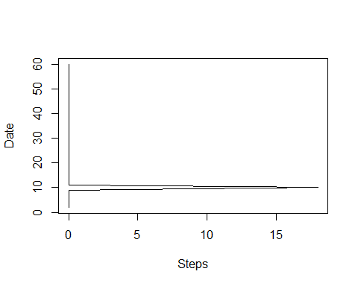

max <- dat2[dat2$steps == max(dat2$steps),]

Maximum number of steps are 18 and date is 2012-10-10.