QUE1 : Execute all the commands explained in this section and write the output.
ANSWER:

##GREP COMMAND :

(base) mca@computinglab25-21:~/Desktop/240905110_OSL/Lab_2$ cat example.txt
Example list :
Spain
France
England
Denmark
Germany
France
Germany
Germany

(base) mca@computinglab25-21:~/Desktop/240905110_OSL/Lab_2$ grep Germany example.txt
Germany
Germany
Germany

(base) mca@computinglab25-21:~/Desktop/240905110_OSL/Lab_2$ grep --color France example.txt
France
France

(base) mca@computinglab25-21:~/Desktop/240905110_OSL/Lab_2$ grep ^D example.txt
Denmark

(base) mca@computinglab25-21:~/Desktop/240905110_OSL/Lab_2$ grep -v Germany example.txt
Example list :
Spain
France
England
Denmark
France

##SORT COMMAND:

(base) mca@computinglab25-21:~/Desktop/240905110_OSL/Lab_2$ sort example.txt
Denmark
England
Example list :
France
France
Germany
Germany
Germany
Spain

(base) mca@computinglab25-21:~/Desktop/240905110_OSL/Lab_2$ sort -r example.txt
Spain
Germany
Germany
Germany
France
France
Example list :
England
Denmark

##WC COMMAND:

(base) mca@computinglab25-21:~/Desktop/240905110_OSL/Lab_2$ wc example.txt
11 11 78 example.txt

(base) mca@computinglab25-21:~/Desktop/240905110_OSL/Lab_2$ wc *
11 11 78 example.txt
1375 7894 419909 Lab 2 -Advanced_UNIX_Shell_Commands_With_Examples.pptx
2377 9885 320919 Lab 2.pdf
63 102 1098 Lab2_q1.txt
3826 17892 742004 total

##CUT COMMAND:

(base) mca@computinglab25-21:~/Desktop/240905110_OSL/Lab_2$ cut -c 1-3 example.txt
Exa
Spa
Fra
Eng
Den
Ger
Fra
Ger
Ger

(base) mca@computinglab25-21:~/Desktop/240905110_OSL/Lab_2$ cut -c 1-3,6 example.txt
Exal
Spa
Frae
Engn
Denr
Gern
Frae
Gern
Gern

(base) mca@computinglab25-21:~/Desktop/240905110_OSL/Lab_2$ cut -c3- example.txt
ample list :
ain
ance
gland
nmark
rmany
ance
rmany
rmany

#SED COMMAND:
(base) mca@computinglab25-21:~/Desktop/240905110_OSL/Lab_2$ cat example.txt
Example list :
Spain
France
England
Denmark
Germany
France
Germany
Germany

(base) mca@computinglab25-21:~/Desktop/240905110_OSL/Lab_2$ sed -e 's/Germany/Desturchland/' example.txt
Example list :
Spain
France
England
Denmark
Desturchland
France
Desturchland
Desturchland

##TR COMMAND:
(base) mca@computinglab25-21:~/Desktop/240905110_OSL/Lab_2$ cat example.txt
Example list :
Spain
France
England
Denmark
Germany
France
Germany
Germany

(base) mca@computinglab25-21:~/Desktop/240905110_OSL/Lab_2$ tr 'a-z' 'A-Z' < example.txt
EXAMPLE LIST :
SPAIN
FRANCE
ENGLAND
DENMARK
GERMANY
FRANCE
GERMANY
GERMANY

##CHMOD COMMAND:
(example1.txt made into an executable as it turned green in ls -l)
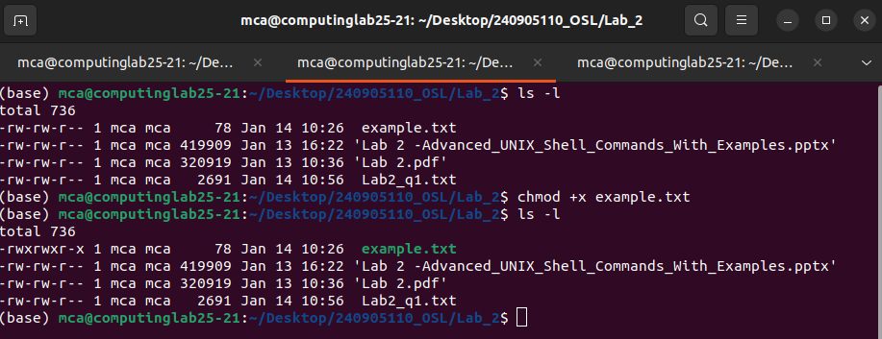

##KILL COMMAND:
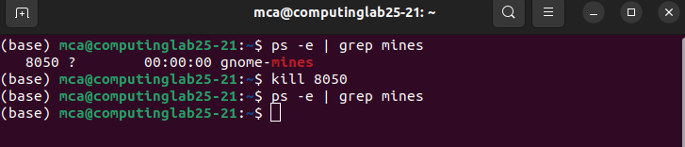

QUE2:2. Write grep commands to do the following activities:
• To select the lines from a file that have exactly two characters.
• To select the lines from a file that start with the upper case letter.
• To select the lines from a file that end with a period.
• To select the lines in a file that has one or more blank spaces.
• To select the lines in a file and di

ANSWER:
(base) mca@computinglab25-21:~/Desktop/240905110_OSL/Lab_2$ grep '^..$' example.txt
ab
(base) mca@computinglab25-21:~/Desktop/240905110_OSL/Lab_2$ grep '^[A-Z]' example.txt
Example list :
Spain
France
England
Denmark
Germany
France
Germany
Germany
United Kingdom
(base) mca@computinglab25-21:~/Desktop/240905110_OSL/Lab_2$ grep '\.$' example.txt
cd.
(base) mca@computinglab25-21:~/Desktop/240905110_OSL/Lab_2$ grep ' *' example.txt
Example list :
United Kingdom
(base) mca@computinglab25-21:~/Desktop/240905110_OSL/Lab_2$ grep '[0-9]' example.txt > new_file.txt

new_file.txt:

QUE3:Create file studentInformation.txt using vi editor which contains details in the
following format.
RegistrationNo:Name:Department:Branch:Section:Sub1:Sub2:Sub3
1234:XYZ:ICT:CCE:A:80:60:70 … (add atleast 10 rows)
i) Display the number students( only count) belonging to ICT department.
ii) Replace all occurrences of IT branch with “Information Technology” and save
the output to ITStudents.txt
iii) Display the average marks of student wit

ANSWER :

(base) mca@computinglab25-21:~/Desktop/240905110_OSL/Lab_2$ vi studentInformation.txt

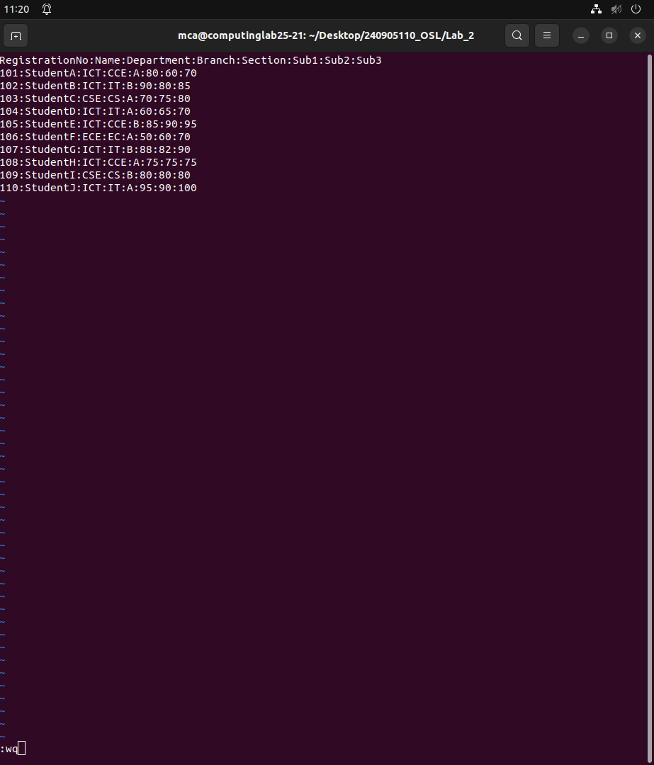

(base) mca@computinglab25-21:~/Desktop/240905110_OSL/Lab_2$ vi studentInformation.txt
(base) mca@computinglab25-21:~/Desktop/240905110_OSL/Lab_2$ grep -c ":ICT:" studentInformation.txt
7
(base) mca@computinglab25-21:~/Desktop/240905110_OSL/Lab_2$ sed -e 's/:IT:/:Information Technology:/g' studentInformation.txt > ITStudents.txt
(base) mca@computinglab25-21:~/Desktop/240905110_OSL/Lab_2$ awk -F: 'NR>1 {avg=($6+$7+$8)/3; print $2 " Average: " avg}' studentInformation.txt
StudentA Average: 70
StudentB Average: 85
StudentC Average: 75
StudentD Average: 65
StudentE Average: 90
StudentF Average: 60
StudentG Average: 86.6667
StudentH Average: 75
StudentI Average: 80
StudentJ Average: 95
Average: 0

