OSL LAB WEEK:3

QUE_1 : Write a shell script to find whether a given file is the directory or regular file.

CODE :
#!/bin/bash

file=$1
counter=1

while read -r line; do
if [ $((counter % 2)) -ne 0 ]; then
echo "$line"
fi

counter=$((counter + 1))
done < "$file"

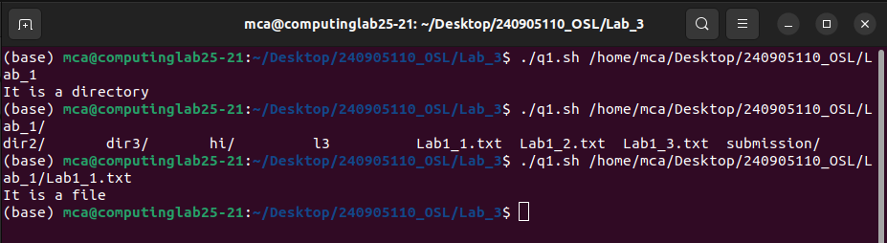

QUE_2 : Write a shell script to list all files (only file names) containing the input pattern
(string) in the folder entered by the user.
CODE :

#!/bin/bash

DirPath=$1

cd ${DirPath}

#fnid files with extension .sh
find ./ -name "*.sh"

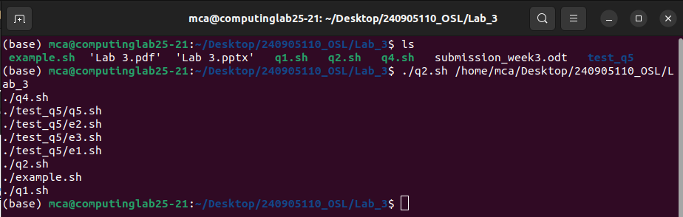
QUE_3 : Write a shell script to replace all files with .txt extension with .text in the current di-
rectory. This has to be done recursively i.e if the current folder contains a folder
“OS” with abc.txt then it has to be changed to abc.text ( Hint: use find, mv )

CODE :

#!/bin/bash

find . -type f -name "*.txt" | while read -r file; do
new_name="${file%.txt}.text"

echo "Renaming: $file -> $new_name"
mv "$file" "$new_name"
done

echo "Done!"

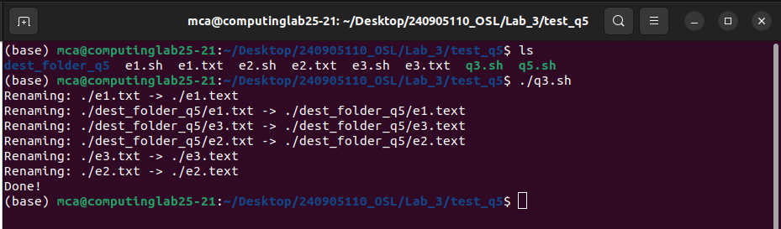

QUE_4 : Write a shell script to calculate the gross salary. GS=Basics + TA + 10% of Basics.
Floating point calculations has to be performed.

CODE :
echo "ENter the value for Basic and TA"

read b t

_bas=$(expr $b / 10)

result=$(expr $b + $t + $_bas)

echo ${result}

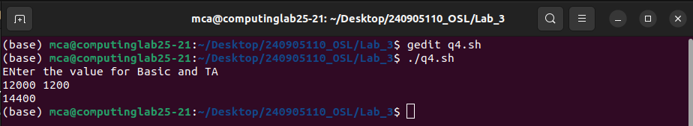

QUE_5 : Write a program to copy all the files (having file extension input by the user) in the
current folder to the new folder input by the user. ex: user enter .text TEXT then all
files with .text should be moved to TEXT folder. This should be done only at single
level. i.e if the current folder contains a folder name ABC which has .txt files then
these files should not be copied toWrite a shell script which deletes all the even numbered lines in a text file. TEXT.

CODE :
echo "Enter file extension (e.g., .txt) and destination folder name:"
read ext folder

mkdir -p "$folder"

cp *$ext "$folder/"

echo "Done! Files ending in $ext have been copied to $folder."

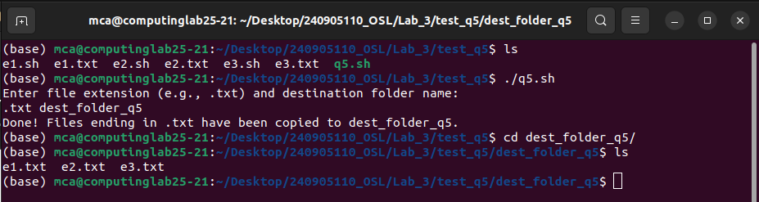

QUE_6 : Write a shell script which deletes all the even numbered lines in a text file.

CODE :
#!/bin/bash

file=$1
counter=1

while read -r line; do
if [ $((counter % 2)) -ne 0 ]; then
echo "$line"
fi

counter=$((counter + 1))
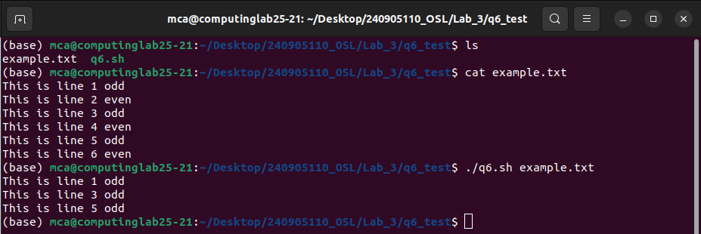
done < "$file"

