Fail2Ban SSH Brute-Force Mitigation
Before and After Mitigation Report

1. Objective
The objective of this task is to demonstrate the effect of an SSH brute-force attack before and after deploying Fail2Ban as a mitigation control on a Kali Linux system.

2. Before Mitigation
In this phase, the SSH service was started with no brute-force protection in place. Hydra was then used to launch a dictionary attack against the SSH service using the rockyou.txt wordlist.

Step 1: Start the SSH Service
The SSH service was started using the sudo service ssh start command, and its status was confirmed as active and running on port 22.

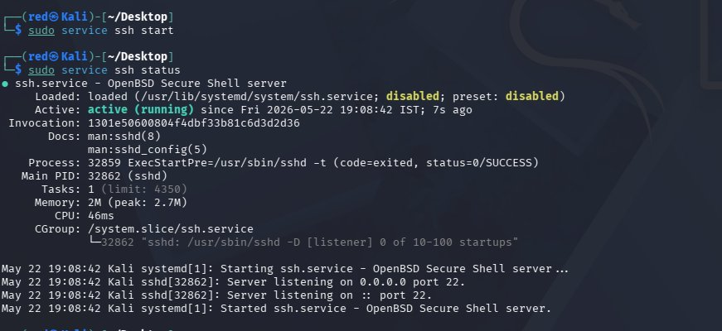
Figure 1: SSH service started and confirmed active on port 22

Step 2: Launch Hydra Brute-Force Attack (No Protection)
Hydra was run against ssh://127.0.0.1 using the rockyou.txt wordlist with 4 parallel tasks. With no Fail2Ban in place, Hydra was able to send thousands of login attempts continuously without being blocked.

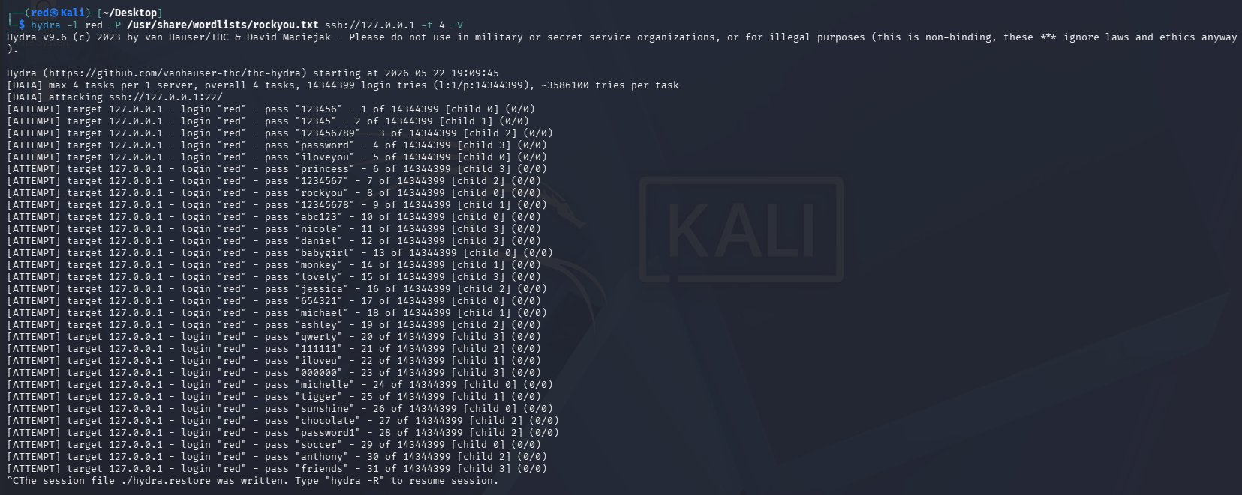
Figure 2: Hydra launching unrestricted brute-force attempts against SSH — no protection active

Step 3: Failed Login Attempts Logged in auth.log
The /var/log/auth.log file recorded a continuous stream of failed password attempts from 127.0.0.1. This confirms the attack was reaching the SSH service and being logged, but not stopped.

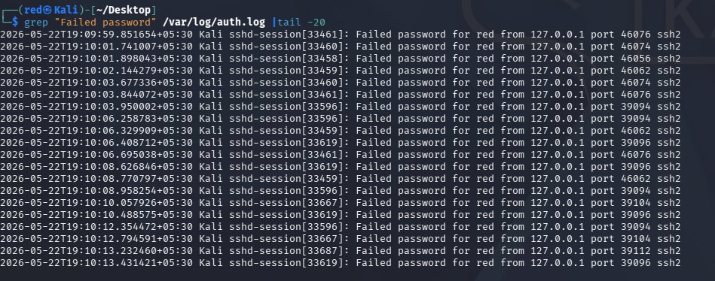
Figure 3: auth.log showing repeated failed SSH login attempts from 127.0.0.1 with no banning

3. Applying the Mitigation — Installing and Configuring Fail2Ban
Fail2Ban was installed and configured to monitor the SSH jail. The configuration was set to ban an IP after 3 failed attempts within a 600-second window for a duration of 600 seconds.

Step 4: Install Fail2Ban
Fail2Ban was installed using sudo apt install fail2ban -y. The package downloaded successfully along with its dependency python3-systemd.

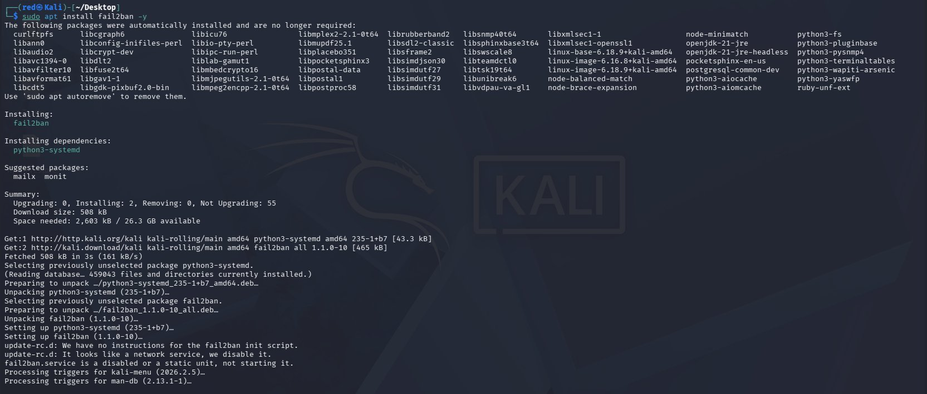
Figure 4: Fail2Ban installed successfully via apt package manager

Step 5: Configure the SSH Jail
The Fail2Ban SSH jail was configured in nano with the following settings: enabled = true, port = 22, maxretry = 3, bantime = 600, findtime = 600, and ignoreself = false. This ensures the local loopback address is not exempt from banning.

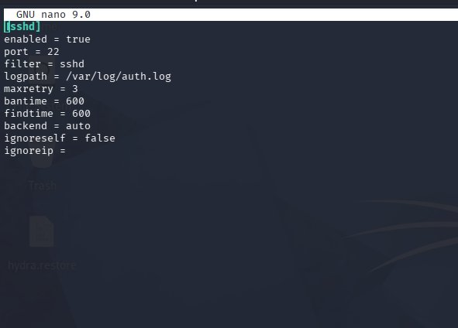
Figure 5: Fail2Ban jail configuration for SSH showing maxretry=3, bantime=600, ignoreself=false

Step 6: Start Fail2Ban and Verify Status
Fail2Ban was started with sudo service fail2ban start and confirmed as active and running. The initial Fail2Ban sshd jail status showed zero failed attempts and no banned IPs, confirming a clean baseline before any attack.

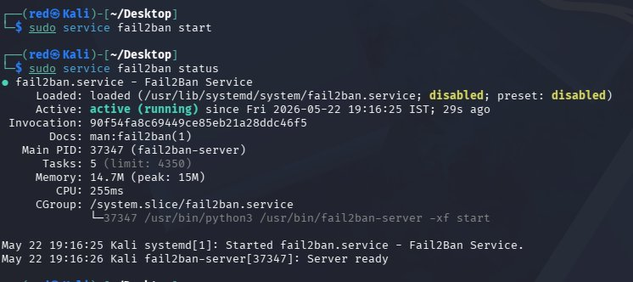
Figure 6: Fail2Ban service started and confirmed active and running

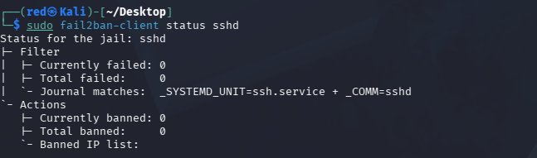
Figure 7: Fail2Ban sshd jail status showing 0 failed attempts and no banned IPs before attack

4. After Mitigation
With Fail2Ban active, the Hydra brute-force attack was run again. This time, Fail2Ban detected the repeated failed login attempts and banned the source IP, preventing any further connection attempts.

Step 7: Re-run Hydra Attack — Connection Refused and IP Banned
When Hydra was launched again, it immediately received a Connection refused error instead of attempting passwords. The Fail2Ban jail status confirmed 13 total failed attempts, 1 currently banned IP, and 127.0.0.1 listed in the banned IP list. This proves Fail2Ban successfully detected and blocked the brute-force attack.

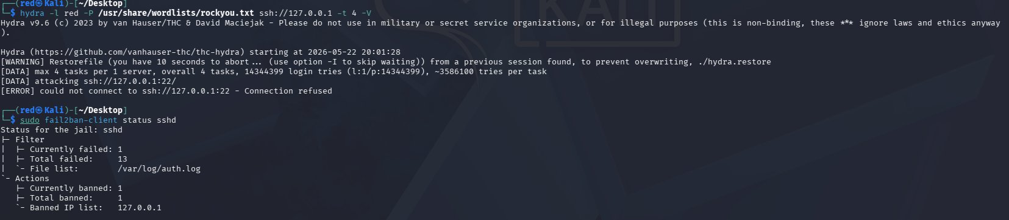
Figure 8: Hydra blocked with Connection refused; Fail2Ban jail showing 127.0.0.1 banned after 13 failed attempts

5. Analysis
Before Fail2Ban was deployed, the SSH service was completely open to brute-force attacks. Hydra was able to send thousands of password attempts continuously, as evidenced by the repeated failed login entries in auth.log. There was no mechanism to detect or stop the attack, making the system highly vulnerable to credential compromise.
After installing and configuring Fail2Ban with a strict SSH jail (maxretry=3, bantime=600, ignoreself=false), the same attack was stopped immediately. Fail2Ban monitored the auth.log in real time, counted the failed attempts, and automatically banned the attacking IP once the threshold was exceeded. Hydra could no longer connect to the SSH port, confirming the mitigation was effective.
The key difference between the two scenarios is that without Fail2Ban the attacker has unlimited attempts, whereas with Fail2Ban the attacker is locked out after just 3 failures within a 10-minute window.

6. Conclusion
This task successfully demonstrated the vulnerability of an unprotected SSH service to brute-force attacks and the effectiveness of Fail2Ban as a mitigation control. Before mitigation, Hydra was unrestricted and could attempt millions of passwords. After Fail2Ban was configured and enabled, the same attack was detected and the source IP was banned within seconds, with Hydra reporting a connection refused error. Fail2Ban is a simple but highly effective tool for defending SSH services against automated brute-force attacks.

