VULNERABILITY ASSESSMENT & PENETRATION TESTING (VAPT) REPORT
Target Environment: Multi-Platform Virtual Security Laboratory
- Standard Reference: NIST Special Publication 800-115
- Document ID: VAPT-NIST-01
- Assessment Model: Remote Black-box network Assessment
- Assessment Date: September 11, 2026
- Assessor: Kamalpreet Singh
- Classification: Lab Assessment Artifact
SECTION 1: ASSESSMENT SCOPE & TARGET IDENTIFICATION
  - Rules of Engagement & Authorization
This assessment is conducted within a strictly isolated, private virtual machine network under explicit testing rules of engagement. All active scanning, service interrogation, and vulnerability detection routines were restricted to the allocated CIDR block to prevent operational degradation or out-of-scope interactions.
  - System & Network Specifications
The engagement evaluated two distinct target endpoints from a single dedicated security evaluation node:
- Assessor Testing Node:
  - Hostname: Kali Linux 64-bit (kernel6.x)
  - Testing IP Address: 192.168.64.129
  - Role: Originator for active Host Discovery, Service Fingerprinting, and Vulnerability Scanning
- Target Node 1 (Linux Ecosystem):
  - System: Metasploitable Linux (Ubuntu Linux 8.04 baseline)
  - Target IP Address: 192.168.64.133
  - Scope Classification: Legacy Unhardened Daemon Environment
- Target Node 2 (Windows Ecosystem):
  - System: Microsoft Windows Server 2022
  - Target IP Address: 192.168.64.130
  - Scope Classification: Modern hardened Enterprise Server Baseline
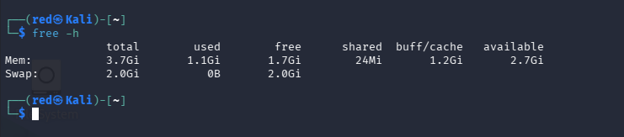
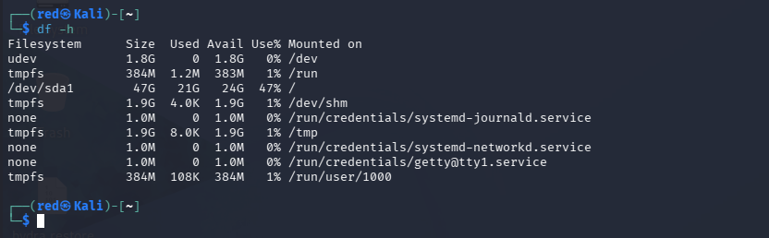
SECTION 2: NIST SP 800-115 METHODOLOGY EXECUTION
The Testing workflow adhered to the technical testing phases defined in NIST Special Publication 800-115:
- Planning: Target scoping, rules of engagement verification, and testing platform readiness (storage, database dependencies, and service checks).
- Discovery: Host identification, port scanning, and service/OS fingerprinting utilizing Nmap.
- Attack (Vulnerability Validation): Automated vulnerability scanning, daemon interrogation, and flaw verification via the Greenbone Vulnerability Management (GVM/OpenVAS) engine.
- Reporting: Risk analysis, CVSS v3.1 scoring, comparative posture evaluation, and prioritized remediation planning.
2.1 Phase 1: Planning, Resource Verification & Tooling Setup (GVM/OpenVAS)
Prior to network transmission, system hardware, runtime engines, and database dependencies were validated on the Kali testing node.
2.1.1 Pre-Flight Hardware & Resource Auditing
- Memory Allocation Audit:
  - Command Use: free -h
  - Observed State: Verified 3.7 GiB Total RAM, 1.1 GiB used, 1.7 GiB free, and 2.7 Gib available headroom, supported by a 2.0 GiB swap allocation to prevent database memory exhaustion.
Terminal output of free -h establishing baseline memory headroom.
- Storage Allocation & Volume Expansion
  - Command Use: df -h
  - Observed State: Primary root volume /dev/sda1 confirmed 47 GiB total capacity, 21 GiB used, and 24 Gib available capacity (47% utilization) prior to expanding the virtual disk to 100 GB to house unpacked NVT signatures and relational indexes.
Terminal output of df -h auditing available partition storage before feed synchronization.
- Storage Partition Auditing Prior to Disk Expansion:
  - Command use: lsblk
  - Observed state: The physical virtual disk /dev/sda was sized to 100G, while /dev/sda1 was restricted to 48G, leaving unallocated capacity and an extended partition containing swap at /dev/sda5.
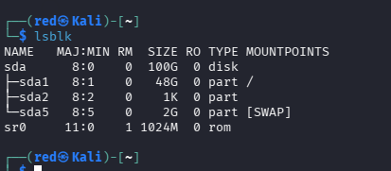
Terminal output of lsblk displaying unallocated disk space on disk /dev/sda prior to partition growth.
- Storage Partition Reallocation & Filesystem Resizing:
  - Command use: sudo swapoff -v /dev/sda5 , sudo growpart /dev/sda 1, sudo resize2fs /dev/sda1
  - Technical Execution: The swap partition residing at /dev/sda5 was disabled via swapoff to clear contiguous block boundaries. The growpart utility dynamically expanded partition 1 across the disk boundary, and resize2fs committed the added storage to the active ext4 filesystem online.

- Online Partition Expansion Verification:
  - Command use: lsblk
  - Observed state: Following partition expansion via growpart and filesystem extension via resize2fs, root partition /dev/sda1 successfully claimed the entire 100G disk allocation.
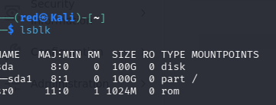
Terminal output of lsblk confirming root partition /dev/sda1 expanded to 100G online.
2.1.2 Database Diagnostics & Dependency Remediation
- PostgreSQL Service Verification:
  - Command use: systemctl status postgresql
  - Diagnostic Output: The service was reported as Loaded: loaded, Active: inactive (dead), and present: disabled.
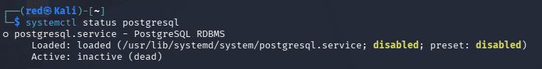
Terminal audit revealing inactive PostgreSQL service status.
- Starting the Relational Engine:
  - Command use: sudo systemctl start postgresql
  - The database engine was activated to support gvmd transactions.
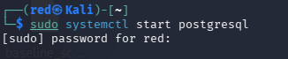
Bringing the PostgreSQL relational database management daemon online.
- GVM Automation Wrapper Audit:
Initial execution of setup verification failed due to missing CLI wrapper utilities:
  - Command use: sudo gvm-check-setup
  - Output: sudo: gvm-check-setup: command not found
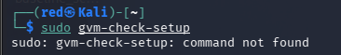
Initial failure indicating missing meta-package wrapper binaries.
- Component Auditing:
  - Command use: which openvas gvm gvmd apt list --installed | grep -iE "gvm|openvas"
  - Audit Findings: identified that backend binaries (openvas-scanner 23.45.1, gvmd 26.24.0, ospd-openvas 22.10.0, postgresql-18-pg-gvm 22.6.15) were present, but the parent gvm metapackage and helper utilities were missing.
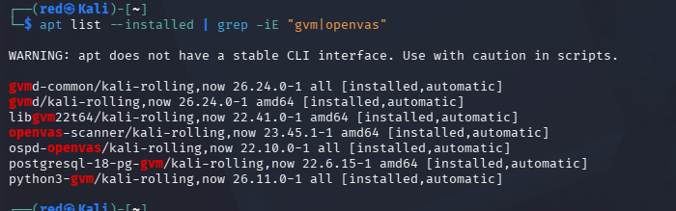
Verification of installed sub-packages and missing binary wrappers.
2.1.3 Package Deployment & Binary Confirmation
- Installing the GVM Metapackage:
  - Command use : sudo apt update && sudo apt install -y gvm
  - Execution Detail: Configured greenbone-security-assistant (26.17.0), gsad (24.16.0), and gvm-tools (25.4.6).
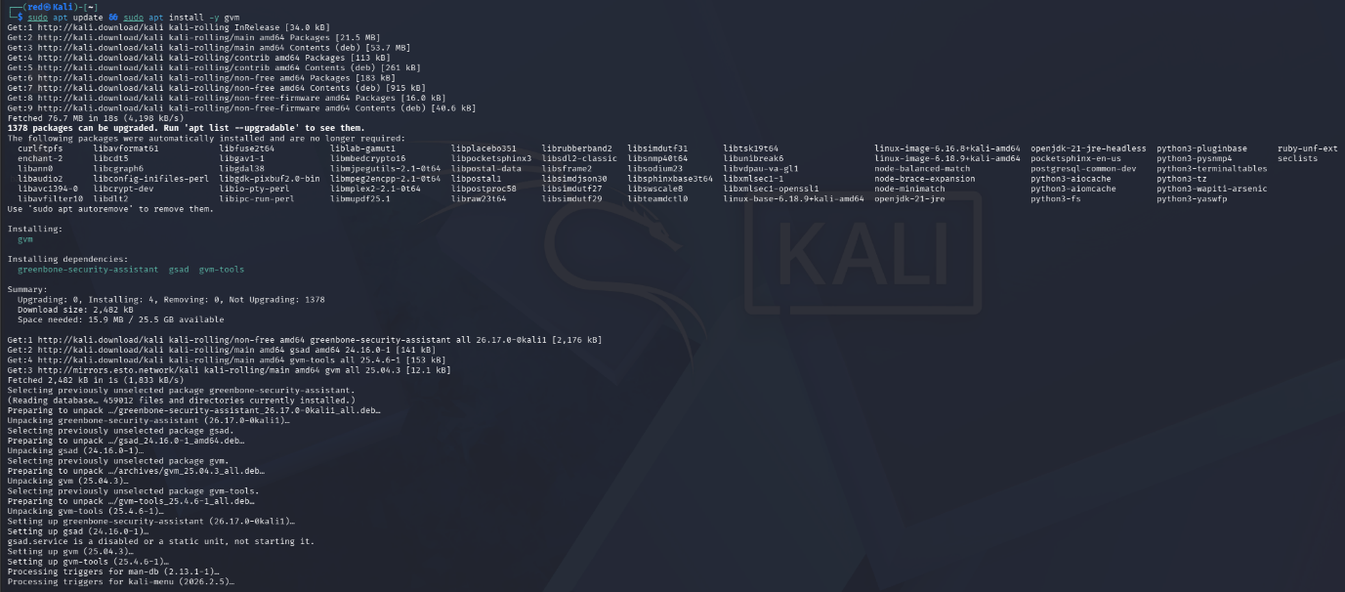
Complete package deployment of gvm metapackage and web server components.
- Validation Automation Binaries:
  - Command use: sudo gvm-check-setup
  - Step 1: Checking OpenVAS (Scanner)...
  - ERROR: No CA certificate file for Server found.
  - FIX: Run 'sudo runuser -u _gvm -- gvm-manage-certs -a -f'
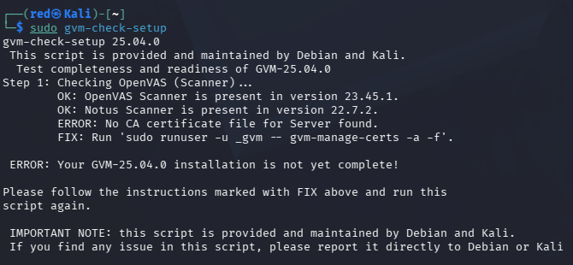
Diagnostic error indicating missing CA certificates during scanner checks.
- Generating Cryptographic authority Certificates:
  - Command use: sudo runuser -u _gvm -- gvm-manage-certs -a -f
  - Execution detail: Generated and installed server keys, CA certificates, and client certificates into /var/lib/gvm/CA/ and /var/lib/gvm/private/CA/.
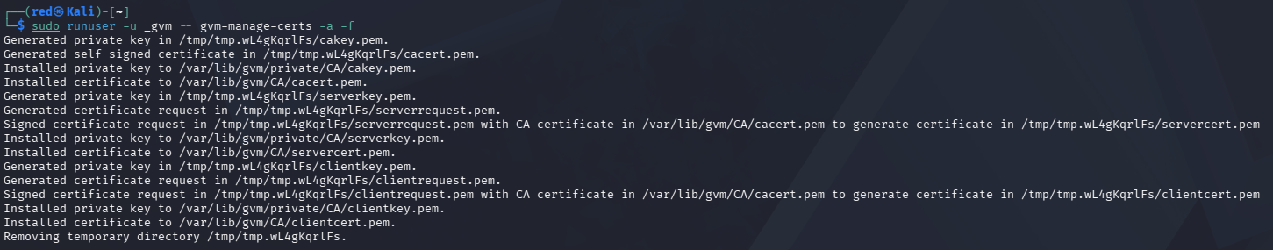
Successful generation and installation of GVM CA, server, and client certificates.
- NVT Collection Diagnostic Check:
Running diagnostics confirmed valid server CA certificates, but reported missing NVT collection signatures:
  - Command use: sudo gvm-check-setup
  - ERROR: Directories containing the NVT collection not found.
  - FIX: Run the NVT synchronization script greenbone-feed-sync.
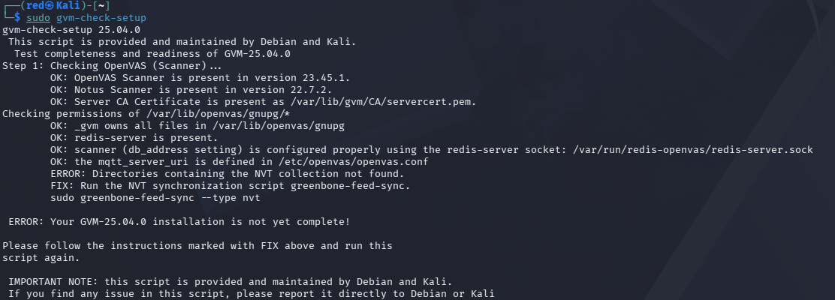
Setup check confirming CA validation and prompting for NVT feed synchronization.
2.1.5 Automated Setup, Collation Conflict & Feed Synchronization
- Executing Automated Setup Script:
  - Command use: sudo gvm-setup
  - Observed state: The routine started PostgreSQL, generated certificates, and flagged database collation mismatches between version 2.41 and 2.42.
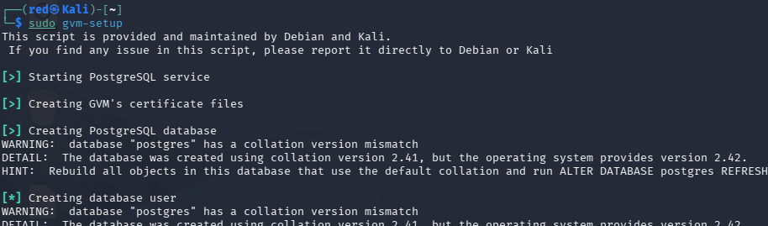
Initial gvm-setup execution encountering PostgreSQL template collation version mismatch.
- Feed Data Synchronization:
The automated synchronization routine successfully acquired locks and downloaded feeds via rsync:
  - Notus files and NASL routines from feed.community.greenbone.net
  - SCAP vulnerability data and CERT-Bund advisories
  - OpenVAS daemon data feeds (gvmd)
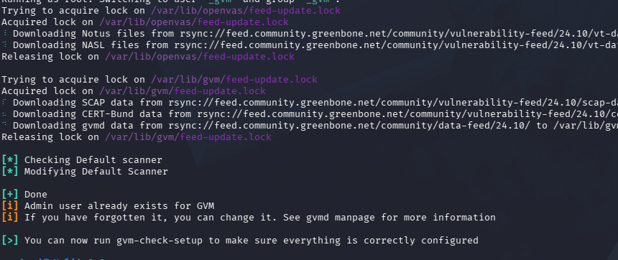
Terminal logs confirming synchronization of Notus, NASL, SCAP, CERT-Bund, and gvmd data.
- PostgreSQL Missing Database Diagnostic:
Diagnostics revealed that the gvmd database did not exist due to collation aborts during table creation:
  - Command use: sudo gvm-check-setup
  - Step 5: Checking Postgresql DB and user ...
  - ERROR: The Postgresql DB does not exist.
  - FIX: Run 'sudo runuser -u postgres -- /usr/share/gvm/create-postgresql-database'
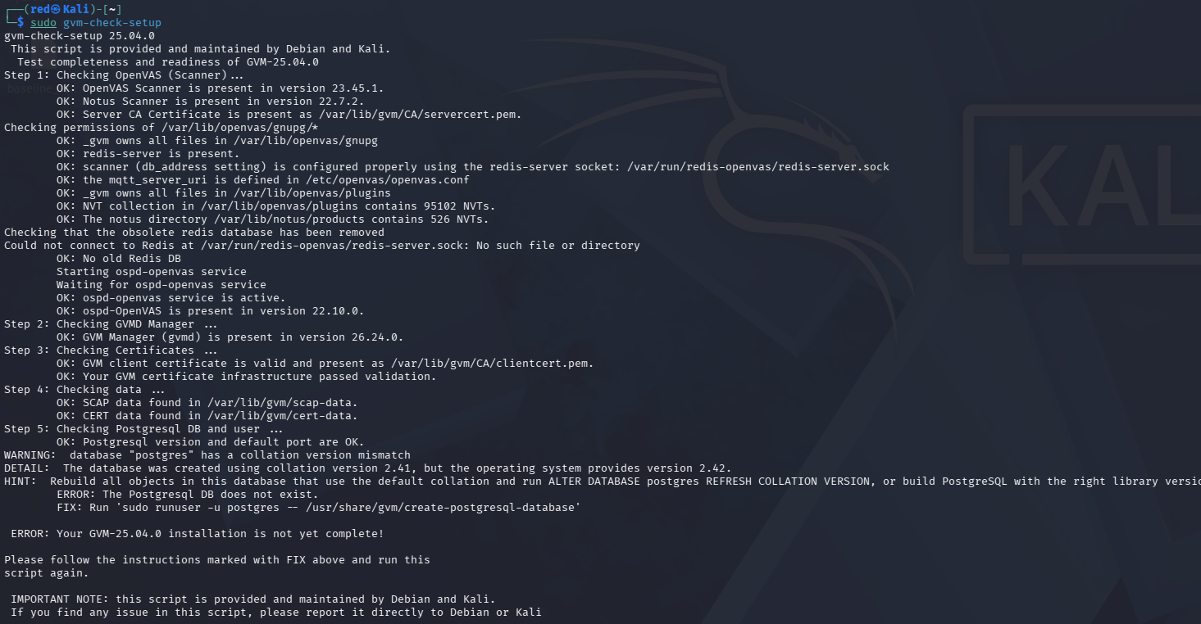
Setup check verifying 95,102 NVTs indexed, but identifying missing gvmd database schema.
- Manual Database Creation Diagnostic Failure:
Attempting manual database creation failed because template template1 possessed a collation mismatch:
  - Command use: sudo runuser -u postgres -- /usr/share/gvm/create-postgresql-database
  - createdb: error: database creation failed: ERROR: template database "template1" has a collation version mismatch
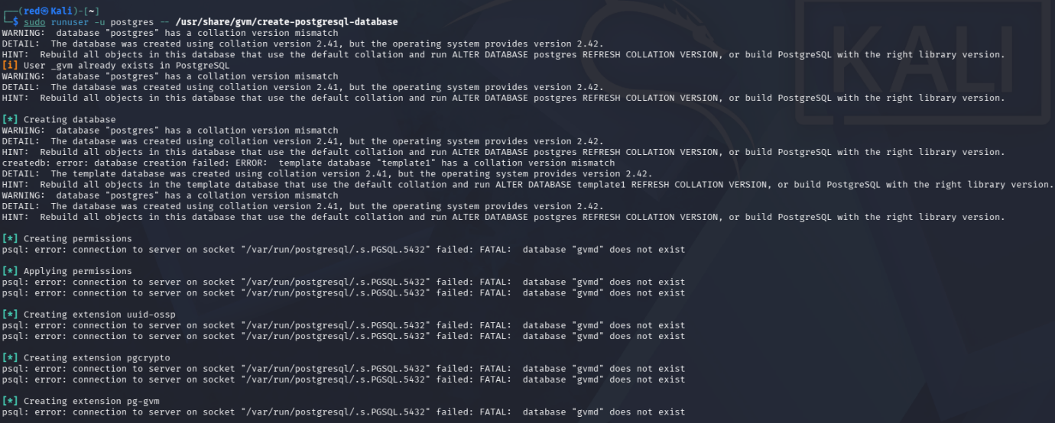
Terminal failure during database creation caused by unrefreshed collation versions in template1.
- Remediating Database Collation Versions:
Refreshed collation version directly inside PostgreSQL:
  - Command use: sudo -u postgres psql -c "ALTER DATABASE template1 REFRESH COLLATION VERSION;"
sudo -u postgres psql -c "ALTER DATABASE postgres REFRESH COLLATION VERSION;"
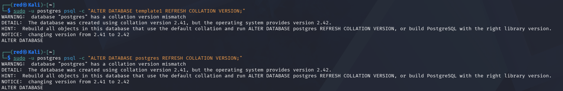
Executing ALTER DATABASE queries to refresh template1 and postgres collation versions.
- Successful Database Creation & Extension Deployment:
Re-Running the creation script successfully established the database, permissions, and extensions.
  - Command use: sudo runuser -u postgres -- /usr/share/gvm/create-postgresql-database
  - Execution Detail: Confirmed CREAT ROLE, GRANT ROLE, and deployed extensions: uuid-ossp, pgcrypto, and pg-gvm.
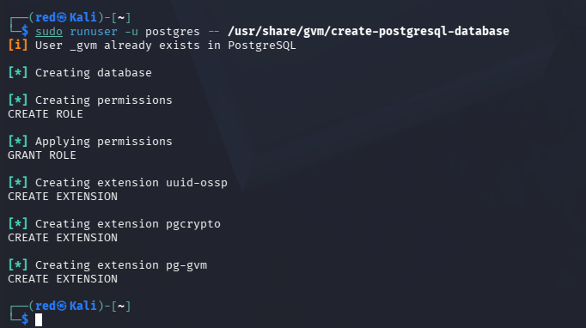
Successful creation of the gvm database and deployment of required PostgreSQL extensions.
2.1.6 User Provisioning, Feed Ownership & Ingestion Monitoring
- User Account Requirement Checks:
Running diagnostics confirmed the database was online, but reported that no administrative user existed:
  - Command use: sudo gvm-check-setup
  - Step 5: Checking Postgresql DB and user ...
  - ERROR: No users found. You need to create at least one user to log in.
  - FIX: create a user by running 'sudo runuser -u _gvm -- gvmd --create-user= --password='
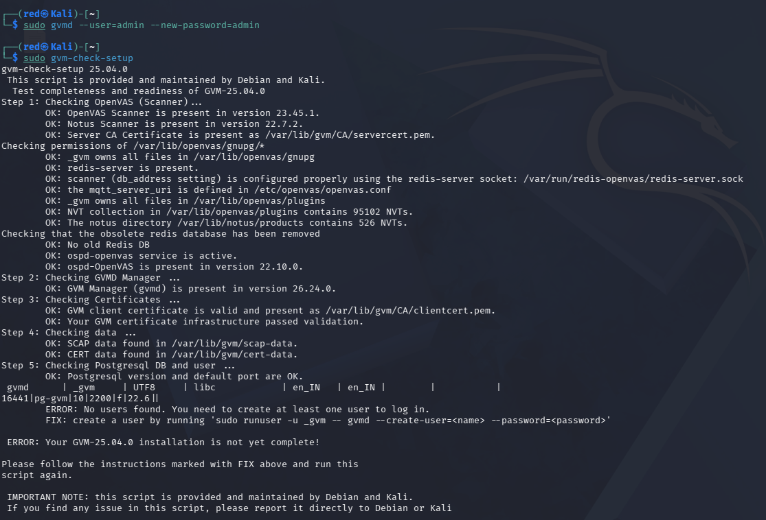
Diagnostic check verifying database readiness and prompting for administrative user creation.
- Provisioning Administrative Account & Validating Setup:
Created the primary administrative account:
  - Command use: sudo runuser -u _gvm -- gvmd --create-user=admin --password=admin && sudo gvm-check-setup
  - Result: Returned It seems like your GVM-25.04.0 installation is OK. Confirming:
    - OpenVAS Scanner Present (23.45.1).
    - Notus Scanner present (22.7.2).
    - Redis Unix Socket connection active (/var/run/redis-openvas/redis-server.sock).
    - 95,102 active NVTs indexed.
    - Background daemons active (gvms 26.24.0, gsad 24.16.0, ospd-opeanvas 22.10.0).
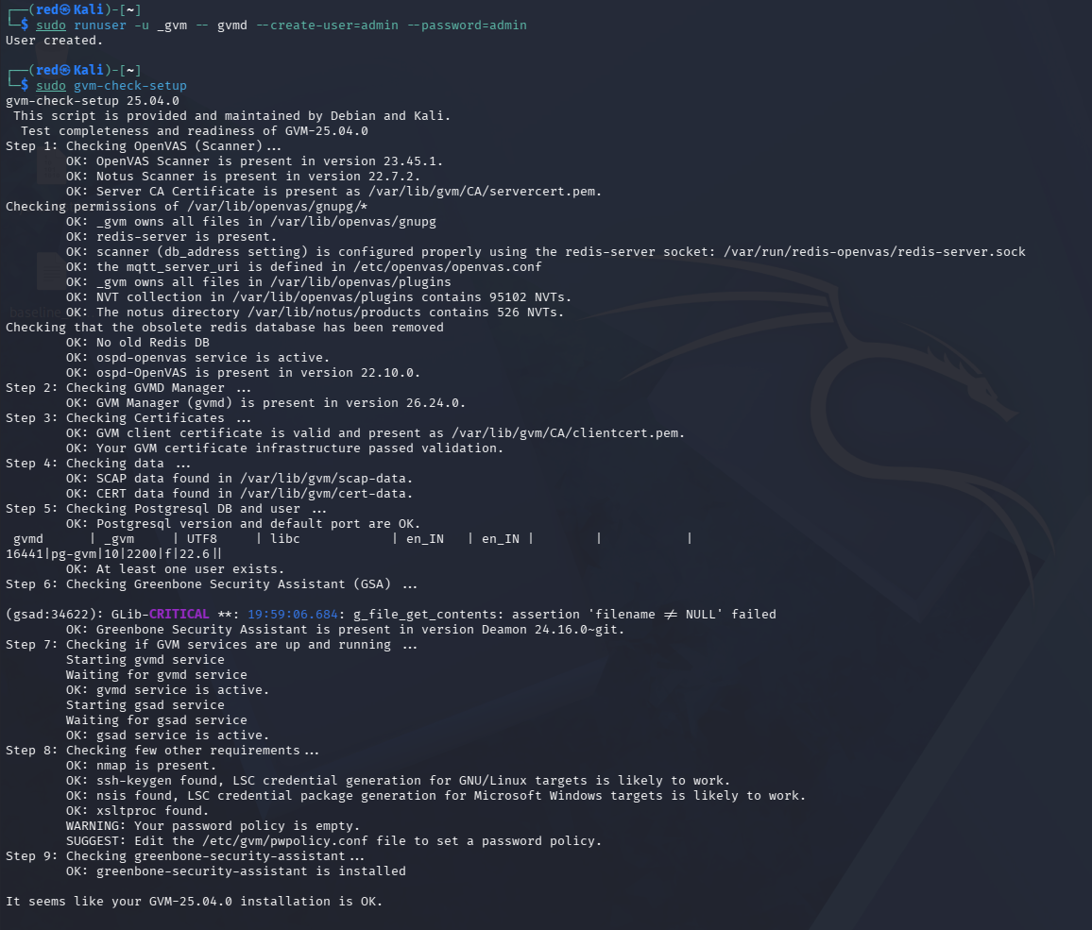
Complete health check confirming “It seems like your GVM-25.04.0 installation OK.”
- Starting Daemon Services:
  - Command use: sudo gvm-start
  - Result: Confirmed GVM Services are already running
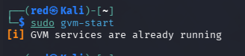
Output of sudo gvm-start verifying all backend GVM daemons are operational.
- Web Browser Console Access & SSL Certification Acceptance:
Navigated to (https://127.0.0.1:9392) in Firefox. The browser presented a self-signed certification warning (SEC_ERROR_UNKNOWN_ISSUER), which was confirmed and bypassed via Advanced-> Accept the Risk and Continue.
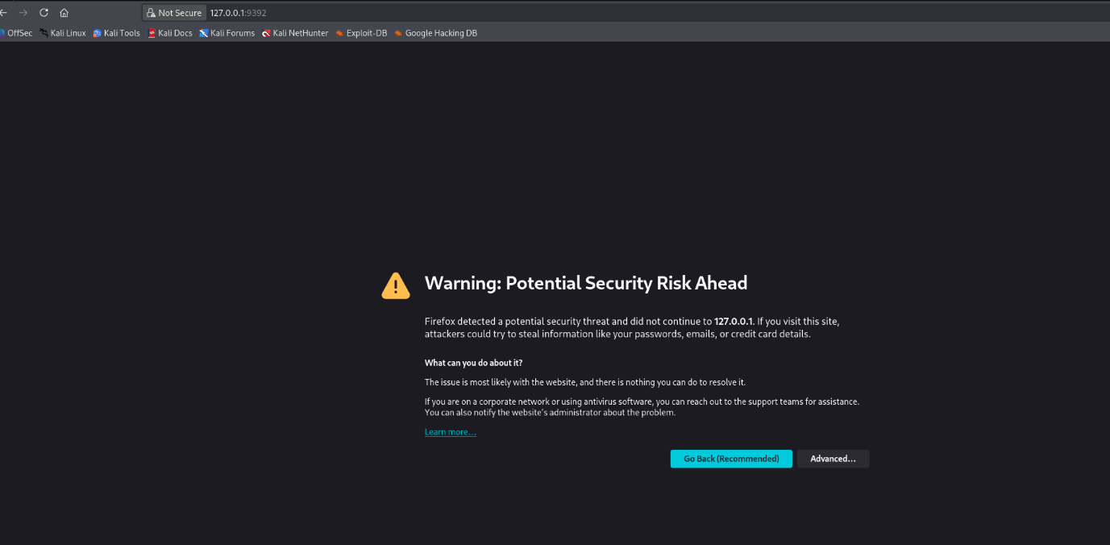
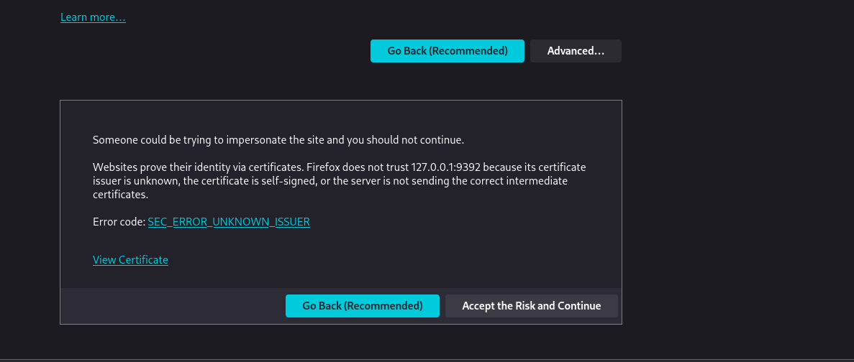
Handling Firefox self-signed TLS warning for Greenbone Security Assistance interface.
Greenbone Security Assistant Authentication:
Authenticated to the GSA console using username admin and password admin.
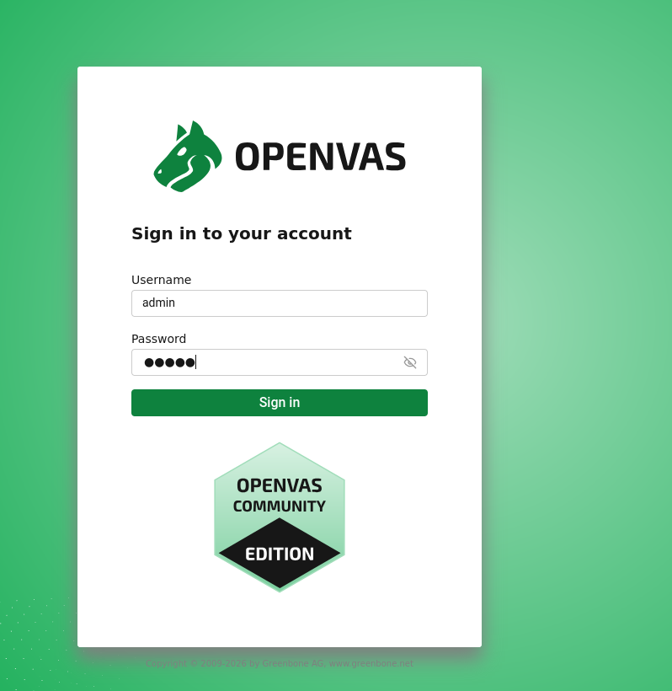
OpenVAS community Edition login screen shot at (https://127.0.0.1:9392).

- Feed Ingestion Monitoring:
The GSA dashboard initially presented a top status notification stating. “Feed is currently syncing. Please wait while the feed is syncing. Scans are not available during this time.”
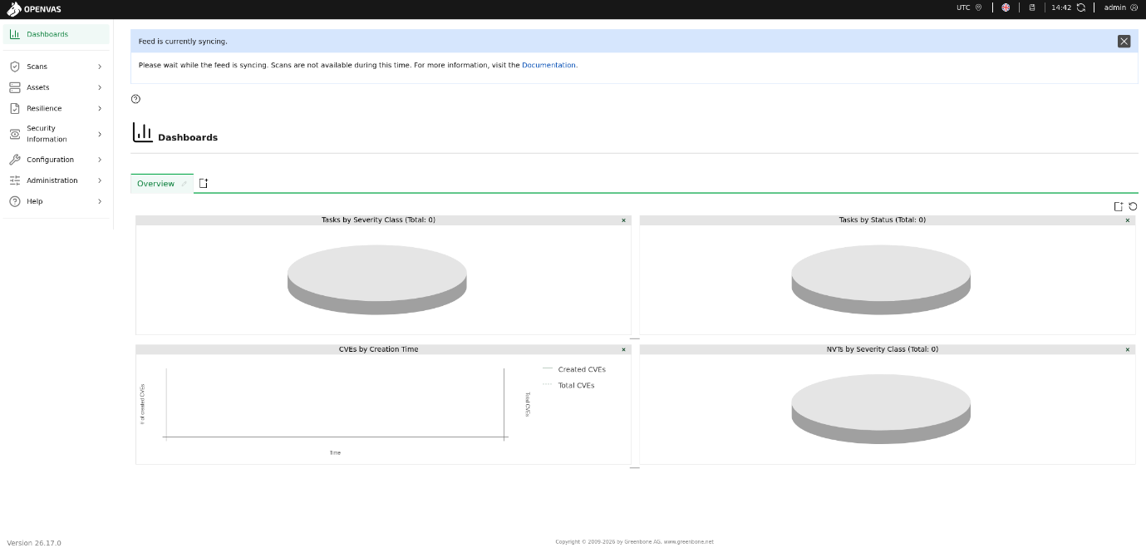
GSA dashboard displaying blue banner indication background feed parsing and database ingestion.
- Feed Status Interface Verification:
Audit synchronization progress via Administration-> Feed Status. The NVT feed was marked current (version 20260909T0553), while SCAP, CERT, and GVMD_DATA displayed Update in progress..
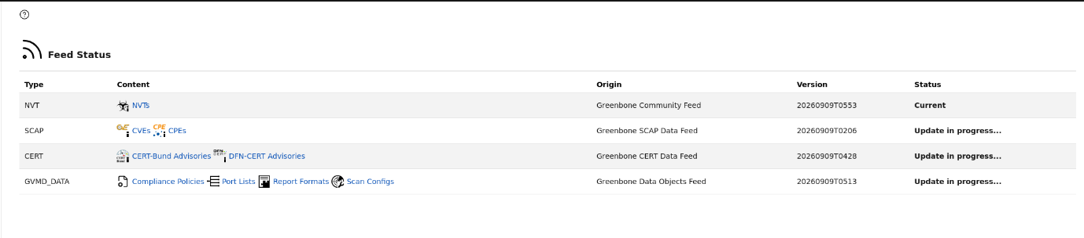
Feed Status page showing NVT feed current and relational SCAP/CERT feeds updating.
- Retrieving User UUID & Binding Feed Ownership:
Retrieved the administrative user UUID and mapped it to the internal feed owner setting 78eceaec-3385-11ea-b237-28d24461215b:
  - sudo runuser -u _gvm -- gvmd --get-users --verbose
  - Output: admin 2b3af001-6dae-4f1c-b61a-006582758c4a

  - sudo runuser -u _gvm -- gvmd --modify-setting 78eceaec-3385-11ea-b237-28d24461215b --value 2b3af001-6dae-4f1c-b61a-006582758c4a
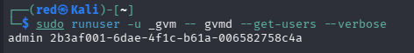
Extraction of admin account UUID (2b3af001-6dae-4f1c-b61a-006582758c4a) via CLI.
2.2 Phase 2: Active Discovery & Fingerprinting (Active Reconnaissance)
Active reconnaissance was conducted from the testing node ( 192.168.64.129) without per-authenticated credentials:
- Subnet Discovery Sweep:
Swept the private segment using ARP/ICMP frame requests:
  - Command use: sudo nmap -sn 192.168.64.0/24
  - Execution Details: Discovered 6 active hosts on the subnet in 3.77 seconds, confirming candidate operational endpoints at 192.168.64.130 (MAC 00:0C:29:13:BA:B7) and 192.168.64.133 (MAC 00:0C:29:5F:D7:36).
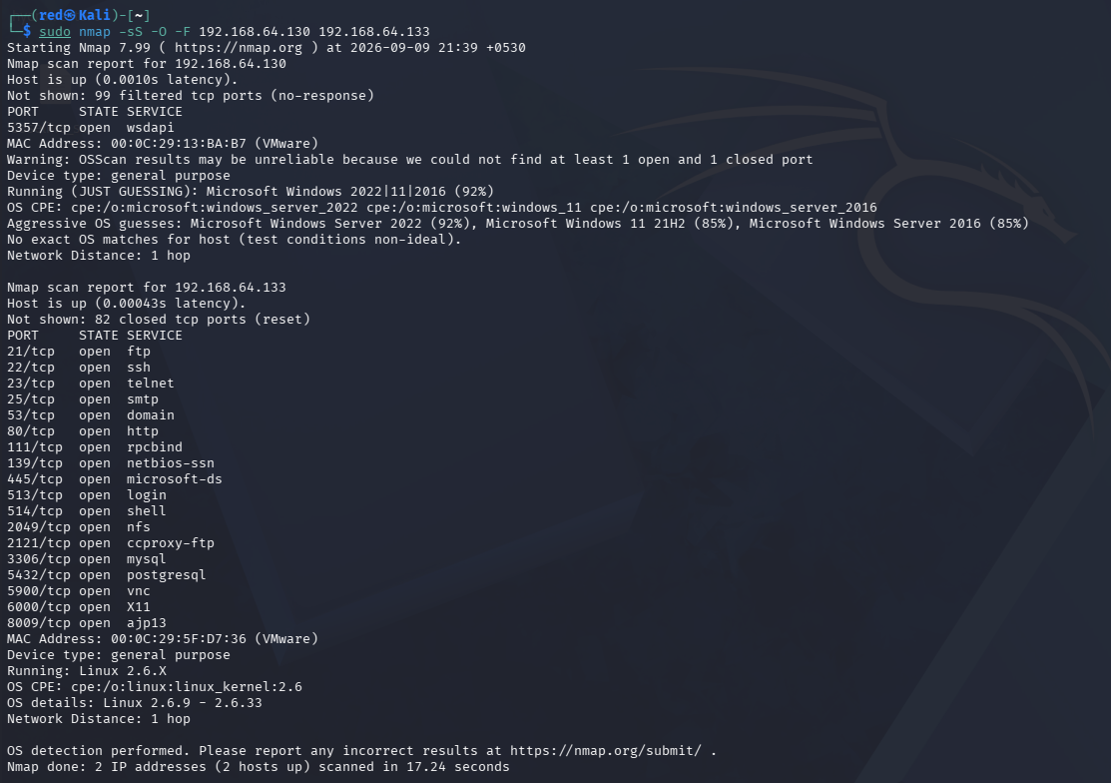
Nmap OS and service banner fingerprinting terminal output distinguishing both targets.
2.3 Phase 3: Vulnerability Analysis & Scanning
Automated vulnerability scanning was executed using Greenbone Vulnerability Management (GVM 25.04.0) under the "Full and Fast" profile:
- Metasploitable Linux Task: Executed between 07:14:48 UTC and 10:08:55 UTC (duration: 2h 54m), executing active vulnerability checks across all exposed listening daemons and identifying 64 filtered findings.
- Windows Server 2022 Task: Executed between 13:13:51 UTC and 13:15:37 UTC (duration: 0h 01m), evaluating the unauthenticated external perimeter.
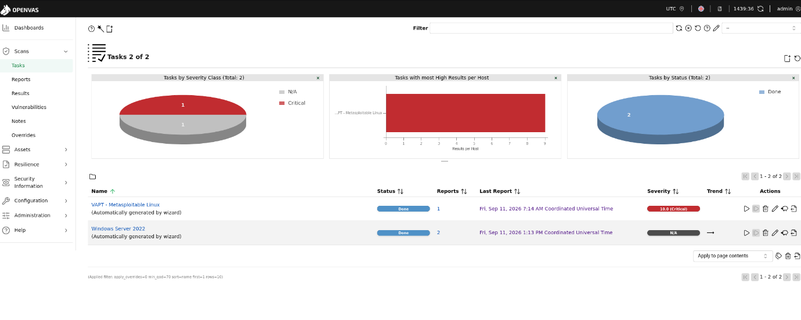
GSA Tasks Dashboard (Tasks 2 of 2) confirming completion of both scans: VAPT - Metasploitable Linux (Severity: 10.0 Critical) and Windows Server 2022 (Severity: N/A)
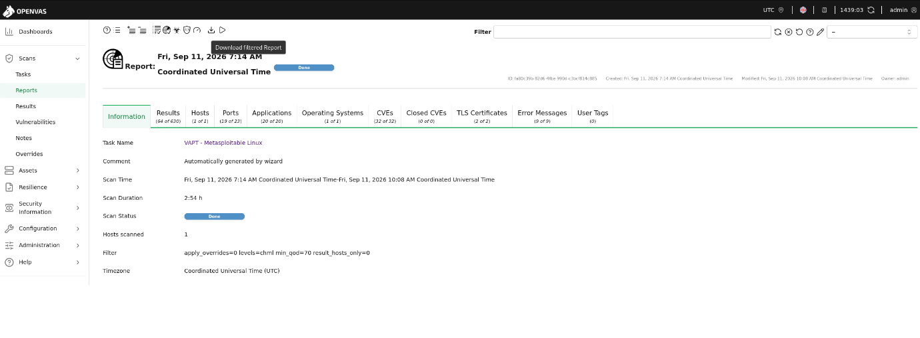
OpenVAS Report Overview for VAPT - Metasploitable Linux confirming Scan Duration 2:54 h, 64 of 630 results filtered, 19 open ports, 20 applications, and 32 CVEs.
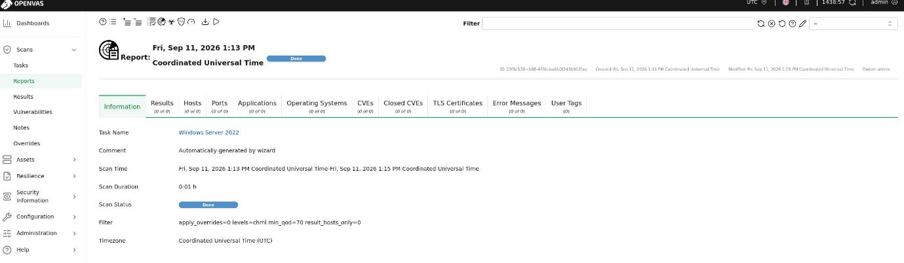
OpenVAS Report Overview for Windows Server 2022 confirming Scan Duration 0:01 h, 0 of 0 results detected due to external perimeter firewall filtering.
Section 3: EXECUTIVE SUMMARY & COMPARATIVE POSTURE MATRIX
3.1 Overall Security Posture Evaluation
The automated assessment revealed an extreme disparity in perimeter security and host hardening:
- Metasploitable Linux (192.168.64.133): Presents a CRITICAL overall risk posture (Severity 10.0). Over 20 legacy network Daemons are exposed without perimeter filtering. The host harbours historic, publicly weaponized vulnerabilities- including unauthenticated remote backdoor access, unencrypted administrative shells, and cleartext database listeners.
- Microsoft Windows Server 2022 (192.168.64.130): Presents a SECURE/HARDENED PERIMETER (Severity N/A). The default host-based firewall dropped unsolicited connection attempts and suppressed ICMP echo probes, resulting in Zero actionable remote exposures under black-box scanning.
3.2 Quantitative Vulnerability Breakdown

Assessment Dimension | Metasploitable Linux (192.168.64.133) | Windows Server 2022 (192.168.64.130)
Operating System | Ubuntu Linux 8.04 (Kernel 2.6.24) | Microsoft Windows 2022 (192.168.64.130)
Scan Execution Duration | 2 Hours 54 Minutes | 0 Hours 01 Minute
Total Unfiltered Scan Detections | 630 Total Detections | 0 Total Detections
Total Actionable Findings (QoD >= 70%) | 64 Actionable Vulnerabilities | 0 Remote Exposures
Critical Severity (CVSS 9.0 – 10.0) | 12 Findings | 0 Finding
High Severity (CVSS 7.0 – 8.9) | 9 Findings | 0 Findings
Medium Severity (CVSS 4.0 – 6.9) | 37 Findings | 0 Findings
Low Severity (CVSS 0.1 – 3.9) | 6 Findings | 0 Findings
Identified Open Ports | 19 Distinct Ports Reported | 0 Unfiltered Ports Reported
Associated CVE Count | 32 Unique CVEs Reported | 0 CVEs Discovered
Overall Perimeter Posture | Extremely Vulnerable / Compromised | Hardened / Fully Filtered

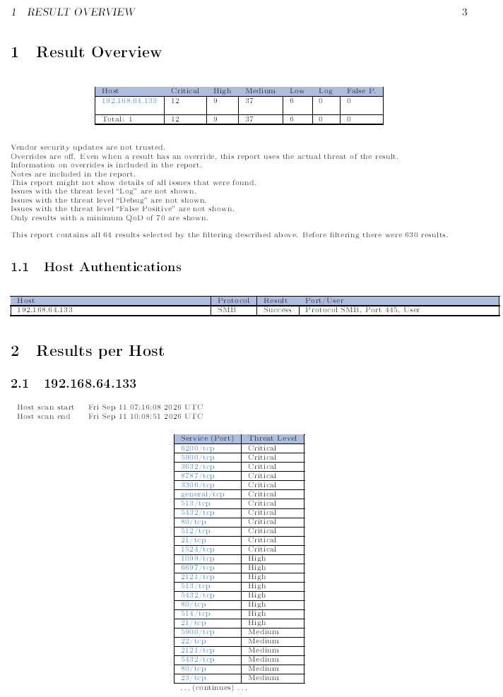
Page 3 of OpenVAS Metasploitable PDF report showing the 64 vulnerability Distribution chart (12 Critical, 9 High, 37 Medium, 6 Low).
SECTION 4: TECHNICAL VULNERABILITY FINDINGS DEEP DIVE
4.1 Target Node 1: Metasploitable Linux (192.168.64.133)
Finding L-01: Vsftpd 2.3.4 Compromised Source Package Backdoor
- Vulnerability Identifier: CVE-2011-2523 (NVT OID: 1.3.6.1.4.1.25623.1.0.103185)
- CVSS v3.1 Score: 9.8 (Critical)
- Affected Ports/Services: 21/TCP (FTP), 6200/TCP (Backdoor Shell)
- Quality of Detection (QoD): 99%
- Technical Summary: The installed vsftpd-2.3.4 daemon contains an embedded malicious backdoor within its source archive. Supplying a username ending with a smiley sequence : ) triggers the daemon to spawn an unauthenticated root bind shell listening on port 6200/TCP.
- Observed Evidence: OpenVAS actively verified the presence of the interactive root listener responding directly on port 6200/TCP.
- Impact: Immediate unauthenticated remote root shell access, allowing complete control over host resources.
- Remediation: Purge the vulnerable package (apt-get purge vsftpd) and enforce OpenSSH Sftp using key-based authentication.
Finding L-02: Ingreslock Interactive Shell Backdoor
- Vulnerability Identifier: CWE-284 (NVT OID: 1.3.6.1.4.1.25623.1.0.103549)
- CVSS v3.1 score: 10.0 (Critical)
- Affected Ports/Services: 1524/TCP (ingreslock)
- Quality of Detection (QoD): 99%
- Technical Summary: A legacy backdoor service is attached to TCP port 1524, providing direct root shell access to connecting clients without authentication.
- Observed Evidence: OpenVAS dispatched the command id; to port 1524 and received output: uid=0(root) gid=0(root).
- Impact: Remote administrative system compromise with no credential requirement.
- Remediation: Terminate the rogue process and remove the service entry from /etc/inetd.conf .
Finding L-03: DistCC Distributed Compilation Daemon Remote Code Execution
- Vulnerability Identifier: CVE-2004-2687 (NVT OID: 1.3.6.1.4.1.25623.1.0.103553)
- CVSS v3.1 Score: 9.3 (Critical)
- Affected Ports/Services: 3632/TCP (distcc)
- Quality of Detection (QoD): 99%
- Technical Summary: The DistCC services fails to validate incoming compilation requests, allowing remote client to execute arbitrary system commands.
- Observed Evidence: The Scanner executed the command id over port 3632, returning: uid = 1 (daemon) gid = 1 (daemon)
- Impact: Unauthenticated remote command executed under Daemon privilege, serving as an initial vector for local privilege escalation.
- Remediation: Upgrade DistCC to a patched release and implement client IP whitelisting via firewall filter.
Finding L-04: Distributed Ruby (dRuby/DRb) Arbitrary Command execution
- Vulnerability Identifier: BID-47071 (NVT OID: 1.3.6.1.4.1.25623.1.0.108010)
- CVSS v3.1 Score: 10.0 (Critical)
- Affected Ports/Services: 8787/TCP (druby_timeserver)
- Quality of Detection (QoD): 99%
- Technical Summary: The Distributed Ruby runtime exposes remote objected methods without access control list, permitting remote callers to execute arbitrary system commands via syscall invocations.
- Observed Evidence: Injected syscalls returned server trackback from /usr/lib/ruby/1.8/drb.rb:1555 confirming execution.
- Impact: Remote code execution within the execution context of Ruby service.
- Remediation: Bind DRb daemons exclusively to 127.0.0.1 and enforce access rule via drb/acl.rb .
Finding L-05: Relational Database Superuser Default Credentials
- Vulnerability Identifier: CVE-2001-0645 (MySQL), CWE-287
- CVVs v3.1 Score: 9.8 (MySQL) and 9.0 (PostgreSQL)
- Affected Ports / Services: 3306/TCP (MySQL), 5432/TCP (PostgreSQL)
- Quality of Detection (QoD): 95% – 99%
- Technical Summary: Both database listeners are exposed to the network using default administrative credentials without authentication requirements.
- Observed Evidence:
  - MySQL: Logged in successfully as root with an empty password.
  - PostgreSQL: Logged in successfully as user postgres with password postgres
- Impact: Direct access to databases, intellectual property exposure, and remote shell escalation via database functions
- Remediation: Bind databases to loopback (127.0.0.1) and enforce strong, non-default passwords.

Finding L-06: Unauthenticated Legacy Berkeley R-Services
• Vulnerability Identifier: CVE-1999-0651 (rlogin), CVE-1999-0618 (rexec)
• CVVs v3.1 Score: 10.0 (Critical)
• Affected Ports / Services: 512/TCP (rexec), 513/TCP (rlogin), 514/TCP (rsh)
• Quality of Detection (QoD): 80%
• Technical Summary: Berkeley r-commands transmit session traffic in cleartext and allow unauthenticated root login based on source addressing.
• Observed Evidence: OpenVAS established a passwordless root session across port 513.
• Impact: Complete remote root takeover without credentials.
• Remediation: Disable inetd r-service sockets ( systemctl disable inetd) and enforce SSHv2.
Finding L-07: Samba MS-RPC Remote Shell Command Execution
• Vulnerability Identifier: CVE-2007-2447 (NVT OID: 1.3.6.1.4.1.25623.1.0.108011)
• CVVs v3.1 Score: 8.0 (High)
• Affected Ports / Services: 139/TCP, 445/TCP (Samba 3.0.20)
• Quality of Detection (QoD): 99%
• Technical Summary: Samba 3.0.20 fails to properly escape input in its username map script configuration, allowing shell commands to be injected into MS-RPC request.
• Observed Evidence: Injected MS-RPC parameters prompted the server to dispatch ICMP packets containing OpenVASVT59931 back to the scanner
• Impact: Remote command execution under root privileges
• Remediation: Upgrade Samba to modern supported version (v3.0.25+ or current stable branch)
Finding L-08: Multi-Protocol Default Credentials (FTP & VNC)
• Vulnerability Identifier: CVE-1999-0501 (FTP), CWE-521
• CVVs v3.1 Score: 7.5 (High) – 9.0 (Critical)
• Affected Ports / Services: 21/TCP, 2121/TCP (FTP), 5900/TCP (VNC)
• Quality of Detection (QoD): 70% - 95%
• Technical Summary: Discovered services accept trivial and well-know default passwords.
• Observed Evidence:
- VNC port 5900 authenticated with password: password
- ProFTPD port 2121 authenticated with credentials: msfadmin:msfadmin , postgres:postgres, user:user
• Impact: Unauthorized interactive graphical desktop access and unrestricted file modification.
• Remediation: Enforce strong password complexity rules, multi-factor authentication, or session encapsulation over SSH.
  - Target Node 2: Microsoft Windows Server 2022 ( 192.168.64.130)
Finding W-01: Perimeter Firewall Suppression & Host Hardening Evaluation
- Vulnerability Metric: 0 Remote Vulnerabilities identified.
- CVSS v3.1 Score: 0.0 (Informational / Hardened)
- Affected Ports/Services: Network Layer (ICMP/TCP)
- Technical Analysis: Windows Defender Firewall operates in a default-drop state for unsolicited incoming probes. The host dropped standard ICMP echo requests, causing the default scanner alive test to mark the host as inactive. (Total: 0 Findings).
- Security Posture Takeaway: The operating system demonstrates effective perimeter resilience against unauthenticated, opportunistic scanning sweeps.
- Internal Risk Note: While perimeter firewall rules are effective externally, internal services (such as SMB signing enforcement on port 445) require credentialed assessment to ensure defense-in-depth against lateral movement.
SECTION 5: STRATEGIC REMEDIATION ROADMAP (NIST SP 800-115)
Remediation milestones are prioritized across three chronological execution tiers based on exploitability, operational exposure, and CVSS v3.1 severity impact:
5.1 Tier 1: Immediate Containment (0 – 48 Hours)
- Backdoor Decommissioning: Immediately kill and purge backdoored packages (vsftpd-2.3.4, UnrealIRCd). Remove rogue root listeners from /etc/inetd.conf (Ingreslock/1524).
- Cleartext Protocol Retirement: Disable rlogin, rexec, rsh, and telnet daemons. Transition administrative sessions to OpenSSH using cryptographic public keys.
- Default Credential Remediation: Configure non-blank, complex passwords for database superuser accounts (root on MySQL, postgres on PostgreSQL) and restrict listening bindings to 127.0.0.1.
5.2 Tier 2: System Hardening & Isolation (1 – 2 Weeks)
- Remote Execution Daemon Hardening: Apply IP-level access controls or terminate unauthenticated compile/execution tools (distcc and druby)
- Obsolete Asset Migration: Plan migration for obsolete operating systems. Ubuntu 8.04 reached official End-of-Life on May 9, 2013, and lacks vendor security patches.
- Internal Windows Auditing: Establish credentialed SMB/RPC auditing accounts to evaluate internal Windows configurations (such as SMB signing and cumulative patch compliance) behind the firewall perimeter.
5.3 Tier 3: Governance & Verification (Ongoing)
- Continuous Vulnerability Assessment: Schedule monthly authenticated scans using GVM/OpenVAS to detect regressions and configuration drift.
- Network Micro-segmentation: Isolate legacy application tiers from production infrastructure using VLANs and stateful firewall boundaries to limit blast radiuses.

SECTION 6: CONCLUSION & ASSESSMENT SIGN-OFF
6.1 Final Risk Summary
The NIST SP 800-115 assessment established a clear divergence in operational security posture:
- Metasploitable Linux (192.168.64.133): Unacceptable security risk. With 12 Critical and 9 High vulnerabilities, the system allows immediate, unauthenticated root takeover through multiple independent entry points.
- Microsoft Windows Server 2022 (192.168.64.130): Strong external defensive posture. The default host-based firewall successfully blocked unsolicited reconnaissance and automated network scans.
6.2 Sign-off & Certification
- Assessment Framework: NIST Special Publication 800-115
- Testing Standard: Non-destructive Technical Assessment & Vulnerability Analysis
- Lead Security Assessor: Kamalpreet Singh
- Artifact Commit Date: September 11, 2026
- Status: Complete / Findings Documented & Remediation Prioritized

