1. **Actual Result -**

The dropdown remains stuck when clicked outside of the Page.

**Please refer to the below-attached screenshot for evidence of the issue –**

**Expected Result –**

The dropdown shouldn’t remain stuck and should return back to the initial state when clicked outside of the Page.

**Steps** **–**

Navigate to the Homepage 🡪Do not Login 🡪 In the header click the Dropdown menu. 🡪 Now click anywhere outside the dropdown area.

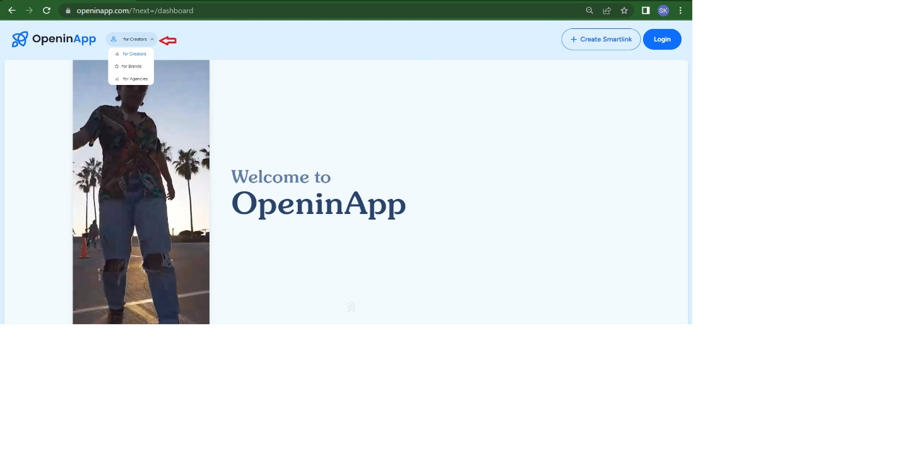

1. **Actual Results -**

Although no proper link format is provided the smart link got generated.

I provided something like "drt.y7h7y.gyg" instead of using "www" and "com".

**Please refer to the below-attached screenshot for evidence of the issue –**

**Expected Result –**

The dropdown shouldn’t remain stuck and should return back to the initial state when clicked outside of the Page.

**Steps** **–**

Navigate to the Homepage 🡪 Login with a valid credential 🡪 In the header click the Create Link menu. 🡪 Now enter something like "drt.y7h7y.gyg" instead of using "www" and "com" 🡪 Now click on the Create Link button. 🡪Check if the link got created.

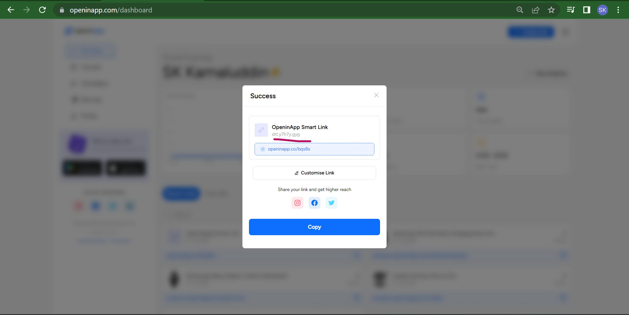

1. **Actual Results -**

When I enter the wrong mobile number it’s getting saved in the Profile details.I provide something like "0000000000".

**Please refer to the below-attached screenshot for evidence of the issue –**

**Expected Result –**

When I enter the wrong mobile number it shouldn’t be saved in the Profile details.

**Steps** **–**

Navigate to the Homepage 🡪 Login with a valid credential 🡪 Now go to the Profile section. 🡪 Now in the Phone Number section enter some invalid number.

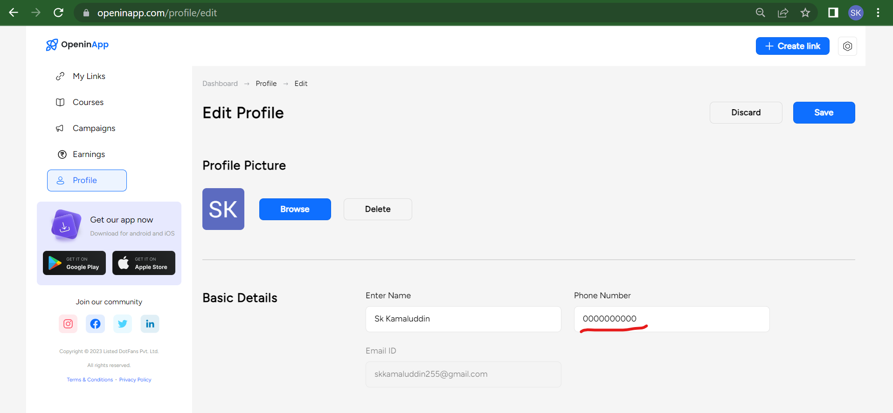

1. **Actual Result –**

When the user does the 1st login on a fresh date then "Today's Clicks", "Top Location", "Top Source", and "Best Time" show N/A instead of 0.

**Please refer to the below-attached screenshot for evidence of the issue –**

**Expected Result –**

When the user does the 1st login on a fresh date then "Today's Clicks", "Top Location", "Top Source", and "Best Time" shouldn’t show N/A and should display 0.

**Steps** **–**

Navigate to the Homepage 🡪 Login with a valid credential

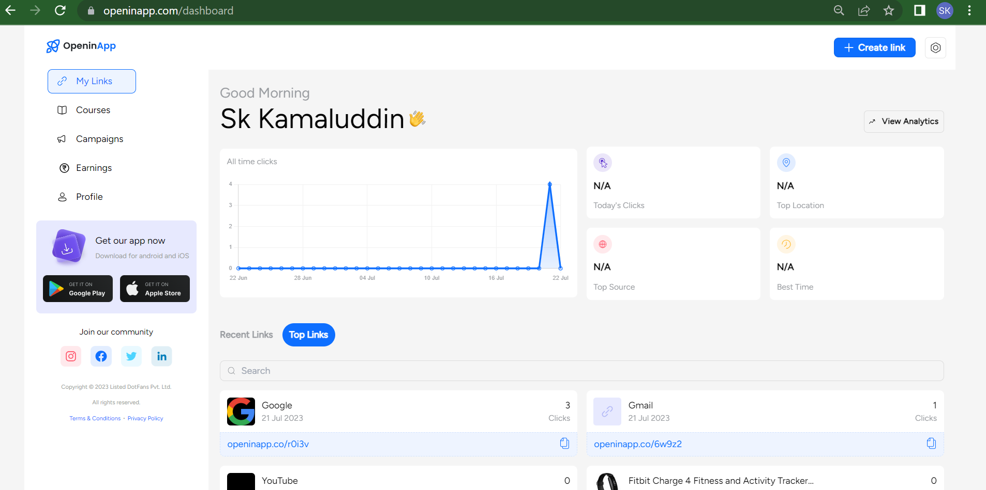

1. **Actual Result –**

Intermittent issue - When I use Mobile and Tablet view and go to profile then for the first time I don’t see my details although I am logged in. I am able to see the details when I refresh the profile page and this I need to do every time.

**Please refer to the below-attached screenshot for evidence of the issue –**

**Expected Result –**

After login When I use Mobile and Tablet view and go to profile then every time my profile details should be visible.

**Steps** **–**

Navigate to the Homepage using a Mobile or Tablet 🡪Login with a valid credential 🡪 Go to the Mobile or Tablet view 🡪 Then Go to the Profile section 🡪 Details are not visible 🡪 Now Refresh the page (After refreshing only the details are visible)

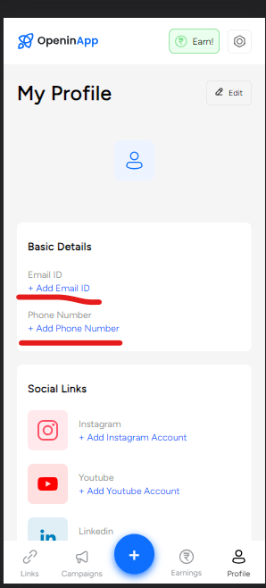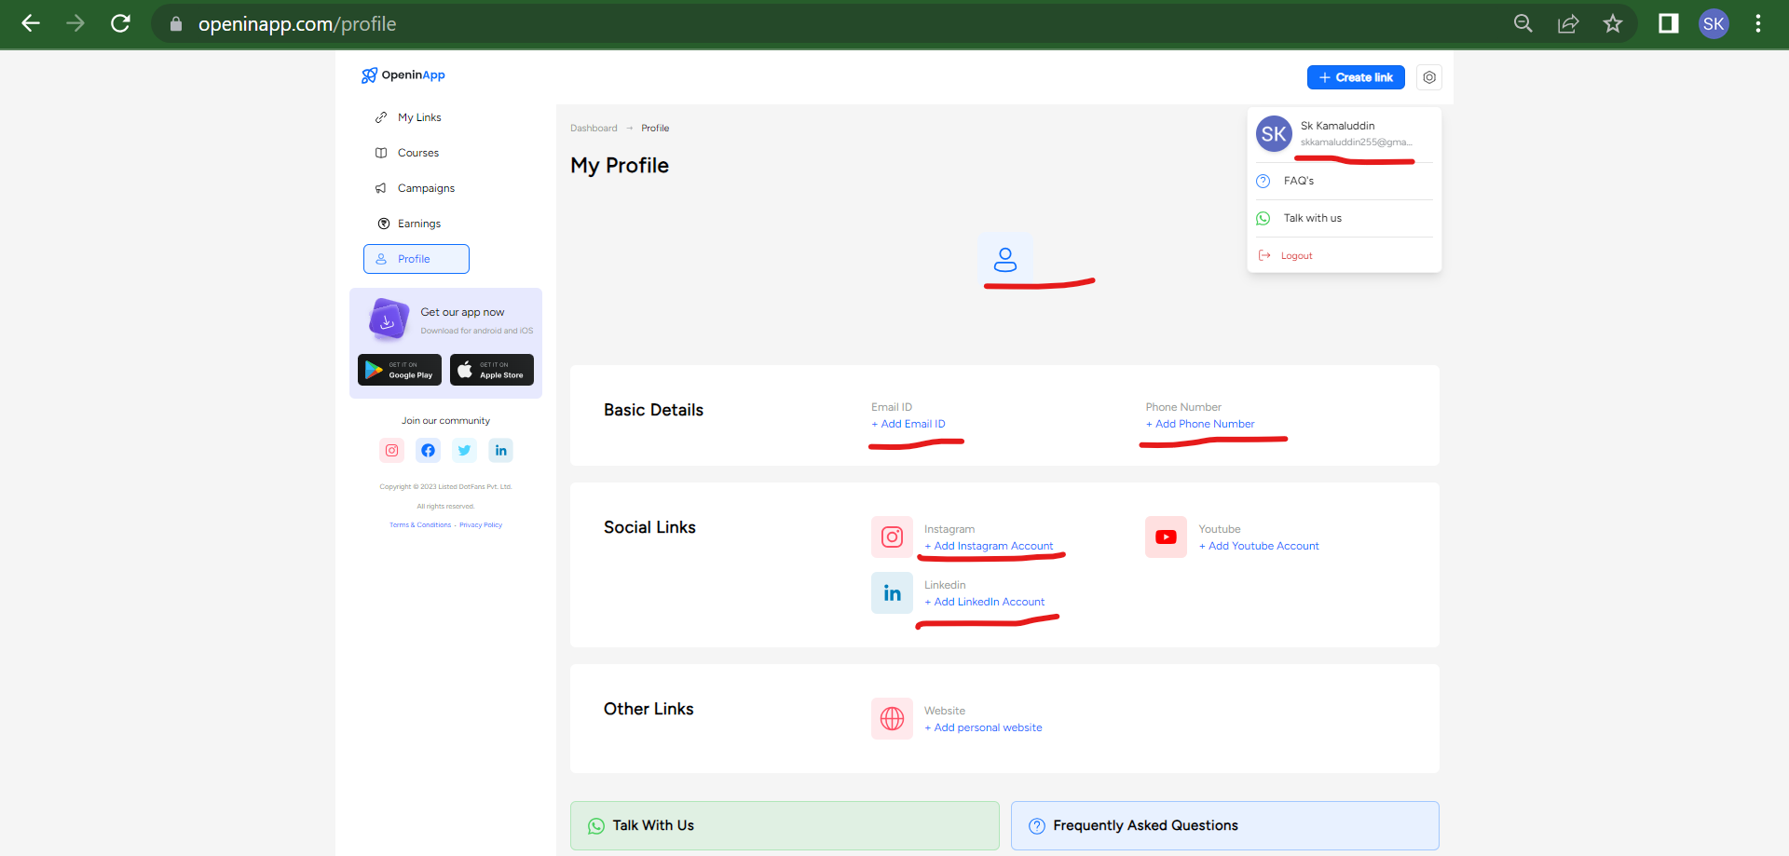

1. **Actual Result –**

The courses section is not visible in Mobile and Tablet View but on desktop view it’s visible.

**Please refer to the below-attached screenshot for evidence of the issue –**

**Expected Result –**

The courses section should be visible in Mobile and Tablet View.

**Steps** **–**

Navigate to the Homepage using a Mobile or Tablet 🡪Login with a valid credential 🡪 Then Scroll Down.

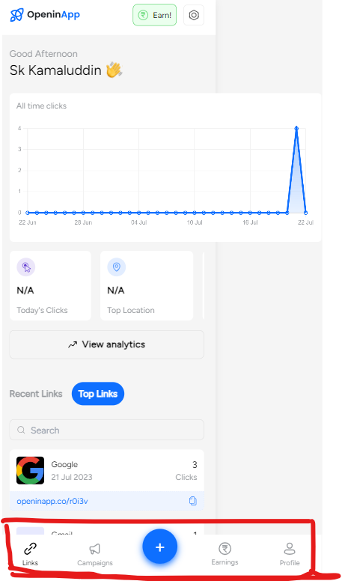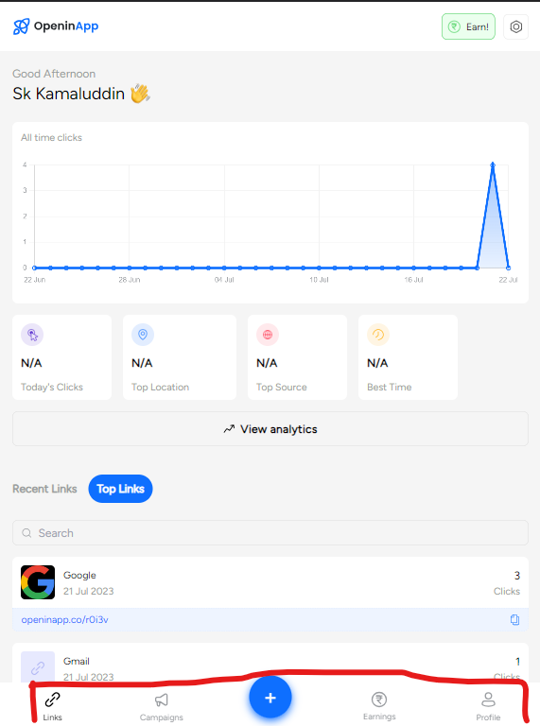

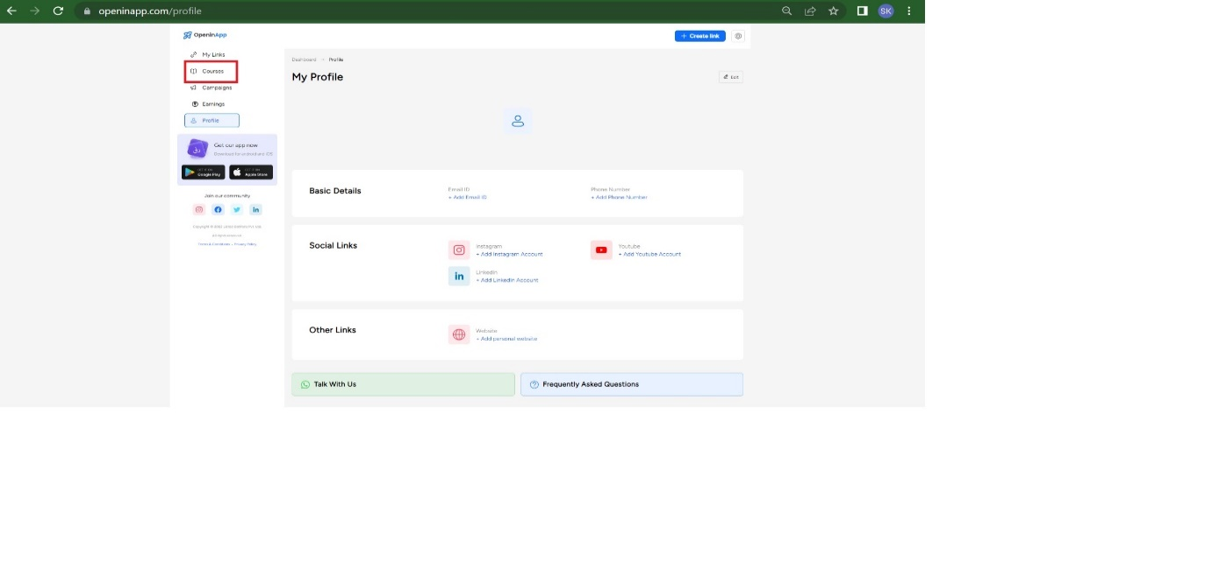

1. **Actual Result –**

In Mobile and Tablet view the Dashboard options are getting hidden when we scroll below. It’s only visible when we scroll up the page.

**Please refer to the below-attached screenshot for evidence of the issue –**

**Expected Result –**

When using a Mobile or Tablet view on a Desktop the time when we scroll down the Dashboard option should be visible.

**Steps** **–**

Navigate to the Homepage using a Mobile or Tablet 🡪Login with a valid credential 🡪 Then Scroll Down. 🡪 Check that the Dashboard options get hidden.

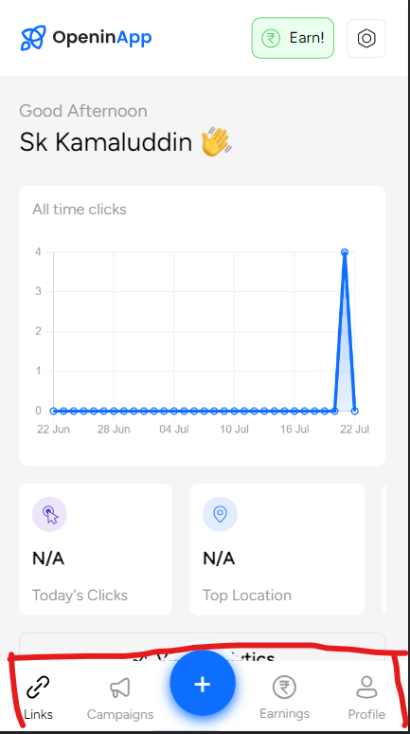 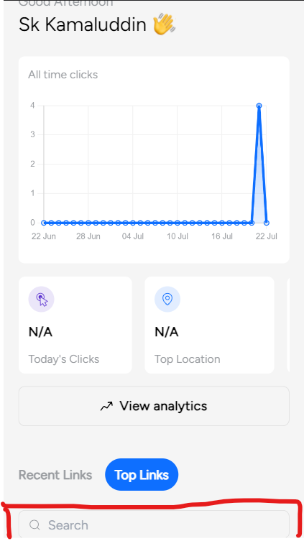

1. **Actual Result –**

Intermittent issue - The dashboard Graph and Analytics section is not visible although the user is logged in.

**Please refer to the below-attached screenshot for evidence of the issue –**

**Expected Result –**

The dashboard Graph and Analytics section should be visible every time after login.

**Steps** **–**

Navigate to the Homepage using a Mobile or Tablet 🡪Login with a valid credential.

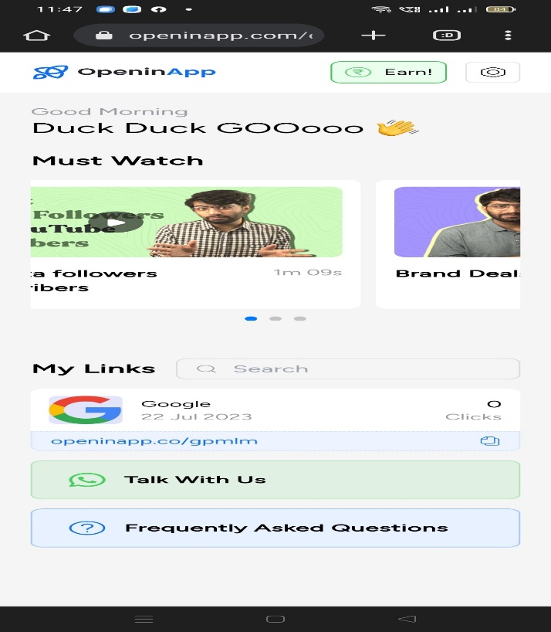

1. **Actual Result –**

Intermittent issue - The dropdown remains stuck when "Sort By" is clicked in the Links Section (Dashboard -> View all links).

**Please refer to the below-attached screenshot for evidence of the issue –**

**Expected Result –**

When I click outside the dropdown area then at that time dropdown should return to the initial state.

**Steps –** Navigate to the Homepage using a Mobile or Tablet 🡪Login with a valid credential 🡪 Go to the Link section 🡪 Click the View All link 🡪 Then click the “Sort By” Dropdown arrow.

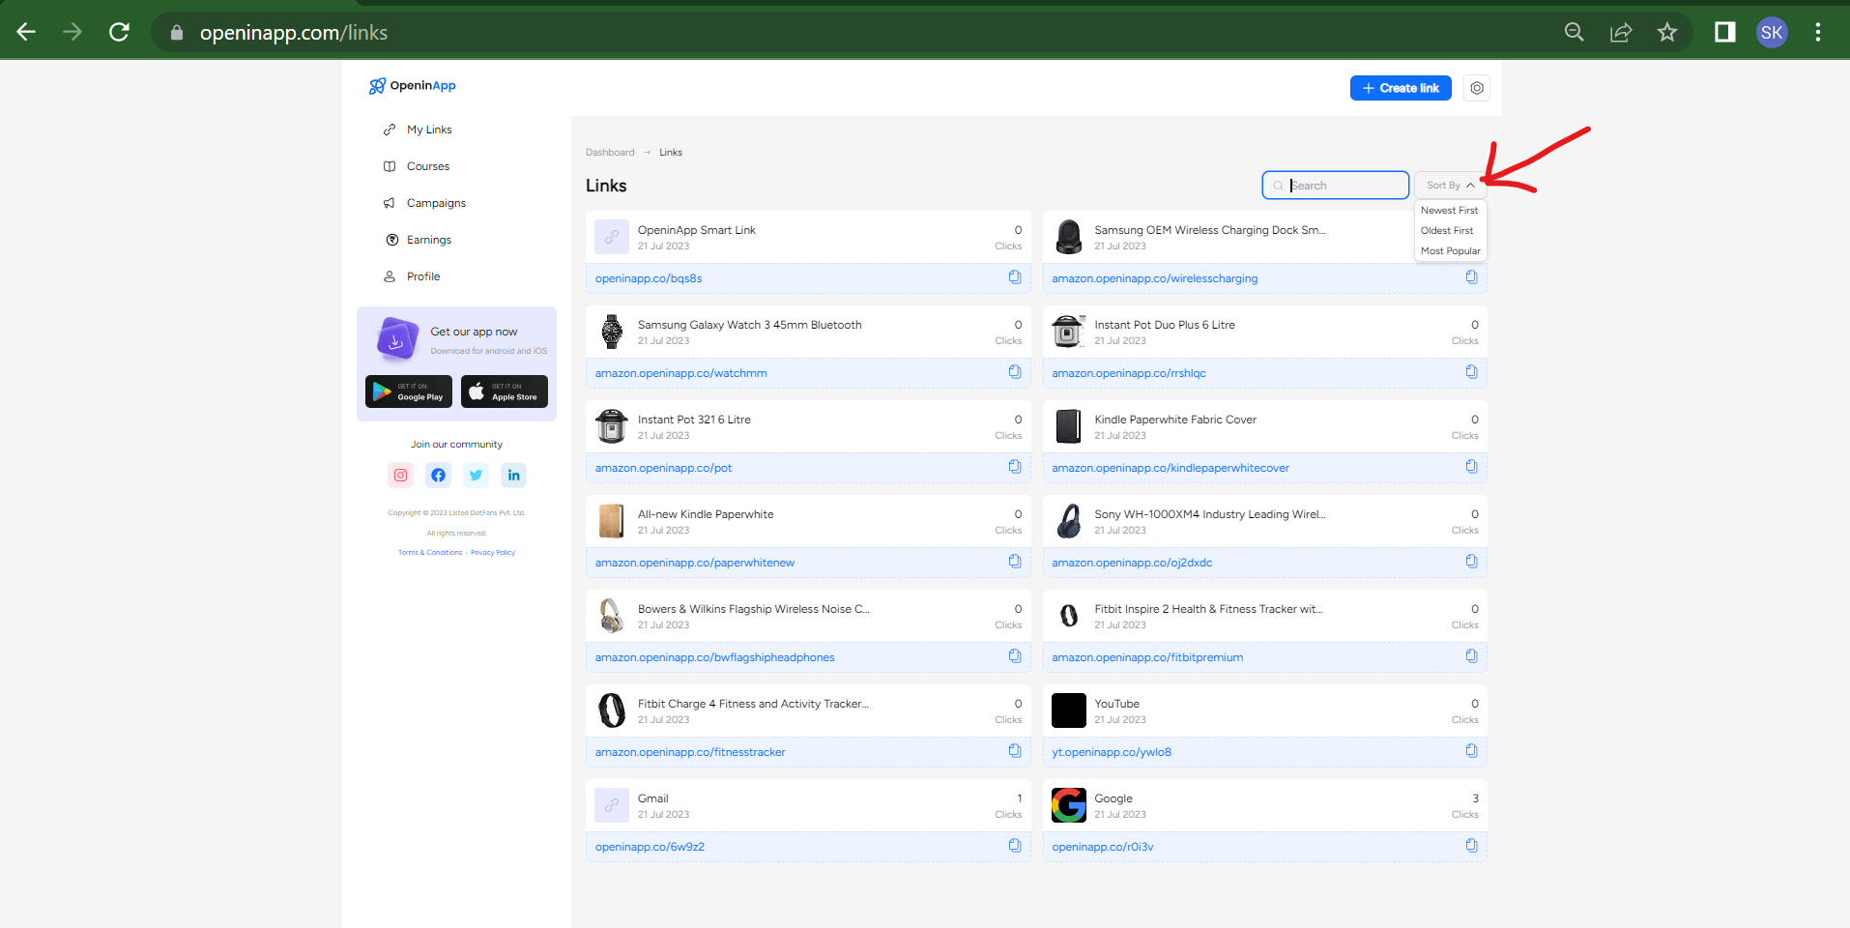

1. **Actual Result –**

Intermittent issue - Getting multiple time Bad Gateway errors while performing any action on the Page.

**Please refer to the below-attached screenshot for evidence of the issue –**

**Expected Result –**

The page should perform error-free in every action.

**Steps –**

Navigate to the Homepage using a Mobile or Tablet

