1. **Actual Result –**

In Mobile and Tablets View the logo name is not displayed when the user is anonymous but when the user logs in the logo name is displayed.

**Please refer to the below-attached screenshot for evidence of the issue –**

**Expected Result –**

In Mobile and Tablets View the logo name should be displayed when the user is anonymous.

**Steps –**

Navigate to the Homepage using a Mobile or Tablet

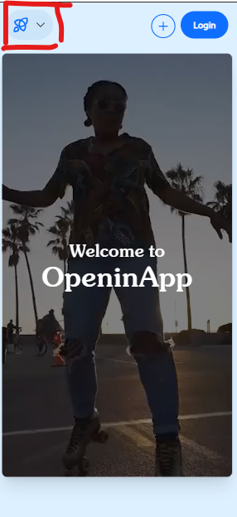

1. **Actual Result –**

Intermittent issue - Due to some reason On the Homepage the video section got removed.

**Please refer to the below-attached screenshot for evidence of the issue –**

**Expected Result –**

Onthe Homepage section, the video should be visible.

**Steps –**

Navigate to the Homepage using a Desktop.

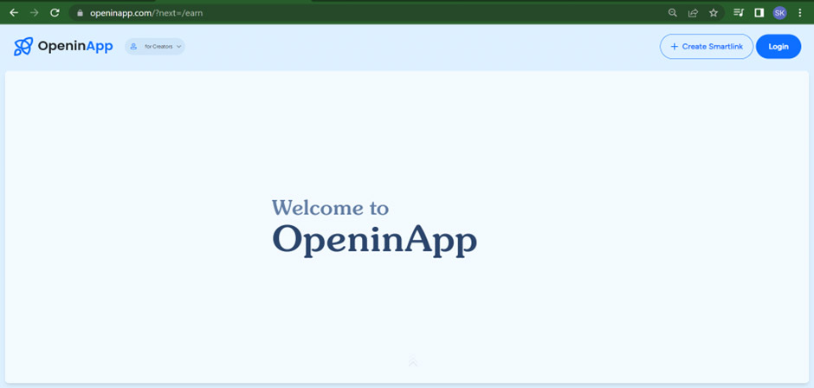

1. **Actual Result –**

In mobile and tablet view the footer links are not displayed but in desktop view it’s visible.

**Please refer to the below-attached screenshot for evidence of the issue –**

**Expected Result –**

In mobile and tablet view the footer links should be visible.

**Steps –**

Navigate to the home page 🡪 Scroll down to the footer section [Using device mobile and tablet]

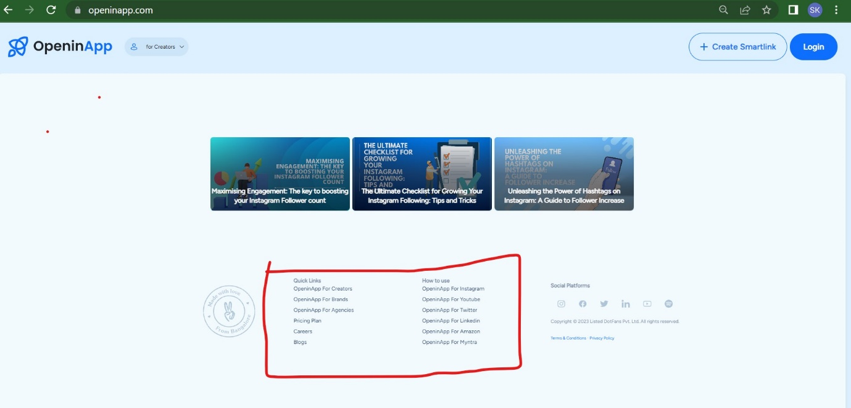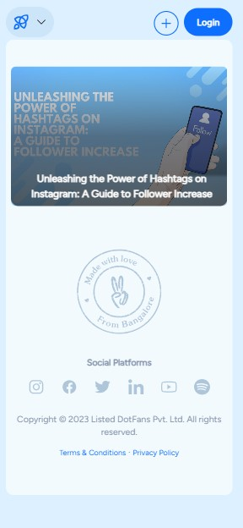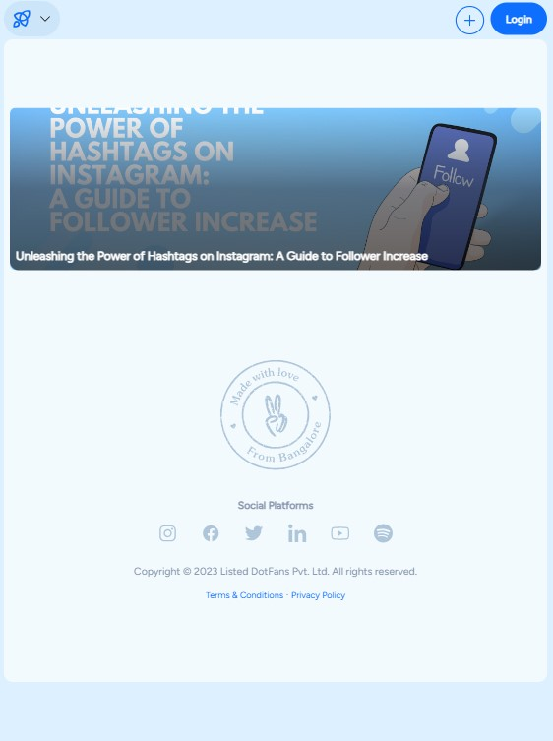

1. **Actual Result –**

Intermittent issue - On doing the Edit from Profile section, the basic details and social links are not displayed although the user is logged in and those details were saved earlier.

**Please refer to the below-attached screenshot for evidence of the issue –**

**Expected Result –**

If a user is logged in then Basic details and social links should be visible.

**Steps –**

Navigate to the home page using the Desktop🡪 Login with a valid username🡪 Click the Profile section.

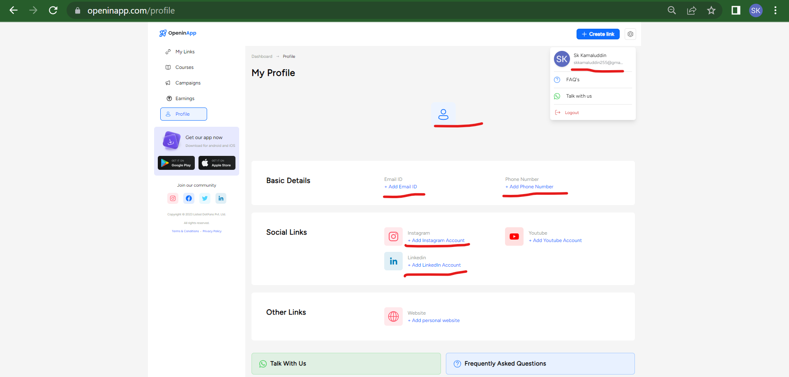

1. **Actual Result –**

There is no scroll bar on the homepage.

**Please refer to the below-attached screenshot for evidence of the issue –**

**Expected Result –**

The scroll bar should be present on the homepage.

**Steps –**

Navigate to the home page using the Desktop -> Search for a scroll bar at the right side of the screen.

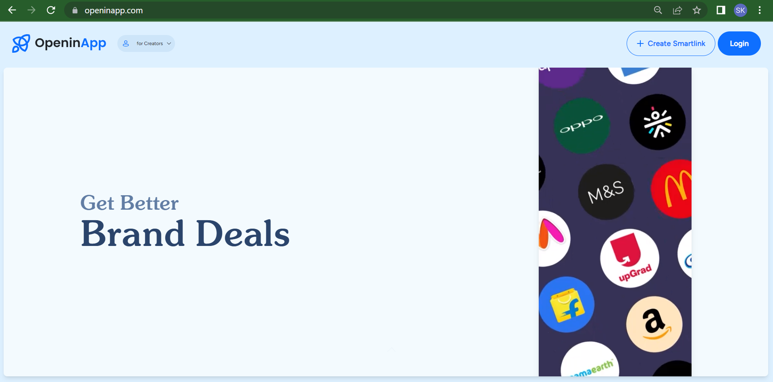

1. **Actual Result –**

When I navigate to the Homepage being an anonymous user the Login Popup is being displayed multiple times although I am closing the Popup box every time.

**Please refer to the below-attached screenshot for evidence of the issue –**

**Expected Result –**

When I navigate to the Homepage being an anonymous user the Login Popup is expected to be visible only one time and when the user closes the Popup post the popup shouldn’t be shown again and again.

**Steps –**

Navigate to the home page using the Desktop and when the popup is displayed click the close icon of the popup.

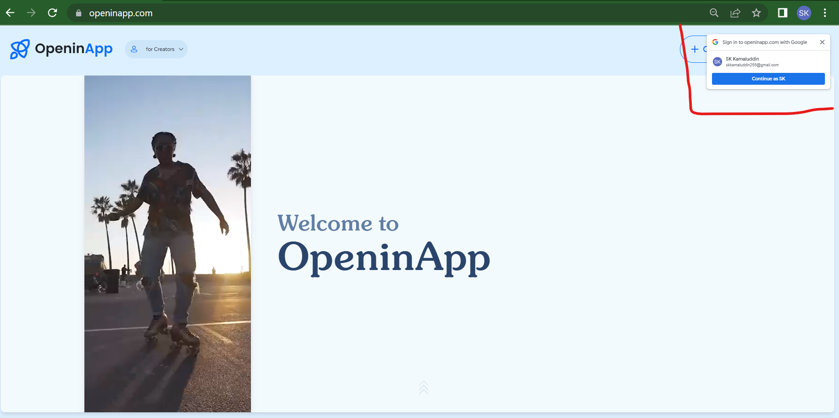

1. **Actual Result –**

When the below footer links in the "Quick Links" and “How to use” sections are clicked, the page opens on the same tab instead of opening in a new tab.

**Please refer to the below-attached recording link for evidence of the issue -**

**Quick Links**

* + **OpeninApp For Brands**
  + **OpeninApp For Agencies**

Screen Recorder link🡪 <https://gdrive.openinapp.co/l56djix>

**How to use**

* **OpeninApp For Instagram**
* **OpeninApp For Youtube**
* **OpeninApp For Twitter**
* **OpeninApp For Linkedin**
* **OpeninApp For Amazon**
* **OpeninApp For Myntra**

Screen Recorder link🡪 <https://gdrive.openinapp.co/2nhgv>

**Expected Result –**

All footer links should be open in a new tab.

**Steps –**

Navigate to the home page using the Desktop🡪 Then Scroll down in the footer section 🡪 Click all the footer links one by one and check whether it’s opening in a new tab or not.

1. **Actual Result –**

When the user scrolls below and clicks on any link on that page and the links open on the same tab then in that case when the user clicks on the back arrow, the user is taken to the start of the page instead of taking the user to that place where the page was last left and where the link was present. This happens before Login as well as after Login.

**Please refer to the below-attached recording link for evidence of the issue -**

* <https://gdrive.openinapp.co/v0hr7>
* <https://gdrive.openinapp.co/aknvp>

**Expected Result –**

When the user scrolls below and clicks on any link on that page and the links open on the same tab then in that case when the user clicks on the back arrow, the user shouldn’t be taken to the start of the page and should be taking the user to that place where the page was last left and where the link was present. This should happen before Login as well as after Login.

**Steps –**

Navigate to the home page using the Desktop🡪 Then Scroll down in the footer section 🡪 Click on any of the footer links 🡪 Now click the back arrow button to go back to the previous page 🡪 Check the scroll bar position of that Page.

1. **Actual Results –**

When the user clicks on any footer link on the homepage and the links open on the same tab then in that case the user scrolls below and clicks on the back arrow.

Now the user is taken to the previous page, and now again when the user clicks on the forward arrow of the page instead of taking the user to that place where the page was last left it takes the user to the start of the Page. This happens before Login as well as after Login.

**Please refer to the below-attached recording link for evidence of the issue -**

* <https://gdrive.openinapp.co/ttrdt>
* <https://gdrive.openinapp.co/ms2wj>

**Expected Result –**

When the user clicks on the forward arrow of the page it should take the user to the place where the page was last left instead of taking the user to the start of the Page.

**Steps –**

Navigate to the home page using the Desktop🡪 Then Scroll down in the footer section 🡪 Click on any of the footer links 🡪 Now scroll below in that footer Page 🡪Now click the back arrow button to go back to the previous page 🡪 Now again click on the forward arrow to go to the footer Page. 🡪 Check the scroll bar position of that Page.

1. **Actual Results –**

Although there are more links to be displayed in the MyLink section of the Dashboard but still the actual homepage displays the links in odd numbers instead of even which makes empty space at the bottom right of that Link section.

**Expected Results -**

When there are more links to be displayed in the MyLink section of the Dashboard then the actual homepage should display the links in even numbers instead of odd numbers so that no empty space is left at the bottom right of that Link section.

**Steps –**

Navigate to the home page using the Desktop🡪 Login to the page 🡪 Go to the MyLinks Section 🡪 Scroll below to the “View all links” section. 🡪 Now check the alignment.

