BILLING SYSTEM

PROJECT NAME: C0777682_W2020_MAD3125_FP.zip

STUDENT ID : C0777682

STUDENT NAME : KAMALPREET KAUR

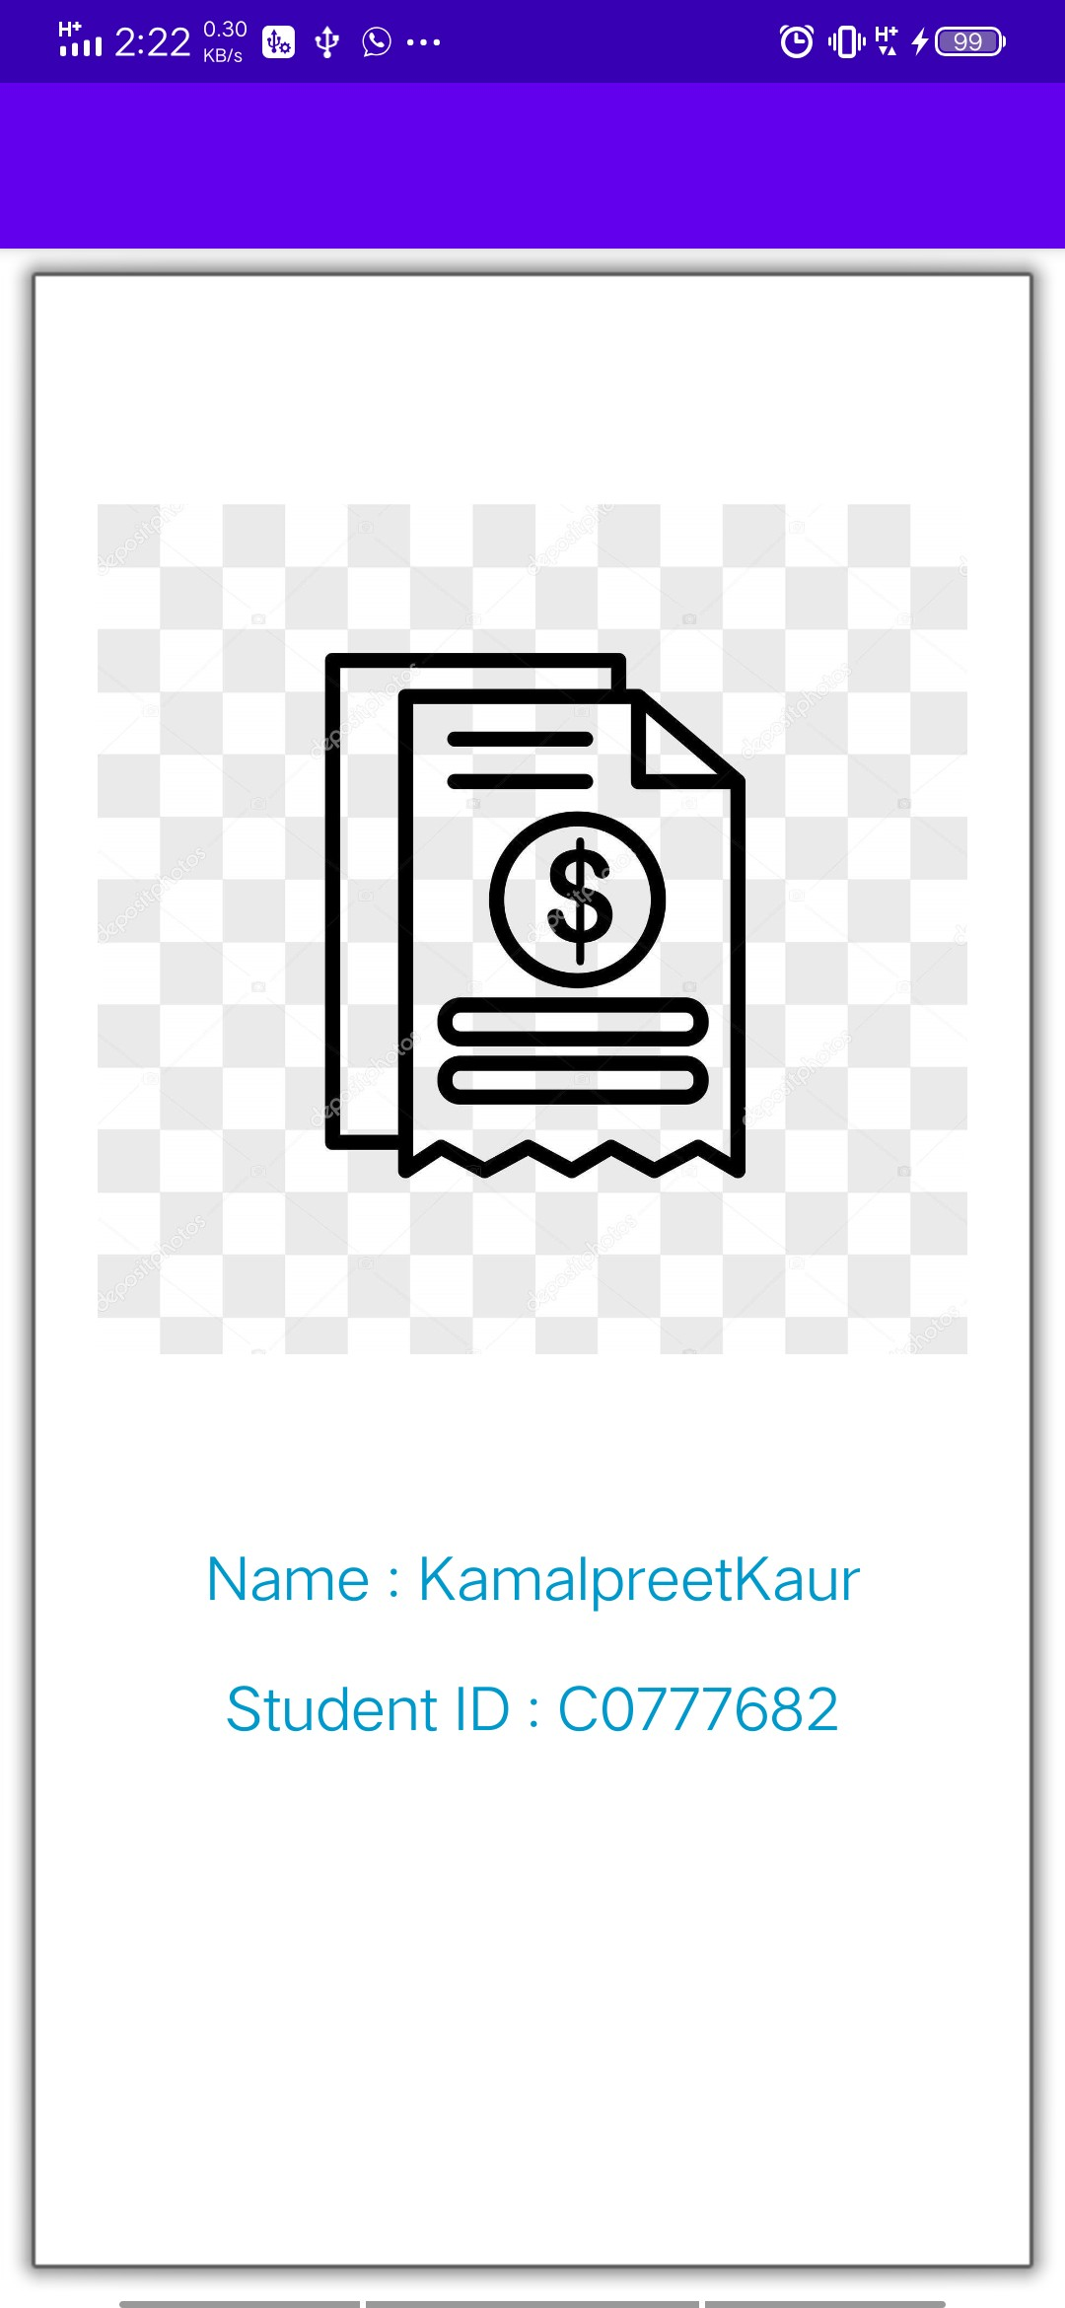

Fig : Splash Screen

-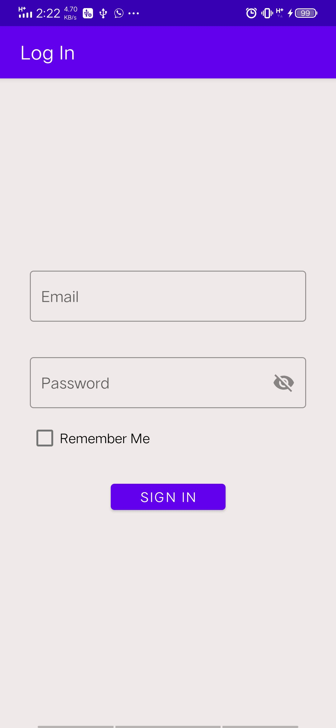

Fig: Login Screen

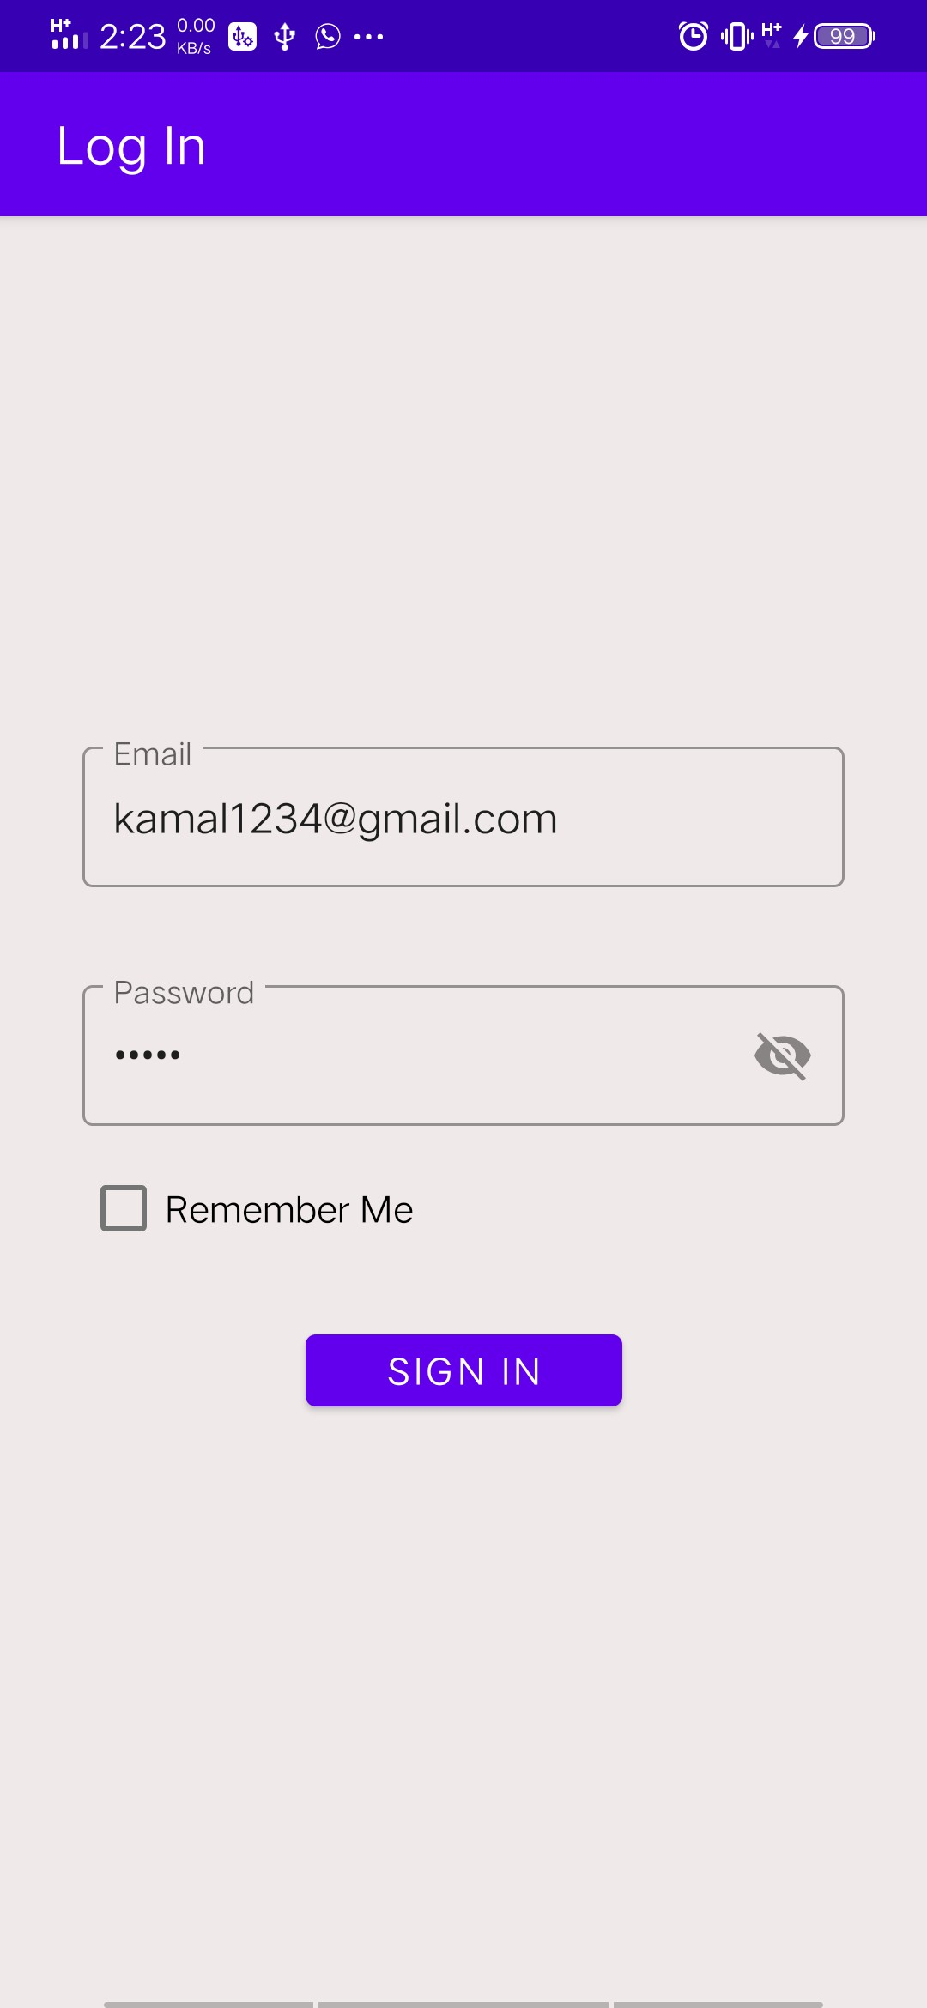

Fig : Fixed email is used for login

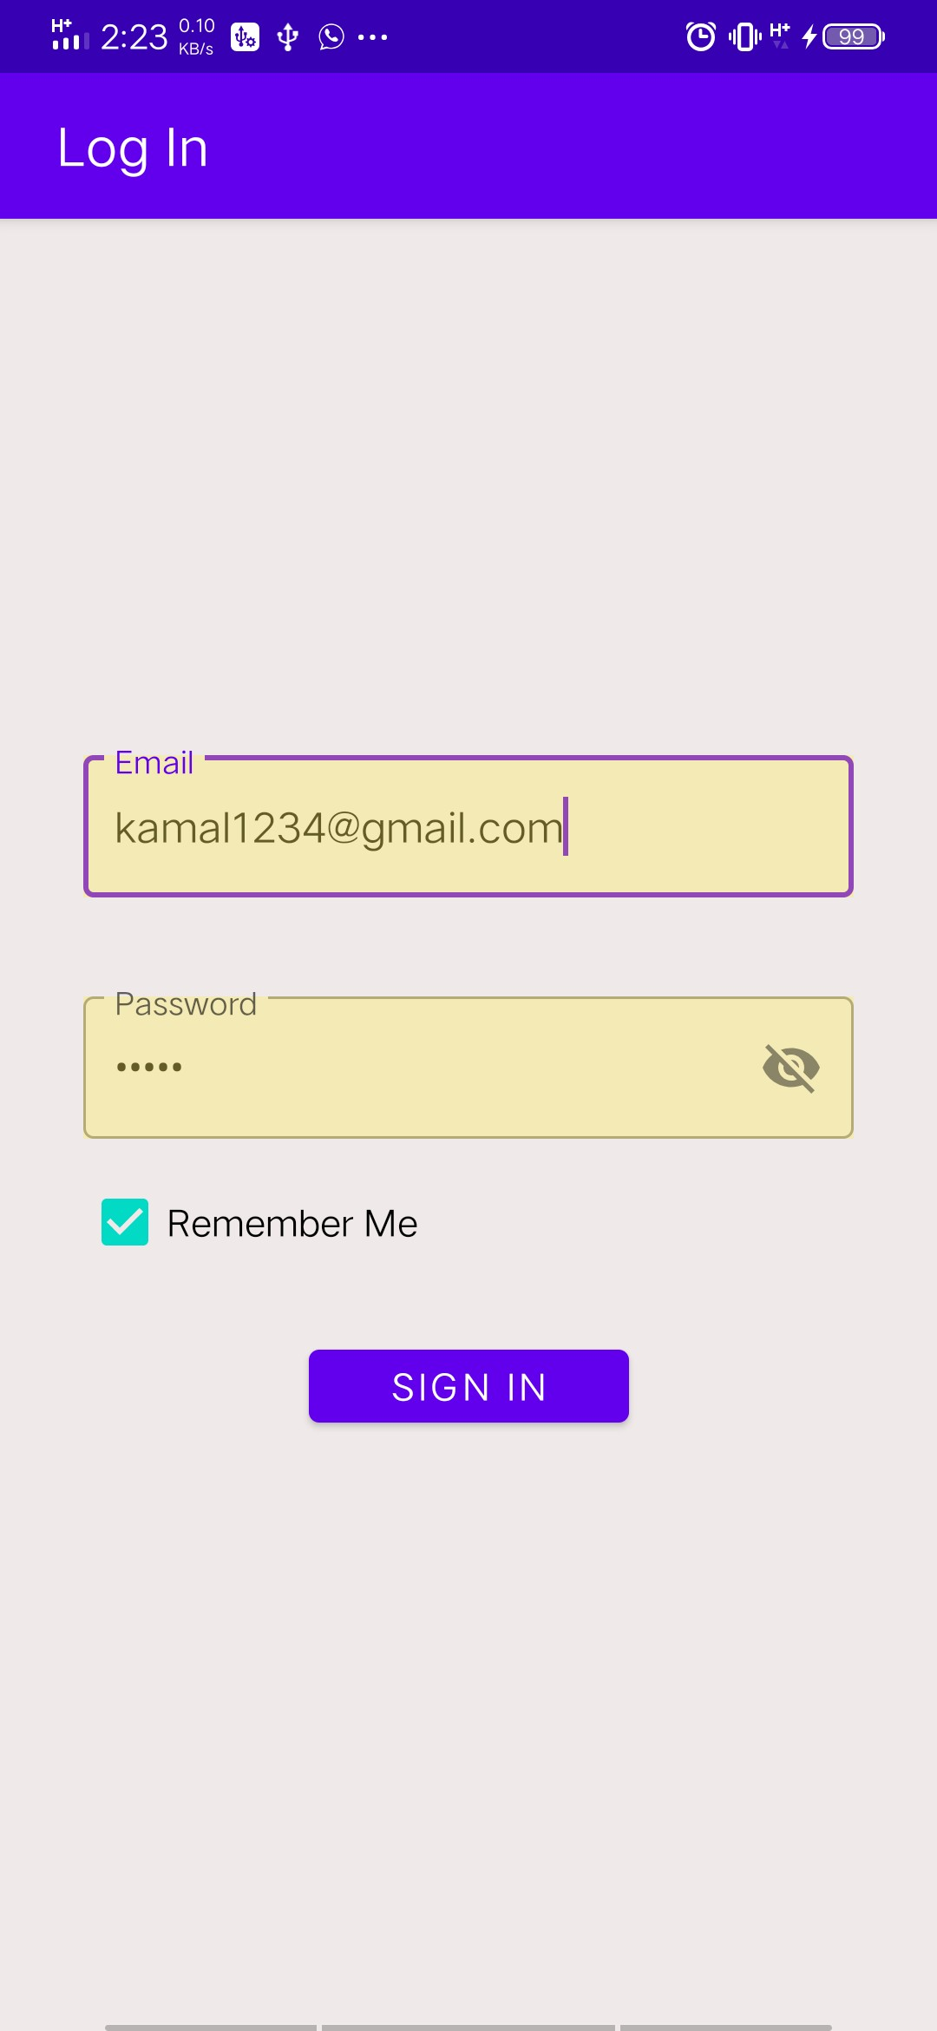

Fig: RememberMe working

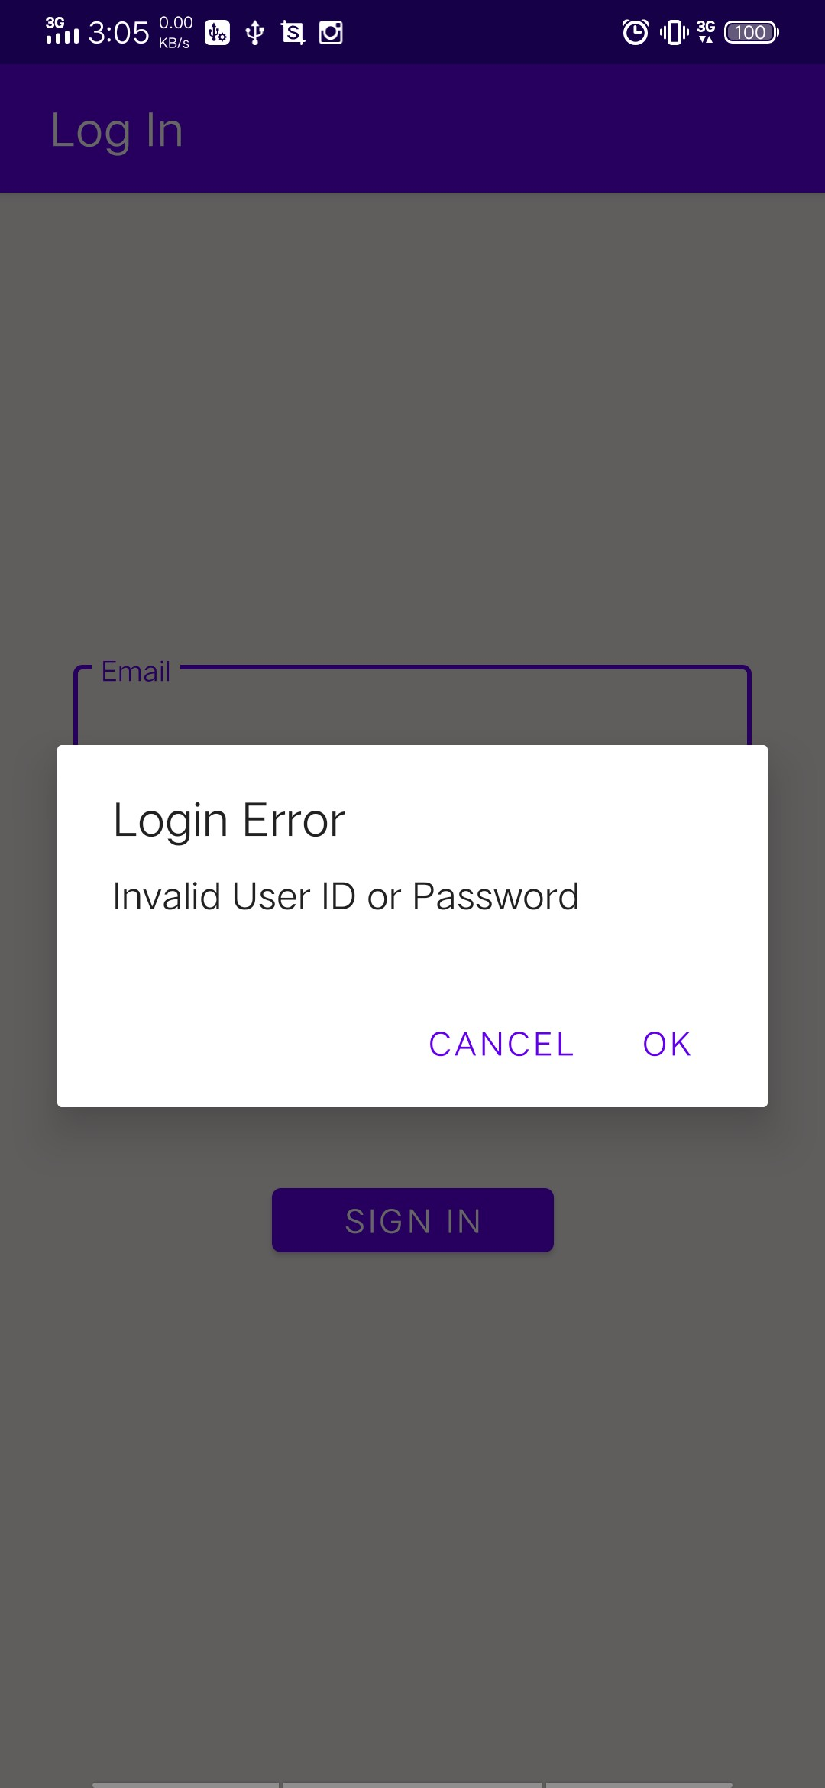

Fig: Validations on login screen

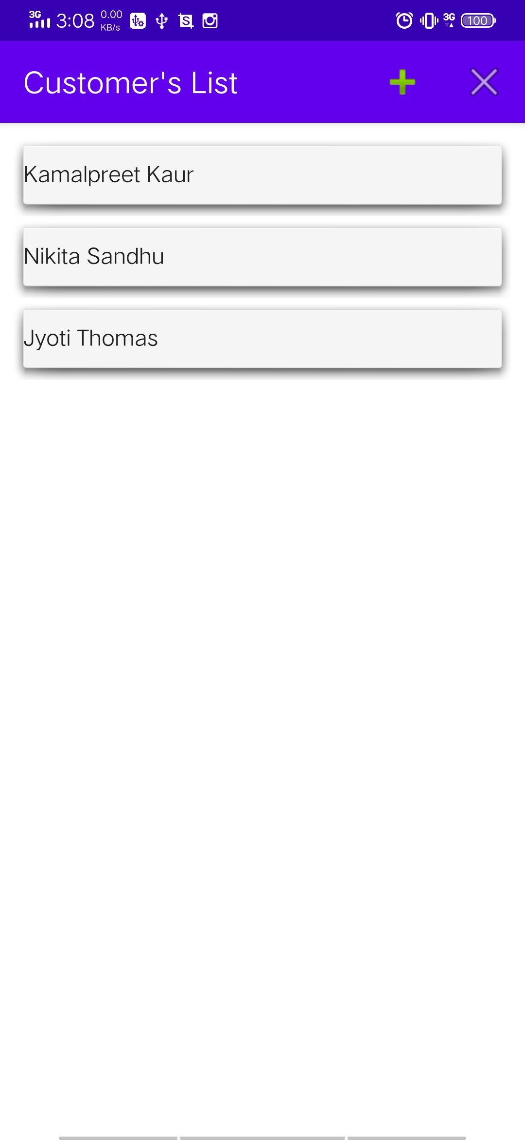

Fig : Customer List

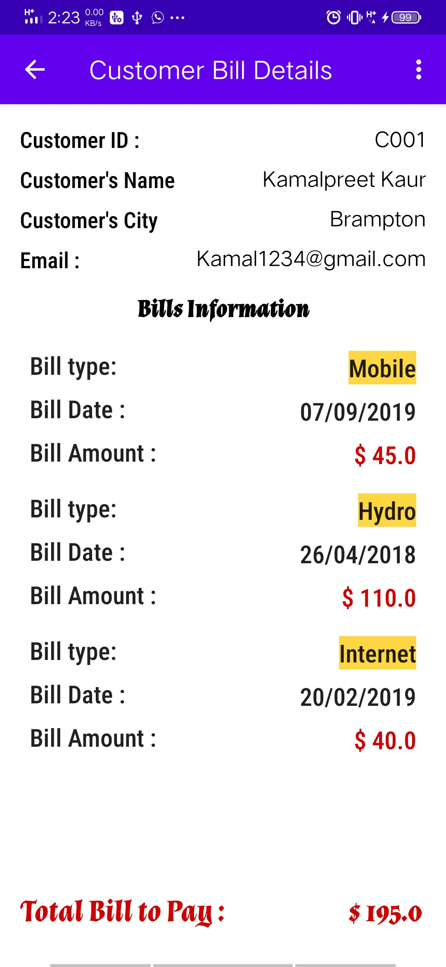

Fig : Displaying selected customer details

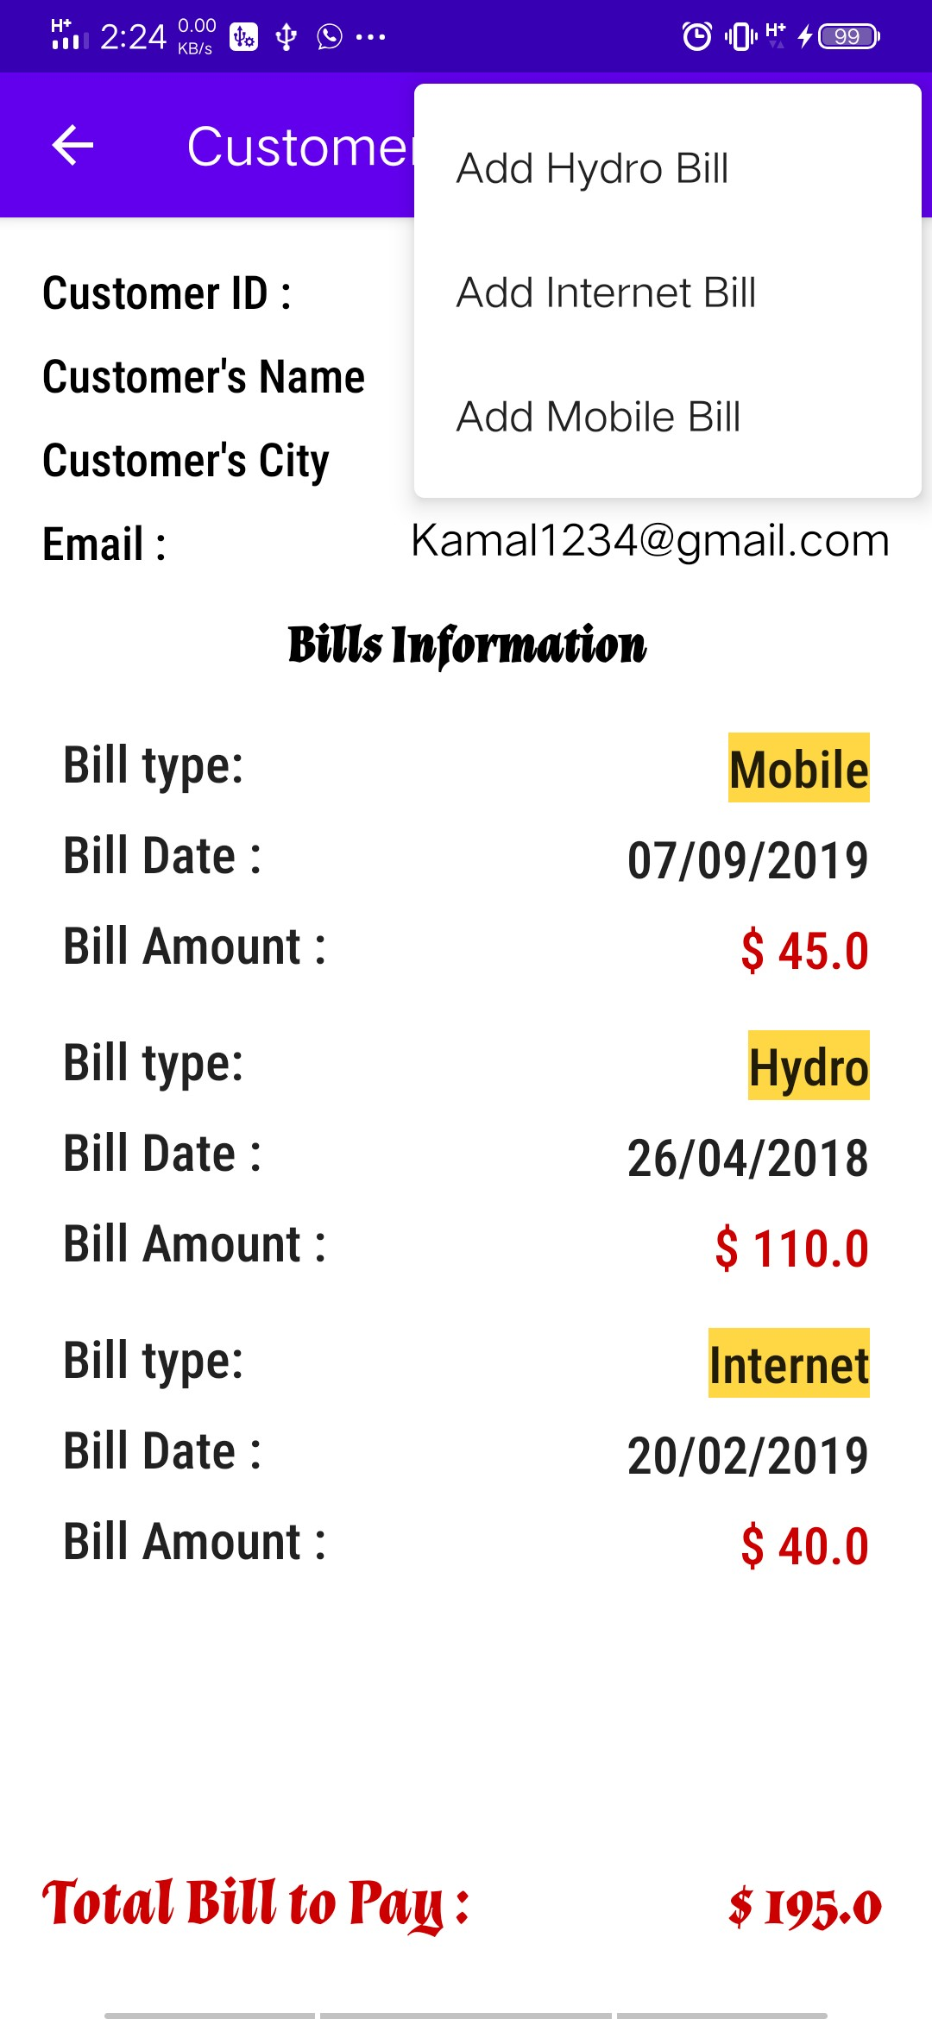

Fig: Bills can be added using menu

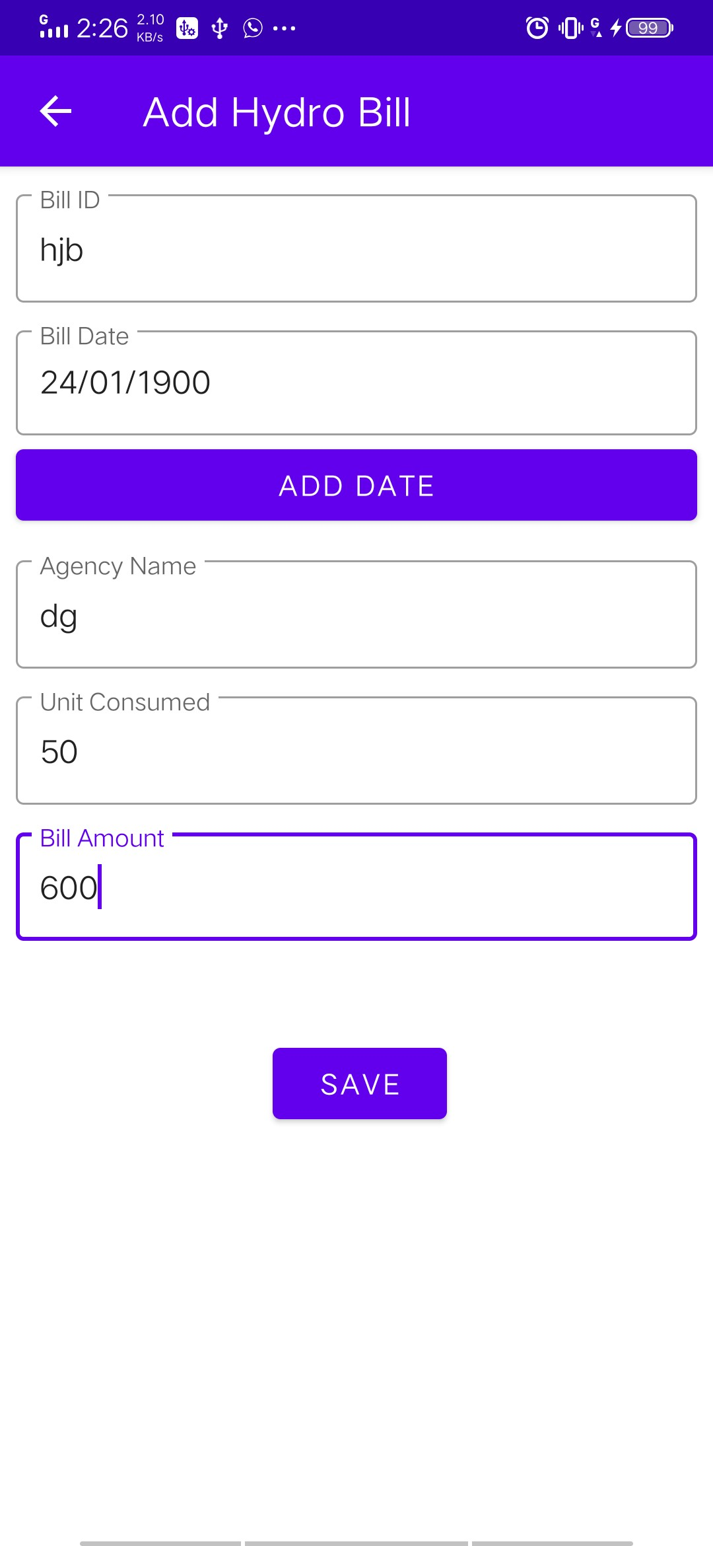

Fig : Adding Hydro Bill

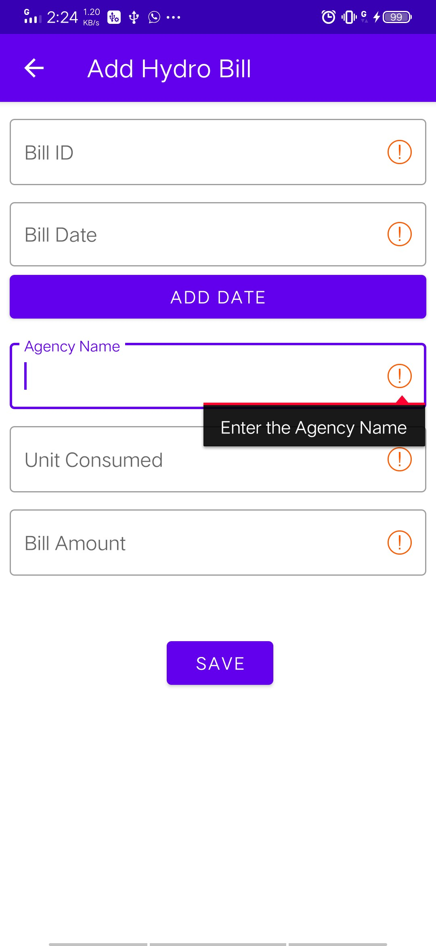

Fig Validations on adding hydro bill

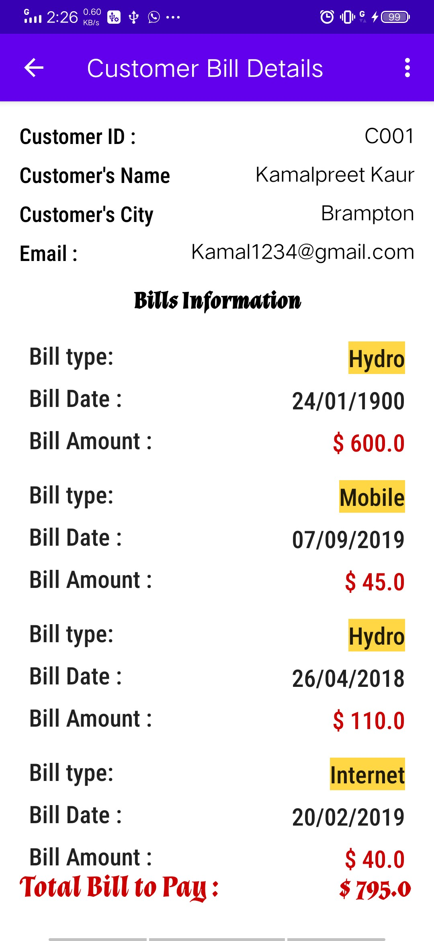

Fig : New Hydro Bill added. Similarly we can add internet and mobile bill to the customer.

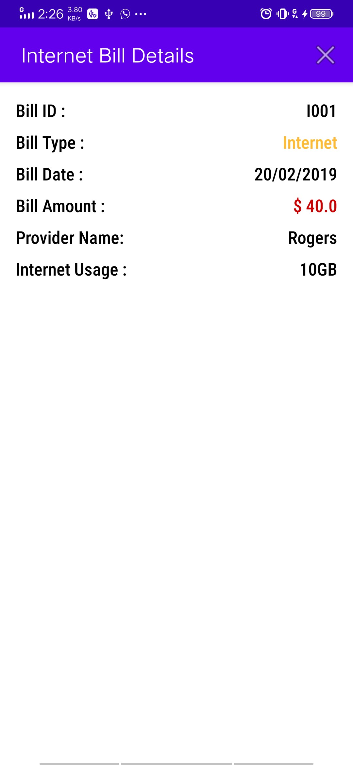

Fig : Showing Bill Summary in new activity when we clicked on the bill details displayed in ShowBillDetailsActivity.

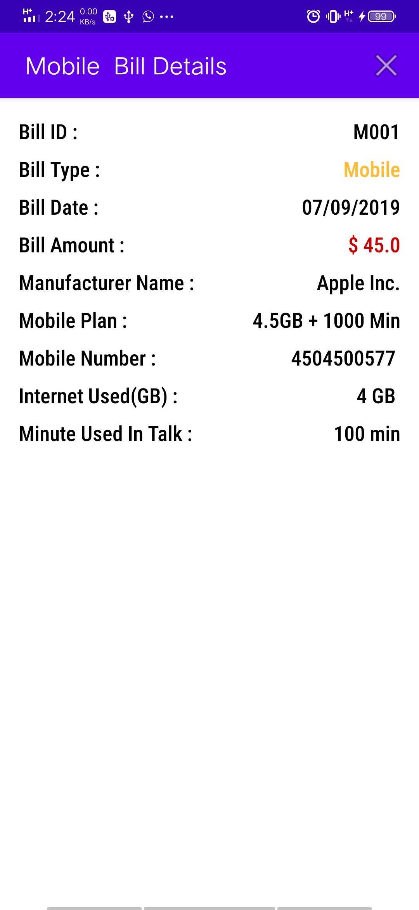

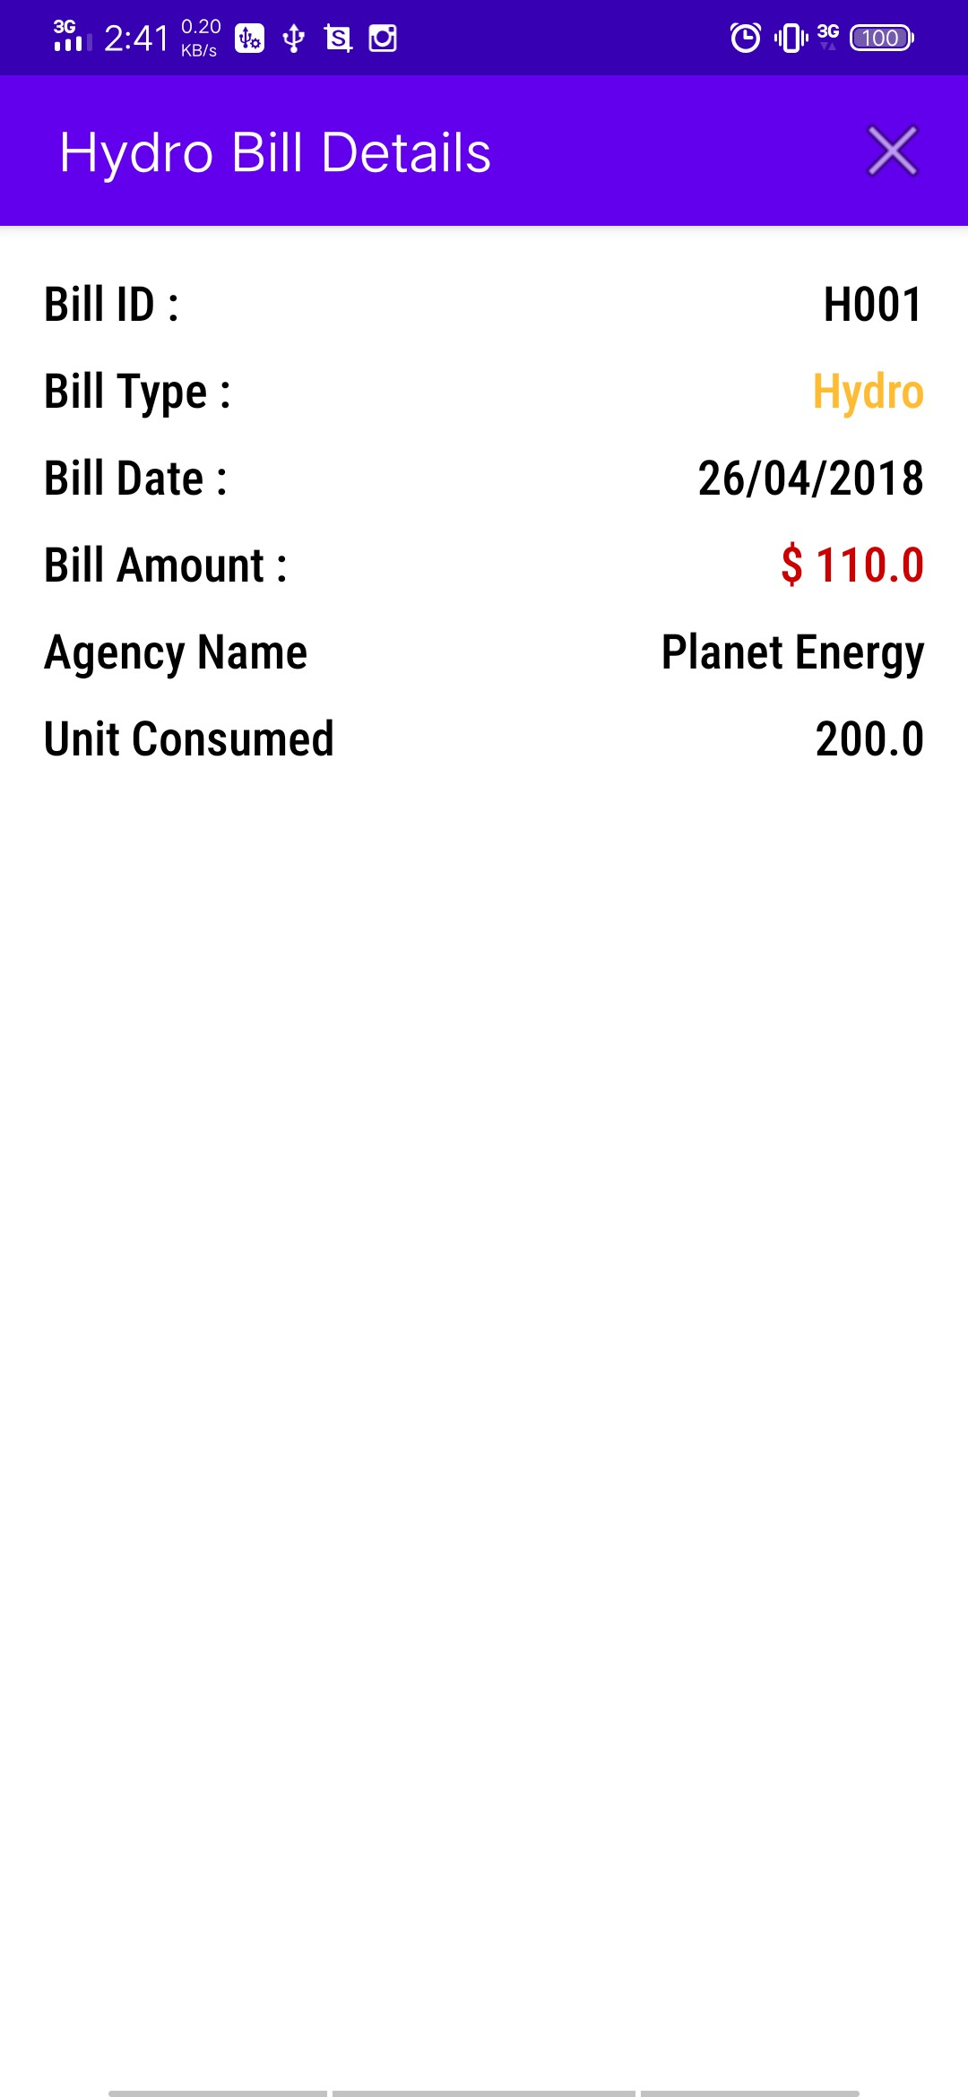

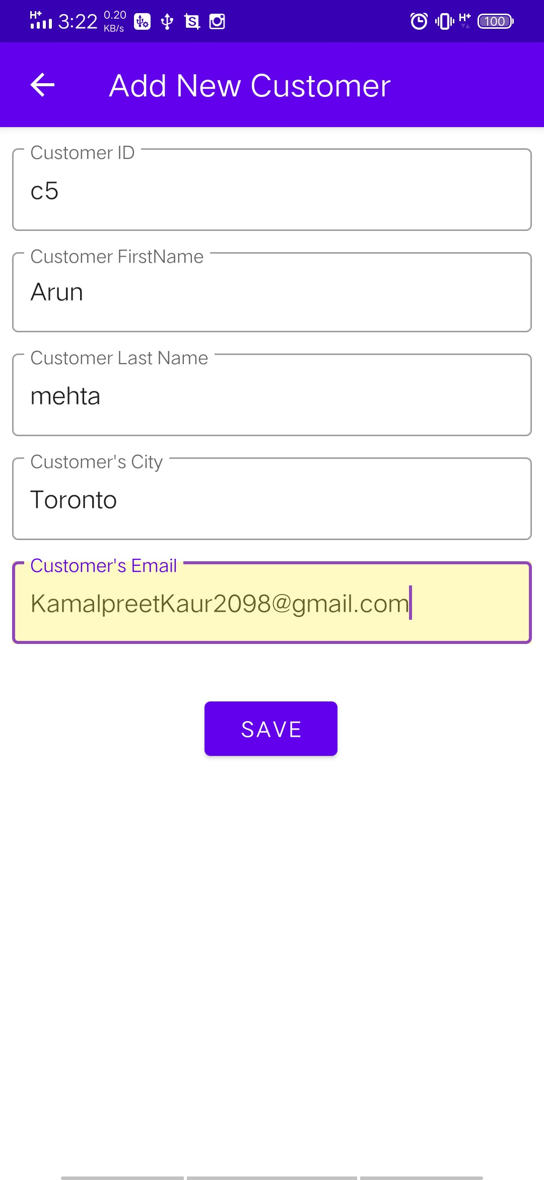

We can also add new customer .

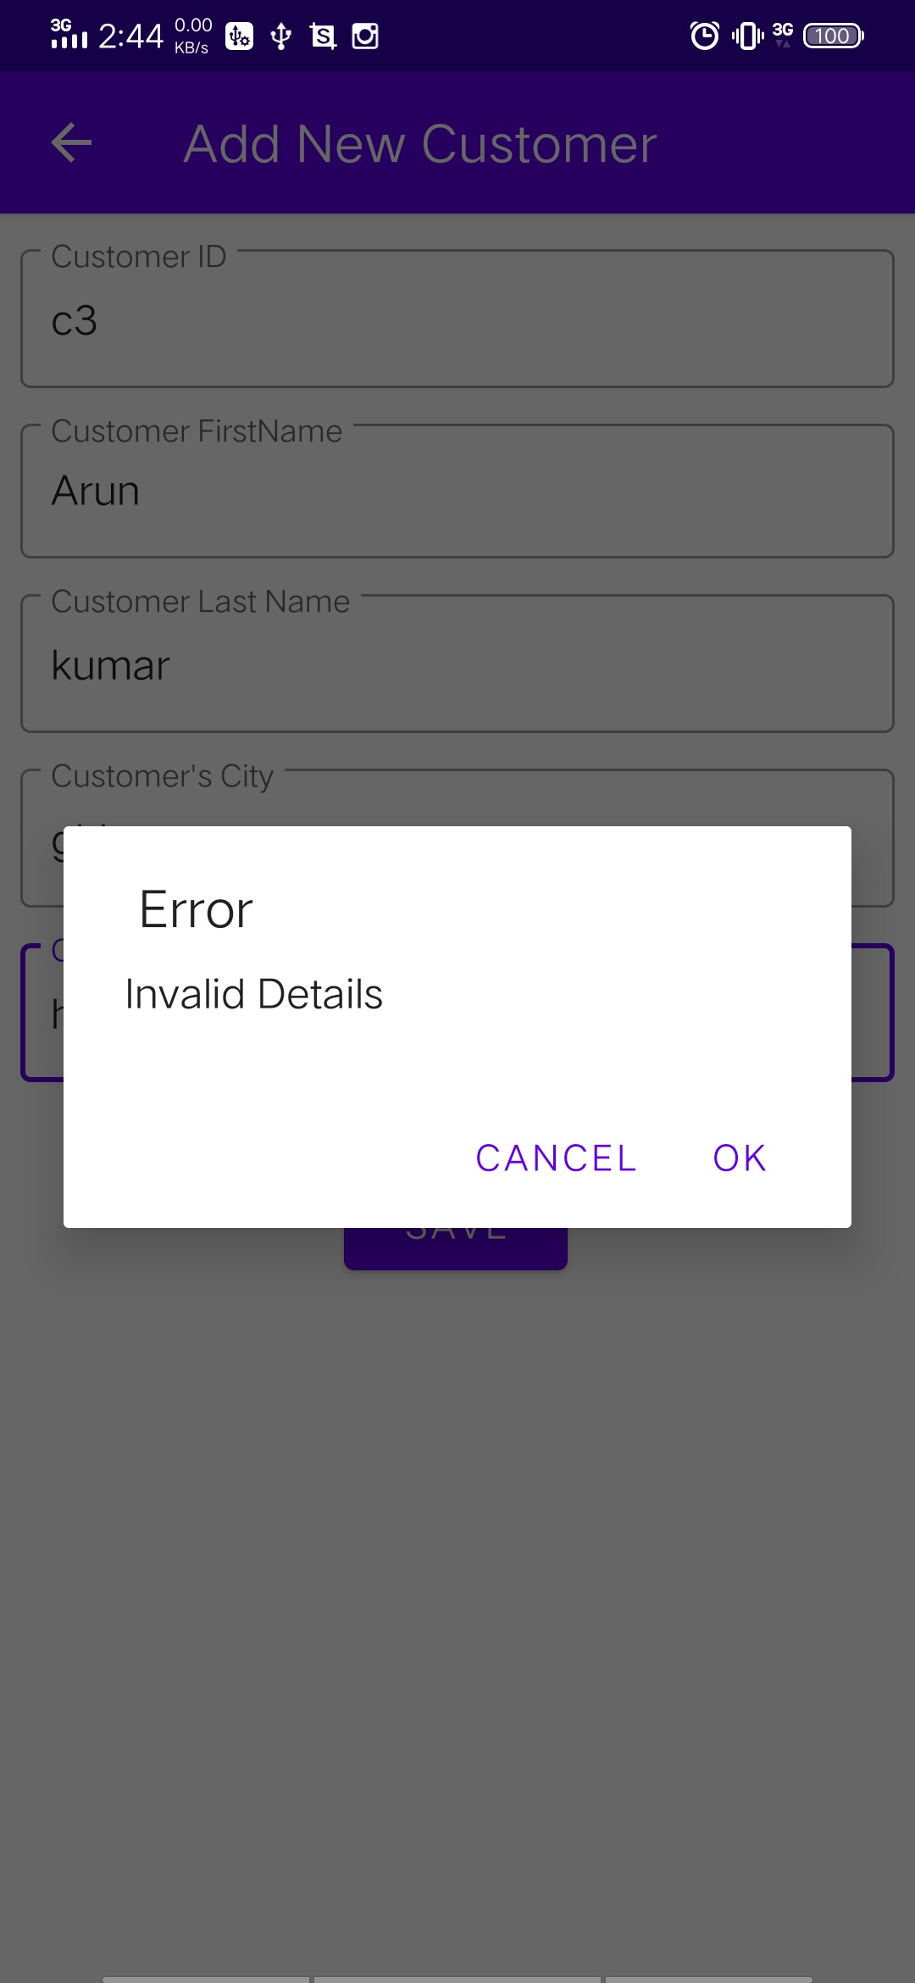

Email Validation while adding new customer.

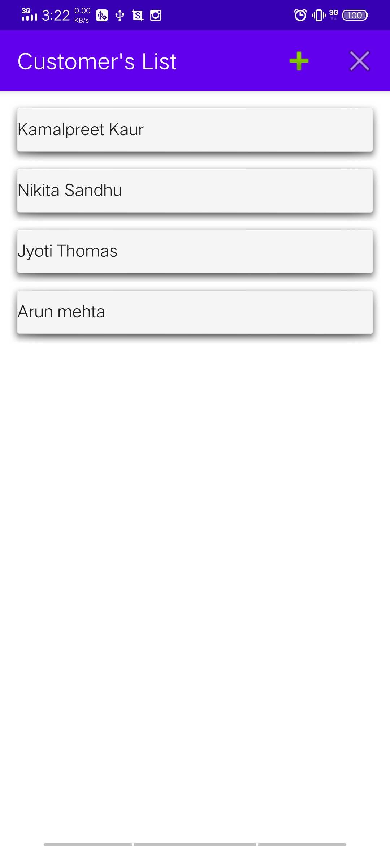

New Customer Successfully Added.

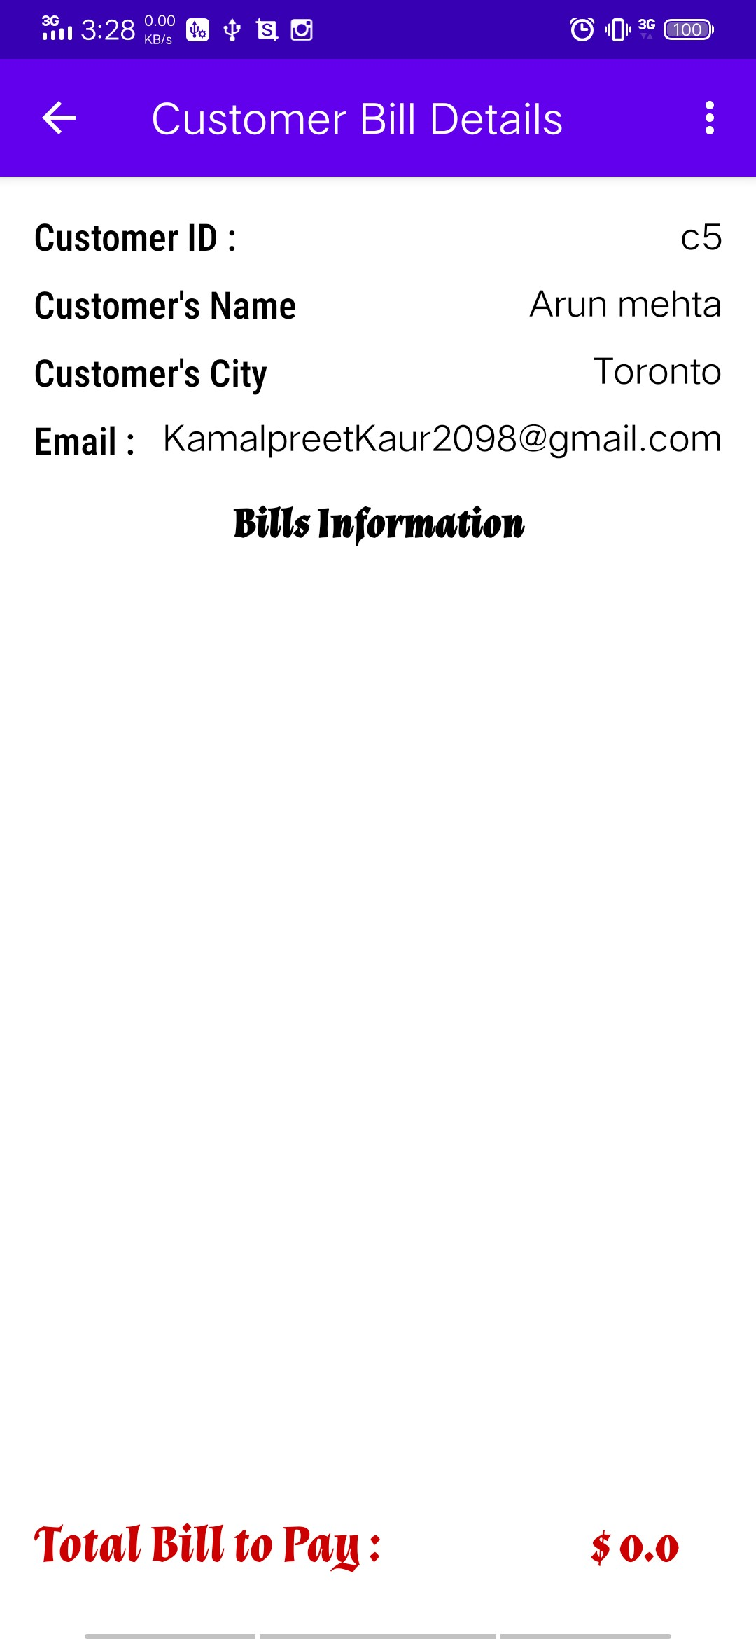

New Customer Details .

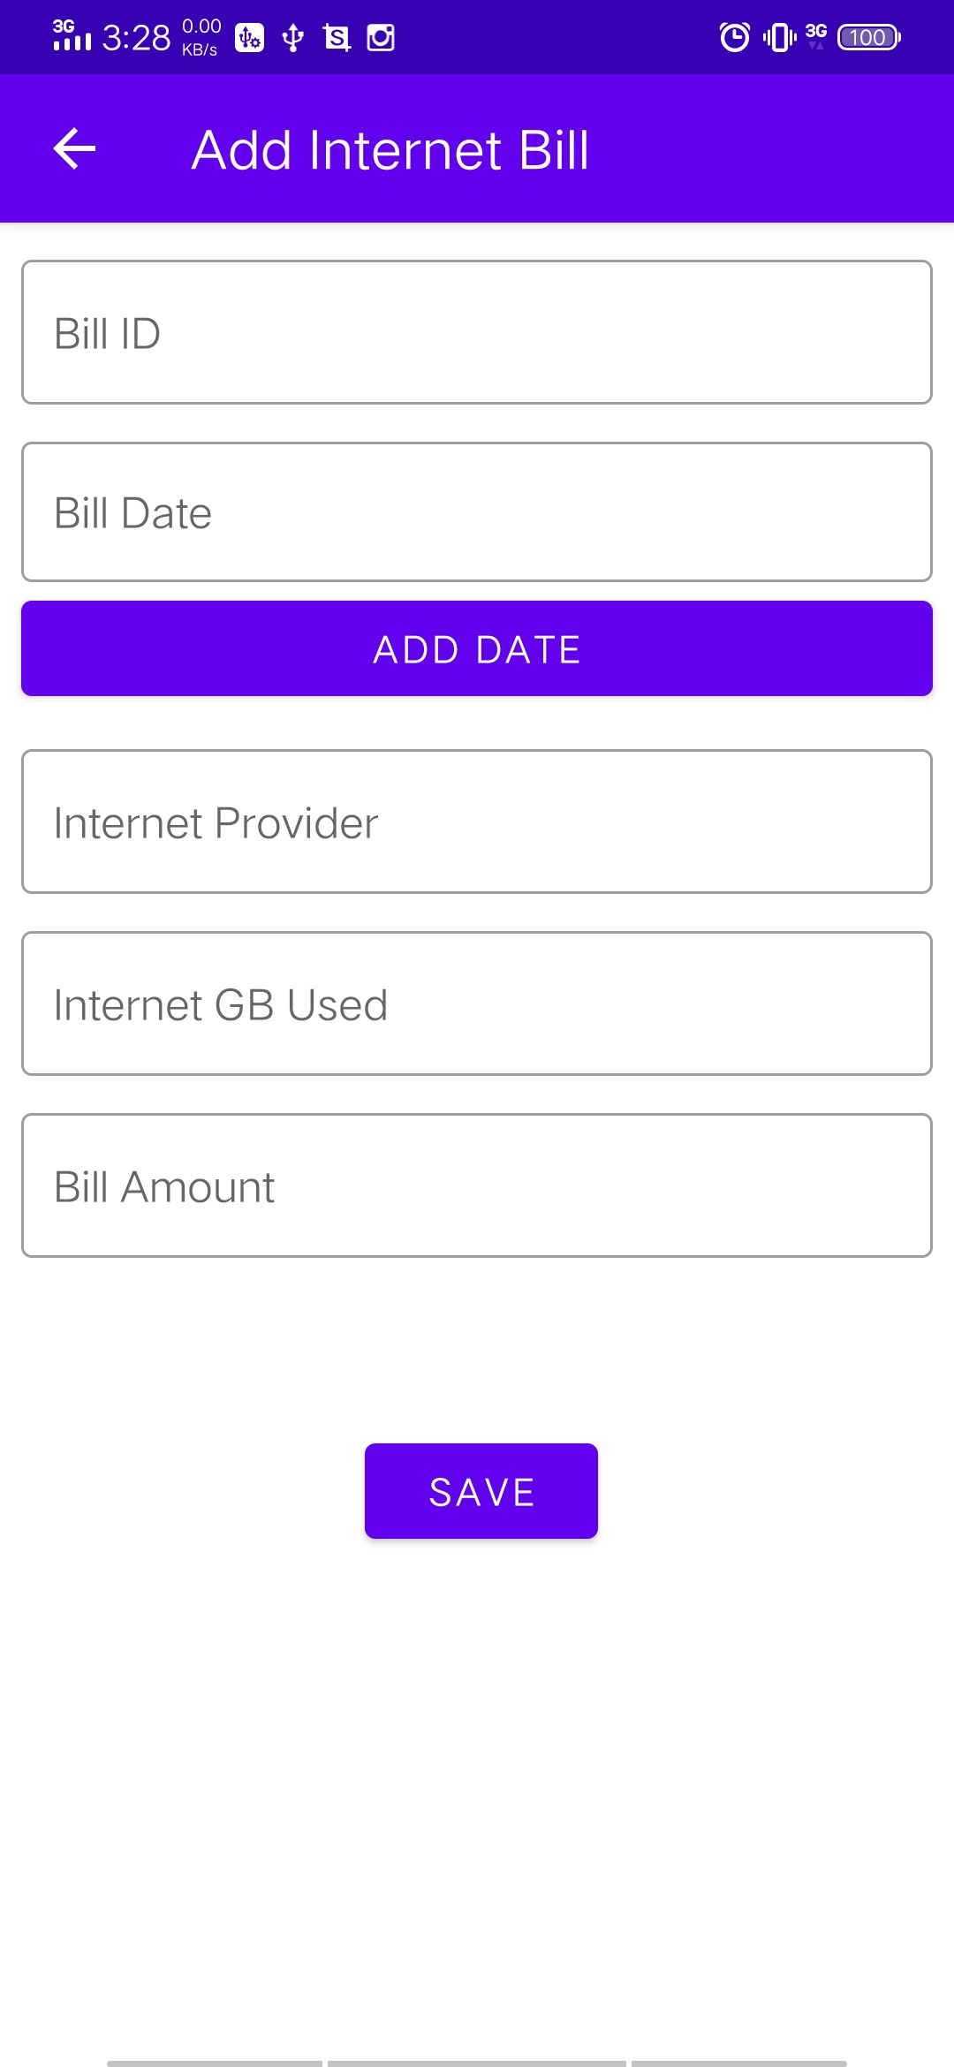

Adding Internet Bill to the Customer.

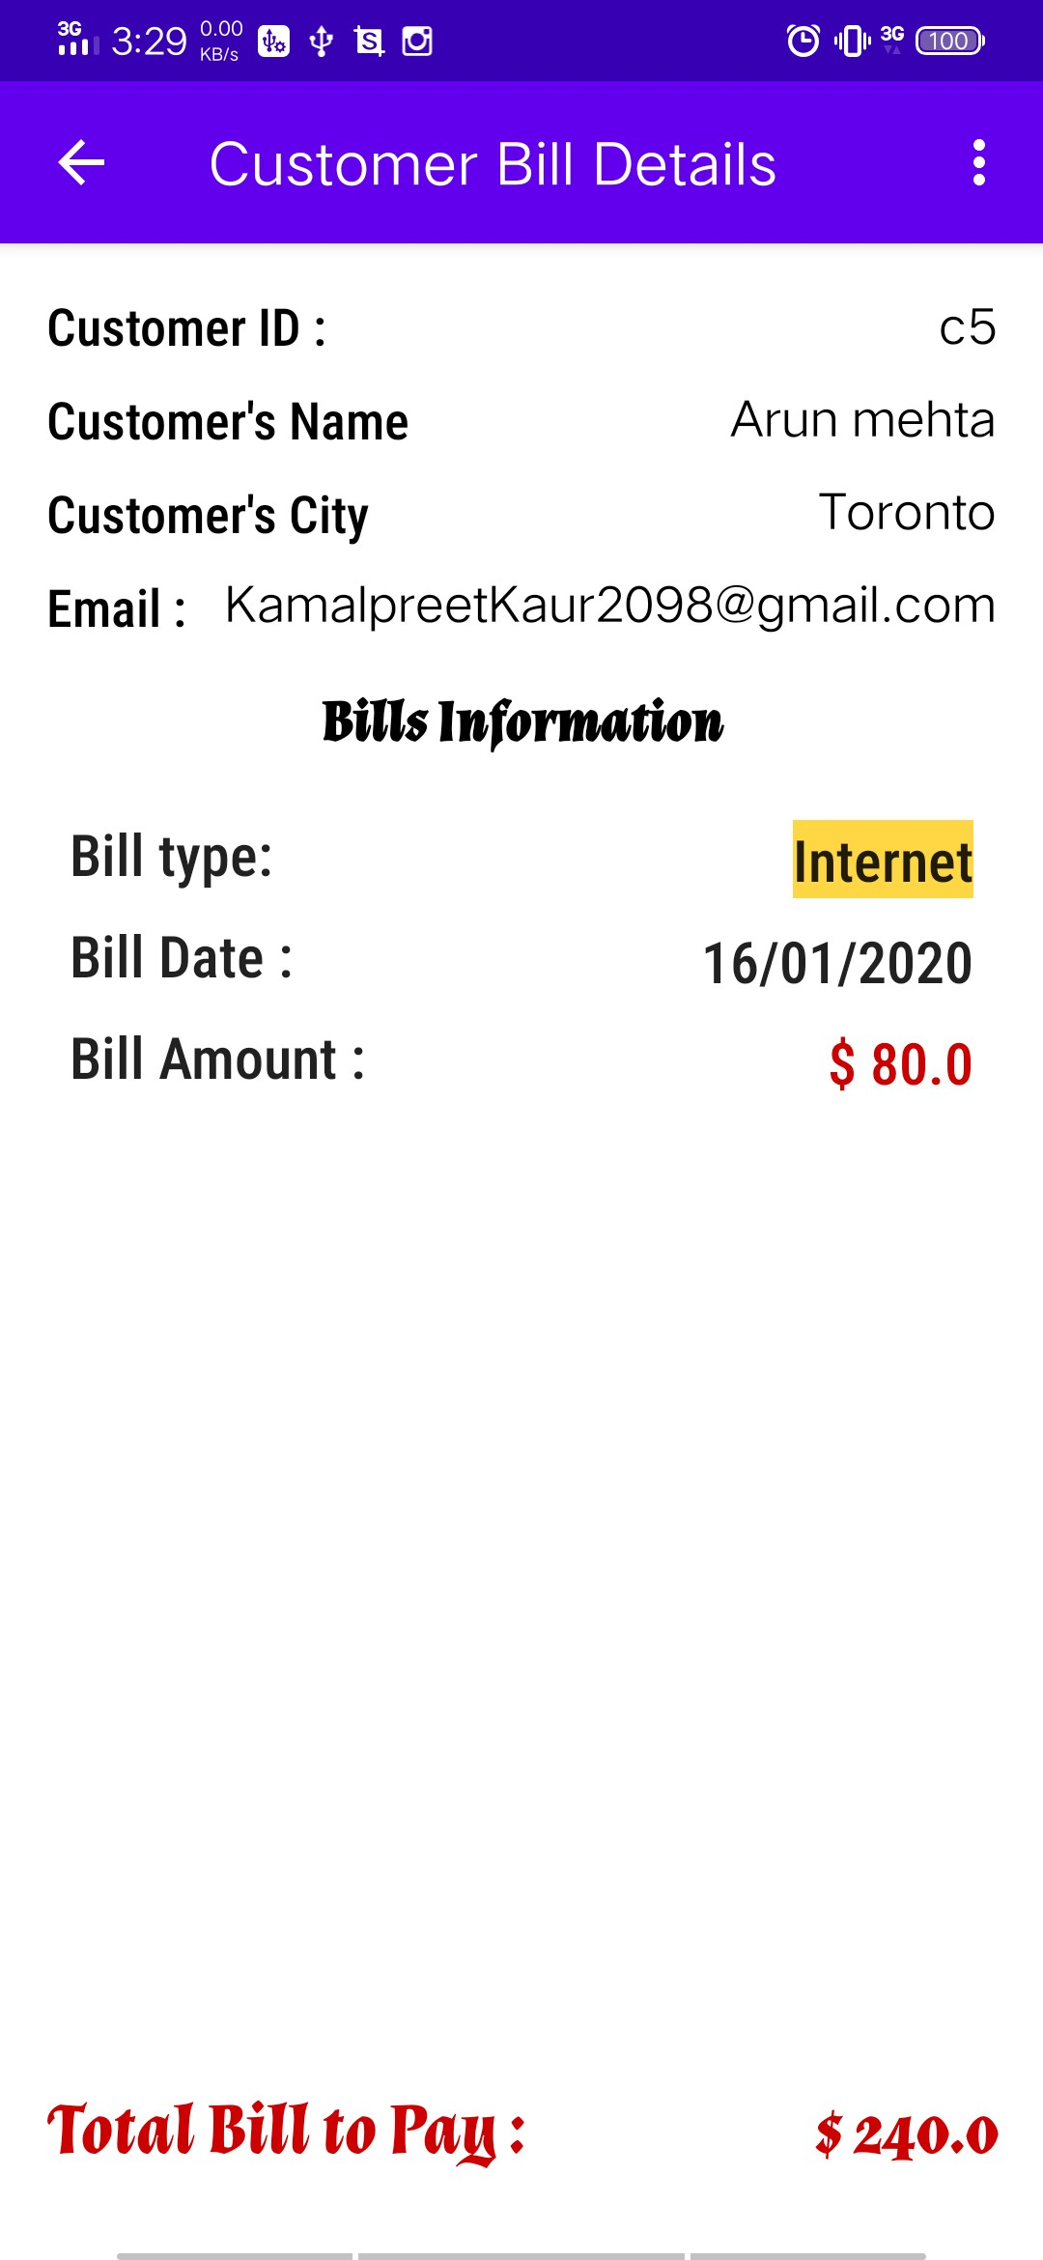

Internet Bill Successfully added

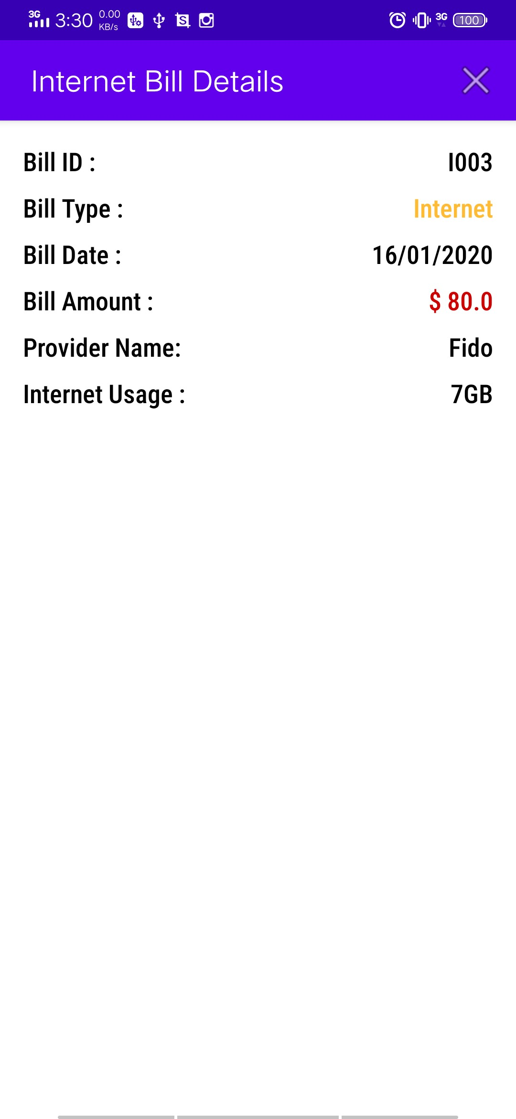

Bill Summary

Thanks