# Task 5 Visual Outputs: Dashboard Simulation

This document shows sample visual outputs (charts) for Task 5, simulating a Tableau dashboard using Python-generated charts.

## 1. Bar Chart: Total Price by Product

This chart represents the total price for each product after applying discounts.

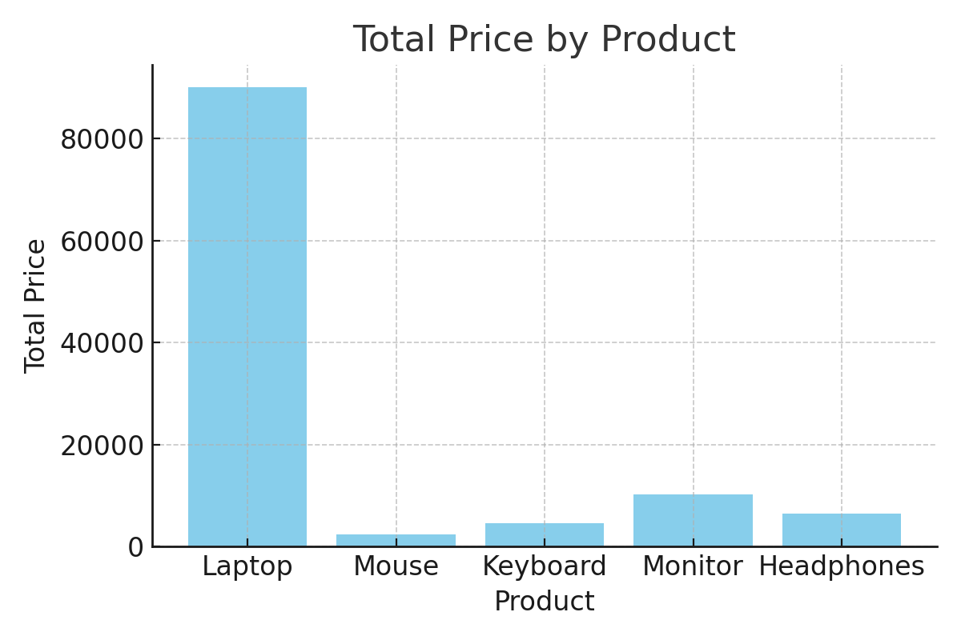

## 2. Pie Chart: Total Price Distribution by Region

This chart represents the distribution of total price across different regions.

