# Task 6: Interactions with Text, Visual Tooltips, and Actions in Tableau

## 1. Dataset (sales.csv)

|  |  |  |  |  |  |
| --- | --- | --- | --- | --- | --- |
| OrderID | Product | Region | Quantity | UnitPrice | Discount |
| 1 | Laptop | East | 2 | 50000 | 0.1 |
| 2 | Mouse | West | 5 | 500 | 0.05 |
| 3 | Keyboard | East | 3 | 1500 | 0 |
| 4 | Monitor | North | 1 | 12000 | 0.15 |
| 5 | Headphones | South | 4 | 2000 | 0.2 |

## 2. Steps to Perform Interactions

Step 1: Load the dataset into Tableau.

Step 2: Create a worksheet with visualizations, e.g.:

- Bar Chart: Total Price by Product

- Pie Chart: Total Price by Region

Step 3: Customize tooltips:

- Hover over bars or pie slices to show detailed info like Quantity, Discount, and Region.

Step 4: Add actions:

- Filter Actions: Click on a product in one chart to filter other charts.

- Highlight Actions: Highlight related data across charts when hovering.

- URL/Text Actions: Add clickable text or URL to open additional info.

Step 5: Test all interactions for interactivity and clarity.

## 3. Sample Visual Outputs

Below are sample charts to represent interactions, tooltips, and actions:

### 3.1 Bar Chart: Total Price by Product

Hover over bars to show detailed tooltip (Quantity, Discount, Region).

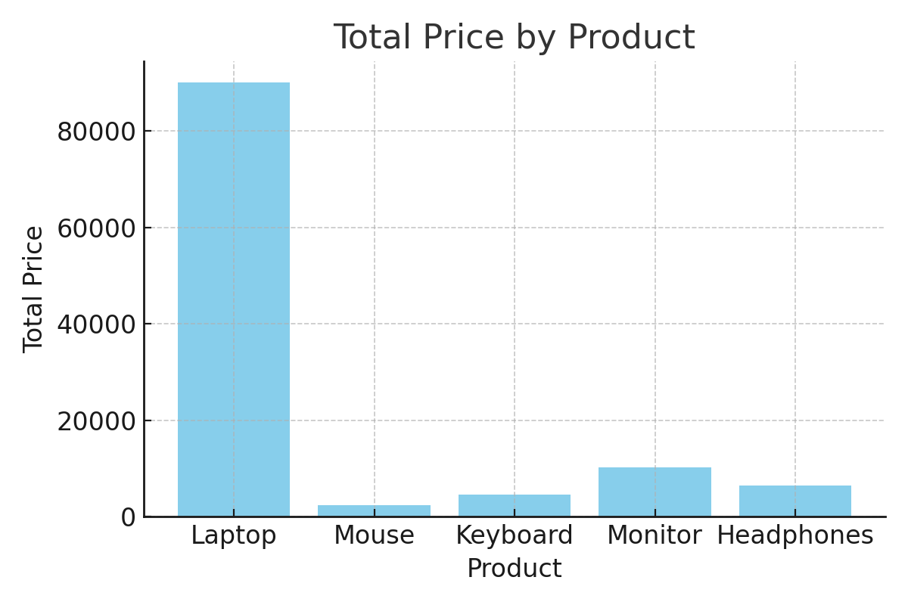

### 3.2 Pie Chart: Total Price Distribution by Region

Clicking a region can filter related products in other charts (simulating action).

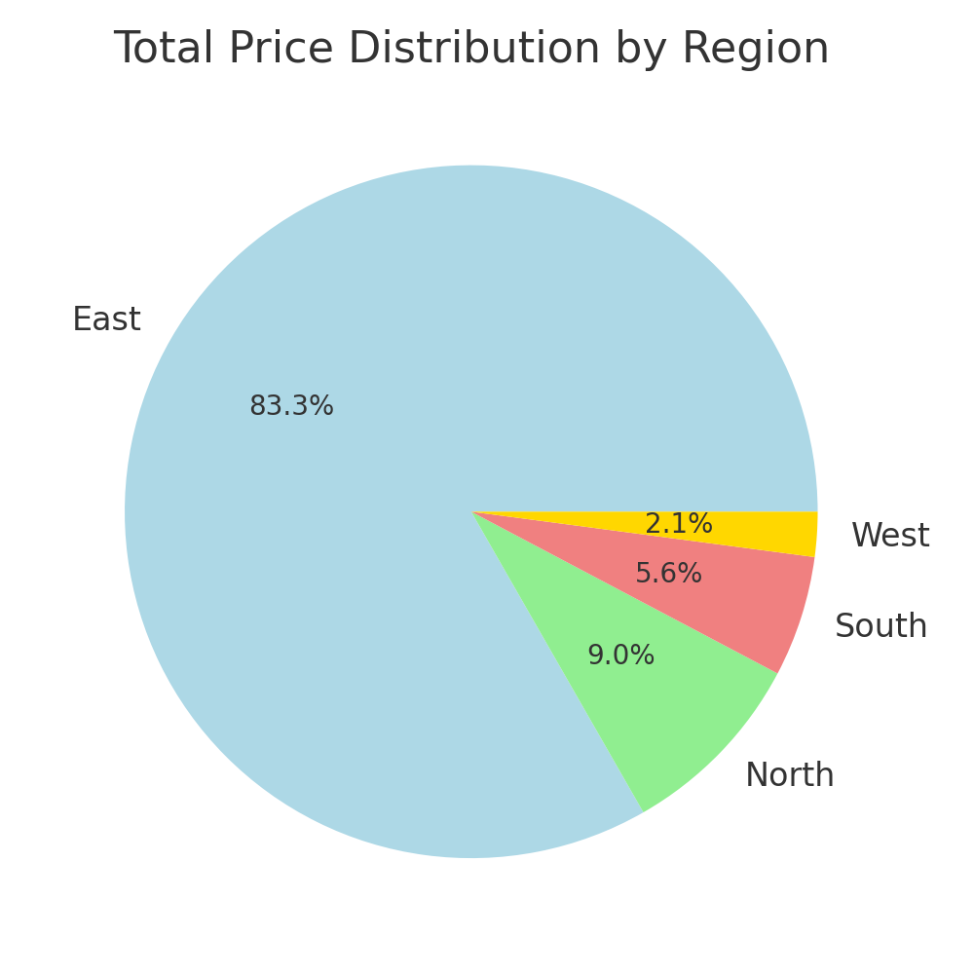

## 4. Instructions to Upload to GitHub

1. Save the dataset (sales.csv).

2. Build worksheets in Tableau and configure tooltips and actions.

3. Save the workbook as Task6_Interactions.twbx.

4. Upload sales.csv and Task6_Interactions.twbx to GitHub.