SmartCare v0.5 – Architecture and Refactoring

Current Architecture Problems
Problem | Evidence | Impact | Refactoring
Mixing up of workflow and presentation responsibilities | The appointment operations and the user interreference are handled together in the system | Hard for testing this system and hard to maintain for the management | Move the workflow coordination to the appointment service
Mixing of the business rules and the responsibilities of the system | The status validation of the appointment is not separated properly in the system | Changes can affect unrelated code | Appointment domain should consist of the business rules in it
Persistence is mixed with application logic | Saving of data steps are handled by high level of the code | Creates tight coupling | Move storage implementation into persistence/
Workflow of the appointment is not fixed in the one place | Creating/checking/saving appointments may be spread across classes | Harder to understand and test | Introduce focused AppointmentService
Repository responsibilities could become too broad | A repository could contain unrelated operations | Unnecessary complexity | Keep repository interface limited to current appointment use cases

Layer Responsibilities

Layer | Responsibilities | Must Not Contain
Presentation | Display the output or information, collect the input from the user of the system and show them the results or errors as per their input | Business rules, database code, persistence logic
Service | Coordinate SmartCare use cases and workflows, call domain objects and repositories | UI/display logic, direct database implementation, unrelated business rules
Domain | Appointments representation and make the business rules enforce in the appointments | UI code, presentation logic, database/file access
Repository | Data access operations definitions which are required by the system | Database implementation details, UI logic, unrelated business functionality
Persistence | Implementation of the repository operations in the system | UI logic, application workflow, business decisions

Architecture Diagram

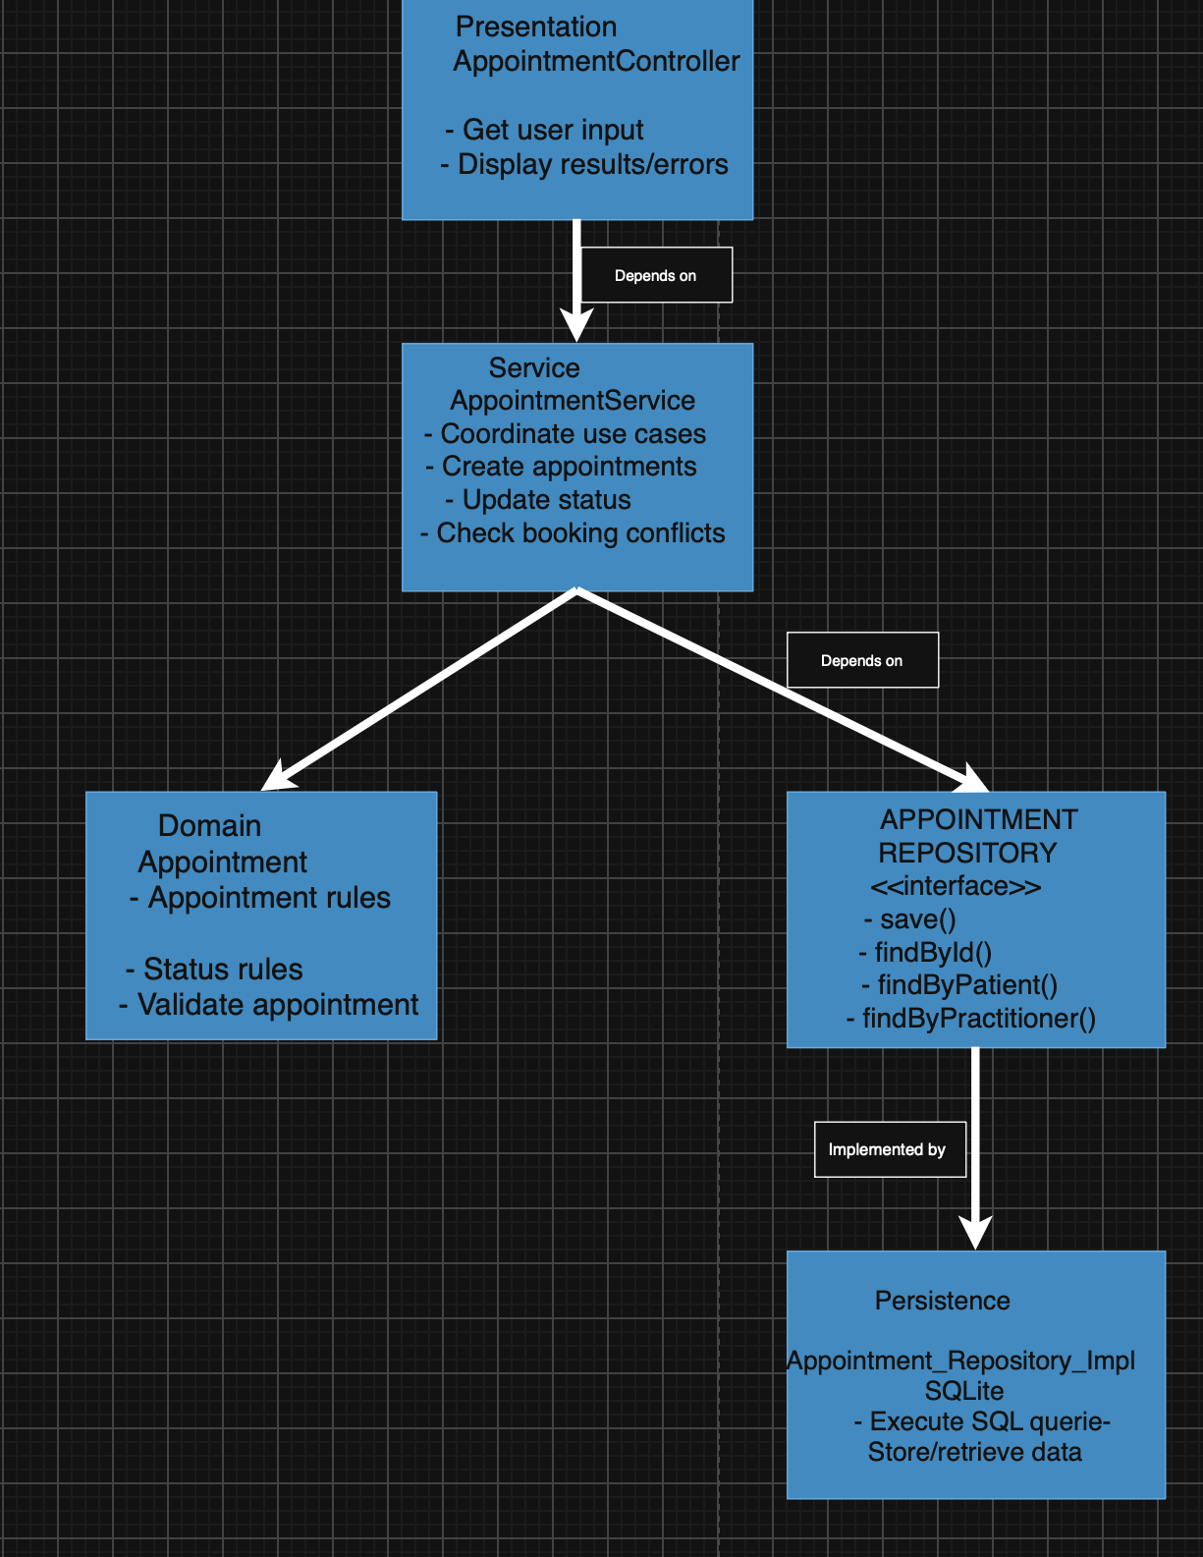

SOLID Review
Principle | Relevant | Evidence | Decision
SRP – Single Responsibility Principle | Yes | The original designed function architecture mixes the workflow, responsibilities together. | Apply –separate the responsibilities into Presentation, Service, Domain and Persistence.
OCP – Open/Closed Principle | Yes | Modifying the storage mechanism in the system should not impact or modify the workflow in the system | Apply – use AppointmentRepository so persistence implementations can be modified or change without changing the service
LSP – Liskov Substitution Principle | Yes, but limited | A persistence implementation should be usable wherever AppointmentRepository is expected. | Apply – AppointmentRepositoryImpl must correctly implement the repository contract.
ISP – Interface Segregation Principle | Yes | The repository should not contain unnecessary operations unrelated to current appointment use cases. | Apply – keep AppointmentRepository small and focused.
DIP – Dependency Inversion Principle | Yes | The service should not be fully dependent on database/file implementation. | Apply – AppointmentService depends on the AppointmentRepository abstraction.

AI Architecture Review
AI Suggestion | Observed Problem | Decision | Reason | Verification
Separating presentation from the persistence | Yes | Accepted | Presentation should not consist of the logics of database | Presentation communicates through AppointmentService.
Moving appointment workflow into AppointmentService. | Yes | Accepted | The appointment workflow has been mixed up with the other responsibilities | The creation of the appointment and the checking of the conflicts between appointments are coordinated by the appointment service.
Enforcing the business rules in the Appointment. | Yes | Accepted | Domain behaviour should remain in the domain object. | Service coordinates but does not take over appointment business rules.
Use a small AppointmentRepository interface. | Yes | Accepted | Data access is needed to be separate without creating the complexity. | Repository contains current appointment use cases.
Make persistence implement the repository interface. | Yes | Accepted | This prevents the service from depending directly on storage technology. | AppointmentRepositoryImpl implements the repository contract.
Add a Unit of Work layer. | No | Rejected | No requirements in the Smart Care System needs additional abstraction. | Existing appointment operations can work without it.
Add a Factory pattern for appointments. | No | Rejected | Appointment creation is simple and does not justify another layer. | AppointmentService can coordinate normal creation.
Add DTOs everywhere. | No | Deferred | There is not any problem demonstrated in the system requiring DTOs at this stage. | The current architecture of the system works well without it .
Add multiple specialised services immediately. | No | Deferred | The system mainly focus on the appointment workflow in the system | Only AppointmentService is introduced.
Add a dependency-injection framework. | No | Rejected | Adding this would make the system more complex and would not solve any problem required by the system | Repository dependency can remain simple without making it complex by adding additional framework.

