CALIBRATION AND INTEGRATION OF TURBOCHARGER FOR SINGLE CYLINDER DIESEL ENGINE
Dissertation submitted
in partial fulfillment of requirements
for the award of degree of

Bachelor of Technology
in
Mechanical Engineering
by
KURACHA MEGHANA (Regd. No: 21135A0308)
BODDU KAMALA SRI (Regd. No: 20131A0320)
ALLADA TEJASWINI (Regd. No: 20131A0304)
BHUKYA SATWIK NAIK (Regd. No: 20131A0319)

Under the guidance of
Dr. B. GOVINDA RAO

Professor & HOD
Department of Mechanical Engineering
GAYATRI VIDYA PARISHAD COLLEGE OF ENGINEERING
(AUTONOMOUS)
(Affiliated to J.N.T.University,Kakinada)
VISAKHAPATNAM - 530048
APRIL,2024

CALIBRATION AND INTEGRATION OF TURBOCHARGER FOR SINGLE CYLINDER DIESEL ENGINE
Dissertation submitted
in partial fulfillment of requirements
for the award of degree of

Bachelor of Technology
in
Mechanical Engineering
by
KURACHA MEGHANA (Regd. No: 21135A0308)
BODDU KAMALA SRI (Regd. No: 20131A0320)
ALLADA TEJASWINI (Regd. No: 20131A0304)
BHUKYA SATWIK NAIK (Regd. No: 20131A0319)

Under the guidance of
DR.B.GOVINDA RAO
Professor & HOD

Department of Mechanical Engineering
GAYATRI VIDYA PARISHAD COLLEGE OF ENGINEERING
(AUTONOMOUS)
(Affiliated to J.N.T.University,Kakinada)
VISAKHAPATNAM - 530048
APRIL,2024

CERTIFICATE

This is to certify that the project titled “CALIBRATION AND INTEGRATION OF TURBOCHARGER FOR SINGLE CYLINDER DIESEL ENGINE” is a bonafide record of the work done by

KURACHA MEGHANA (21135A0308)
BODDU KAMALA SRI (20131A0320)
ALLADA TEJASWINI (20131A0304)
BHUKYA SATWIK NAIK(20131A0319)
in partial fulfillment of the requirements for the award of the degree of
Bachelor of Technology in Mechanical Engineering
of Gayatri Vidya Parishad College of Engineering (Autonomous), affiliated to Jawaharlal Nehru Technological University, Kakinada during the year 2023-2024.

Project Guide Head of the Department
Dr. B. GOVINDA RAO Dr. B. GOVINDA RAO
Professor & HOD Professor & HOD
Mechanical Engineering Mechanical Engineering

Project Viva-voce held on:

External Examiner

ABSTRACT

In present days, turbocharger is most commonly used in multi-cylinder diesel engines as there is continuous flow of mixture. This happens because of number of cylinders present in engine there may be suction stroke in each and every revolution of crank.

But in single-cylinder diesel engine, there is one suction stroke for every 2 revolutions so that air flow is not possible and there is no continuous discharge of mixture. So, turbocharging single-cylinder diesel engine is difficult than turbocharging multi-cylinder diesel engine.

In the present work turbo charger will be incorporated to a single cylinder diesel engine as single cylinder diesel engines have varying inlet pressures and difficult pulsating operation. The present work aims at overcoming this difficulties by incorporating a air-capacitor before the inlet manifold of the engine and turbocharger. The turbocharger is incorporated to the air capacitor and experiments are carried out at different inlet pressures.

In order for the air capacitor to be practical, it needs to be sized large enough to maintain turbo pressure, cause minimal turbo lag and significantly increase the density of intake air. By analyzing, we found that the optimal size of the air capacitor is between four to five times the engine capacity.

The project aims at successful incorporation and calibration of the turbocharger to the single-cylinder diesel engine. In this work the effect of air inlet temperatures, pressures and load on the performance parameters such as Brake thermal efficiency, Brake specific fuel consumption and emissions such as Carbon monoxide (CO), Hydro Carbons (HC), Nitrogen oxides (NO x) and smoke are studied.

ACKNOWLEDGEMENT

We would like to express our deep sense of gratitude to our esteemed institute Gayatri Vidya Parishad College of Engineering (Autonomous), which has provided us an opportunity to fulfil our cherished desire.

We express our sincere thanks to our course internal supervisor and Head of the Department Dr. B. GOVINDA RAO, Department of Mechanical Engineering, Gayatri Vidya Parishad College of Engineering (A) for the kind suggestions and his inspiring guidance for the successful completion of our project.

We express our sincere thanks to our Principal Dr. A.B. KOTESWARA RAO, Gayatri Vidya Parishad College of Engineering (Autonomous) for providing all the necessary resources for completing the project, giving us a chance to explore and learn new technologies through this project. We express our heartful thanks to the Dean UG, studies and other members of Departmental review committee for reviewing the progress of dissertation work from the beginning to the end and for their thoughtful insights.

We felt happy to convey our sincere thanks to Mr. Y. DATTA BHARADWAZ, Assistant Professor, Mechanical Engineering, for giving us proper guidance and support throughout our project.

We convey our heartful thanks to the teaching and non-teaching staff of the Mechanical Department for all their support in completion of our project.

KURACHA MEGHANA (21135A0308)
BODDU KAMALA SRI (20131A0320)
ALLADA TEJASWINI (20131A0304)
BHUKYA SATWIK NAIK (20131A0319)

CHAPTER 1
INTRODUCTION

SI engines are mechanical devices that generate work using the products of combustion as the working fluid rather than as a heat transfer medium. In SI engine combustion is carried out under high pressure and combustion products are allowed to expand through a piston to produce mechanical work. IC engines are used in thousands of applications in transport and industrial sector. Also, IC engines are major consumers of fossil fuels. Depletion of fossil fuels and environmental degradation are the main problems of the world in 21st century. Automobile sector is the main source of exhaust gas emission and consumption of fossil fuels because of IC engines. Hence there is requirement of new eco- friendly and energy efficient IC engines. Out of many technologies Turbocharging is the promising technology to save fuel and to decrease emissions from IC engines.

1.1 Turbocharger
Turbocharger is the mechanical device which increases density of air entering into the combustion chamber of IC engine with compressor which is driven by a turbine driven by exhaust gas of same IC engine. Turbocharging increases quantity of air entering into the combustion chamber which promotes lean combustion, this further result into better performance and lower exhaust emissions. From last few years many researchers made effort to improve the power output of an engine and to reduce exhaust gases by making some changes in conventional turbocharger and installing some additional accessories like turbocharger and intercooler. Due to increase in the demand of fuel efficient engines with more power and minimum emissions more research will take place in this field. All these new requirements of IC engine can be fulfilled by making some advancements in turbo charging technology. Fig 1 shows typical turbocharger installed on a IC engine.

1.2 Types of Turbochargers
According to use, requirement and type of engine turbochargers are divided into following types,
- Gasoline Turbocharger
Gasoline (Petrol) Turbocharger is similar to that of diesel engine turbocharger in its working. However, the materials used are special and will have additional features like water cooled bearing housing and recirculation valve to meet specific gasoline engine operating requirements.
- Non Waste gated Turbocharger
This is a basic Turbocharger without boost control. It is mainly used in Industrial and off-highway engines and in some commercial vehicles.
- Waste gated Turbocharger
It is a turbocharger with maximum boost pressure control. It is currently used in Passenger cars and commercial vehicles.
- Turbocharger with integrated exhaust manifold
The Engine exhaust manifold and turbine housing of this turbocharger is made in single piece. This eliminates joints and facilitates ease of assembly onto the engine.
- Variable Turbine Geometry Turbocharger
Variable Turbine Geometry (VTG) Turbocharger provides boost on demand due to its unique control mechanism. Mainly used in new generation Passenger cars and Vehicles meeting BS IV and above Emission norms.
- Regulated two stage Turbocharger
Regulated two stage Turbocharger (R2S), this system uses one low pressure turbocharger and one high pressure turbocharger i.e. two turbochargers for one engine to obtain high density power. This system offers possibility in downsizing the engine to meet future Emission norms while meeting the customer drivability requirements.

1.3 Functions of a Turbocharger
- Increases engine power by compressing air.
- Enhances fuel efficiency by allowing for more complete combustion.
- Reduces emissions by improving combustion efficiency.
- Provides greater altitude performance in aircraft engines.
- Enhances engine torque and responsiveness.

1.4 Benefits of using a Turbocharger
- Turbocharger increases the volumetric efficiency of the engine.
- It increases the output power produced.
- It reduces the intake of fuel or air-fuel mixture.
- More power compared to the same size naturally aspirated engine.
- Better thermal efficiency over naturally aspirated engine and super charged engine, because the engine exhaust is being used to do the useful work which otherwise would have been wasted.
- Better Fuel Economy by the way of more power and torque from the same sized engine. A century of development and refinement—for the last century the SI engine has been developed and used widely in automobiles.
- Low cost–The SI engine is the lowest cost engine because of the huge volume currently produced.
- High Thermal efficiency.
- Better Volumetric efficiency.
- High speed obtained.
- Better average obtained.
- Eco-friendly

1.5 Disadvantages of using a Turbocharger
- Increased complexity and cost.
- Potential for turbo lag.
- Greater heat generation and management are required.
- Additional maintenance and potential for component failure.
- Increased stress on engine components.
- Potential for decreased engine longevity if not properly maintained.
- Fuel efficiency gains may not always offset increased maintenance costs.
- Noise and vibrations may be more pronounced in some setup.

1.6 Applications of Turbocharger
- Automotive engines for increased power and efficiency.
- Aircraft engines to maintain performance at high altitudes.
- Diesel engines to improve torque and fuel efficiency.
- Marine engines for enhanced power and fuel economy.
- Industrial machinery for higher productivity.
- Racing vehicles to boost engine output.
- Construction equipment for improved performance.
- Generator sets for better power output.

1.7 Basic Principle of Turbocharger
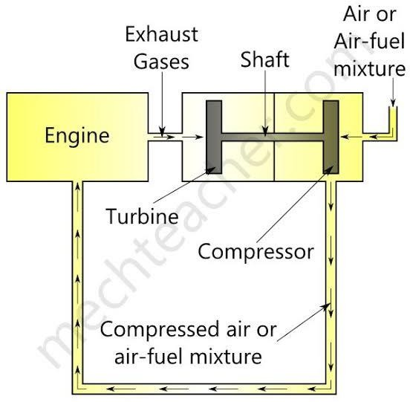
The turbocharger principle involves using exhaust gas energy to drive a turbine connected to a compressor. This compressor then compresses the air to high pressure and temperature which means that it forces more air into the engine during its intake stroke, allowing it to burn more fuel and generate more power. This process is commonly used in automotive engines to increase their efficiency and performance.
Fig. 1.1 Working of turbocharger

1.8 Turbocharger Design and Principle
- The turbocharger is like a miniature gas turbine, it is a small radial fan driven by the forward motion of the engine exhaust. Comprising the turbocharger are the turbine and the compressor sharing a single shaft. When the exhaust gasses enter, the fan rotates which drives a compressor.
- Air is then squeezed by the compressor before being delivered to the engine air intake manifold. Because air is compressed, the engine could then take in greater amounts of air to the cylinders.
- Usually the engine takes in air through a vacuum created by the downward stroke of the cylinder.
- The normal air pressure is at 14.7 psi and there is a limit to the pressure difference across the intake valves resulting in a limited air mass flow rate.
- In order to increase the intake, pressure must then be increased. In this way additional oxygen to the engine makes it possible to burn more fuel which increases the power of the engine.
- Increase air pressure is possible with the turbocharger application.
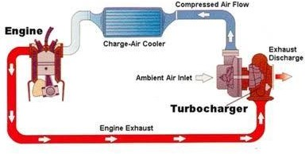
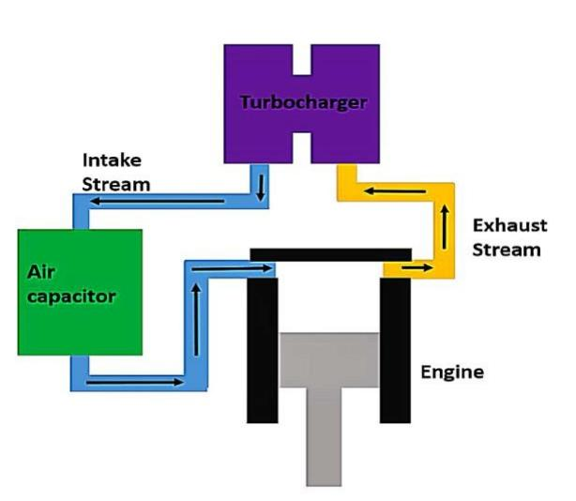

Fig.1.2(a) Fig. 1.2 (b)
Fig.1.2: Circuit diagram of turbocharger
Turbochargers, although applies the same as superchargers except for small variations. Superchargers, particularly Centrifugal superchargers were spun by the rotation of the engine’s crankshaft. This made turbochargers more efficient in terms of recycling energy loss through the exhaust.
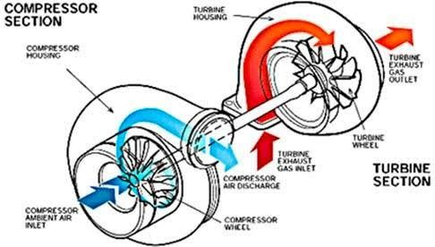
Fig.1.3 Compressor section
- Although the turbocharger consists of a turbine and a compressor, several working components actually comprise it.
- The turbine and the impeller are contained in their own housing. The housings fitted around the compressor impeller and turbine directs the flow of gasses through the wheels.
- The motion of the gasses causes the impeller to spin. In this case the size of the impeller wheel dictates the amount of gas it could take.
- The single shaft connecting the turbine to the compressor is housed in the center hub rotating assembly (CHRA).
- The CHRA also contains bearing to minimized friction, lubrication and in some cases the turbocharger cooling system; water cooled models have entry and exit points for the engine coolants to cycle.
- Devices such as waste gates then control the spin of the turbine.

1.8.1 Three Critical Design Factors
- Capacitor size - 4 to 5 times the engine capacity
- Capacitor charge time - less than 2 seconds
- Density gain of air fed into the engine - without cooling air – atleast 50%
with ideal cooling – upto 80%

1.9 Introduction to Diesel Engine
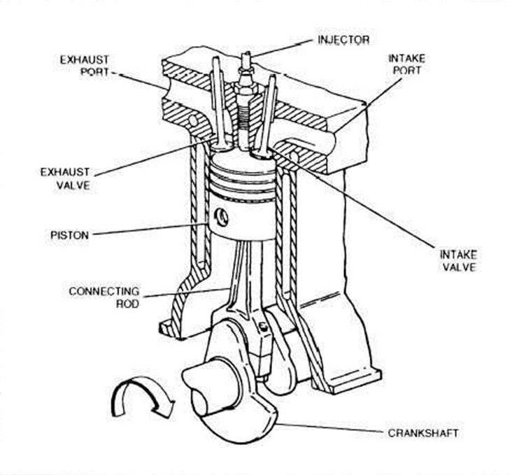
A diesel engine is an internal combustion engine that uses the heat of compression to initiate ignition to burn the fuel, the engine was developed by Rudolf Diesel in 1893. The diesel engine has the highest thermal efficiency of any regular internal or external combustion engine due to its very high compression ratio. Diesel engine are manufactured in two stroke & four stroke engine version.
Fig. 1.4 Construction of diesel engine

1.10 Working of Diesel Engine
In four stroke diesel engine there are four different strokes used to produce power.
Various four strokes of engine
- Suction stroke
- Compression stroke
- Power or expansion stroke
- Exhaust stroke
In four stroke diesel engine one power stroke can be obtained in every two full rotations of the crank shaft.
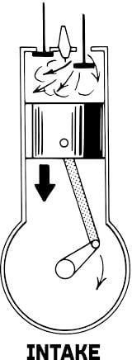
1.10.1 Suction Stroke
Fig. 1.5 Suction stroke
- During the suction stroke, the piston moves from TDC to BDC.
- The inlet valve is in open condition where as exhaust valve is closed When the piston moves from top to bottom, the fresh air is admitted inside the cylinder through inlet valve.

1.10.2 Compression stroke
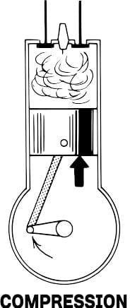

Fig.1.6: Compression stroke
- During the compression stroke, both the inlet and exhaust valves are closed.
- The piston moves from BDS to TDC to compress the air. In case of CI compression is about 3500 to 4000 (KN/m^2).
- The temperature of the compressed air reaches 600 to 700 Celsius.
- Engine, the compression ratio various from 12 to 18.

1.10.3 Power stroke
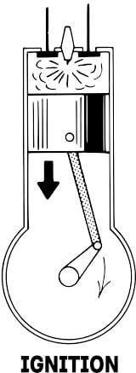

Fig.1.7 Power stroke

- In this stroke also, both the inlet and exhaust valves are in closed position.
- The fuel injector opens just before the beginning of the third stroke; it injects the fuel in atomized form.
- Ignition of the fuel takes place automatically by means of high pressure and temperature air.
- The pressure and temperature further will increase due to combustion, it pushes the piston towards down. Thus, it produces power stroke.

1.10.4 Exhaust stroke
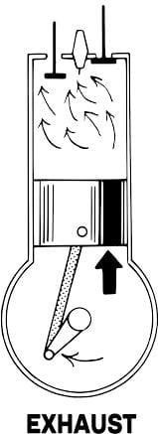
Fig.1.8 Exhaust stroke

- In this stroke inlet valve is closed and exhaust valve is open condition.
- In this stroke power is exhausted through the exhaust valve.

1.11 Working Principle of Single Cylinder Diesel Engine
A single-cylinder diesel engine operates on the principle of compression ignition, where air is compressed in the cylinder to a high enough temperature and pressure to ignite the fuel without the need for a spark plug. Here's a simplified explanation of how it works:

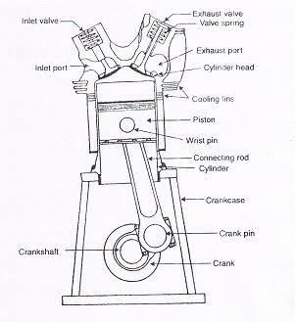
Fig.1.9 Single Cylinder Diesel Engine
- Intake Stroke
The intake valve opens, and the piston moves down, drawing air into the cylinder.
- Compression Stroke
The intake valve closes, and the piston moves up, compressing the air in the cylinder. This compression raises the temperature of the air significantly.
- Injection of Fuel
Near the top of the compression stroke, fuel is injected into the highly compressed air. The heat and pressure cause the fuel to ignite spontaneously.
- Power Stroke
The ignited fuel-air mixture rapidly expands, pushing the piston down with force. This downward movement is harnessed as mechanical energy.
- Exhaust Stroke
The exhaust valve opens, and the piston moves back up, pushing the exhaust gases out of the cylinder.
In a single-cylinder diesel engine, this cycle repeats continuously, with each stroke occurring in sequence. Single-cylinder engines are commonly used in applications where simplicity, reliability, and cost-effectiveness are prioritized, such as small agricultural machinery, generators, and some motorcycles.

1.12 Working Principle of Multi-Cylinder Diesel Engine
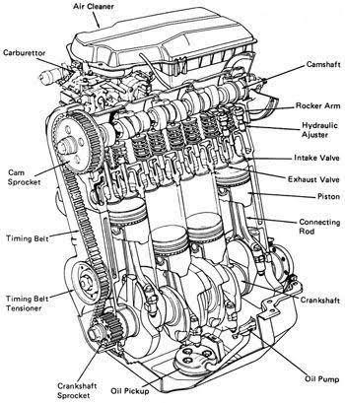
A multi-cylinder diesel engine works on the same principles as a single-cylinder diesel engine but with multiple cylinders working together. Here's a simplified explanation of how it operates:
Fig.1.10 Multi Cylinder Diesel Engine

- Intake Stroke
Air is drawn into the cylinder as the piston moves down. In a multi-cylinder engine, each cylinder goes through this process at different times, depending on its position in the firing order.
- Compression Stroke
The intake valve closes, and the piston moves up, compressing the air in the cylinder. This increases the air temperature and pressure.
- Injection of Fuel
Near the top of the compression stroke, fuel is injected into the highly compressed air. This causes combustion due to the high temperature and pressure.
- Power Stroke
The fuel-air mixture ignites spontaneously due to the high temperature of the compressed air. The expanding gases push the piston down, creating mechanical energy.
- Exhaust Stroke
The exhaust valve opens, and the piston moves back up, pushing the exhaust gases out of the cylinder.
In a multi-cylinder engine, each cylinder operates in a sequence, with one cylinder reaching each stage of the cycle at different times. This allows for smoother operation and greater power output compared to a single-cylinder engine. Additionally, multi-cylinder engines often have balancing mechanisms to reduce vibration and improve overall efficiency.

1.13 Differences between Single and Multi-Cylinder Diesel Engines

- Power Output
Multi-cylinder diesel engines generally produce more power compared to single-cylinder engines due to the combined output of multiple cylinders working together.

- Smoothness of Operation
Multi-cylinder engines tend to run more smoothly than single- cylinder engines due to the balanced nature of multiple cylinders firing in sequence, which reduces vibrations.

- Efficiency
Multi-cylinder engines often offer better fuel efficiency because they can operate more efficiently across a wider range of loads and speeds.

- Complexity
Single-cylinder engines are simpler in design and construction compared to multi-cylinder engines, which can make them easier to maintain and repair.

- Applications
Single-cylinder engines are commonly used in smaller equipment such as generators, water pumps, and agricultural machinery, while multi-cylinder engines are found in larger vehicles like cars, trucks, ships, and heavy machinery where higher power output and smoother operation are required.

- Cost
Generally, single-cylinder engines are less expensive to manufacture and purchase compared to multi-cylinder engines, which can be a factor in some applications where cost is a primary concern.

- Size and Weight
Multi-cylinder engines tend to be larger and heavier than single-cylinder engines due to the additional components required for each cylinder.

1.14 Comparison of Naturally Aspirated Engines & Turbocharger Engines
1.14.1 Naturally Aspirated Engines
An engine that does not use a turbocharger or a supercharger is called a naturally aspirated or normally aspirated engine. Normally, when engine specifications are listed, a note is only made if the engine uses a turbocharger or supercharger. Most car engines are naturally aspirated. The power they can create is limited by the amount of air the pistons can pull into the cylinders.
1.14.2 Turbocharged Engines
A turbocharger is a small fan pump that spins around a shaft. The pump is driven by the pressure of the exhaust gas. A turbocharger consists of a turbine and a compressor. They are both mounted on the same shaft. The turbine is a heat engine. It converts exhaust heat and pressure to rotation. This rotation is used to turn the compressor. The compressor takes in the draws in the outside air. It squeezes or compresses the air. It then sends the air to the engine. Because the air pressure has been increased, more air and fuel may be put into the cylinders. This is sometimes called boost pressure. With more fuel to burn, the engine can create more power. This increases the horsepower of the engine.

1.15 Reason for why Turbo-charging a Single Cylinder Diesel Engine is more Challenging than Multi-Cylinder Engines
- Size and vibration
Single-cylinder diesel engines tend to be smaller and have higher vibrations compared to multi-cylinder engines. This can make it harder to integrate and balance the turbocharger effectively.

- Exhaust pulsation
Single-cylinder engines produce irregular exhaust pulses, which can lead to turbocharger lag and decreased efficiency compared to multi-cylinder engines that produce more consistent exhaust flow.
- Pressure variation
Single-cylinder engines experience greater pressure variations during the combustion cycle, leading to more stress on the turbocharger components and potentially affecting its performance and reliability.
- Packaging constraints
Limited space in single-cylinder engine compartments can make it difficult to install and maintain a turbocharger system, compared to the more spacious engine bays of multi-cylinder configurations.
- Cost-effectiveness
The added complexity and engineering required to turbocharge a single- cylinder engine may not always justify the performance gains, especially considering the relatively lower power output of single-cylinder engines compared to multi-cylinder configurations.
- Balance and Stability
Multi-cylinder engines inherently have better balance and stability compared to single-cylinder engines, which helps in smoother operation and reduces vibrations. This stability is crucial for turbocharger performance and longevity.
- Consistent Load Distribution
In multi-cylinder engines, the load is distributed among multiple cylinders, resulting in more consistent exhaust gas flow to the turbocharger. This consistency allows the turbocharger to operate more efficiently and effectively.

- Easier Integration
Multi-cylinder engines often have more space and design flexibility for integrating turbocharging systems compared to single-cylinder engines, which may have tighter space constraints.
- Economies of Scale
Manufacturers often develop turbocharging systems for multi-cylinder engines due to economies of scale. Developing and producing turbochargers for single- cylinder engines may not be as cost-effective.
- Engineering Considerations
Single-cylinder engines typically operate at higher RPMs and may experience more extreme load variations, which can complicate turbocharger design and operation compared to multi-cylinder engines.

1.16 Regression Analysis
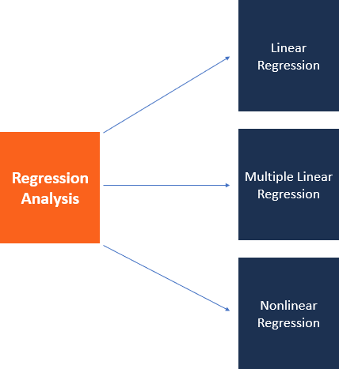
Regression analysis is a set of statistical methods used for the estimation of relationships between a dependent variable and one or more independent variables. It can be utilized to assess the strength of the relationship between variables and for modelling the future relationship between them.
Fig.1.11 Types of Regression Analysis
Regression analysis includes several variations, such as linear, multiple linear, and nonlinear. The most common models are simple linear and multiple linear. Nonlinear regression analysis is commonly used for more complicated data sets in which the dependent and independent variables show a nonlinear relationship. Regression analysis offers numerous applications in various disciplines, including finance.

1.16.1 Simple Linear Regression

Simple linear regression is a model that assesses the relationship between a dependent variable and an independent variable. The simple linear model is expressed using the following equation:

Y = a + bX + ϵ
Where:
- Y – Dependent variable
- X – Independent (explanatory) variable
- a – Intercept
- b – Slope
- ϵ – Residual (error)

1.16.2 Multiple Linear Regression

Multiple linear regression analysis is essentially similar to the simple linear model, with the exception that multiple independent variables are used in the model. The mathematical representation of multiple linear regression is:
Y = a + bX₁ + cX₂ + dX₃ + ϵ
Where:

- Y – Dependent variable
- X1, X2, X3 – Independent (explanatory) variables
- a – Intercept
- b, c, d – Slopes
- ϵ – Residual (error)

CHAPTER-2
LITERATURE SURVEY

Mohd Muqeem et. al., [1] stated that without increasing the cylinder capacity, turbochargers enhance the output of an internal combustion engine. The application of such a mechanical device enables automotive manufacturers to adopt smaller displacement engines. The goal of this paper is to provide a review on the current techniques used in turbocharging to improve the engine efficiency and exhaust emissions as much as possible.
Abhishek Saini et. al., [2] stated that they have designed and fabricated a prototype of turbocharger which was implemented in two wheeler, in which the efficiency of the engine can be increased and also to control the emissions from the engine. This type of engine will be more efficient than existing engines and it reduce our dependency on foreign oil.
Panting et. al., [3] stated that turbocharging of internal combustion engines was an established technology used for the purpose of increasing both power density and in some cases the cycle efficiency of diesel engines relative to naturally aspirated engines. However, one significant drawback was the inability to match the characteristics of the turbocharger to the engine under full load and also to provide sufficiently good transient response. Under many conditions the study results in reduced efficiency and leads to higher exhaust emissions.
Michael R. Buchman et. al., [4] stated that the aim of this paper is to turbocharge a four-stroke, single cylinder, internal combustion engine by adding an air capacitor to the intake in order to deal with the pulsating air flow conditions. This analysis addresses three critical design factors: Capacitor size, Capacitor charge time and Density gain of the air fed into the engine which was helpful for us to choose a air-capacitor.
Mayur Ingale et. al., [5] stated that the aim of this paper is to show the importance of turbocharger in automotive sector. In last two decades various new advancements are done to improve power output of an engine and to reduce its emissions by making some changes and installing some additional accessories like inter cooler in the turbocharging technology. It shows there is need of turbocharging so that efficiency of engine increases and control of toxic gases emitted from automotive vehicle can be control.
Devarajan Ramanuja et. al., [6] stated that currently, turbocharging is common in multi- cylinder engines, but due to the inconsistent nature of intake air flow, it is not commonly used in single-cylinder engines. So they propose a novel method for turbocharging which adds an air capacitor-an additional volume in series with the intake manifold, between the turbocharger compressor and the engine intake-to buffer the output from the turbocharger compressor and deliver pressurized air during the intake stroke. Therefore, turbocharging single-cylinder engines using an air capacitor can provide a lower cost alternative for increasing the power output in diesel-powered machinery such as tractors, generators and water-pumps.
Kumarappa et. al., [7] stated that the aim of this paper is to check feasibility of turbocharging single-cylinder four-stroke internal combustion engine with modifications and vibration analysis of engine with both conditions of turbocharging and without turbocharging by FFT analyzer. After completing their analysis they got some conclusions for both naturally aspirated and turbocharged engine like increase in brake thermal efficiency and volumetric efficiency for turbocharged engine and reduction in brake specific fuel consumption, exhaust temperatures and emissions for turbocharged engines.
Prashant. N. Pakale et. al., [8] for increasing the performance of IC engine there are so many inventions. That’s why most of the engines todays are employed with turbocharger and supercharger. To increase amount of air or mixture in the cylinder supercharger plays an important role. Without the need to increase its cylinder capacity, Turbochargers enhance the output of an internal combustion (IC) engine. The emphasis today is to provide a feasible engineering solution to manufacturing economics and “Greener” road vehicles. It is because of these reasons that superchargers and turbochargers are now becoming more and more popular in automobile applications. The aim of this paper is to provide a review on the techniques used in supercharging and turbocharging to increase the engine output and reduce the exhaust emission levels.

Naser et. al., [9] concluded that efficient way which was used that time was to reduce the fuel consumption was based in reduction cylinder volume of internal combustion engine and power to be same or higher. Key component was turbocharged diesel internal combustion engine. Increased compressor outlet air pressure can result in an excessively hot intake charge, significantly reducing the performance gains of turbo charging due to decreased density. Author concluded that maximal temperature in engine cylinder was
decreasing from 1665.6 K at SU =1000 to 1659.2 K at SU (surface area*heat transfer coefficient)=1600, sometimes engine power and volumetric efficiency was increased. Also intercooler performance was increased with increased the design parameter.

Peng Geng et. al., [10] stated that this review evaluates the effects of some alternative
fuels (alcohol, biodiesel, natural gas and Di Methyl Ether (DME)) on combustion characteristics and emission products from diesel engines to meet future emission regulations using alternative fuel. They concluded that there is a significant reduction of regular gas and PM emissions by the use of an alcohol/diesel dual fuel and the PM emissions decrease significantly with increasing alternative fuel quantity, whereas the regular gaseous emissions vary according to the type of the alternative fuel and the engine conditions.

Shaabani Jafroubi et. al., [11] performed an experimental turbocharger matching process for a naturally aspirated diesel engine to compensate for the reduction of the engine’s generated power due to changing the fuel to CNG. They selected a Holset 4LEV turbocharger and suggested the required engine modifications. Their results showed that by using this turbocharger, the engine’s generated power could be increased by 25%. However, observing the engine performance by executing empirical tests is too expensive and time consuming and should only be done at the final stages of the engine design or turbocharger selection.

Manoj Kumar et. al., [12] designed an intercooler with proper heat transfer area to increase the mass flow rate by mixing some additional amount of conditioned air into the atmospheric air entering into the intercooler to cool the hot air delivered by the turbo compressor. Their results shows that there is high gain in the mass flow rate of air into the engine on using the designed intercooler. Due to this more oxygen will be available in the combustion chamber to burn the fuel. Increasing the oxygen content with air leads to faster burn rates and the ability to control exhaust emissions. Added oxygen in the combustion air offers more potential for burning fuel.

- S. Lad et. al., [13] studied the behavior of IC engine with application of turbocharger and need of turbocharging installation. They observed that the existing studies on turbochargers shows positive influence of turbocharger in IC engine performance characteristics as well as emission characteristics. But in turbocharging air-fuel ratio is always constant, so the scope to vary the air-fuel ratio, combustion analysis have received the lower attention than ignition analysis and there is future scope for the combustion analysis, by variation of air-fuel ratio using the turbocharger.

Gopal Sahu et. al., [14] stated that the efficient way which currently uses to reduce the fuel consumption is based in reduction cylinder volume of internal combustion engine and power to be same or higher. Key component is turbocharged diesel internal combustion engine. It is practical to use heat transfer calculations when sizing a turbocharger cooling system. However, one must take into considerations of the operational environment and flow characteristics of the system in order to make an informed decisions on which installed. Mutual confrontations of output simulation and experiment will be employed in the improvement of further scopes taken to make the obtained results accessible.

R. Vishnu Varthan et. al., [15] conducted emission test on the 350 CC single cylinder diesel engines by changing the method of air induction (turbocharger) and the type of fuel (diesel and biodiesel). Results showed increased NOx emissions due to higher combustion temperature, decreased HC emissions and increased CO2 emissions due to more fuel burning. The turbocharger reduced CO2 emissions by providing more oxygen for oxidation, while biodiesel had little effect on CO emissions. The results suggest that biodiesel has little effect on CO emissions.

H M Herzwan et. al., [16] stated that this paper reviews previous research on turbochargers, focusing on heat transfer, flow, and mechanical studies. Heat transfer studies analyse the impact of heat transfer on overall turbocharger performance, combining experimental and modelling methods. Flow studies focus on turbines and compressors, with flow conditions and design parameters significantly impacting results. Mechanical studies focus on bearing parts, involving high-speed rotations and loads. The main author's research will focus on heat transfer studies, analysing how heat travels from turbine to bearing housing and compressor, and comparing it to standard manufacturer mapping.

S. Mousavi et. al., [17] stated that a new algorithm for turbocharger matching has been developed to create an integrated program for examining the performance of different turbocharger combinations with a specified engine. The program uses a database containing compressor and turbine maps and allows users to compare the results with experimental results. The program can be used for four other fuels and has been validated with a gasoline engine. The program also evaluates two other suitable turbocharger combinations, with one eliminated for low turbine efficiencies and the other having less turbo lag but higher engine back pressure. Both combinations are acceptable, with the new combination being used for better transient responses.

R. Ganapathi et. al., [18] had done experimental investigations on an LHR diesel engine under turbocharging conditions reveal that increasing intake boost pressure improves brake thermal efficiency, requires 4% intake boost pressure for volumetric efficiency compensation, reduce smoke emissions by 30-40%, reduces exhaust temperatures and marginalises smoke emissions due to jatropha combustion.

Badal Dev Roy et. al., [19] concluded that their study examines the turbo-matching of B60J67 and B60J68 turbochargers for a TATA 497 TCIC -BS III engine using a simulation method and experimental data-logger. Results show good turbo-match at medium and higher speeds for both turbochargers, but B60J67 has a surge at lower speeds. The data-logger method suggests B60J68 is better for the engine, and the simulated solution cannot be considered for final decision.

Bin Mao et. al., [20] concluded that prioritizing turbocharger design and matching is crucial for improving thermal efficiency. High boost pressure can improve ITEg but also deteriorates PMEP and delays combustion phasing. High boost pressure can improve HP EGR, but it's difficult to introduce. Delaying IVC timing can mitigate constraints on CR, boost pressure, and combustion phasing, leading to higher ITEn. The study found that the proposed thermal efficiency improvement strategy improved brake thermal efficiency and overall energy efficiency by 2.2% and 1.98%, respectively.

Will F. Colban et. al., [21] explores the impact of boost pressure on engine performance and emissions in a small-bore diesel engine. Results show that increased boost pressure can limit UHC and CO emissions, reduce NOx, and increase combustion efficiency. Turbocharging is beneficial for efficiency and power density, while dilution-controlled LTC yields lower emissions and better combustion efficiency.

Mandeep Singh et. al., [22] stated that the AB20 blend of fuels shows maximum brake thermal efficiency, but higher NOx emissions, especially at high load conditions. Lowering boost pressure from 160 kPa to 150 kPa reduces NOx emissions by 6% and enhances engine thermal efficiency by 4.04% compared to diesel fuel. Higher boost pressure decreases combustion characteristics like ignition delay and premixed heat release, while lower boost increases ignition delay and peaks of CP and HRR. This study could help researchers find the optimum boost for biodiesel engines, but future research should focus on calibrated ECU maps and DOE techniques.

Kalaisselvane et. al., [23] stated this study analysed a new method for supercharging a diesel engine using an exhaust gas assisted jet compressor. The jet compressor's specifications were determined using the constant momentum method, and engine operating conditions were optimized. The performance of the jet compressor was analysed using commercial software Fluent and experimentally. The results were found to be closely matching, and a performance map was drawn to determine the optimum boost pressure and maximum entrainment ratio for a given percentage of exhaust gas recirculation and power output.
CHAPTER-3
EXPERIMENTATION METHODOLOGY

3.1 Engine setup
The setup consists of single cylinder, four stroke, Multi-fuel, research engine connected to eddy current type dynamometer for loading. The operation mode of the engine can be changed from diesel to ECU Petrol or from ECU Petrol to Diesel mode by following some procedural steps. In both modes the compression ratio can be varied without stopping the engine and without altering the combustion chamber geometry by specially designed tilting cylinder block arrangement. In Diesel mode fuel injection point and pressure can be manipulated for research tests. In Petrol mode fuel injection time, fuel injection angle, ignition angle can be programmed with open ECU at each operating point based on RPM and throttle position. It helps in optimizing engine performance throughout its operating range. Air temp, coolant temp, Throttle position and trigger sensor are connected to Open ECU which control ignition coil, fuel injector, fuel pump and idle air. Set up is provided with necessary instruments for combustion pressure, Diesel line pressure and crank-angle measurements. These signals are interfaced with computer for pressure crank-angle diagrams. Instruments are provided to interface airflow, fuel flow, temperatures and load measurements. The setup has stand-alone panel box consisting of air box, two fuel tanks for duel fuel test, manometer, fuel measuring unit, transmitters for air and fuel flow measurements, process indicator and hardware interface. Rota meters are provided for cooling water and calorimeter water flow measurement. A battery, starter and battery charger is provided for engine electric start arrangement. The setup enables study of VCR engine performance for brake power, indicated power, frictional power, BMEP, IMEP, brake thermal efficiency, indicated thermal efficiency, Mechanical efficiency, volumetric efficiency, specific fuel consumption, A/F ratio, heat balance and combustion analysis. Lab view based Engine Performance Analysis software package “Engines oft” is provided for on line engine performance evaluation. PE3 series software package is provided for programming open ECU for petrol mode operation of the engine.
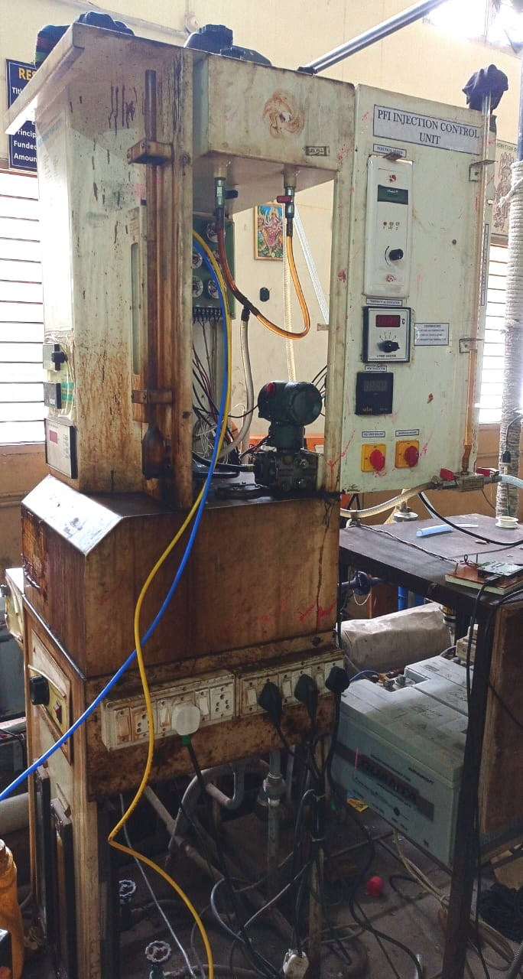
Fig. 3.1 (a)
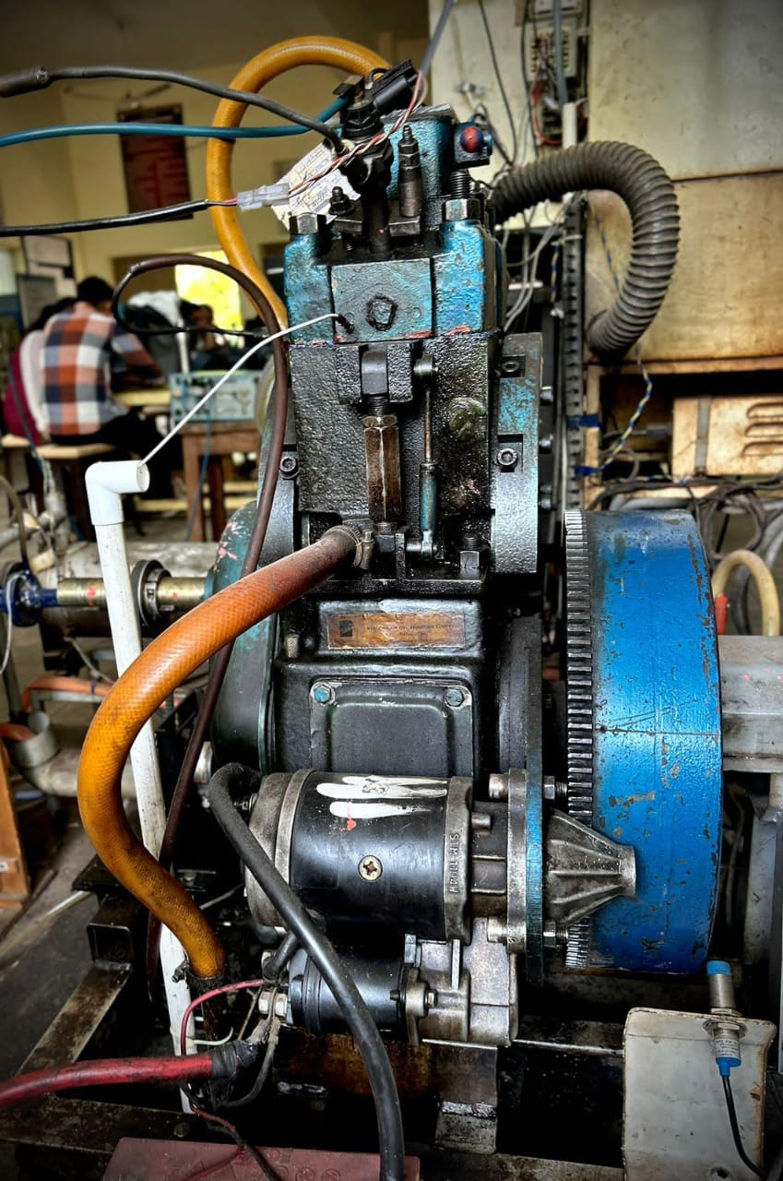
Fig. 3.1 (b)
Fig. 3.1 Engine setup
3.1.1 Engine Specifications
Table 3.1 Engine Specifications
Product | Research Engine test setup 1 cylinder, 4 stroke, Multifuel VCR with open ECU for petrol mode (Computerized)
Product code | 240 PE
Engine | Type 1 cylinder, 4 stroke, water cooled, stroke 110 mm, bore 87.5 mm. Capacity 661 cc.  Diesel mode: Power 3.5 KW, Speed 1500 rpm, CR range 12:1-18:1.  Injection variation:0- 25 Degrees BTDC ECU Petrol mode: Power 3.5 KW @ 1500 rpm, Speed range 1200-1800 rpm, CR range 6:1-10:1
Dynamometer | Type eddy current, water cooled, with loading unit
Propeller shaft | With universal joints
Air box | M S fabricated with orifice meter and manometer
Fuel tank | Capacity 15 lit, Type: Duel compartment, with fuel metering pipe of glass
Calorimeter | Type Pipe in pipe
Piezo sensor | Combustion: Range 5000 PSI, with low noise cable Diesel line: Range 5000 PSI, with low noise cable
Crank angle sensor | Resolution 1 Degree, Speed 5500 RPM with TDC pulse
Data acquisition device | NI USB-6210, 16-bit, 250kS/s
Piezo powering unit | Make-Apex, Model AX-409
Engine control unit | PE3 series ECU, full build potted enclosure.
Sensors for ECU | Air temp, coolant temp, Throttle position and trigger
Engine control hardware | Fuel injector, Fuel pump, ignition coil, idle air
Digital voltmeter | Range 0-200mV, panel mounted
Temperature sensor | Type RTD, PT100 and Thermocouple, Type K
Temperature transmitter | Type two wire, Input RTD PT100, Range 0–100 Degrees C, Output 4–20 mA and Type two wire, Input Thermocouple, Range 0–1200 Degrees C, Output 4–20 mA
Load indicator | Digital, Range 0-50 Kg, Supply 230VAC
Load sensor | Load cell, type strain gauge, range 0-50 Kg
Fuel flow transmitter | DP transmitter, Range 0-500 mm WC
Air flow transmitter | Pressure transmitter, Range (-) 250 mm WC
Software | “IC Engine Soft” Engine performance analysis software
ECU software | Pe Monitor & pe Viewer software
Rota meter | Engine cooling 40-400 LPH; Calorimeter 25-250 LPH
Pump | Type Mono block
Overall dimensions | W 2000 x D 2500 x H 1500 mm

3.2 Turbocharger setup
The purpose of turbo charging is used for forced-induction of an internal combustion engine and to increase the density of air entering the engine to create more power. The system consists of a 3HP turbine blower connected with a variable Speed AC frequency drive. The outlet of the turbine blower is routed to the intake manifold of the engine via an Air Heating system, digital manometer, valve (V2), and finally to the engine intake manifold. A temperature sensor is also provided in the engine manifold to know the temperature of incoming air to the engine. Before using the turbo air charging system to the engine, the engines air consumption at different loads should be MAPPED. Whenever a turbo air charging system is not required Valve (V2) should be closed and valve (V1) should be in open condition.

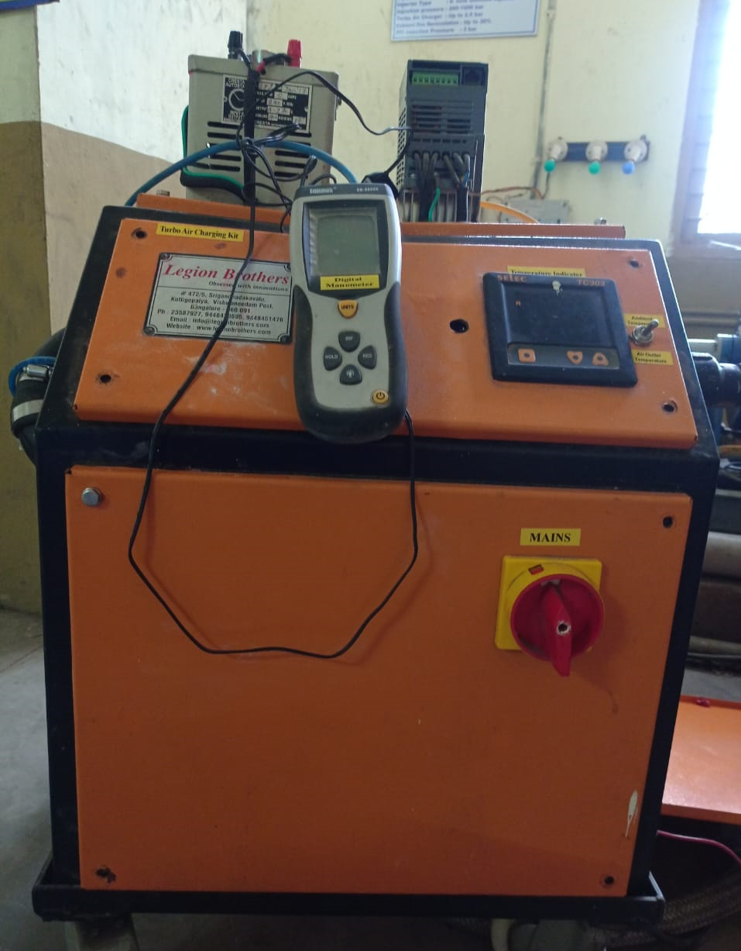
Temperature Indicator
Air outlet temperature
Ambient Temperature
Mains
Digital Manometer
Fig 3.3 Turbo air-charger set up
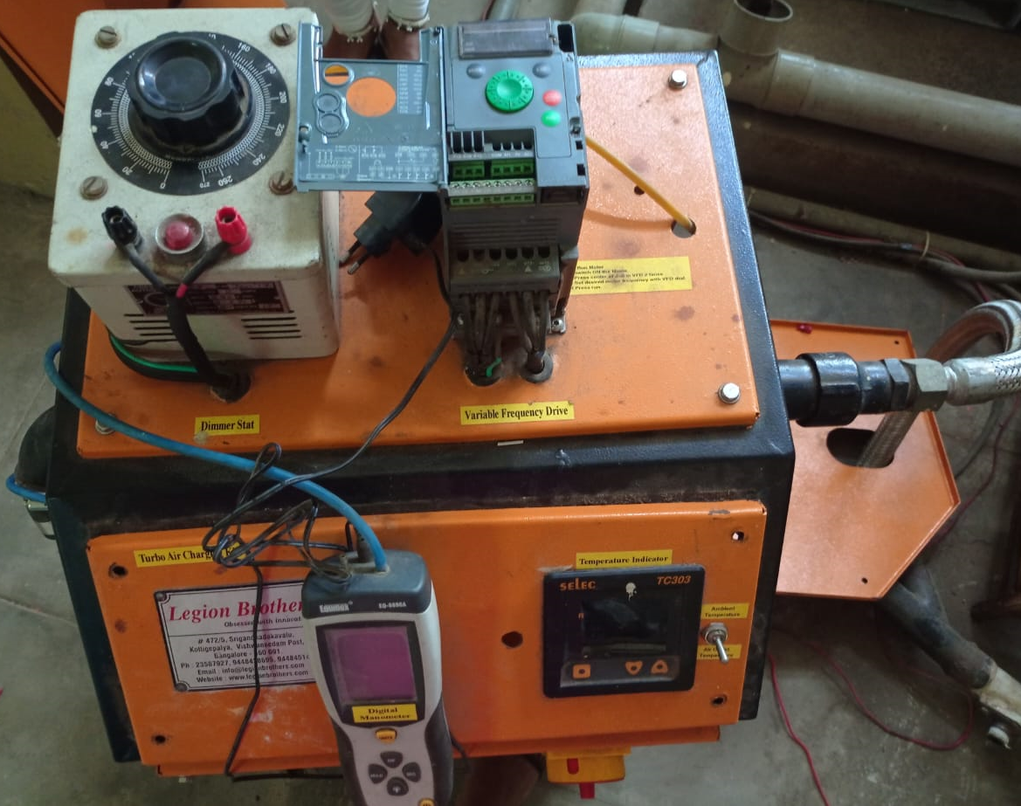
Variable frequency drive
Dimmer Stat
Fig. 3.4 Top view of turbo air-charger setup

3.2.1 Turbo air-charger Specifications
Table 3.2 Turbo air-charger specifications
Turbine blower | 1 HP
VFD controller for AC motor | Hitachi
Valve | Flow control valve
Heat exchanging method | Stainless steel shell and tube
Air inlet manifold | Mild steel pipe
Connecting pipe to engine | Flexible braided hose
Mounting frame | Mild steel powder coated
Heaters | Coil pipe
Air flow measurement | Digital manometer
Temperature measurement | Thermocouple- Digital temperature indicator

Table 3.3 Component Specifications
Component | Specification
Dimmer stat  Max load  Input  Output | 1  2 Amps  240V, 50 Hz  0-270 V
Variable Frequency drive  Motor power  Rated supply voltage  Motor power | ATV0H075N4E  0.75 kW  380V-410V  1 hp
Temperature indicator  Ambient temperature  Air outlet temperature | 1

3.2.2 Turbo air-charger components functions
- Temperature indicator
Temperature indicators are installation instruments which can process signals from temperature sensors and show them on the display. It can display both ambient temperature and air outlet temperature by adjusting the switch.
- Variable frequency drive
Variable frequency drive is an electrical device which controls the speed of a motor by varying the frequency.
- Dimmer stat
Dimmer stat is used to adjust the output potential/voltage to an electrical circuits.
- Mains
Main switch is used to switch on the turbocharger.
- Manometer
A manometer is a measuring instrument that measures the pressure of a fluid or gas in a confined space.
3.3 Experimental setup
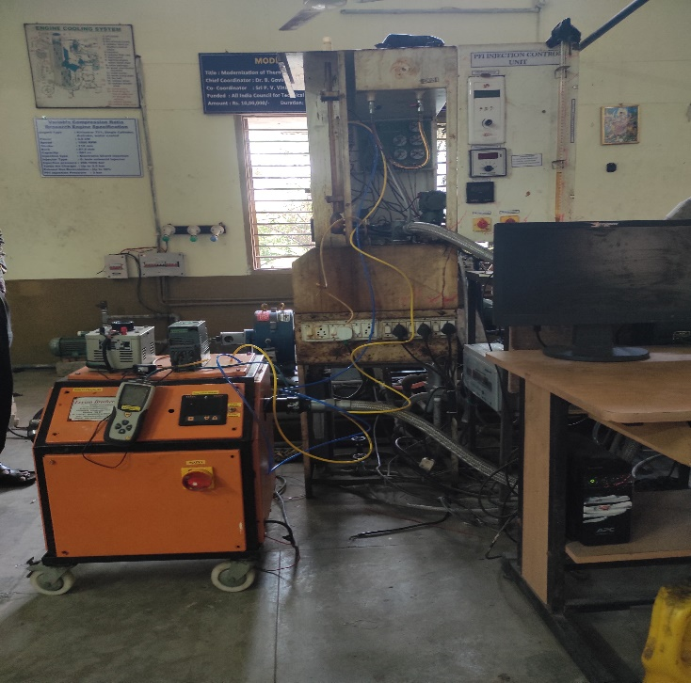
Fig. 3.5 Turbocharger and engine experimental setup
3.3 Experimentation Methodology
- Analyzing the Engine and Air Capacitor Volume
The air capacitor's volume is 81 times larger than the engine's volume.
- Engine configuration
Ensuring the Engine operates correctly with the right connections, configurations, and without any leaks and defects.
- Configuration of the turbocharger
The turbo air charger's component parts are connected and arranged correctly. Connecting the turbocharger setup and the manual manometer.
- The turbocharger's discharge calibration
Determine the discharge at various frequencies, by monitoring the airflow rate with an anemometer at various frequencies. Utilizing regression analysis, determine the turbocharger's discharge.

- The turbocharger's heat input calibration
Note the heat input value at which the temperature remains constant at different output air temperatures by altering the heat input. Utilizing regression analysis, determine the turbocharger’s heat input.
- Connecting the turbocharger to a single-cylinder, four-stroke diesel engine
Using a pipe, join the turbocharger's outlet pipe to the diesel engine's input manifold.
- Examining performance
Perform performance tests at different loads once the turbocharger is integrated with the engine. Record manometer readings and the amount of time it takes for a 10-cc engine. Calculate performance metrics like brake thermal efficiency and brake-specific fuel consumption.
- Influence of air inlet pressures, temperatures, and load on performance metrics like
BTH and BSFC and emissions like CO, HC, NOx, and smoke
Utilizing graphs to compare the engine's performance metrics with and without a
turbo charger.
CHAPTER – 4
CALIBRATION AND REGRESSION
4.1 Calibration
The primary significance of calibration is that its accuracy, standardization and repeatability in measurements, assuring reliable benchmarks and results. Without regular calibration, equipment can fall out of spec, provide inaccurate measurements and threaten quality, safety and equipment longevity.
Calibrating a turbocharger is an essential job. If not carried out, it can lead to a number of performance issues.
Calibrating the amount of air that the turbocharger can release at various speeds by adjusting the frequencies. Calibrating the heat input of the turbocharger at various air outlet temperatures.
After calibrating these parameters, it’s easy to compare the amount of air that the turbocharger delivers with the amount of air that the engine needs at different loads.
4.2 Regression
Regression analysis is a set of statistical methods used for the estimation of relationships between a dependent variable and one or more independent variables.
By considering the discharge as dependent variable and frequency as independent variable, a relationship will be determined to find the discharge by using the regression analysis.
By considering the temperature as dependent variable and heat input as independent variable, a relationship will be determined to find the heat input by using the regression analysis.

4.3 Calibration and Regression of Discharge of Turbocharger
Table 4.1 Flow rate calibration
Sl No. | Frequency(Hz) |  | Air flow rate  (m/s) | Discharge of turbocharger(m³/s)
Sl No. | % | Hz | Air flow rate  (m/s) | Discharge of turbocharger(m³/s)
1 | 10 | 5.1 | 1.7 | 0.008007
2 | 20 | 10 | 3.4 | 0.016014
3 | 40 | 20 | 6.8 | 0.032028
4 | 60 | 30 | 10 | 0.0471
5 | 80 | 40.1 | 13.2 | 0.062172
6 | 100 | 50 | 16 | 0.07536

4.3.1 Calculation of turbocharger outlet area
- Diameter of outlet pipe, d=4 cm = 0.04 m
Length of the outlet pipe, l=15 cm = 0.15 m

- Turbocharger outlet area, A= πdl/4
= (π*0.04*0.15)/4
A = 0.00471 m²
- Discharge of turbocharger, Q = Area*Velocity
By using the above formula, we can calculate the discharge of the turbocharger shown in table 4.1.

4.3.2 Discharge of turbocharger through Regression analysis
For regression analysis we consider frequency as x and discharge as y. From the table 4.2 (c), we got intercept and x variable which are 0.00113054 and 0.00150707 respectively.
To find the discharge through regression analysis, we have to use the equation
Y=aX+b
Y= F (0.00150707) + 0.00113054
where
Y = Discharge
b = Intercept
X = Variable
F = Frequency

Table 4.2 Regression statistics to find the discharge of turbocharger
Table 4.2 (a)
Multiple R | 0.99949
R Square | 0.99899
Adjusted R Square | 0.99874
Standard Error | 0.00093
Observations | 6

Table 4.2 (b)
 | df | SS | MS | F | Significance F
Regression | 1 | 0.00345 | 0.00345 | 3979.733 | 3.782E-07
Residual | 4 | 3.4687E-06 | 8.6719E-07
Total | 5 | 0.00345

Table 4.2 (c)

 | Coefficients | Standard Error | t Stat | P-value | Lower 95% | Upper 95%
Intercept | 0.00113054 | 0.000725 | 1.55824 | 0.19418 | -0.00088 | 0.00315
X Variable 1 | 0.00150707 | 0.000024 | 63.0851 | 3.782E-07 | 0.001441 | 0.00157

Table 4.3 Residual output

Observation | Predicted Y | Residuals | Standard Residuals
1 | 0.00882 | -0.00081 | -0.9720
2 | 0.01620 | -0.00019 | -0.2248
3 | 0.03127 | 0.000756 | 0.90764
4 | 0.04634 | 0.000757 | 0.90917
5 | 0.06156 | 0.000608 | 0.72975
6 | 0.07648 | -0.001124 | -1.3497

Table 4.4 Probability output
Percentile | Y
8.333 | 0.008
25 | 0.016
41.667 | 0.032
58.333 | 0.047
75 | 0.062
91.667 | 0.075

In table 4.2 (a),
- Multiple R means the correlation coefficient that measures the strength of a linear relationship between two variables. It can be any value between -1 and 1.
- R square means a statistical measure in a regression model that determines the proportion of variance in the dependent variable that can be explained by the independent variable.
- Adjusted R square means a modified version of R square that adjusts for predictors that are not significant in a regression model.
- Standard error represents the average distance that the observed values fall from the regression line.
In table 4.2 (b),
- Regression df is the number of independent variables in our regression model.
- Sum of Squares (SS) is a statistical tool that is used to identify the dispersion of data as well as how well the data can fit the model in regression analysis.
- Mean squared error (MS) are the mean of the sum of squares or the sum of squares divided by the degrees of freedom for both regression and residuals.
- F is a test for statistical significance of the regression equation as a whole. It is obtained by dividing the explained variance by the unexplained variance.
- Significance F gives you the probability that the model is wrong. We want the significance F or the probability of being wrong to be as small as possible.
- Residual is the difference between the actual value and the value predicted by the model for any given point.

In table 4.2 (c),
- P value is statistical test that determines the probability of extreme results of the statistical hypothesis test, taking null hypothesis to be correct.
- T- statistics is used to assess the strength of evidence in support of the null hypothesis. It is computed by subtracting the hypothesized value from the statistical value and dividing it by the standard error.
- The 95% confidence interval is also shown as lower 95% and upper 95% in many packages. You can be 95% confident that the real, underlying value of the coefficient you are estimating falls somewhere in that 95% confidence interval.
- Intercept is the difference between the mean of the response variable and the product of the slope and the mean of the explanatory variable.
- X is an explanatory variable.
In table 4.3,
- Standard residual means the residual divided by its standard deviation where the residual is the difference between the data response and the fitted response.
- Y is the predicted or expected value of the outcome.
- Observations are assumed to be the result of random deviations from an underlying relationship between a dependent variable (y) and an independent variable (x).
In table 4.4,
- Percentile are given as percent values.

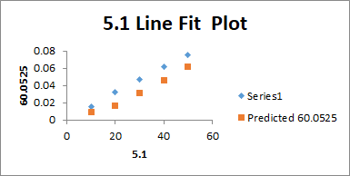
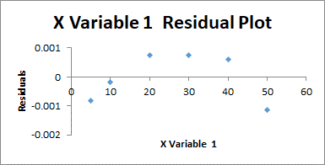

Fig. 4.1 X variable 1 residual plot Fig. 4.2 5.1 Line fit plot

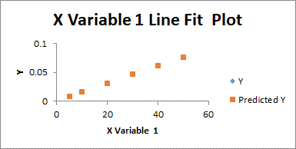
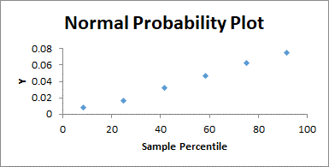

Fig. 4.3 Normal probability plot Fig. 4.4 X variable 1 line fit plot

In Fig. 4.1,
- Residual plot is a scatter plot of the residual values of the response variable ( actual y – predicted y) graphed on the vertical axes versus the explanatory variable (x) graphed on the horizontal axis.
- In this graph, we consider frequency as explanatory variables (x) on X-axis and residual values on Y-axis.
In Fig. 4.2,
- Line fit plot displays the response and predictor data. The plot includes the regression line, which represents the regression equation.
- This graph is 5.1 line fitted plot where 5.1 is the frequency. In this graph, we consider frequency on X-axis and discharge on Y-axis.
In Fig. 4.3,
- Normal probability plot is formed by plotting the sorted data vs. an approximation to the means or medians of the corresponding stastistics.
- In this graph, percentage of the probability output consider on X-axis and discharge through regression analysis (y) are consider on Y-axis.
In Fig. 4.4,
- In this graph, we consider frequency as x variables on X-axis and discharge through regression analysis (y) on Y-axis.

By using the equation we obtained through the regression statistics, the discharge of the turbocharger at various frequencies are

Table 4.5 Discharge of turbocharger through calibration and regression
Sl No. | Frequency(Hz) |  | Air flow rate  (m/s) | Discharge of turbocharger(m³/s) | Discharge through regression analysis(m³/s)
Sl No. | % | Hz | Air flow rate  (m/s) | Discharge of turbocharger(m³/s) | Discharge through regression analysis(m³/s)
1 | 10 | 5.1 | 1.7 | 0.008007 | 0.008817
2 | 20 | 10 | 3.4 | 0.016014 | 0.016201
3 | 40 | 20 | 6.8 | 0.032028 | 0.031272
4 | 60 | 30 | 10 | 0.0471 | 0.046343
5 | 80 | 40.1 | 13.2 | 0.062172 | 0.061564
6 | 100 | 50 | 16 | 0.07536 | 0.076484

4.2 Calibration and regression of heat input of the turbocharger
Table 4.6 Calibration of heat input
Temperature( degree C) | Heat input (v)
30 | 50
40 | 96
50 | 118
60 | 140

4.2.1 Heat input of the turbocharger through regression
For regression analysis, we consider temperature as y and heat input as x.
Table 4.7 Regression statistics to find the heat input of the turbocharger
Table 4.7 (a)
Multiple R | 0.98033
R Square | 0.96105
Adjusted R Square | 0.94156
Standard Error | 3.12066
Observations | 4

Table 4.7 (b)
 | df | SS | MS | F | Significance F
Regression | 1 | 480.523 | 480.523 | 49.343 | 0.01967
Residual | 2 | 19.477 | 9.7385
Total | 3 | 500

Table 4.7 (c)
 | Coefficients | Standard Error | t Stat | P-value | Lower 95% | Upper 95%
Intercept | 11.7583 | 4.983 | 2.359 | 0.1422 | -9.681 | 33.198
X Variable 1 | 0.3291 | 0.047 | 7.024 | 0.0197 | 0.1275 | 0.531
Observation | Predicted Y | Residuals | Standard Residuals
1 | 28.2146 | 1.7854 | 0.7007
2 | 43.3544 | -3.354 | -1.3165
3 | 50.5951 | -0.595 | -0.2336
4 | 57.8359 | 2.1641 | 0.8493

Table 4.8 Residual output

Table 4.9 Probability output
Percentile | Y
12.5 | 30
37.5 | 40
62.5 | 50
87.5 | 60

Fig. 4.5 X variable 1 residual plot Fig. 4.6 50 Line fit plot

Fig. 4.7 Normal probability plot Fig. 4.8 X variable 1 line fit plot

In Fig. 4.5,
- Residual plot is a scatter plot of the residual values of the response variable ( actual y – predicted y) graphed on the vertical axes versus the explanatory variable (x) graphed on the horizontal axis.
- In this graph, we consider heat input as explanatory variables (x) on X-axis and residual values on Y-axis.
In Fig. 4.6,
- Line fit plot displays the response and predictor data. The plot includes the regression line, which represents the regression equation.
- This graph is 50 line fitted plot where 50 is the heat input. In this graph, we consider heat input on X-axis and temperature on Y-axis.
In Fig. 4.7,
- Normal probability plot is formed by plotting the sorted data vs. an approximation to the means or medians of the corresponding stastistics.
- In this graph, percentage of the probability output consider on X-axis and temperature through regression analysis (y) are consider on Y-axis.
In Fig. 4.8,
- In this graph, we consider heat input as x variables on X-axis and temperature through regression analysis (y) on Y-axis.

From table 4.7 (c), we got the intercept and x variable which are 11.7583408 and 0.32912534 respectively. To find heat input through regression we got the equation as
Y= 11.75 + 0.329 * T
Where
T = temperature
By using this equation the heat input of the turbocharger through regression analysis are

Table 4.10 Heat input of the turbocharger through calibration and regression
Temperature  (degree C) | Heat input  (v) | Heat input through regression(v)
30 | 50 | 21.62
40 | 96 | 24.91
50 | 118 | 28.2
60 | 140 | 31.49

CHAPTER-5
RESULTS AND DISCUSSION

- Results are obtained for various parameters of the engine with and without the turbocharger.
- Variations of cylinder pressure with respect to crank angle of the engine with and without the turbocharger are obtained.
- Variations of net heat release with respect to crank angle of the engine with and without the turbocharger are obtained.
- Variations of rate of pressure rise with respect to crank angle of the engine with and without the turbocharger are obtained.
- Variations of mass fraction of fuel burnel with respect to crank angle of the engine with and without the turbocharger are obtained.
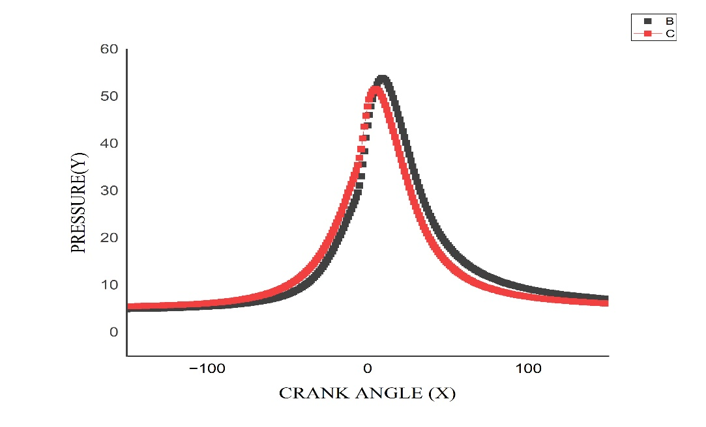
Fig. 5.1 Variation of cylinder pressure with crank angle for the engine with and
without the turbocharger

In Fig. 5.1,
- The red curve represents the cylinder pressure with crank angle of the engine without the turbocharger.
- The black curve represents the cylinder pressure with crank angle of the engine with the turbocharger.
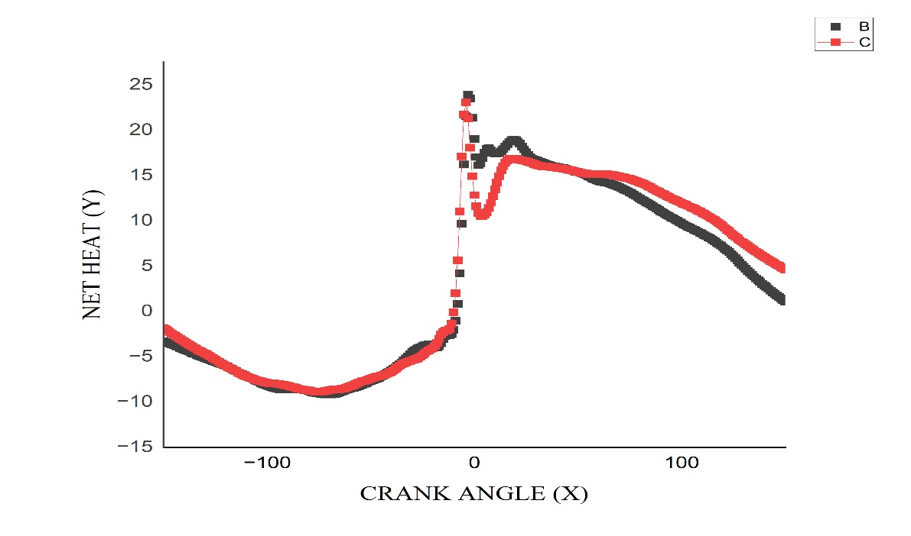
Fig. 5.2 Variation of net heat release with crank angle of the engine with and without
the turbocharger

In Fig. 5.2,
- The red curve represents the net heat release with crank angle of the engine without the turbocharger.
- The black curve represents the net heat release with crank angle of the engine with the turbocharger.

