**Personal details**

Surname; **.............Kawia**

Forename**;............Joseph**

Othernames**;........William barton**

Date of birth**;........17-08-1986**

Gender**;............... Male**

Marital status**;......Single**

Nationality**;...........Tanzanian**

Religion**;................Christian**

Hobies**;..................Reading**

Address**;................1267 Iringa**

Phone;………**+255745-445518**

Email**:jowikafungus@yahoo.com**

**Languages.**

I am capable to speak, write and understanding;

**English**

**Swahili**

**Declaration.**

I, **Joseph .W.B Kawia** certify that, to the best of my knowledge and belief, this curriculum vitae is correctly describes my qualifications and myself I understand that any willful miss statement describes herein, may lead to disqualification or dismissal.

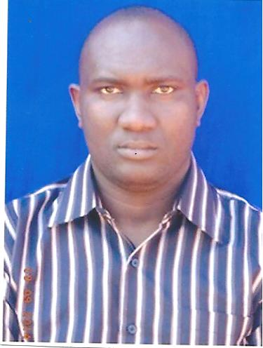

**Personal vision & ambition.**

Through my professional career, I wish and hope to become one among the important person in your institution especially being a hard, energetic, skilled and self-motivated employee working perfectly without any enforcement to do my work.

**Education details.**

Name of institution Duration Awards

**The University of Dodoma 2007-2010 Degree**

**Mpwapwa high school 2005-2007 Certificate**

**Masimbwe secondary school 2001-2004 Certificate**

**Kisawasawa primary school 1993-1999 Certificate**

**Computer skills.**

Competent in;

**Microsoft office applications**

**Internet and email**

**Workshop attended.**

**Customer care**

**Career skills**

**Experience**

Organization name Position

**Aarsleff & Interbeton Assistant Supervisor**

**MTL Consulting company ltd Assistant Research officer**

**Referees.**

* + Name…………Fortunate Ndwange.
  + Place………….Iringa Ummusalama Education Centre.
  + Position……….Accountant.
  + Region…………Iringa.
  + Address…………P.O.Box 1648, Iringa.
  + Mobile……………+255787 -146084.
  + Name……………Charles Wikes.
  + Place……………Njombe Municipal council.
  + Position…………Trade officer.
  + Region……………Njombe.
  + Address……………P.O.Box 577, Njombe.
  + Mobile………………+255755 -353681.