OPERATIONS RESEARCH PROJECT
Hospital Nurse Rostering
An optimisation-based decision-support system using Integer Programming and Goal Programming

Item | Details
Dataset | Nurse Rostering Benchmark Instance 3 (20 nurses, 14 days, 3 shift types) - schedulingbenchmarks.org/nrp
Optimisation techniques | Integer Programming (benchmark objective); Goal Programming (weighted deviation goals)
Tools | Python, Pandas, PuLP with the CBC solver, Streamlit, Plotly
Application | 8-page Streamlit app: load data, statistics on demand, two selectable optimisations, results, comparison, roster
Submitted by | ______________________________________ (name / roll number / group)
Course / Instructor | ______________________________________
Date | 13 October 2026

Contents
Executive summary
1 Introduction
2 Dataset
3 Methodology and system design
4 Mathematical formulation
5 Implementation and user interface
6 Results
7 Verification and testing
8 Discussion
9 Conclusion and future scope
References
Appendix A How to run and reproduce
Appendix B Project structure

Executive summary
Hospital wards must staff every shift while respecting working-time rules, individual contracts and nurses' requests. This project builds a decision-support system that formulates that problem mathematically and solves it with two techniques from the Operations Research course - Integer Programming and Goal Programming - behind an interactive Streamlit interface that loads the data, generates statistics on demand, lets the user choose the optimisation, and presents and compares the resulting rosters.
The data are the public Nurse Rostering Benchmark Instance 3 (20 nurses, 14 days, 3 shift types, 64 shift requests). Three results stand out:
- The Integer Programming model is faithful to the benchmark. It reaches the published optimum of 1001 on Instance 3, and CBC proves optimality. It also reaches the published optima on Instances 1, 2 and 4 (607, 828, 1716), each with a 0 % gap.
- The two models express a real trade-off. On Instance 3 the Integer Programming roster leaves 10 nurse-shifts unfilled (the proven minimum) and breaks one request; the default Goal Programming roster leaves 14 unfilled, breaks no request and narrows the workload range from 2400 to 1920 minutes.
- The trade-off is controlled by one weight. A sensitivity study (all eight runs proven optimal) shows a single switch point at w4 = 100/480 = 0.208: below it the Goal Programming model puts coverage first, above it fairness first, with an identical roster profile for every weight from 0.21 to 1.0.
The solution is verified in several independent ways: every roster is re-checked against all hard constraints, every objective is recomputed from the roster alone, the two formulations are pinned by a regression test against the original code, and 117 automated tests (including live solves and every page of the interface) pass. Solver statuses are reported honestly - "optimal" appears only when optimality has been proven.

1 Introduction

1.1 Problem
A nurse roster assigns each nurse a shift (or a day off) for every day of a planning period. A good roster covers the required number of nurses on every shift, obeys legal and contractual rules (rest between shifts, limits on consecutive working days and weekends, workload bounds), respects nurses' requests where possible and shares the burden fairly. Preparing such rosters by hand is slow and error-prone; the rules interact in ways that make good rosters hard to find, which is why the problem is a classic application of integer programming.

1.2 Objectives
1. Parse a public nurse-rostering benchmark instance automatically and convert it into structured tables.
2. Provide descriptive statistics and charts of the data on demand, before any optimisation.
3. Formulate the problem as an Integer Programming model and as a Goal Programming model, and solve both.
4. Let the user choose and run either optimisation from a web interface, and inspect and compare the results.
5. Validate every result: hard constraints, objective values, and agreement with the published benchmark optimum.

1.3 Relation to the course
The project applies two topics of the syllabus: integer programming models (binary assignment variables, logical constraints, a scheduling application) and multicriteria decision making - goal programming (goal equations with positive and negative deviation variables and a weighted objective). The comparison of the two models is the multicriteria discussion.

2 Dataset

2.1 Source
The data are the Nurse Rostering Benchmark instances of Curtois and Qu, published at www.schedulingbenchmarks.org/nrp. The project uses Instance 3 as its main dataset (the file is byte-identical to the official one) and bundles Instances 1, 2 and 4 as additional samples. For these instances the site lists the same value as best known lower bound and best known solution, so the published value is the proven optimum of the benchmark objective.
Instance | Nurses | Days | Shift types | Published optimum
Instance 1 | 8 | 14 | 1 | 607
Instance 2 | 14 | 14 | 2 | 828
Instance 3 (main) | 20 | 14 | 3 | 1001
Instance 4 | 10 | 28 | 2 | 1716

Table 1 - Bundled benchmark instances.

2.2 Structure of Instance 3
The XML describes a two-week horizon (6-19 January 2014) with three 8-hour shifts - Early (6:00), Day (9:00) and Late (14:00) - and 20 nurses, each holding the generic contract All plus a personal contract A-T. The contracts define valid shifts, workload bounds (full-time nurses 3360-4320 minutes, i.e. 7-9 shifts; part-time nurses 1200-2160 minutes, i.e. 3-4 shifts), maximum and minimum consecutive working days, minimum days off, a limit of one working weekend, limits on Late shifts for some nurses, and a minimum rest time of 840 minutes between shifts. The file also holds 20 fixed days off, 39 ShiftOn requests (a nurse wants a given shift), 25 ShiftOff requests (a nurse wants to avoid a shift) and, for every day and shift, the required number of nurses together with penalty weights (100 per missing nurse, 1 per surplus nurse; request weights 1-3).

2.3 Statistics generated by the application
The Statistics page generates, on demand, the figures below. Total demand is 154 nurse-shifts against a maximum contractual capacity of 155 - the roster is extremely tight before fixed days off, weekend and sequence rules are even considered, which already hints that some demand cannot be met.
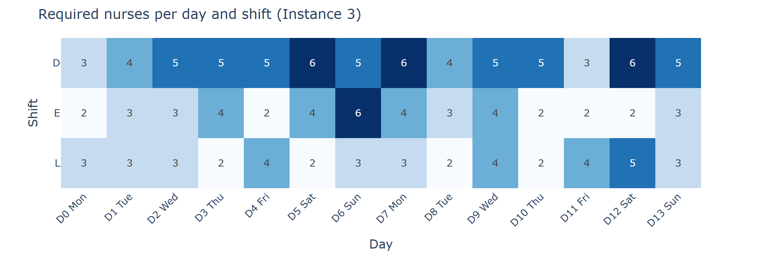
Figure 1 - Required nurses per day and shift (Instance 3).
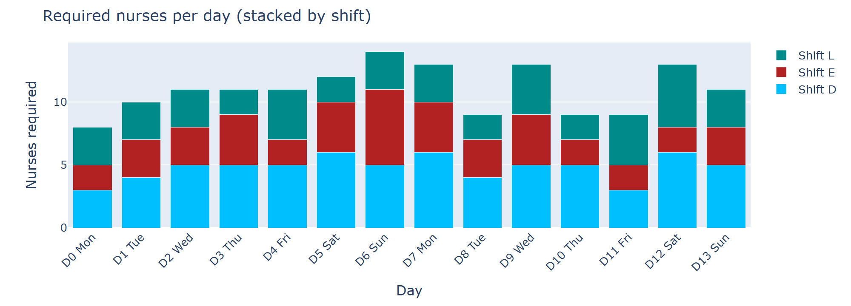
Figure 2 - Daily requirement stacked by shift; the second week is the most demanding.
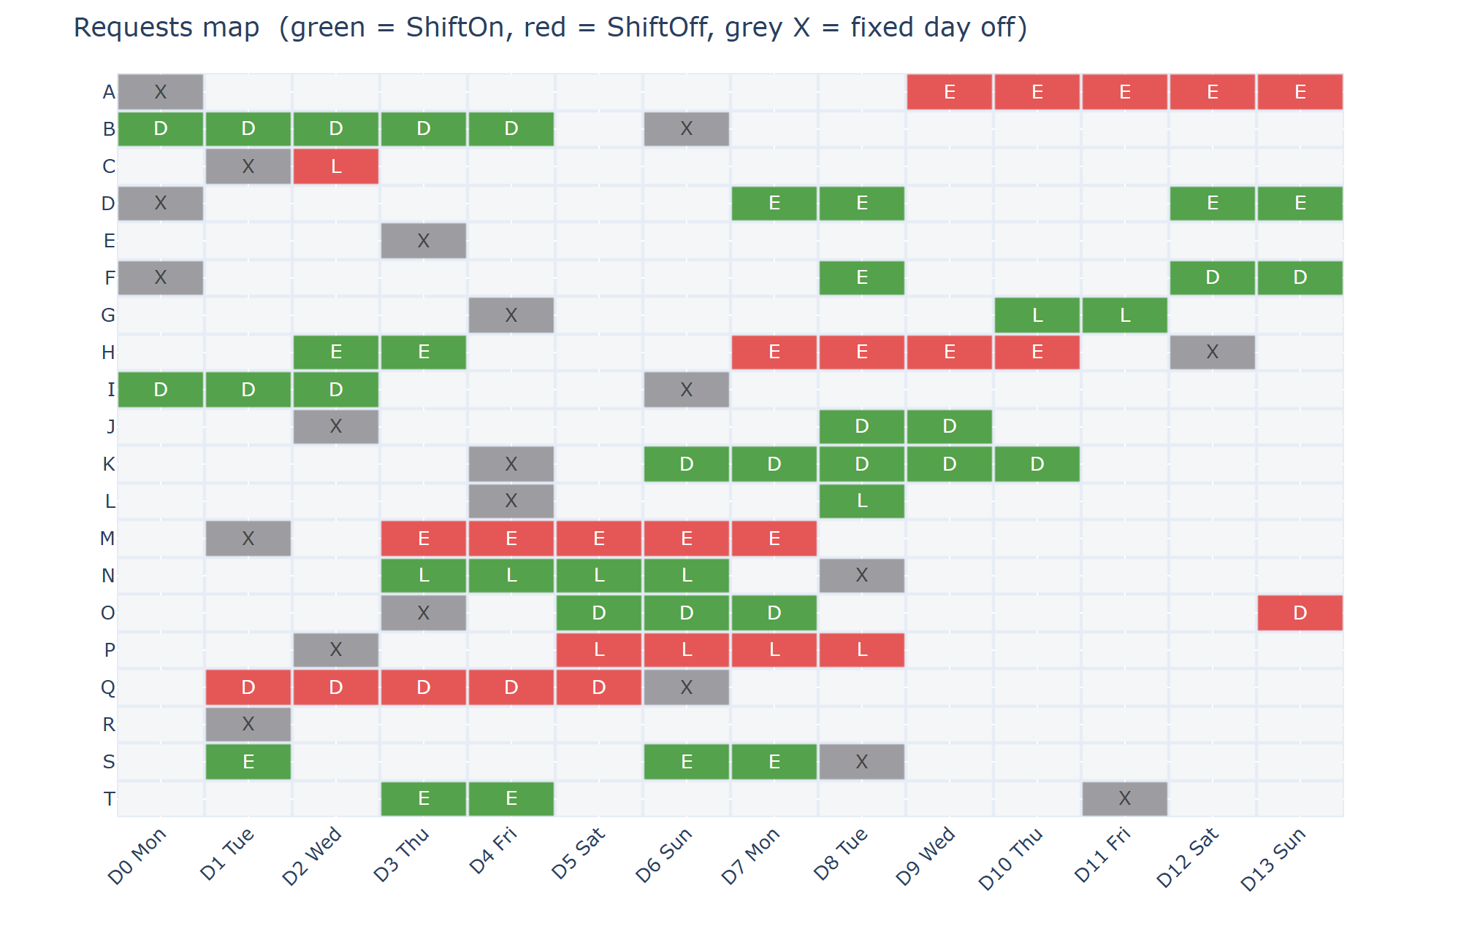
Figure 3 - Requests map: green = ShiftOn, red = ShiftOff, grey X = fixed day off.

3 Methodology and system design
The system is organised in layers:
- Data layer - parser.py reads the XML (never edited) into data classes, validates references and reports any XML feature the models do not implement; tables.py builds Pandas DataFrames and CSV files.
- Analysis layer - data_statistics.py and stat_charts.py compute the on-demand statistics and charts.
- Optimisation layer - integer_program.py and goal_program.py build and solve the two models with PuLP and the CBC branch-and-cut solver; solver_utils.py reports the solver status truthfully.
- Verification layer - validation.py re-checks every hard constraint on a roster; evaluation.py recomputes both objectives from the roster alone; reference_solutions.py stores verified rosters; benchmarks.py holds the published values of Instances 1-8.
- Presentation layer - comparison.py, reporting.py, visualization.py and the Streamlit app app.py.
Three design principles run through the project. First, nothing is invented: only data present in the XML is used, and unsupported features are reported. Second, nothing is trusted without a check: rosters are validated, objectives are recomputed, saved solutions are re-verified when loaded. Third, solvers run only on request - never on a page refresh.

4 Mathematical formulation
Both models share the sets, the binary roster variables and the hard constraints; they differ in how the soft requirements enter the objective.

4.1 Notation
Nurses n ∈ N, days d ∈ D, shift types s ∈ S, weekends w ∈ W (Saturday and Sunday of each week). Data from the XML: R^min(d,s) and R^max(d,s) are the minimum and maximum number of nurses required; c^min and c^max the penalties per missing and surplus nurse; a_i and b_i the weights of ShiftOn and ShiftOff request i; L_s the duration of shift s; MinWL_n and MaxWL_n the workload bounds of nurse n. Contract limits are merged over each nurse's contracts (valid shifts: intersection; maxima: smallest value; minima: largest value).
x[n,d,s] ∈ {0,1} nurse n works shift s on day d y[n,d] = Σ_s x[n,d,s] z[n,w] ∈ {0,1} nurse n works weekend w
For Instance 3 this gives 840 assignment variables x, 280 y, 40 z, and the deviation and violation variables - 1308 variables and 2547 constraints in the Integer Programming model.

4.2 Hard constraints (identical in both models)
1. One shift per day: Σ_s x[n,d,s] = y[n,d] ≤ 1
2. Valid shifts: x[n,d,s] = 0 if shift s is not allowed for nurse n
3. Fixed days off: y[n,d] = 0
4. Workload bounds: MinWL_n ≤ Σ_{d,s} L_s · x[n,d,s] ≤ MaxWL_n
5. Maximum shifts of a type: Σ_d x[n,d,s] ≤ MaxTot[n,s]
6. Minimum rest (840 min): x[n,d,s1] + x[n,d+1,s2] ≤ 1 whenever start(s2) + 24 h − end(s1) < 840 min; this forbids Late→Early, Late→Day and Day→Early
7. Maximum consecutive working days M: Σ_{k=0..M} y[n,d+k] ≤ M for every window of M+1 days
8. Minimum consecutive working days / days off: a block starting inside the horizon must last at least the minimum (y[n,d] − y[n,d−1] ≤ y[n,d+k]; y[n,d−1] − y[n,d] + y[n,d+k] ≤ 1); blocks touching the horizon boundary are exempt, the benchmark convention
9. Weekends: z[n,w] ≥ y[n,Sat], z[n,w] ≥ y[n,Sun], z[n,w] ≤ y[n,Sat] + y[n,Sun]; Σ_w z[n,w] ≤ MaxWeekends_n

4.3 Model 1 - Integer Programming
The objective is the benchmark's own: the penalties of the soft requirements. u and o are integer under- and over-staffing variables; v are binary violation indicators.
min Z_IP = Σ c^min[d,s]·u[d,s] + Σ c^max[d,s]·o[d,s] + Σ a_i·v_on[i] + Σ b_i·v_off[i]
Σ_n x[n,d,s] + u[d,s] ≥ R^min[d,s] Σ_n x[n,d,s] − o[d,s] ≤ R^max[d,s]
x[n,d,s] + v_on[i] ≥ 1 (ShiftOn i) x[n,d,s] − v_off[i] ≤ 0 (ShiftOff i)

4.4 Model 2 - Goal Programming
The soft requirements become goals with deviation variables; a workload-fairness goal is added that the benchmark does not have. The target T_n is the midpoint of the nurse's contractual workload bounds, so it can always be met without breaking a hard constraint.
G1 (coverage): Σ_n x[n,d,s] + d⁻[d,s] − d⁺[d,s] = R^min[d,s]
G2 (requests): x[n,d,s] + v_on[i] ≥ 1 ; x[n,d,s] − v_off[i] ≤ 0
G3 (workload): Σ_{d,s} L_s·x[n,d,s] + wp⁻[n] − wp⁺[n] = T_n , T_n = (MinWL_n + MaxWL_n) / 2
min Z_GP = w1·Σ c^min·d⁻ + w3·Σ c^max·d⁺ + w2·(Σ a_i·v_on + Σ b_i·v_off) + w4·Σ (wp⁺ + wp⁻)
The default weights are w1 = w2 = w3 = 1 and w4 = 0.5 per minute. This is a weighted-sum goal program (priorities are expressed through the weights), not a pre-emptive one.

4.5 What the fairness weight means
w4 converts minutes into penalty units. One 8-hour shift of deviation from a nurse's target costs 480 × w4; one unfilled nurse-slot costs 100. The Goal Programming model therefore prefers to leave a slot unfilled rather than push a nurse a full shift away from the target exactly when 480 × w4 > 100, i.e. w4 > 0.208. At the default 0.5 a shift of imbalance costs 240 - more than a missing nurse - so fairness is weighted above a single unit of coverage. Section 6.4 confirms this threshold experimentally.
The two objectives measure different things (the GP has the fairness term and different weights), so their raw values are never compared; the models are compared on common components - coverage, request violations and workload spread.

5 Implementation and user interface
The Streamlit application has eight pages. The table summarises what each does; Figures 4-6 are screenshots of the running application.
Page | Function
Dataset | Upload an NRP file or load a bundled sample; parser diagnostics; recognition of published instances; structured tables
Statistics | Generate on demand: overview, staffing demand, nurses and contracts, requests, data tables (10 charts, CSV download)
Model | The two formulations written out
Optimization | Run Integer Programming and/or Goal Programming; time limits; editable GP weights; load a saved verified solution
Results | Status, objective, benchmark gap, validation; coverage, shift-wise and day-wise staffing, violations, workload
Visualizations | Coverage, shortfall map, roster heat map, workload and fairness, requests, benchmark indicator
Comparison | IP vs GP on status, time, validation, coverage, requests and workload; JSON download
Roster | Colour-coded nurse x day roster, per-day staffing, CSV downloads

Table 2 - Pages of the application.
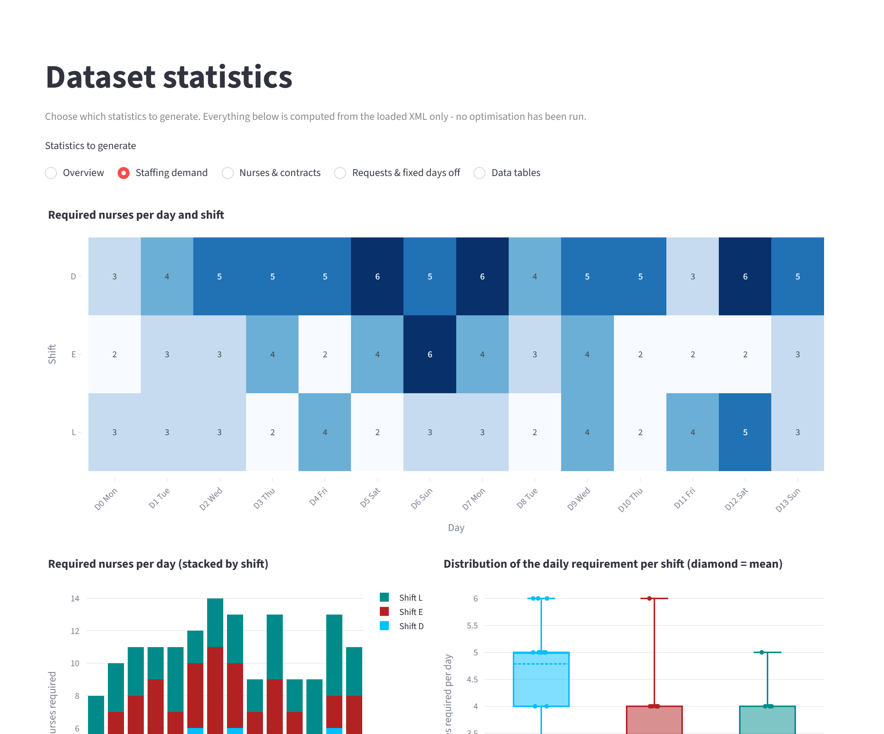
Figure 4 - Statistics page (on-demand staffing-demand panel).
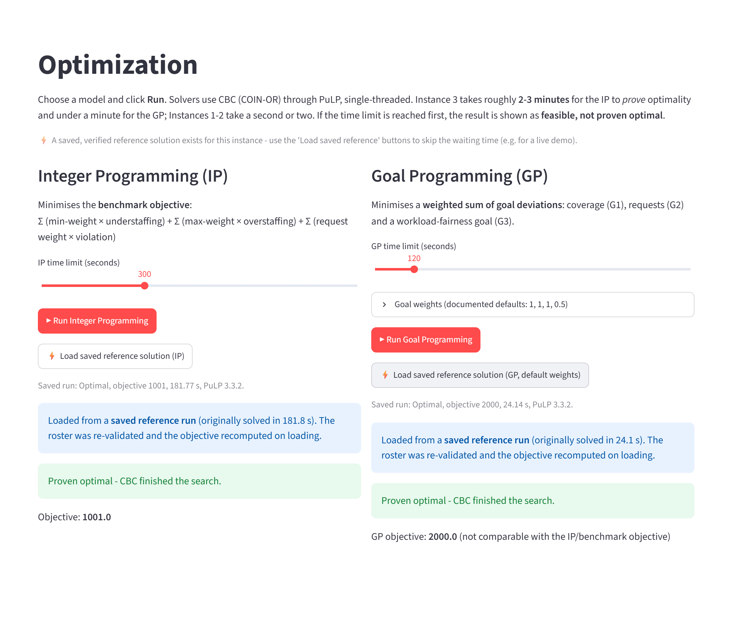
Figure 5 - Optimization page after loading the saved, proven-optimal IP and GP solutions.
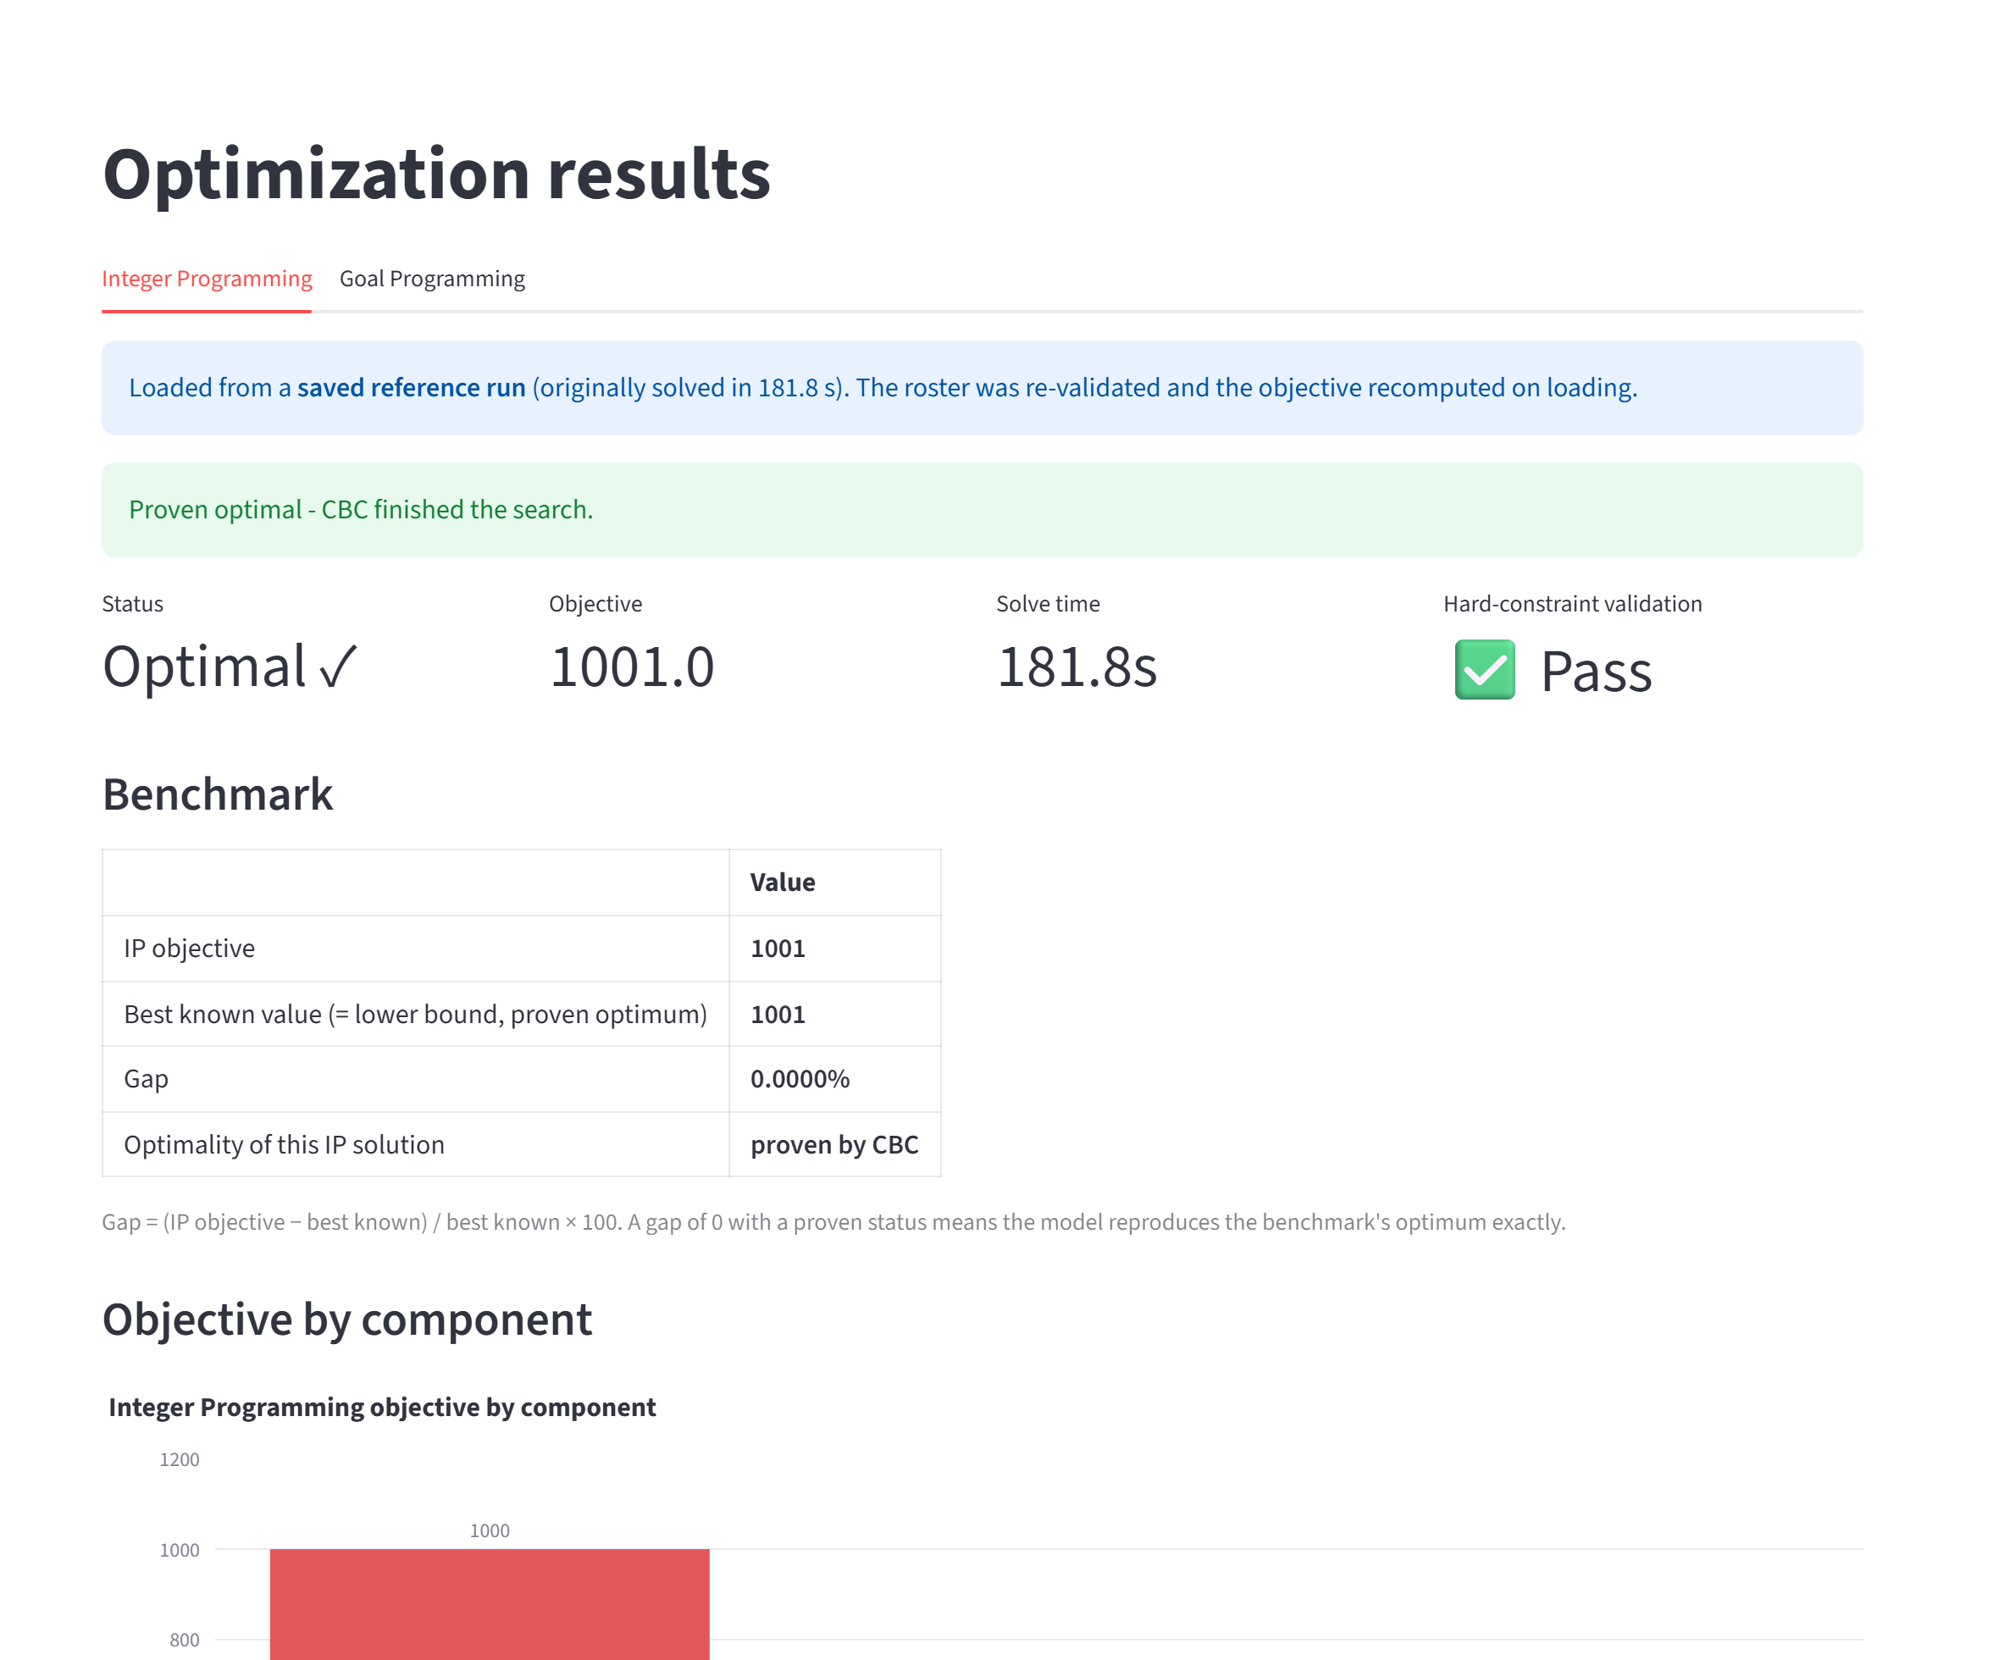
Figure 6 - Results page: proven-optimal IP solution, 0 % gap to the published optimum.
Honest solver status. PuLP returns status "Optimal" whenever CBC returns, even when the time limit stopped the search. The application reads the real solution status and shows "Optimal" only when optimality is proven; a time-limited run is labelled "Feasible, not proven optimal". Saved solutions. Because proving optimality on Instance 3 takes about three minutes, verified solutions can be loaded instantly for demonstrations; on loading, the roster is re-validated against every hard constraint and its objective is recomputed, and a mismatch is rejected.

6 Results

6.1 Integer Programming against the published optima
Instance | Published optimum | IP objective | CBC status | Gap | Solve time*
Instance 1 | 607 | 607 | proven optimal | 0.00 % | 1.4 s
Instance 2 | 828 | 828 | proven optimal | 0.00 % | 1.6 s
Instance 3 | 1,001 | 1,001 | proven optimal | 0.00 % | 181.8 s
Instance 4 | 1,716 | 1,716 | proven optimal | 0.00 % | 126.6 s

Table 3 - The Integer Programming model reproduces the published optimum on every bundled instance. *Single-threaded CBC, several solves running in parallel; machine-dependent.
Matching a proven optimum exactly on four instances of different size is strong evidence that the formulation, the parser and the solver set-up are correct. On Instance 3 the optimum 1001 decomposes into 1000 (ten nurse-shifts that cannot be filled, at 100 each) plus 1 (one ShiftOn request of weight 1 that cannot be honoured). Within 240 seconds the same model also produced valid rosters 0.6 % and 0.3 % above the proven optima of the larger Instances 5 and 6.
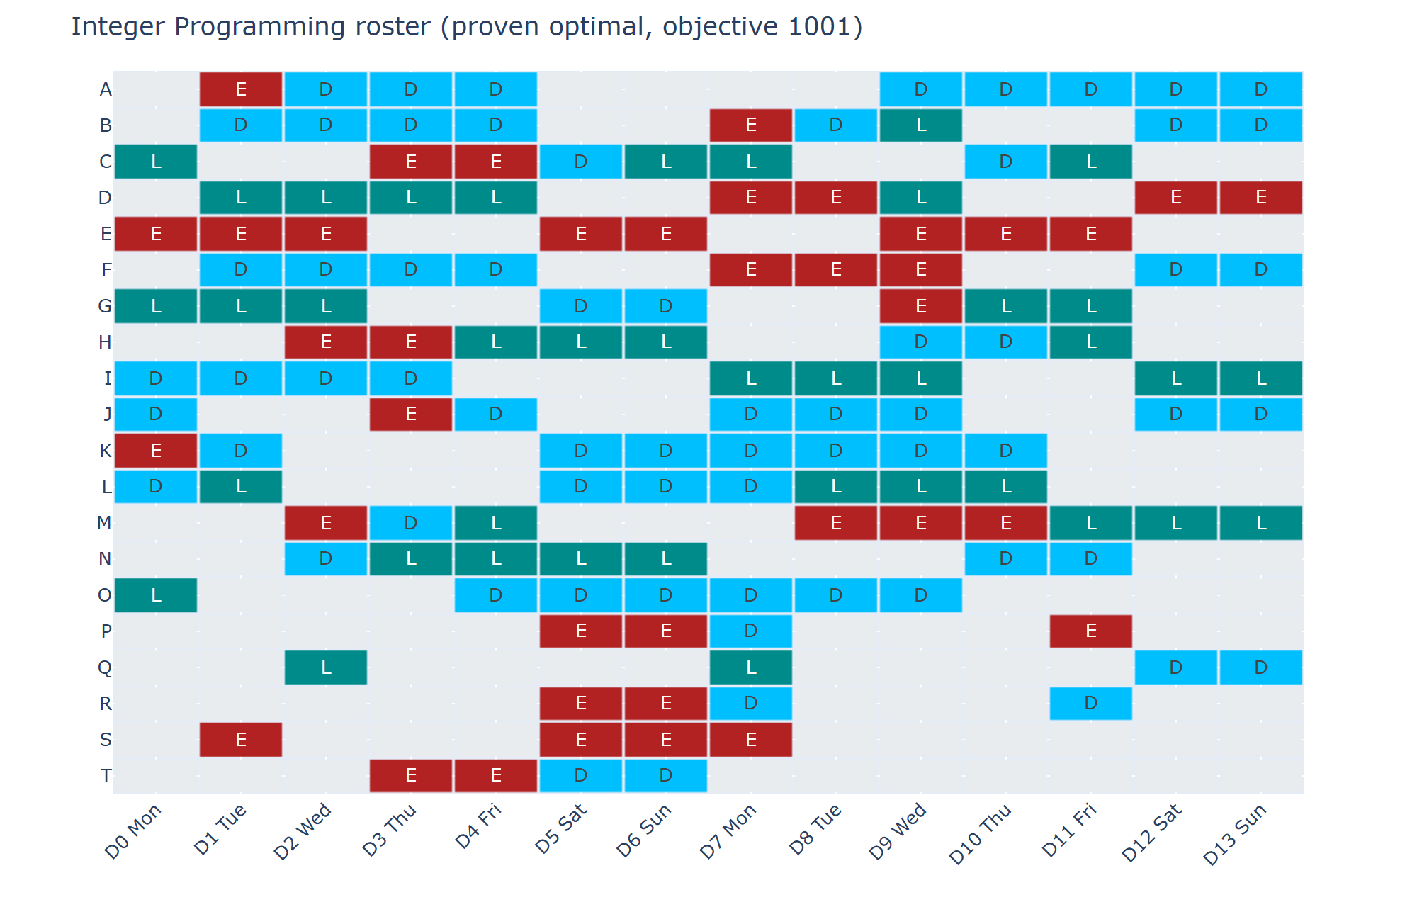
Figure 7 - The proven-optimal Integer Programming roster for Instance 3 (blank = day off).

6.2 Goal Programming
Instance | GP objective | Status | Time | Unfilled GP (IP) | Requests broken GP (IP) | Workload range GP (IP), min
Instance 1 | 716 | proven optimal | 0.9 s | 7 (6) | 8 (4) | 0 (960)
Instance 2 | 1,694 | proven optimal | 0.3 s | 12 (8) | 11 (18) | 1,920 (2,400)
Instance 3 | 2,000 | proven optimal | 24.1 s | 14 (10) | 0 (1) | 1,920 (2,400)
Instance 4 | 2,021 | proven optimal | 372.6 s | 17 (17) | 8 (7) | 0 (960)

Table 4 - Goal Programming results with default weights; IP values in brackets for comparison. GP objectives are not comparable with the IP objective.
On Instance 3 the GP objective 2000 decomposes into 1400 (14 unfilled nurse-shifts × 100) + 0 (overstaffing) + 0 (requests) + 600 (fairness: 0.5 × 1200 minutes of total deviation from the targets).

6.3 Comparison of the two models on Instance 3
Metric | Integer Programming | Goal Programming
Solution status | proven optimal | proven optimal
Objective | 1,001 (published optimum 1001, gap 0 %) | 2,000 (not benchmark-comparable)
Unfilled nurse-shifts (of 154) | 10 | 14
Coverage rate | 93.51 % | 90.91 %
Violated requests (of 64) | 1 | 0
Workload range (min) | 2400 | 1920
Std. deviation of workload (min) | 930.8 | 831.4
Jain's fairness index | 0.9324 | 0.9423
Hard constraints | all satisfied | all satisfied

Table 5 - Component-level comparison on Instance 3.
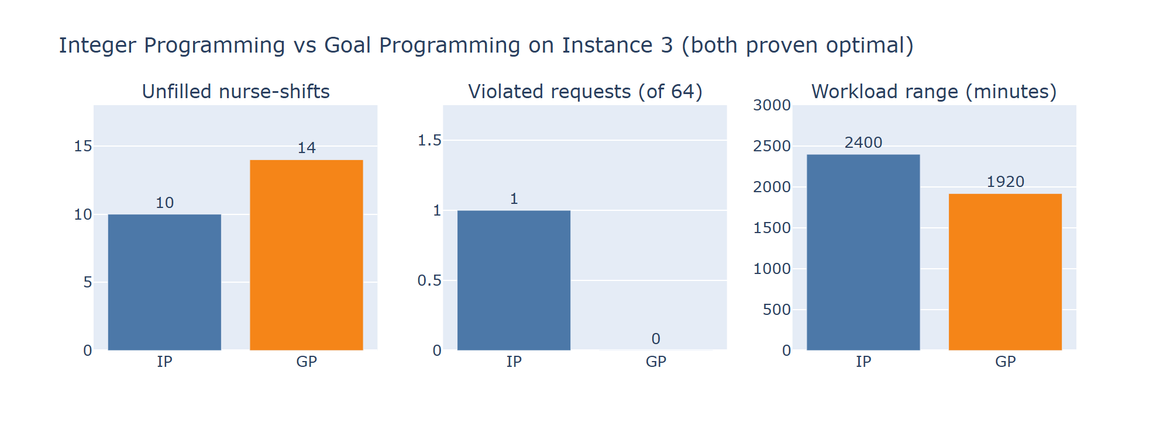
Figure 8 - The three metrics on which the models differ.
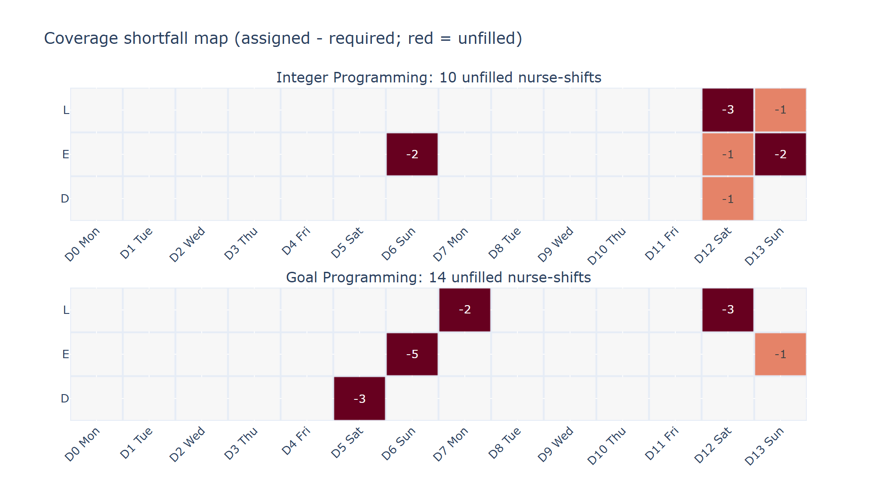
Figure 9 - Where the nurse-shifts remain unfilled: the IP concentrates them on the last weekend and one Sunday; the GP spreads them over two weekends.
The Integer Programming roster fills four more nurse-shifts, and ten unfilled is the proven minimum. The Goal Programming roster accepts four more unfilled nurse-shifts in exchange for no broken request and a workload range 480 minutes narrower. Neither model dominates: which is better depends on whether the hospital ranks coverage or nurse fairness first. The request result is instance-dependent - the GP breaks fewer requests on Instances 2 and 3 but more on Instances 1 and 4 - so the Instance 3 pattern must not be generalised.

6.4 Goal Programming weight sensitivity
To quantify the effect of the fairness weight, the unchanged Goal Programming model was re-solved on Instance 3 for eight values of w4 (w1 = w2 = w3 = 1). Every run was solved to proven optimality.
w4 | GP objective | Unfilled nurse-shifts | Requests broken | Fairness penalty | Workload range (min)
0.0 | 1,001 | 10 | 1 | 0 | 2,400
0.1 | 1,315 | 10 | 2 | 312 | 2,400
0.2 | 1,627 | 10 | 3 | 624 | 2,400
0.21 | 1,652 | 14 | 0 | 252 | 1,920
0.25 | 1,700 | 14 | 0 | 300 | 1,920
0.3 | 1,760 | 14 | 0 | 360 | 1,920
0.5 | 2,000 | 14 | 0 | 600 | 1,920
1.0 | 2,600 | 14 | 0 | 1,200 | 1,920

Table 6 - Weight sensitivity on Instance 3 (default highlighted).
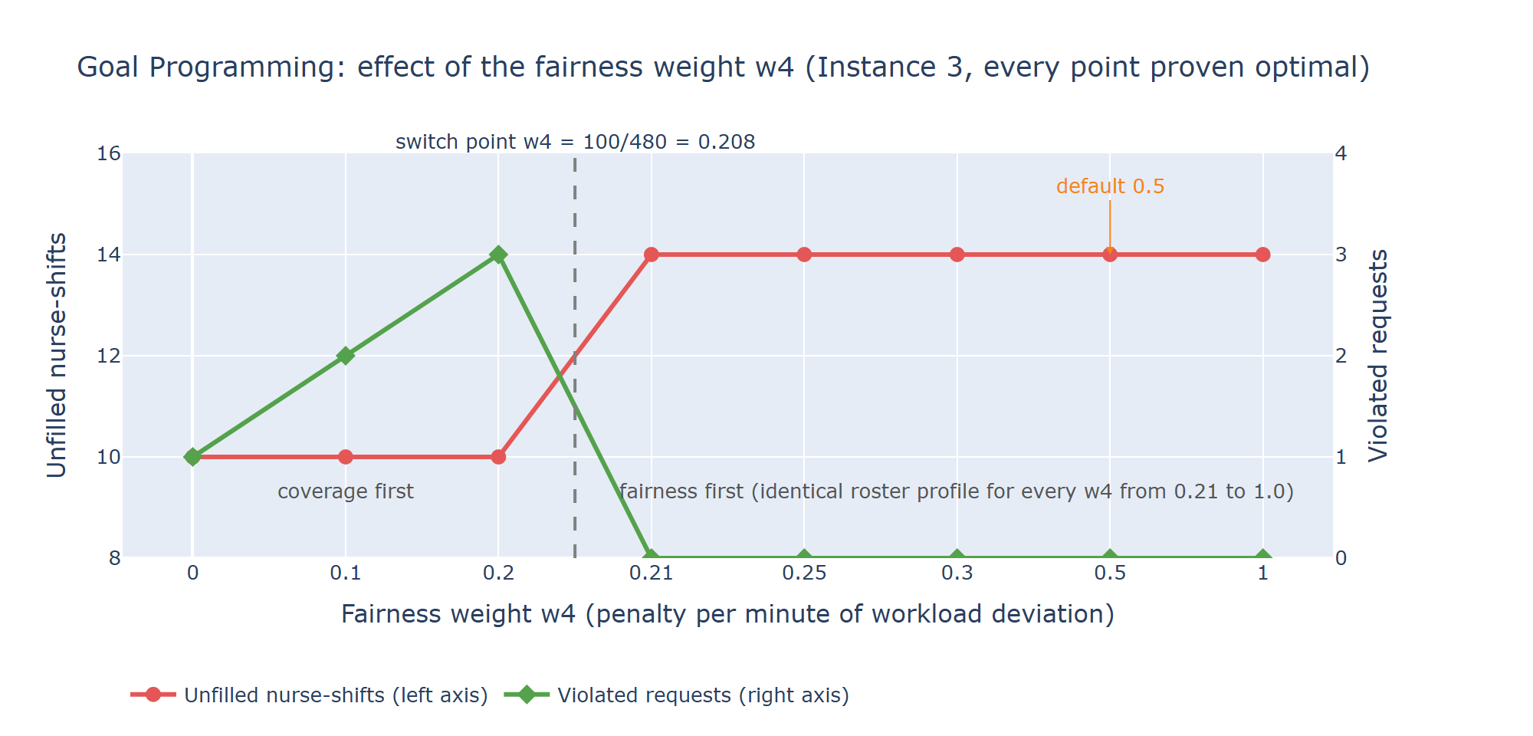
Figure 10 - A single switch point at w4 = 100/480 = 0.208, exactly as the arithmetic predicts.
Three findings follow. (i) With w4 = 0 the Goal Programming objective equals the Integer Programming objective (1001): the GP is the IP plus one extra goal. (ii) There is one switch point, at w4 = 100/480 ≈ 0.208 - the observed change between 0.2 and 0.21 matches it. (iii) For every w4 from 0.21 to 1.0 the roster has the same profile (14 unfilled, 0 requests broken, range 1920 minutes) and only the objective value scales, so the default 0.5 is not a knife-edge choice.

6.5 Statistics: what the data already imply
Demand (154 nurse-shifts) is 99 % of the nurses' maximum contractual capacity (155 shifts). Once fixed days off, the one-weekend limit, the consecutive-day rules and the rest rules are applied, ten nurse-shifts cannot be filled - which the proven optimum confirms. The statistics page makes this visible before any optimisation is run.

7 Verification and testing
Check | What it establishes
Published optima | The IP reaches 607, 828, 1001 and 1716 exactly, proven by CBC - the formulation matches the benchmark
Independent hard-constraint validator | Every roster (IP, GP, saved) satisfies all hard constraints; a deliberately broken roster is rejected
Independent objective evaluator | Z_IP and Z_GP recomputed from the roster alone equal the solver objectives (GP for several weights)
Model-regression test | A hash of every variable, bound, constraint and the objective of both models, taken from the original code, is pinned; the original and final code generate byte-identical LP files - the models were not changed by the polishing work
Saved-solution tamper tests | A changed objective, a roster that breaks constraints, or a file for the wrong instance are all rejected on loading
Solver-status tests | "Optimal" only when proven; a 5-second run on Instance 3 is reported as feasible, not proven
User-interface tests | Every page driven headlessly: cold start, loading data, every statistics panel, loading and running solutions, all result pages, failure path, GP-weight warning
Real-browser check | The running application driven in Microsoft Edge through the full demonstration path with no page errors
Clean-install check | A fresh virtual environment built only from requirements.txt runs all tests successfully

Table 7 - Verification measures.
The automated suite contains 117 tests, all passing (three minutes-long live solves of Instances 3 and 4 run only on request). During this work several weaknesses of an earlier version were found and fixed: the interface reported "Optimal" for time-limited solves, a validation flag was hard-coded to "passed", the results pages crashed when a solve returned no solution, the statistics page had no charts, and some documented numbers did not match the generated results.

8 Discussion

8.1 Managerial insight
The experiments quantify a management question rather than hide it. Patient cover is cheapest in the benchmark's own objective: 10 unfilled nurse-shifts is provably the minimum. Giving fairness real weight costs four more unfilled nurse-shifts on Instance 3 but removes the broken request and narrows the workload spread. Because the effect switches on at a single, explainable weight, a planner can decide how much cover to trade for fairness with full knowledge of the price.

8.2 Limitations
- The data are a research benchmark, not live hospital data: no skills, departments, leave rules or legal regulations beyond the instance's contracts.
- Minimum-sequence rules at the horizon boundary follow the benchmark convention (boundary blocks are exempt); weekends assume a Monday start (true for all official instances; the parser warns otherwise).
- The Goal Programming model is weighted-sum, not pre-emptive; its workload goal measures closeness to each nurse's contract midpoint, not equality between nurses.
- Proving optimality on Instance 3 needs about three minutes with single-threaded CBC (multithreaded CBC hung in testing); Instances 5 and 6 reached near-optimal but unproven solutions within 240 seconds.
- Workload range and Jain's index treat full-time and part-time nurses alike, so they understate the fairness of rosters on mixed-contract instances.

9 Conclusion and future scope
The project delivers a complete, verified decision-support system for nurse rostering: automatic data loading, on-demand statistics, two selectable optimisation models, and a result and comparison interface. The Integer Programming model reproduces the published, proven optimum on every bundled benchmark instance - 1001 on the main dataset - and the Goal Programming model exposes the coverage-versus-fairness trade-off through a single weight whose effect is fully characterised. Solver results are reported honestly and every figure shown can be traced to the data, the solver or an independent recomputation.
Future scope: pre-emptive (lexicographic) goal programming; skills and multi-ward rostering; rolling horizons with history from the previous period; robust rostering under uncertain demand; a fairness measure between comparable nurses; larger instances with decomposition or heuristics.

References
1. Curtois, T. and Qu, R. (2014). Computational results on new staff scheduling benchmark instances. Technical report, ASAP Research Group, University of Nottingham. Benchmark data: https://www.schedulingbenchmarks.org/nrp/
2. Strandmark, P., Qu, Y. and Curtois, T. (2020). First-order linear programming in a column generation-based heuristic approach to the nurse rostering problem. Computers & Operations Research.
3. Rahimian, E., Akartunalı, K. and Levine, J. (2017). A hybrid integer programming and variable neighbourhood search algorithm to solve nurse rostering problems. European Journal of Operational Research.
4. Forrest, J. and Lougee-Heimer, R. (2005). CBC User Guide. COIN-OR Foundation.
5. Mitchell, S., O'Sullivan, M. and Dunning, I. (2011). PuLP: A linear programming toolkit for Python. University of Auckland.

Appendix A How to run and reproduce
Start the application with run_app.bat (the first run creates a virtual environment and installs requirements.txt) or streamlit run app.py. Recommended demonstration: Dataset → Load sample (Instance 3) → Statistics → Optimization → Load saved reference solutions → Results → Comparison → Roster.
Command | Purpose
run_app.bat | Launch the application
run_tests.bat / run_tests.bat slow | Fast test suite (about 1 min) / all 117 tests incl. live Instance 3 and 4 solves (about 6 min)
python scripts/generate_reference_solutions.py | Solve both models on Instances 1-4, prove optimality, save verified rosters
python scripts/generate_comparison_reports.py | Regenerate results/*.json and summary.csv/md
python scripts/gp_weight_sensitivity.py | Regenerate the weight-sensitivity study
python scripts/export_tables.py | Export structured tables to data/processed

Appendix B Project structure
Path | Content
app.py | Streamlit application (8 pages)
src/parser.py, data_model.py, tables.py | XML to data classes to DataFrames; compatibility diagnostics
src/integer_program.py, goal_program.py | The two optimisation models
src/solver_utils.py, validation.py, evaluation.py | Honest status; independent verification
src/data_statistics.py, stat_charts.py | On-demand statistics and charts
src/comparison.py, reporting.py, visualization.py | Comparison, result tables, solution charts
src/benchmarks.py, reference_solutions.py | Published values; verified saved solutions
data/raw, data/processed | Benchmark XML files; structured CSV tables
results/ | Reference solutions, comparison JSON, summary, weight-sensitivity study
tests/ | 117 automated tests
docs/ | Model documentation, results, user guide, viva guide, this report

