CHAPTER 1
INTRODUCTION
In the early days, software applications were designed and deployed as a Monolithic application. In Monolithic application, a single instance performed all the business functions. They were deployed and maintained on premises these applications could guarantee high performance and robustness. Downtime for maintenance was accepted, as the 24/7 availability of these applications wasn’t a requirement in those days. As the size of the applications, and the demand for their around the clock availability grew, maintaining these applications on-premises became a challenge, a new alternative quickly became the popular choice, on-demand cloud computing platforms. Cloud computing platforms offered the physical hardware resources required to run the applications as a service. These organizations promise high availability and reliability of their infrastructure. Even with cloud taking care of the physical hardware problem, numerous issues in an application life-cycle remain unsolved like large build times, Slow Development, Poor resilience to failures, resulted in the development of architectural-style that is Microservices. The application is designed as a collection of loosely coupled services instead of a single large monolithic application. Although the Microservices style solved most of the problems with monolithic on-premises applications, it introduced new challenges. The first key innovation, that became an integral part of the solution to handle the deployment of distributed applications on the cloud, was Containerization. As soon as the industry embraced containerization, the need for our second key innovation was born. This innovation was the container orchestration system On a high level, a container orchestration system allows the user to effectively manage the deployment of containerized applications. Two important container orchestration tool was used
Docker Swarm: A Docker Swarm is a group of either physical or virtual machines that are running the Docker application and that have been configured to join together in a cluster. Docker swarm is a container orchestration tool, meaning that it allows the user to manage multiple containers deployed across multiple host machines
Kubernetes: Kubernetes (also known as k8s or “kube”) is an open source container orchestration platform that automates many of the manual processes involved in deploying, managing, and scaling containerized applications.
1.1 Problem statement
Although the Microservices style solved most of the problems with monolithic on-premises applications, it introduced new challenges. Tracking all the containers and information of all the containers whenever there are 100’s containers because by default the container will not be aware of other containers. Additionally, it will not be aware of the systems files, network interfaces, and processes, Scaling of containers to equally balance application workloads across infrastructure, Health monitoring of containers
1.2 Objective:
Container orchestration tools provide a framework for managing containers and microservices architecture at scale. container orchestrator can greatly reduce the complexity in production as these tools are designed to resolve like load balance allow upgrades of individual containers with no downtime and compare the performance of Docker Swarm and Kubernetes.

CHAPTER 2
LITERATURE REVIEW

2.1 Literature Survey

2.1.1 Containers and Cloud: From LXC to Docker to Kubernetes

Most commercial cloud computing systems both services and cloud operating system software products use hypervisors. Enterprise VMware installations, which can rightly be called early private clouds, which gained tremendous popularity because of its early open source inclusion with Linux. Docker (www.docker.com) is an open source project providing a systematic way to automate the faster deployment of Linux applications inside portable containers. Basically, Docker extends LXC with a kernel-and application-level API that together run processes in isolation: CPU, memory, I/O, network, and so on. Google announced Kubernetes, an open source cluster manager for Docker containers. According to Google, Kubernetes is the decoupling of application containers from the details of the systems on which they run. Google Cloud Platform provides a homogenous set of raw resources to Kubernetes, and in turn, Kubernetes schedules containers to use those resources. In Kubernetes, we’ve taken an alternative approach: that each group of containers (called a Pod) deserves its own, unique IP address that’s reachable from any other Pod in the cluster.

2.1.2 DATA STORAGE & LOAD BALANCING IN CLOUD COMPUTING USING CONTAINER CLUSTERING

Kubernetes is an open-source platform for automating deployment, scaling, and operations of application containers across clusters of hosts, providing container-centric infrastructure. It groups containers that make up an application into logical units for easy management and discovery. Kubernetes builds upon 15 years of experience of running production workloads at Google, combined with best-of-breed ideas and practices from the community.

Kubernetes is:
1. portable: public, private, hybrid, multi-cloud
2. extensible: modular, pluggable, hookable, composable
3. self-healing: auto-placement, auto-restart, auto-replication, auto-scaling
Kubernetes has three main quality that make it different from other container clustering tool:
1. Planet Scale: Designed on the same principles that allows Google to run billions of containers a week, Kubernetes can scale without increasing your operation team.
2.Never Outgrow: Whether testing locally or running a global enterprise, Kubernetes flexibility grows with you to deliver your applications consistently and easily no matter how complex your need is.
3.Run Anywhere: Kubernetes is open source giving you the freedom to take advantage of on-premise, hybrid, or public cloud infrastructure, letting you effortlessly move workloads to where it matters to

2.1.3 A performance comparision of cloud based container orchestration tools
Compared to the traditional approach of using virtual machines as the basis for the development and deployment of applications running in Cloud-based infrastructures, container technology provides developers with a higher degree of portability and availability, allowing developers to build and deploy their applications in a much more efficient and flexible manner. Many tools have been proposed to orchestrate complex applications comprising multiple containers requiring continuous monitoring and management actions to meet application-oriented and non-functional requirements. Different container orchestration tools provide different features that incur different overheads. To manage multiple containers concurrently, a centralized orchestration tool is typically required. Container orchestration tools can be broadly defined as frameworks that integrate, manage, control and or schedule containers at scale. This is typically achieved across multiple processing nodes. Docker Swarm and Kubernetes are two leading technologies that serve this purpose. We have undertaken several benchmarking exercises from well-known benchmarking tools to evaluate the performance overheads of container orchestration tools and identify their pros and cons more generally. However, Docker in Swarm mode is not as flexible or powerful as Kubernetes in more complex situations.

2.1.4 Docker Swarm
A Docker Swarm is a group of either physical or virtual machines that are running the Docker application and that have been configured to join together in a cluster.
One of the key benefits associated with the operation of a docker swarm is the high level of availability offered for applications. In a docker swarm, there are typically several worker nodes and at least one manager node that is responsible for handling the worker nodes' resources efficiently and ensuring that the cluster operates efficiently.
Benefits of Running a Docker Swarm
1.Leverage the Power of Containers:
Developers love using docker swarm because it fully leverages the design advantages offered by containers. Containers allow developers to deploy applications or services in self-contained virtual environments, a task that was previous the domain of virtual machines.
2. Docker Swarm Helps Guarantee High Service Availability
One of the main benefits of docker swarms is increasing application availability through redundancy. In order to function, a docker swarm must have a swarm manager that can assign tasks to worker nodes. By implementing multiple managers, developers ensure that the system can continue to function even if one of the manager nodes fails.
3. Automated load Balancing
Docker swarm schedules tasks using a variety of methodologies to ensure that there are enough resources available for all of the containers. Through a process that can be described as automated load balancing, the swarm manager ensures that container workloads are assigned to run on the most appropriate host for optimal efficiency.

CHAPTER 3
SYSTEM ANALYSIS AND DESIGN
3.1 Existing system
Docker are now been used for package applications so that they can access a specific set of resources on a physical or virtual host’s operating system. Microservice architectures, applications are further broken up into various discrete services that are each packaged in a separate container. But scalability is an operational challenge when we have more containers.
3.2 Proposed System
Container orchestration tools provide a framework for managing containers and microservices architecture at scale. container orchestrator can greatly reduce the complexity in production as these tools are designed to resolve it. The Container in Docker Swarm allows the developers to deploy the application or services in self contained virtual environment, docker swarm also increases the application availability through redundancy. Docker swarm schedules tasks using a variety of methodologies to ensure that there are enough resources available for all of the containers. Docker swarm and Kubernetes manages the workload on each and every worker node.

CHAPTER 4
IMPLEMENTATION
Cloud computing is the practice of using a network of remote servers hosted on the Internet to store, manage, and process data, rather than a local server or a personal computer. The application is deployed in cloud infrastructure by creating the docker containers and maintaining the containers through container orchestration tools (Docker Swarm and Kubernetes) which can be accessed by users.
Cloud Computing
Cloud computing is the on demand availability of computer system resources, especially data storage and computing power, without direct active management by the user. The term is generally used to describe data centers available to many users over the Internet. It is a type of computing that relies on shared computing resources rather than having local servers or personal devices to handle applications. The services are delivered and used over the Internet and are paid for by the cloud customer on an as-needed or pay-per-use business model.
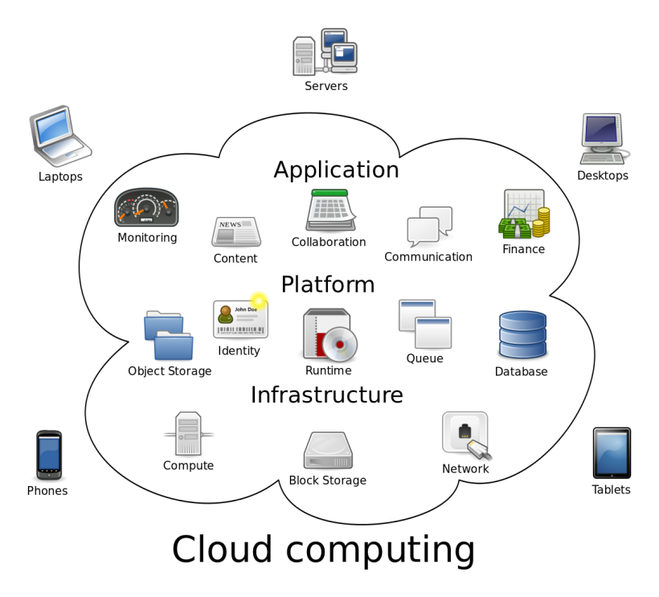
Fig 4.1: Cloud Computing

Cloud Infrastructures
Cloud infrastructure refers to the hardware and software components such as servers, storage, a network and virtualization software that are needed to support the computing requirements of a cloud computing model

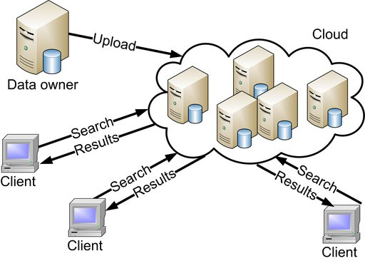
Fig 4.2 : Cloud Infrastructure

Fig 4.3: Deployment models

1. Software as a Service (SaaS):
The capability provided to the consumer is to use the provider’s applications running on a cloud infrastructure. The applications are accessible from various client devices through either a thin client interface, such as a web browser or a program interface. The consumer does not manage or control the underlying cloud infrastructure including network, servers, operating systems, storage, or even individual application capabilities, with the possible exception of limited user-specific application configuration settings.
2. Platform as a Service (PaaS):
The capability provided to the consumer is to deploy onto the cloud infrastructure consumer-created or acquired applications created using programming languages, libraries, services, and tools supported by the provider.The consumer does not manage or control the underlying cloud infrastructure including network, servers, operating systems, or storage, but has control over the deployed applications and possibly configuration settings for the application-hosting environment.
3. Infrastructure as a Service (IaaS):
The capability provided to the consumer is to provision processing, storage, networks, and other fundamental computing resources where the consumer can deploy and run arbitrary software, which can include operating systems and applications. The consumer does not manage or control the underlying cloud infrastructure but has control over operating systems, storage, and deployed applications; and possibly limited control of select networking components (e.g., host firewalls).

Container:
Compartments give a standard method to bundle your application's code, designs, and conditions into a solitary item. Compartments share a working framework introduced on the server and keep running as asset detached procedures, guaranteeing fast, dependable, and predictable organizations, paying little heed to condition. Containers offer a sensible bundling component in which applications can be disconnected from the earth in which they run. This decoupling permits compartment based applications to be conveyed effectively and reliably, paying little respect to whether the objective condition is a private server farm, people in general cloud, or even an engineer's close to home workstation. Containerization gives a spotless division of worries, as designer’s center around their application rationale and conditions, while IT tasks groups can concentrate on organization and the board without wasting time with application subtleties, for example, explicit programming adaptations and arrangements explicit to the application

Docker:
Docker is a product stage that enables you to manufacture, test, and send applications rapidly. Docker bundles programming into institutionalized units considered holders that have everything the product needs to run including code, libraries, runtime, framework, and devices. Utilizing Docker, we can rapidly use and extends applications into any environment and know your code will run.

Docker Swarm:

Fig 4.4: Docker Swarm Architecture

A swarm is a crew of machines that are functioning Docker and merged into a group. After that has occurred, you keep on running the Docker directions you're utilized to, however at this point they are executed on a bunch by a swarm administrator. The machines in a swarm can be physical or virtual. A swarm consists of multiple Docker hosts which run in swarm mode and act as managers (to manage membership and delegation) and workers (which run swarm services). A given Docker host can be a manager, a worker, or perform both roles. When you create a service, you define its optimal state (number of replicas, network and storage resources available to it, ports the service exposes to the outside world, and more). Docker works to maintain that desired state. For instance, if a worker node becomes unavailable, Docker schedules that node’s tasks on other nodes. A task is a running container which is part of a swarm service and managed by a swarm manager, as opposed to a standalone container. One of the key advantages of swarm services over standalone containers is that you can modify a service’s configuration, including the networks and volumes it is connected to, without the need to manually restart the service. Docker will update the configuration, stop the service tasks with the out of date configuration, and create new ones matching the desired configuration.
When Docker is running in swarm mode, you can still run standalone containers on any of the Docker hosts participating in the swarm, as well as swarm services.
Nodes:
A node is an instance of the Docker engine participating in the swarm. You can also think of this as a Docker node. You can run one or more nodes on a single physical computer or cloud server, but production swarm deployments typically include Docker nodes distributed across multiple physical and cloud machines.
To deploy your application to a swarm, you submit a service definition to a manager node. The manager node dispatches units of work called tasks to worker nodes.
Manager nodes also perform the orchestration and cluster management functions required to maintain the desired state of the swarm. Manager nodes elect a single leader to conduct orchestration tasks.
Worker nodes receive and execute tasks dispatched from manager nodes. By default manager nodes also run services as worker nodes, but you can configure them to run manager tasks exclusively and be manager-only nodes. An agent runs on each worker node and reports on the tasks assigned to it. The worker node notifies the manager node of the current state of its assigned tasks so that the manager can maintain the desired state of each worker.
Kubernetes:

Fig 4.5: kubernetes Architecture

etcd:
It stores the configuration information which can be used by each of the nodes in the cluster. It is a high availability key-value store that can be distributed among multiple nodes. It is accessible only by the Kubernetes API server as it may have some sensitive information. It is a distributed key-value store that is accessible to all.

API Server:
Kubernetes is an API server which provides all the operation on a cluster using the API. API server implements an interface, which means different tools and libraries can readily communicate with it kubeconfig is a package along with the server-side tools that can be used for communication. It exposes Kubernetes API.

Controller Manager:
This component is responsible for most of the collectors that regulate the state of the cluster and performs a task. In general, it can be considered as a daemon that runs in a nonterminating loop and is responsible for collecting and sending information to the API server. It works toward getting the shared state of the cluster and then make changes to bring the current status of the server to the desired state. The controller manager runs a different kind of controllers to handle nodes, endpoints, etc.

Scheduler:
This is one of the key components of Kubernetes master. It is a service in master responsible for distributing the workload. It is responsible for tracking the utilization of working load on cluster nodes and then placing the workload on which resources are available and accept the workload. In other words, this is the mechanism responsible for allocating pods to available nodes. The scheduler is responsible for workload utilization and allocating pod to a new node.

Docker:
The main necessity of every hub is Docker which helps in running the typified application holders in a generally disengaged however lightweight working condition

Kublet Service:
This part is in charge of a large portion of the gatherers that directs the condition of the bunch and plays out an errand. As a rule, it tends to be considered as a daemon that keeps running in a nonterminating circle and is in charge of gathering and sending data to the API server. It progresses in the direction of getting the common condition of the bunch and after that makes changes to bring the present status of the server to the ideal state.

Kubernetes Proxy Service:
This is a proxy service that runs on each node and helps in making services available to the external host. It helps in forwarding the request to correct containers and is capable of performing primitive load balancing. It makes sure that the networking environment is predictable and accessible and at the same time it is isolated as well. It manages pods on node, volumes, secrets, creating new containers’ health checkups, etc.

CHAPTER 5

RESULTS AND DISCUSSION
Fig 5.1: Master Node in Swarm Cluster

Fig 5.2: worker Node 1

Fig 5.3 Worker Node 2

5.1 Performance of Docker Swarm and Kubernetes
Fig 5.4: Docker Swarm cluster Performance

Fig 5.5 Kubernetes Performance

CHAPTER 6
CONCLUSION
Since from previous couple of years, cloud computing has widely been used to both the individuals and the establishment. The technology docker and container is been used, which would be helpful everyone in terms of load balancing, security etc. further we had implemented the docker swarm and kubernetes in form of cluster and run the services on it and we got that kubernetes is superior than the docker swarm even though kubernetes is difficult in installing process but if it effective in major ways then installation will
be consider in a negligible manner.

References

1.Ms. Shalini Joshi, Dr. Uma Kumari, “ Load Balancing in Cloud Comput ing: Challenges&Issues”, 2016 2nd International Conference on Contemporary Comput ing and Informat ics (ic3i).

2.Trapti Gupta & Abhishek Dwivedi in IJESRT 2017 “DATA STORAGE & LOAD BALANCING IN CLOUD COMPUTING USING CONTAINER CLUSTERING”

3. Yao Pan, Ian Chen, Francisco Brasileiro, Glenn Jayaputera, Richar O. Sinnott. “A performance comparision of cloud based container orchestration tools “2019 IEEE International Conference on Big Knowledge (ICBK)

4 Anureet kaur, Bikrampal Kaur, “Load Balancing in t asks using Honey bee Behavior Algorithm in Cloud Comput ing”, 978-1-5090-0893- 3/16/$31.00 ©2016 IEEE.

5. “ Docker: Build, ship, run.” [Online]. Available: https://www.docker.com/

6. https://www.tutorialspoint.com/kubernetes/kubernetes_architecture.htm

