

The University of Azad Jammu and Kashmir,
Muzaffarabad

Lab Title: Python Setup, Fundamentals, and Imports
Course Name: Digital Image Processing
Lab No : 01
Course Code: CS-3112
Submitted to: Engr. Fahad Nisar

Student Name: Kamal Ali Akmal
Roll No: 2024-SE-38
Session: 2024-2028
Semester: 5th
Submission date: 23rd October 2026

Objective
The objective of this lab is to install and configure Python and Visual Studio Code, practice basic Python syntax, conditions, loops, functions, and collections, install the required introductory packages, and verify the required import statements.
Installation and Setup
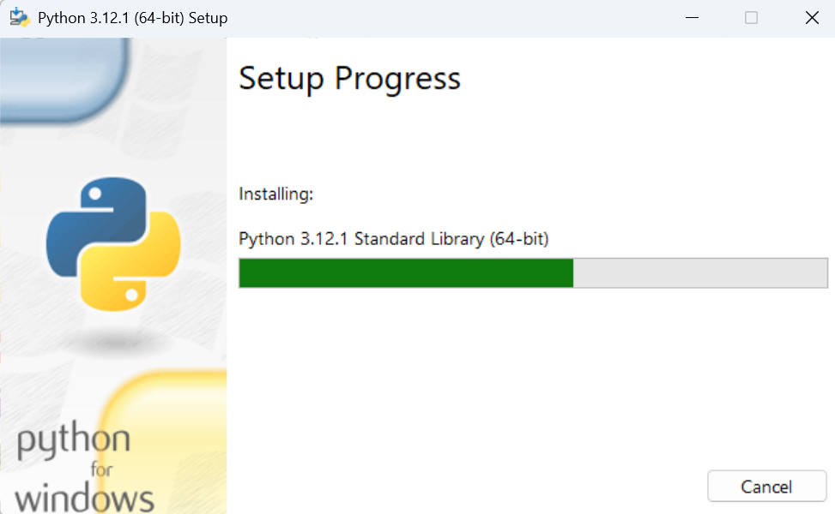
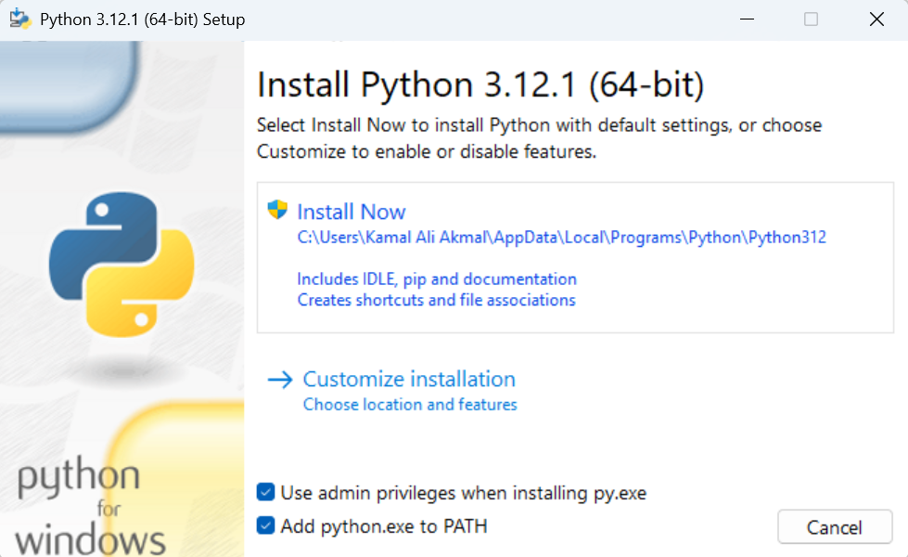
Step 1: Install Python
Step 2: Verify Python and pip
The following commands are used to check the installation:
python --version
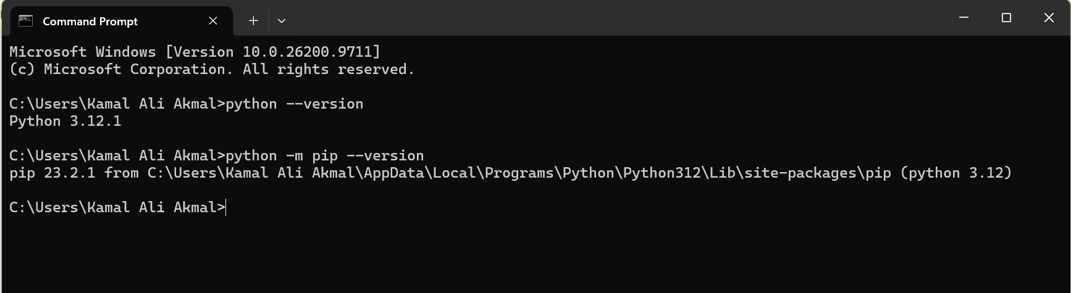
python -m pip --version
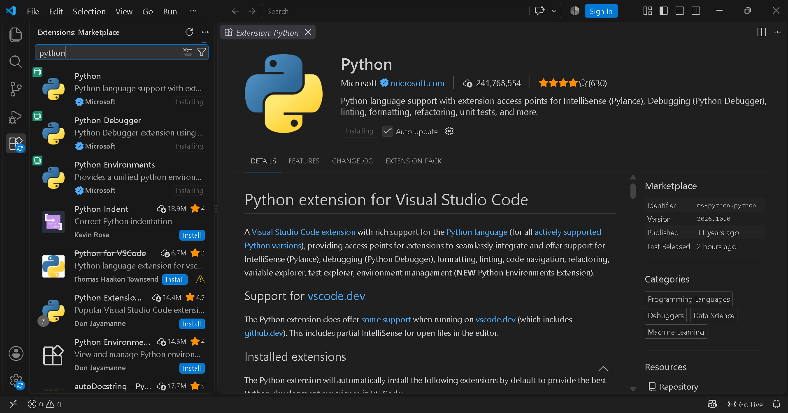
Step 3: Install VS Code and Select Python
Step 4: Run My First Python Program
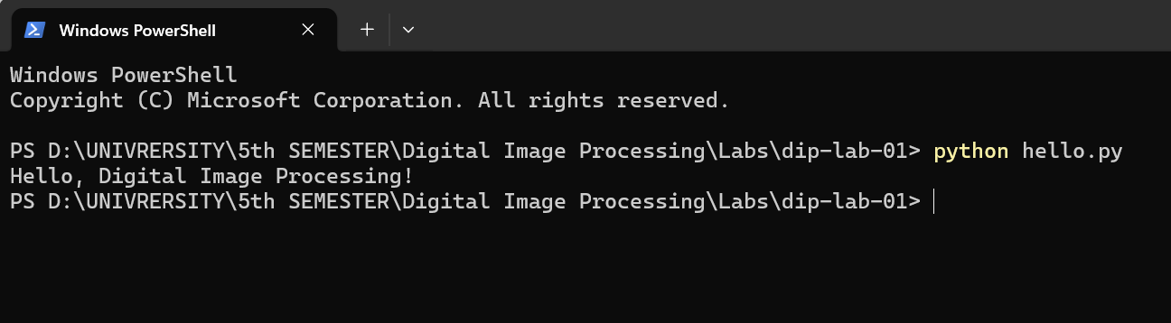
Step 5: Complete Basic Python Exercises

Exercise 1: Variables and Data Types
The variables width, height, image_name, and is_color store an integer, integer, string, and Boolean value, respectively. The total number of pixels is calculated by multiplying the width by the height: 640 × 480 = 307,200.
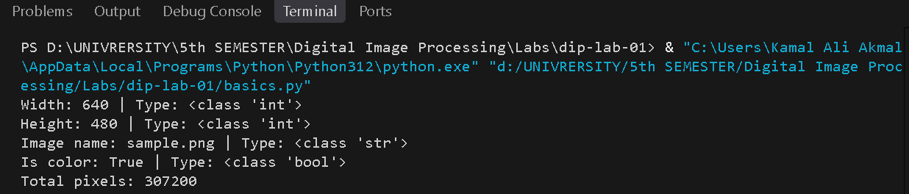

Exercise 2: Conditions
The program checks whether each intensity is outside the valid range 0–255. Values from 0–127 are labeled Dark pixel, and values from 128–255 are labeled Bright pixel.
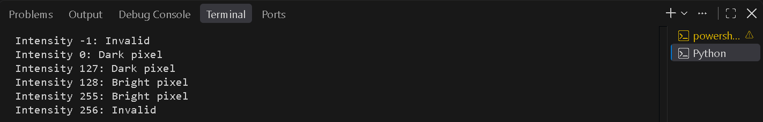

Exercise 3: for and while Loops
The for loop visits the pixel values 20, 130, and 255 and labels them using 128 as the threshold. The while loop prints 0, 1, and 2. The counter is increased on each iteration so that the loop stops when the counter reaches 3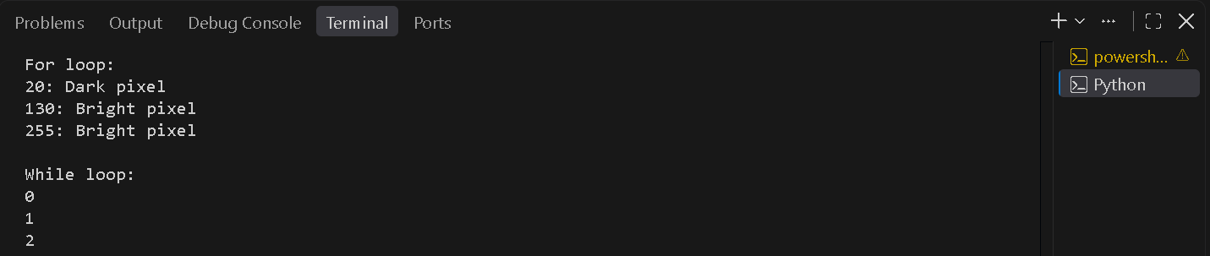

Exercise 4: Functions
The function is_bright(pixel, threshold=128) returns True when the pixel value is greater than or equal to the threshold; otherwise, it returns False. The threshold can be changed when calling the function.
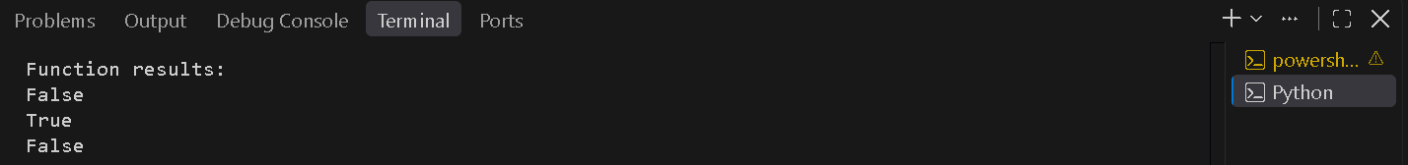

Exercise 5: Lists and Tuples
The list begins as [0, 128, 255]. Its middle item is changed to 150 and 64 is appended, producing [0, 150, 255, 64] with length 4. The tuple (640, 480) is unpacked into width and height.
A list is mutable, meaning its items can be changed. A tuple is immutable, meaning its items cannot be reassigned after the tuple is created.
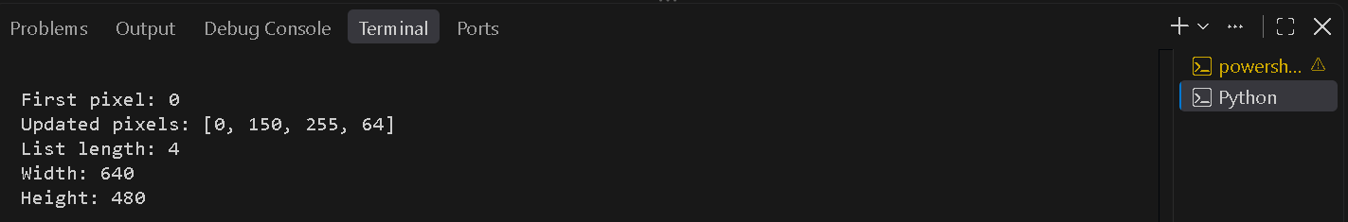

Exercise 6: Dictionaries and Sets
The image dictionary stores width and height as key-value pairs. The key mode is added with the value RGB. Converting the list ['cat', 'dog', 'cat', 'bird'] into a set removes duplicate labels, leaving three unique values.
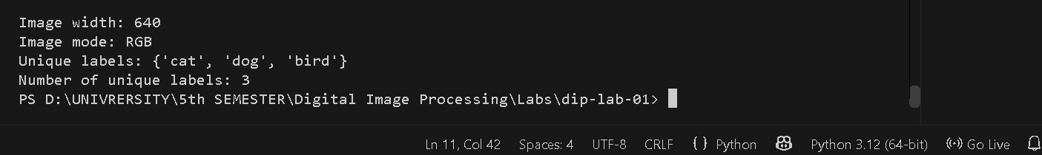
Step 6: Install the Required Packages
The following command installs the required packages:
python -m pip install numpy pillow matplotlib
To verify their installation, use:
python -m pip show numpy pillow matplotlib
- NumPy: numerical calculations and array operations.
- Pillow: image opening, creation, and processing.
- Matplotlib: plotting and visualization.
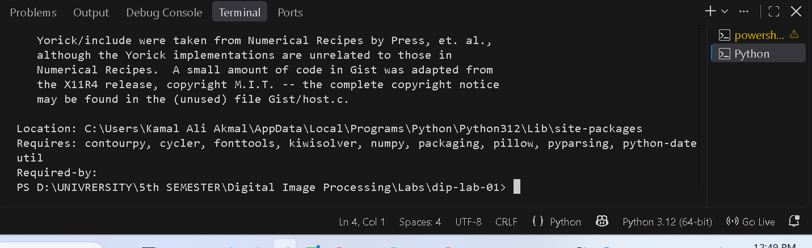
Step 7: Write and Verify Import Statements
The file lab01_imports.py contains the following statements:
import numpy as np
from PIL import Image
import matplotlib.pyplot as plt
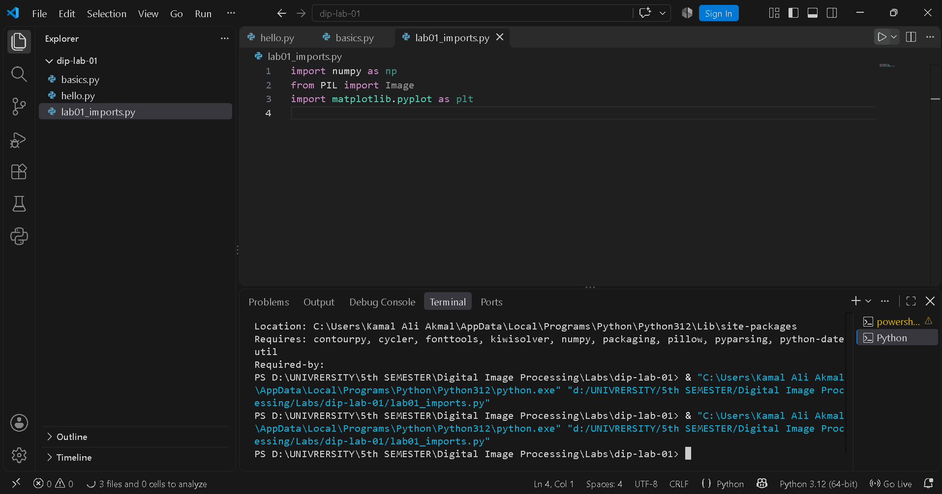
The statement import numpy as np imports NumPy using the short name np. The statement from PIL import Image imports the Image class from Pillow. The statement import matplotlib.pyplot as plt imports Matplotlib's plotting interface as plt.

Python versus pip
Python is the programming language and runtime used to write and execute programs. pip is a package installer that downloads and installs additional Python libraries. Import statements allow a program to use functionality provided by installed libraries, such as numerical arrays, image processing, and plotting.

Results and Conclusion
This lab practices Python variables and data types, conditional statements, for and while loops, functions, lists, tuples, dictionaries, and sets. It also covers installing NumPy, Pillow, and Matplotlib and writing the required import statements. After running all files on the local computer and adding the required screenshots, the report and three Python files can be submitted.

