

The University of Azad Jammu and Kashmir,
Muzaffarabad

Lab Title: Sequence Diagram
Course Name: Software Construction and Development
Lab No : 03
Course Code: SE-3101
Submitted to: Engr. Dr. Asma Javaid

Student Name: Kamal Ali Akmal
Roll No: 2024-SE-38
Session: 2024-2028
Semester: 5th
Submission date: 3rd November 2026

Sequence Diagram for ATM Cash Withdrawal
Understanding the scenario
When a customer withdraws cash from an ATM, several components communicate with each other.
- Customer: The person who wants to withdraw money.
- ATM: The machine through which the customer performs the transaction.
- Bank Server: Checks the customer's account and verifies the transaction.
- Cash Dispenser: Releases the requested cash.
- Receipt Printer: Prints the transaction receipt.
Sequence Diagram
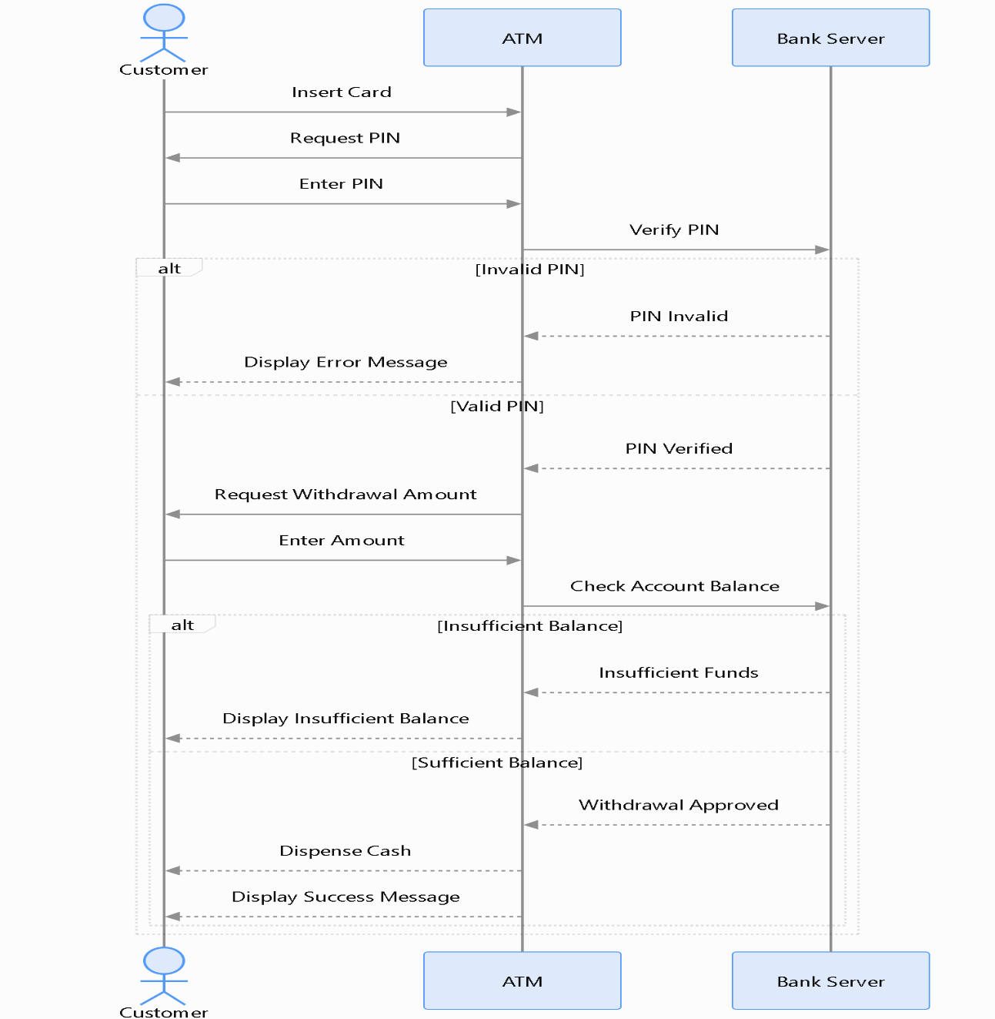
Explanation
The sequence works as follows:
- The customer inserts their ATM card.
- The ATM asks for the PIN.
- The customer enters the PIN.
- The ATM sends the card and PIN information to the bank server.
- The bank verifies the information.
- If authentication is successful, the ATM displays the transaction menu.
- The customer selects cash withdrawal.
- The ATM asks for the withdrawal amount.
- The customer enters the amount.
- The bank checks the available balance and withdrawal limit.
- If approved, the bank deducts the amount from the account.
- The ATM instructs the cash dispenser to release money.
- The ATM prints the receipt and returns the card.
Sequence Diagram for Online Ticket Reservation System
Understanding the scenario
An online ticket reservation system allows customers to search for available tickets, select seats, make payments, and receive booking confirmation.
The main components are:
- Customer: The person who wants to reserve a ticket.
- Website/Application: The platform used for booking.
- Reservation System: Manages ticket availability and reservations.
- Payment Gateway: Processes customer payments.
- Database: Stores ticket and booking information.
- Notification System: Sends booking confirmation to the customer.

Sequence diagram
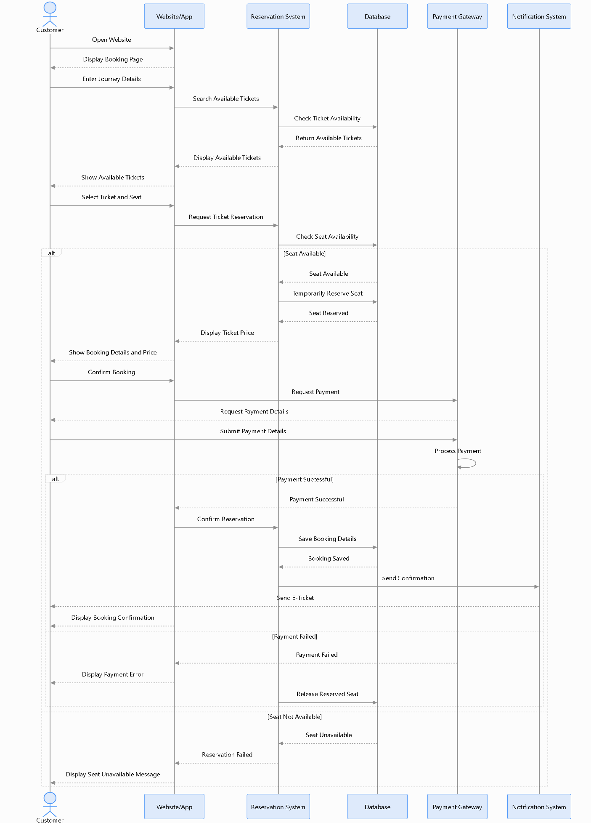
Explanation
- The customer opens the website or application.
- The system displays the booking page.
- The customer enters journey details, such as departure, destination, and date.
- The website sends a search request to the reservation system.
- The reservation system checks available tickets in the database.
- The available tickets are displayed to the customer.
- The customer selects a ticket and seat.
- The reservation system checks whether the selected seat is available.
- If available, the system temporarily reserves the seat and displays the ticket price.
- The customer confirms the booking.
- The payment gateway processes the payment.
- If payment is successful, the reservation system saves the booking details.
- The notification system sends an electronic ticket to the customer.
- Finally, the website displays the booking confirmation.

