

The University of Azad Jammu and Kashmir,
Muzaffarabad

Lab Title: UML Class Diagram
Course Name: Software Construction and Development
Lab No : 04
Course Code: SE-3101
Submitted to: Engr. Dr. Asma Javaid

Student Name: Kamal Ali Akmal
Roll No: 2024-SE-38
Session: 2024-2028
Semester: 5th
Submission date: 3rd November 2026

Online Doctor Appointment Management System
Problem Understanding
The Online Doctor Appointment Management System allows patients to book appointments with health specialists.
The system works as follows:
- Patients create accounts and log in.
- Doctors create their own accounts.
- Patients request appointments with doctors.
- Doctors check their schedules and availability.
- Doctors accept appointment requests if they have available time slots.
- Doctors reject appointment requests if they are busy.
- If an appointment is accepted, a confirmation notification is sent to the patient.
To implement this system, we identify the following classes.
Identification and Explanation of Classes
Class 1: Patient
The Patient class represents a person who wants to book an appointment with a doctor.
Attributes:
- patientID: Unique identification number of the patient.
- name: Name of the patient.
- email: Email address of the patient.
- password: Password used for login.
- phone: Contact number of the patient.
Methods:
- createAccount(): Creates a new patient account.
- login(): Allows the patient to log in.
- requestAppointment(): Sends an appointment request.
- viewAppointmentStatus(): Checks the status of an appointment.

Class 2: Doctor
The Doctor class represents a health specialist who manages appointment requests.
Attributes:
- doctorID: Unique identification number of the doctor.
- name: Name of the doctor.
- specialization: Medical specialization of the doctor.
- email: Email address of the doctor.
- password: Password used for login.
Methods:
- createAccount(): Creates a doctor account.
- login(): Allows the doctor to log in.
- viewAppointmentRequests(): Displays appointment requests.
- acceptAppointment(): Accepts an appointment request.
- rejectAppointment(): Rejects an appointment request.
Class 3: Appointment
The Appointment class stores the details of an appointment between a patient and a doctor.
Attributes:
- appointmentID: Unique identification number of the appointment.
- date: Appointment date.
- time: Appointment time.
- status: Current status of the appointment.
Methods:
- bookAppointment(): Creates an appointment request.
- updateStatus(): Updates the appointment status.
- getAppointmentDetails(): Returns appointment information.
The appointment status may be:
- Pending
- Accepted
- Rejected
Class 4: Schedule
The Schedule class manages the availability of a doctor.
Attributes:
- scheduleID: Unique identification number of the schedule.
- availableDate: Available date.
- availableTime: Available time.
- isAvailable: Indicates whether the doctor is available.
Methods:
- checkAvailability(): Checks whether the doctor is available.
- updateAvailability(): Updates the doctor's availability.
Class 5: Notification
The Notification class sends appointment-related messages to patients.
Attributes:
- notificationID: Unique identification number of the notification.
- message: Notification message.
- notificationDate: Date of the notification.
Methods:
- sendConfirmation(): Sends confirmation when an appointment is accepted.
- sendRejection(): Sends a message when an appointment is rejected.

UML Class Diagram
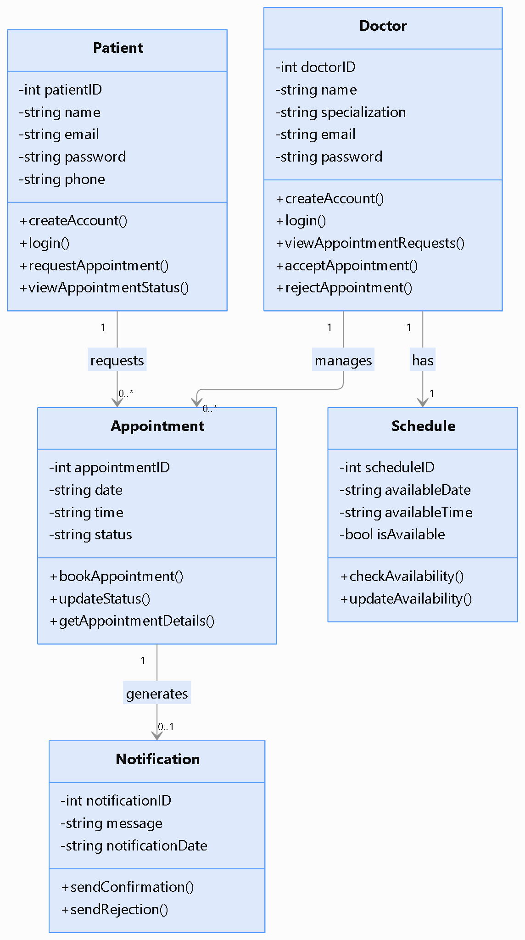
Explanation of Relationships
Relationship | Explanation
Patient — Appointment | One patient can request multiple appointments.
Doctor — Appointment | One doctor can manage multiple appointments.
Doctor — Schedule | Each doctor has a schedule.
Appointment — Notification | An appointment may generate a notification.
The system is divided into five classes. Each class performs a specific responsibility, making the system easier to understand, maintain, and develop.
Animal, Cat, and Dog Using Inheritance
Problem Understanding
We have a superclass named Animal.
The Animal class has two common functions:
- eat()
- sleep()
We create two subclasses:
- Cat
- Dog
The Cat class has its own function: - meow()
The Dog class has its own function: - bark()
UML Class Diagram
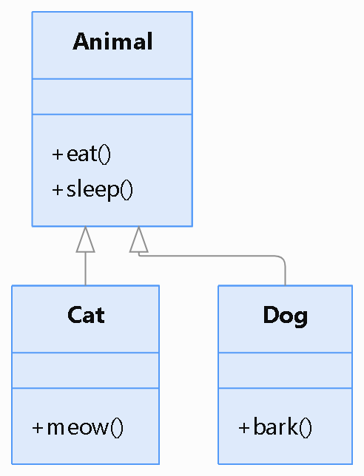
Explanation
The UML diagram shows that:
- Cat inherits from Animal.
- Dog inherits from Animal.
- Cat can use eat() and sleep().
- Dog can use eat() and sleep().
- Cat has its own meow() function.
- Dog has its own bark() function.
C++ Code
#include <iostream>
using namespace std;
// Superclass
class Animal
{
public:
void eat()
{
cout << "Animal is eating." << endl;
}

void sleep()
{
cout << "Animal is sleeping." << endl;
}
};
// Subclass Cat
class Cat : public Animal
{
public:
void meow()
{
cout << "Cat says Meow!" << endl;
}
};
// Subclass Dog
class Dog : public Animal
{
public:
void bark()
{
cout << "Dog says Woof!" << endl;
}
};
int main()
{
Cat cat;
Dog dog;
cout << "Cat Actions:" << endl;
cat.eat();
cat.sleep();
cat.meow();

cout << endl;

cout << "Dog Actions:" << endl;

dog.eat();
dog.sleep();
dog.bark();

return 0;
}
Inheritance allows Cat and Dog to reuse the common functions of Animal without writing the same code again.

Shape, Triangle, and Rectangle Using Inheritance
Problem Understanding
We create a superclass named Shape.
The Shape class represents a general geometric shape.We create two subclasses:
- Triangle
- Rectangle
The Triangle class takes the base and height as input and calculates its area.
The Rectangle class takes the length and width as input and calculates its area.
UML Class Diagram
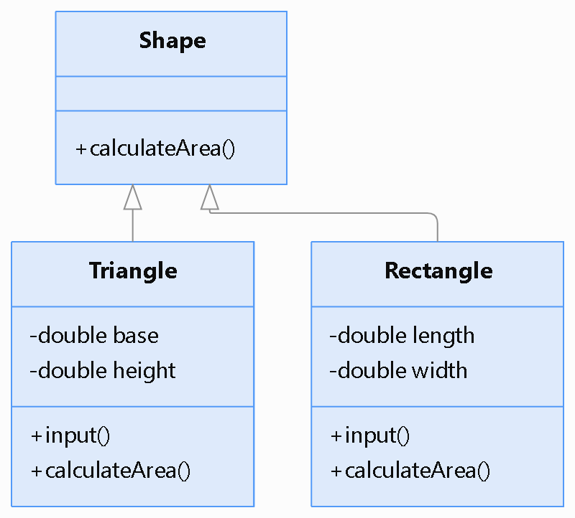
Explanation
The UML class diagram shows:
- Shape is the superclass.
- Triangle inherits from Shape.
- Rectangle inherits from Shape.
- Triangle has base and height attributes.
- Rectangle has length and width attributes.
- Both subclasses have their own input() and calculateArea() functions.
The calculateArea() function performs different calculations for Triangle and Rectangle.
C++ Code
#include <iostream>
using namespace std;
// Superclass
class Shape
{
public:
void calculateArea()
{
cout << "Area calculation of a shape." << endl;
}
};
// Subclass Triangle
class Triangle : public Shape
{
private:
double base;
double height;
public:
void input()
{
cout << "Enter base of triangle: ";
cin >> base;
cout << "Enter height of triangle: ";
cin >> height;
}
void calculateArea()
{
double area = 0.5 * base * height;
cout << "Area of Triangle = "
<< area << endl;
}
};
// Subclass Rectangle
class Rectangle : public Shape
{
private:
double length;
double width;
public:
void input()
{
cout << "Enter length of rectangle: ";
cin >> length;
cout << "Enter width of rectangle: ";
cin >> width;
}
void calculateArea()
{
double area = length * width;
cout << "Area of Rectangle = "
<< area << endl;
}
};
int main()
{
Triangle t;
Rectangle r;
cout << "Triangle Area Calculation" << endl;
t.input();
t.calculateArea();
cout << endl;
cout << "Rectangle Area Calculation" << endl;
r.input();
r.calculateArea();
return 0;
}
The program demonstrates inheritance by creating Triangle and Rectangle as subclasses of Shape. Both classes take input from the user and calculate their respective areas.
Overall Conclusion
This lab demonstrates important concepts of Object-Oriented Programming and Software Construction.
The following concepts were implemented:
- Class Identification: Identifying classes, attributes, and methods in a real-world problem.
- UML Class Diagrams: Representing classes and their relationships visually.
- Inheritance: Reusing common functionality through superclass and subclass relationships.
- Code Reusability: Avoiding repeated code by defining common methods in a superclass.
- User Input: Taking input from the user to perform calculations.
- Area Calculation: Applying mathematical formulas to calculate the areas of geometric shapes.
The Online Doctor Appointment Management System demonstrates class identification and relationships, while the Animal and Shape programs demonstrate inheritance in C++.

