

The University of Azad Jammu and Kashmir,
Muzaffarabad

Lab Title: Graphical User Interface (GUI)
Course Name: Software Construction and Development
Lab No : 05
Course Code: SE-3101
Submitted to: Engr. Dr. Asma Javaid

Student Name: Kamal Ali Akmal
Roll No: 2024-SE-38
Session: 2024-2028
Semester: 5th
Submission date: 10th November 2026

Create a User Login Page
We need to create a login form containing:
- CNIC – TextBox
- Password – TextBox
- Login – Button
- Hardcoded Validation – Check the CNIC and password against predefined values.
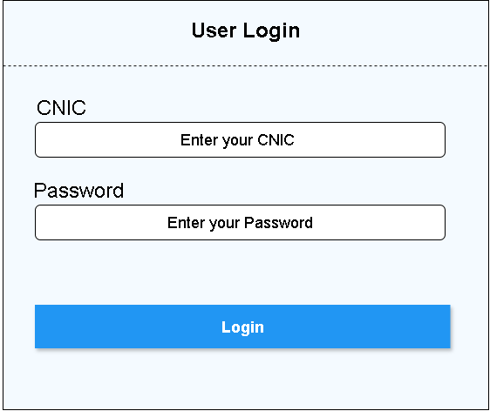

Create a User Information Form
We need to create a form containing:
- First Name: TextBox (Mandatory)
- Last Name: TextBox (Mandatory)
- Gender: Two RadioButtons:
  - Male
  - Female
- DOB: DatePicker
- Hobbies: Five Checkboxes:
  - Playing Cricket
  - Watching TV
  - Reading Books
  - Listening Music
  - Travelling to New Places
- Submit: Button
Validation Rules
Your form must follow these rules:
- First Name and Last Name must not be empty.
- Male must be selected by default.
- The default DOB must be the current date.
- Minimum selectable DOB: 1 October 1950.
- Maximum selectable DOB: Current date.
- When the Submit button is clicked, the program must validate the form.
- If the form is valid, display an Information MessageBox containing:
Welcome FirstName LastName


