

The University of Azad Jammu and Kashmir,
Muzaffarabad

Lab Title: Use Case Diagram
Course Name: Software Construction and Development
Lab No : 01
Course Code: SE-3101
Submitted to: Engr. Dr. Asma Javaid

Student Name: Kamal Ali Akmal
Roll No: 2024-SE-38
Session: 2024-2028
Semester: 5th
Submission date: 27th October 2026

Use Case Diagram for an Online Ticket Reservation System
Actors
- Customer/User: Searches for tickets, selects a ticket, enters details, pays, and receives confirmation.
- Payment Gateway: Processes online payment.
- Ticket Reservation System: The system boundary, containing the use cases.
Use cases
- Register or log in.
- Search for available tickets.
- View ticket details.
- Select a ticket.
- Enter passenger details.
- Make payment.
- Confirm reservation.
- Generate ticket.
- View or download ticket.
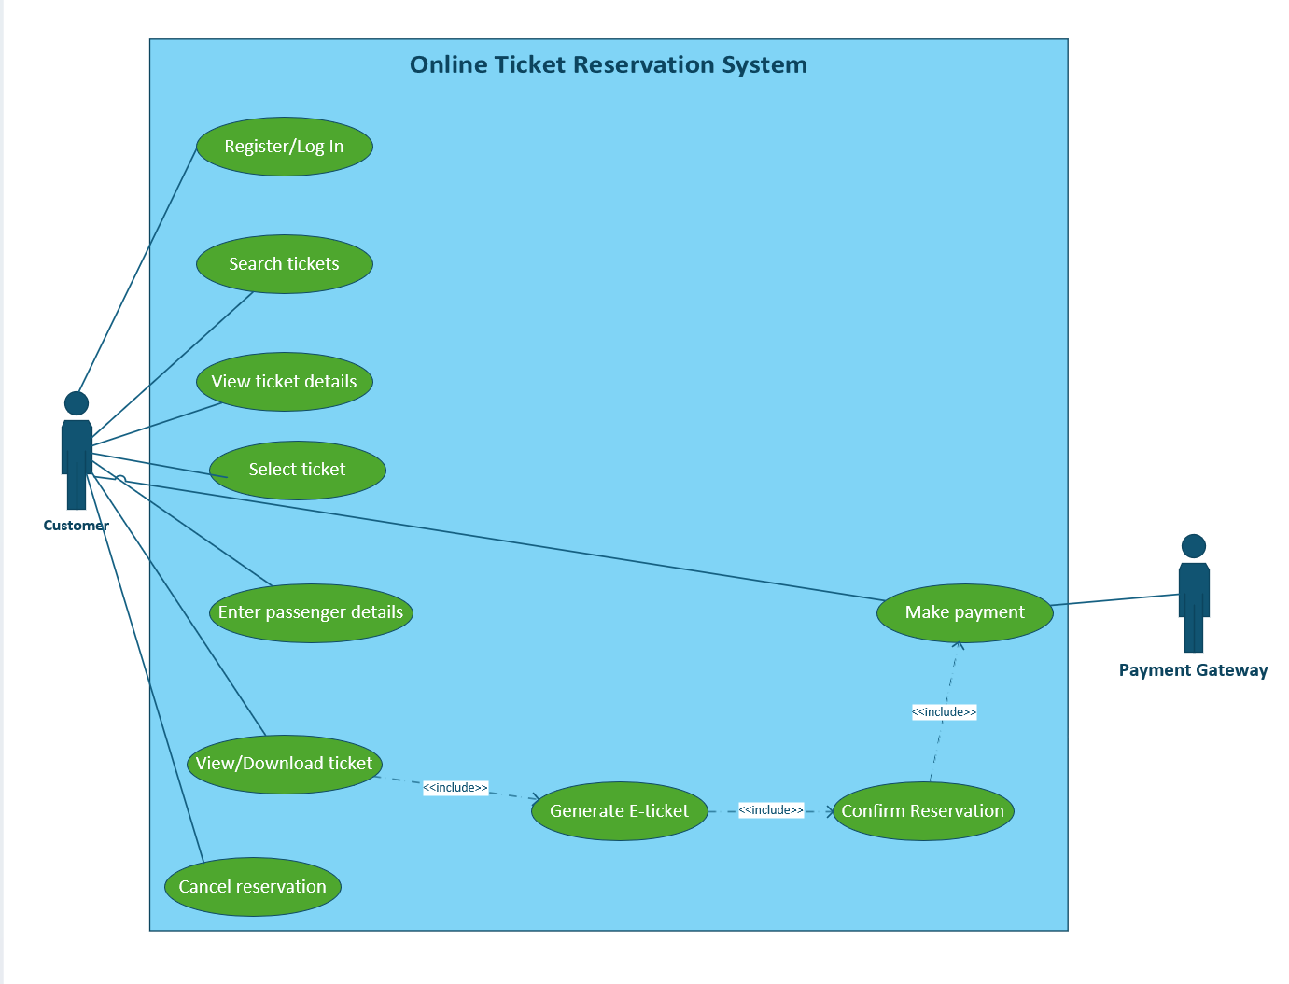
- Cancel reservation.
Explanation
The customer first searches for tickets and selects a suitable option. The customer then enters passenger details and makes payment through the payment gateway. After successful payment, the reservation is confirmed and an electronic ticket is generated.
Important: The diagram represents a reasonable design for the requested system. The lab does not specify a particular ticket type, so the design is generic.

Use Case Diagram for Credit Card Processing System
Actors
Actor | Responsibility
Customer | Selects items, presents a credit card, and signs the receipt.
Vendor / Shopkeeper | Prepares the bill and gives the receipt to the customer.
Credit Card Machine / Card Reader | Reads the card and processes the requested transaction.
Bank / Card Authorization System | Checks whether the transaction can be authorized and updates the transaction status.
The bank or authorization system is a reasonable external actor for a real credit card system, although it is not explicitly named in the case study.
Use cases
- Select item.
- Prepare bill.
- Present or swipe credit card.
- Enter transaction amount.
- Process transaction.
- Check available credit limit.
- Approve or decline transaction.
- Print receipt or transaction statement.
- Sign receipt.
- Return signed receipt to vendor.

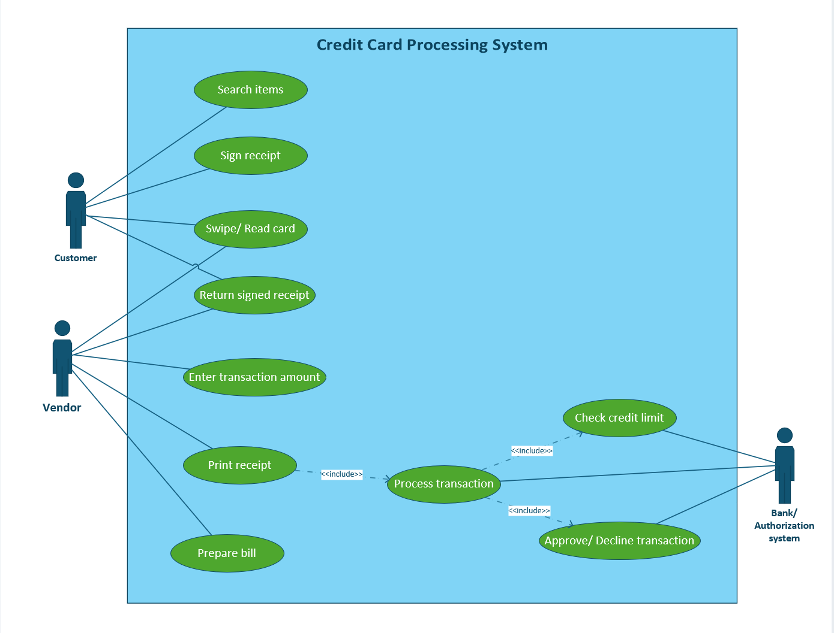
Working of the system
- The customer selects an item from the shop.
- The vendor prepares the bill.
- The customer gives the credit card to the vendor.
- The vendor reads the card and enters the amount.
- The transaction is sent for authorization.
- The system checks the credit limit and returns an approval or decline.
- The machine prints a receipt or transaction statement.
- The customer signs the receipt and returns it to the vendor.

