

The University of Azad Jammu and Kashmir,
Muzaffarabad

Lab Title: Activity Diagram and State Diagrams
Course Name: Software Construction and Development
Lab No : 02
Course Code: SE-3101
Submitted to: Engr. Dr. Asma Javaid

Student Name: Kamal Ali Akmal
Roll No: 2024-SE-38
Session: 2024-2028
Semester: 5th
Submission date: 27th October 2026

Activity Diagram of Foodpanda Using Swimlanes
A swimlane activity diagram divides the workflow according to the person or system responsible for each activity.
Swimlanes
- Customer: Selects food, places the order, and makes payment.
- Foodpanda Application: Displays restaurants, sends orders, and updates order status.
- Restaurant: Accepts the order and prepares the food.
- Delivery Rider: Collects and delivers the food.
Activity Diagram
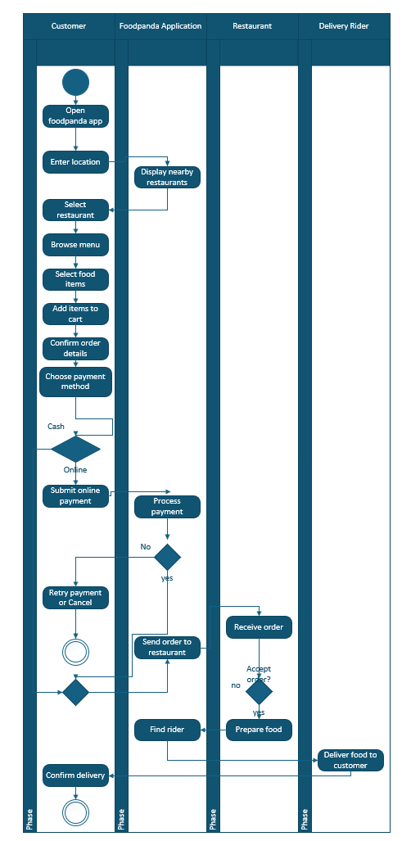
Explanation
- The customer opens the application and enters a delivery location.
- The application displays nearby restaurants.
- The customer selects a restaurant, chooses food, and adds it to the cart.
- The customer confirms the order and selects a payment method.
- If online payment is selected, the application processes it. If payment fails, the customer can retry or cancel.
- The restaurant receives the order and either accepts or rejects it.
- If accepted, the restaurant prepares the food.
- The application arranges a delivery rider.
- The rider collects the food and delivers it to the customer.
- The customer receives the order and confirms delivery.
State Diagram for a Toaster
Objective: Draw a state diagram for a toaster, list activities within each state, and identify triggered and triggerless events/actions.
A state diagram describes the different states of an object and the events that cause it to move from one state to another.
States and activities
State | Activity
Off | The toaster is not heating.
Ready | The toaster has power and is ready for bread.
Loading | The user inserts bread into the toaster.
Toasting | The heating elements toast the bread.
Completed | The bread has finished toasting.
Ejecting | The toaster raises the bread.
Fault | The toaster detects a problem and stops heating.

State diagram
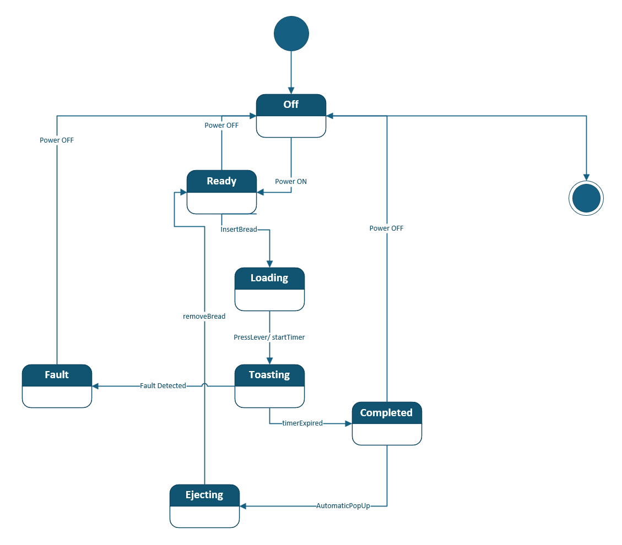
Triggered and triggerless events/actions
A triggered transition occurs because an event happens. A triggerless transition occurs without an explicit event trigger; it can happen when a condition is satisfied or a state is completed.
Type | Example | Explanation
Triggered event | powerOn | The user switches on the toaster.
Triggered event | insertBread | The user inserts bread.
Triggered event | pressLever | The user pushes down the lever.
Triggered event | timerExpired | The timer signals that toasting is complete.
Triggered event | faultDetected | The toaster detects a fault.
Triggerless transition | automaticPopUp | In this model, the toaster automatically raises the bread after toasting.
Triggerless transition | Automatic return to Ready | The toaster returns to the ready state after the bread is removed, if modeled as an automatic transition.
The diagram above labels automaticPopUp as an event for clarity. In a strictly triggerless UML model, the transition from Completed to Ejecting would have no event label; the toaster would move automatically.
Actions performed in each state
- Off: Heating elements remain inactive.
- Ready: Wait for bread to be inserted.
- Loading: Position the bread and wait for the lever to be pressed.
- Toasting: Heat the bread and monitor the timer.
- Completed: Stop heating.
- Ejecting: Raise the toast.
- Fault: Stop heating and prevent normal operation until the fault is cleared.
Important distinction: A state describes what condition the toaster is in. An event describes what causes a transition. An action describes what the toaster does.
State Machine Diagram of an Elevator/Lift
An elevator changes its state when passengers press buttons, doors open or close, or the elevator reaches a requested floor.
State | Description
Idle | The elevator is waiting at a floor.
Door Opening | The doors are opening.
Door Open | Passengers can enter or leave.
Door Closing | The doors are closing.
Moving Up | The elevator travels to a higher floor.
Moving Down | The elevator travels to a lower floor.
Emergency | Normal movement stops because an emergency is detected.

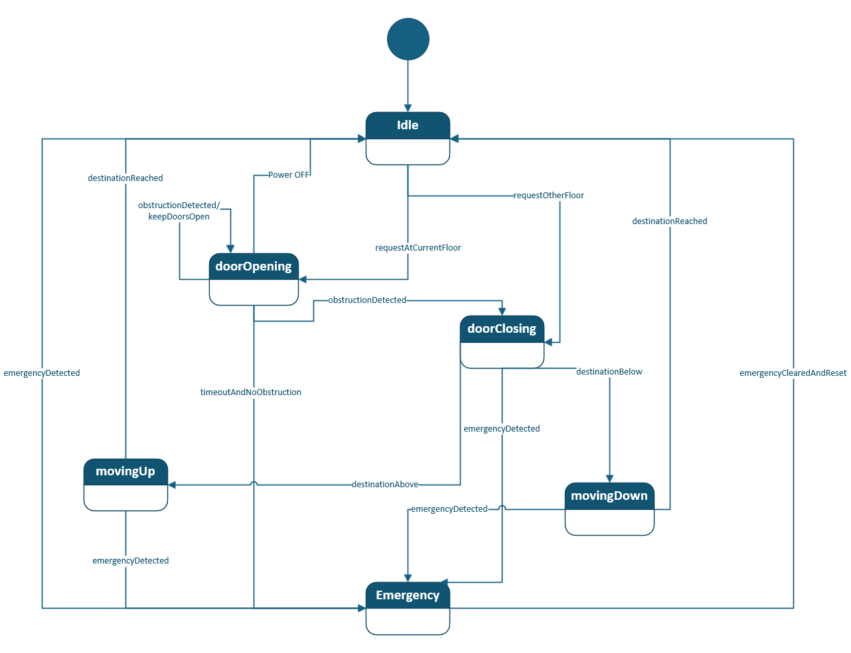
Explanation of the working
- Idle: The elevator waits for a passenger request.
- Door Opening: When a passenger requests service at the current floor, the doors open.
- Door Open: Passengers enter or leave. If an obstruction is detected, the doors remain open.
- Door Closing: The doors close after the waiting period, provided there is no obstruction.
- Moving Up: If the requested destination is above the current floor, the elevator moves upward.
- Moving Down: If the destination is below the current floor, the elevator moves downward.
- Destination Reached: The elevator stops at the destination and returns to Idle. In a more detailed model, it would open the doors again.
- Emergency: If an emergency is detected, normal operation stops. The elevator returns to normal operation only after the emergency is cleared and the system is reset.
Events and actions
Event | Action or transition
Passenger presses a floor button | Record the destination request.
Destination is above | Move to Moving Up.
Destination is below | Move to Moving Down.
Destination reached | Stop the elevator.
Doors fully open | Enter Door Open.
Obstruction detected | Reopen or keep the doors open.
Emergency detected | Enter Emergency state.
Emergency cleared and reset | Return to normal operation.
This is a simplified educational model. A real elevator has additional safety interlocks, door-lock checks, floor sensors, and control logic.

