

The University of Azad Jammu and Kashmir,
Muzaffarabad

Name | Kamal Ali Akmal
Course Name | Computer Networks
Submitted to | Engr. Dr. Asma Javaid
Semester | 4th
Session | 2024-2028
Roll No | 2024-SE-38
Lab No | 05
Submission date | 02 April 2026

Create and Test a Two LAN’s in Cisco Packet Tracer
Step 01: Open Cisco Packet Tracer and take two switches and six PCs. Click on the PCs. Go to the Desktop tab. Click on IP Configuration. Enter the IP Addresses and Subnet Masks to all PCs as instructed.
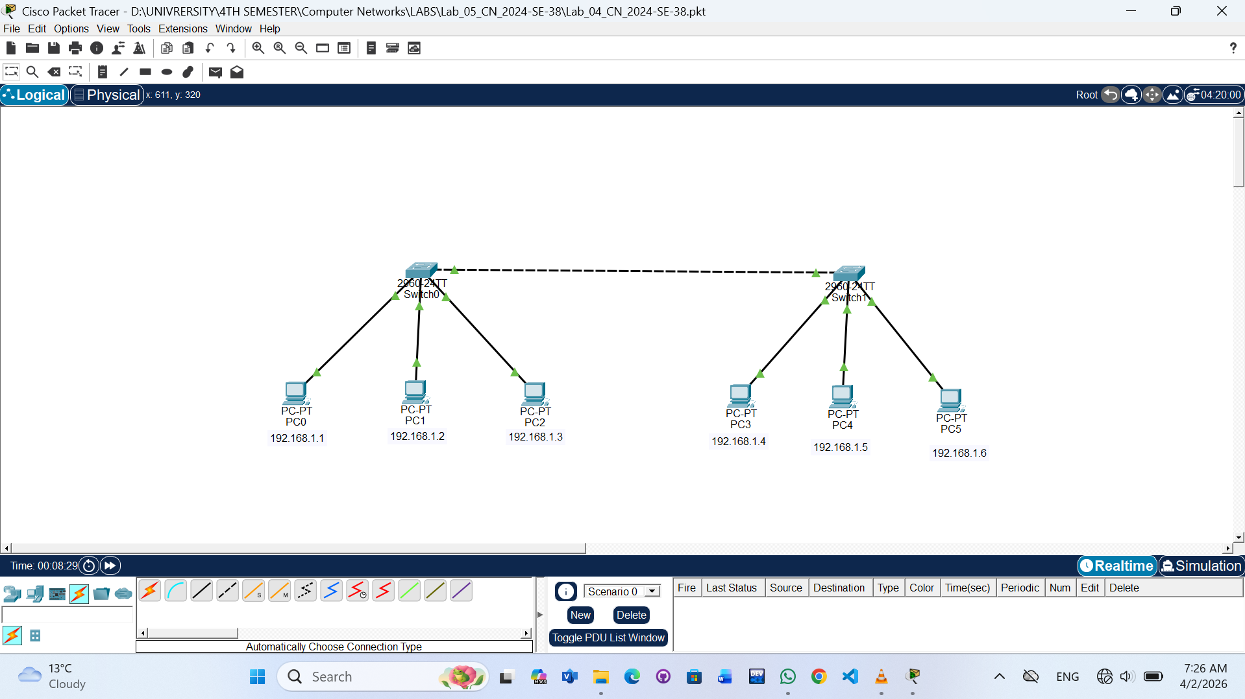
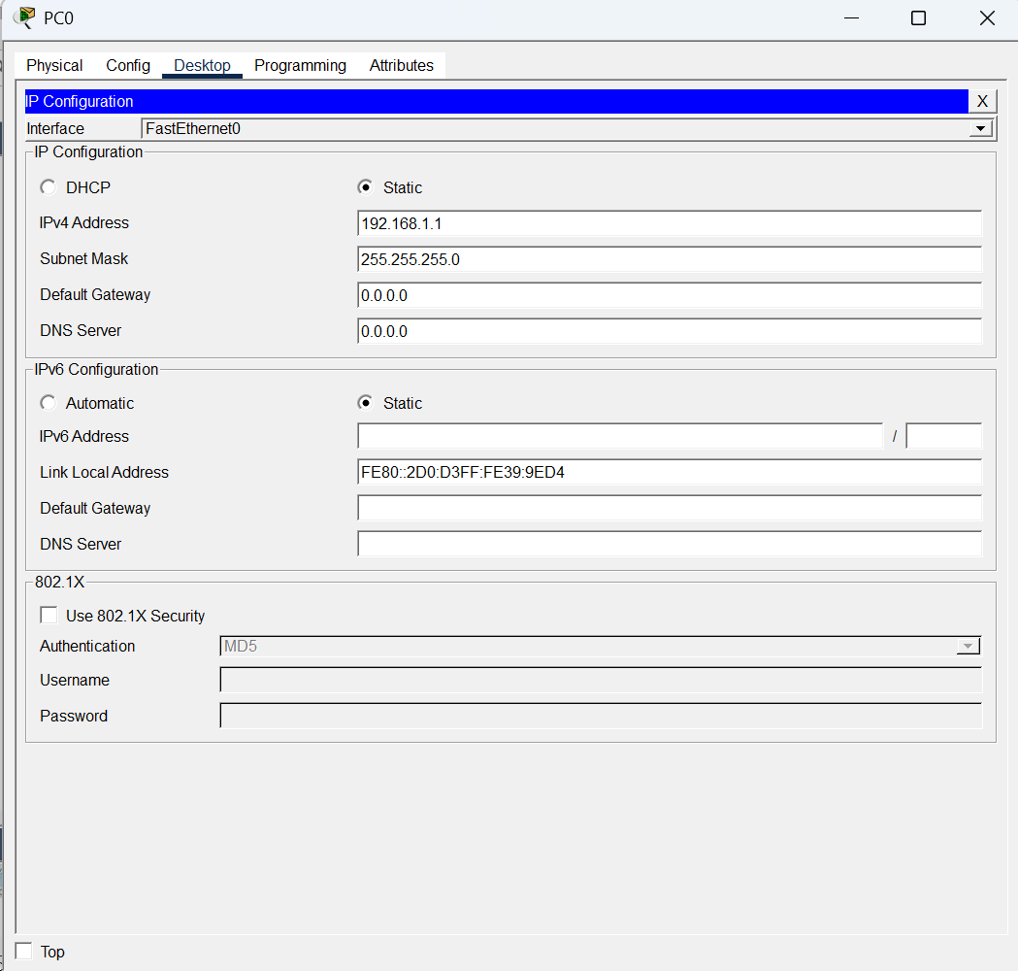
Step 02: Packet has been given to each PC and start simulation.
