

The University of Azad Jammu and Kashmir,
Muzaffarabad

Lab Title: Basic Router Access and CLI Configuration
Course Name: Database Systems
Lab No: 06
Course Code: CS-2203
Submitted to: Engr. Dr. Asma Javaid

Student Name: Kamal Ali Akmal
Roll No: 2024-SE-38
Session: 2024-2028
Semester: 4th
Submission date: 7th May 2026

Basic Router Access and CLI Configuration
Introduction
Network devices such as routers and switches must be configured before they can operate in a network. Configuration is usually done through the Command Line Interface (CLI). There are two main ways to interact with networking devices:
• GUI (Graphical User Interface)
• CLI (Command Line Interface)
In networking, CLI is widely used because it provides more control and flexibility.
Connecting to Network Devices
To configure routers or switches directly, a computer must be connected to the device using a console connection.
Common connection components:
• Console Port on router/switch
• RJ45 Console Cable
• DB9 Connector (older PCs)
• USB Mini Console Port (newer devices)
• Rollover Cable used for console connection
Task
Step 1: Open Router
- Go to Cisco Packet Tracer
- Drag a router
- Click it → go to CLI tab

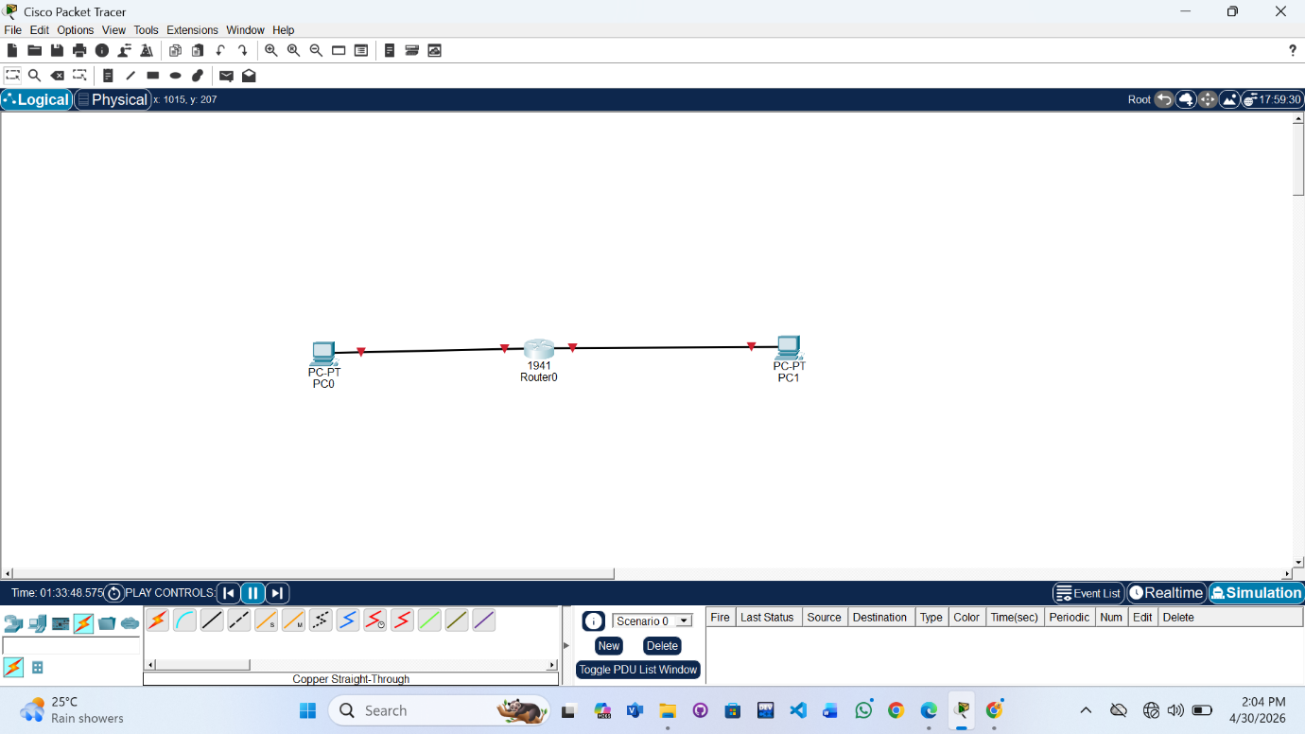
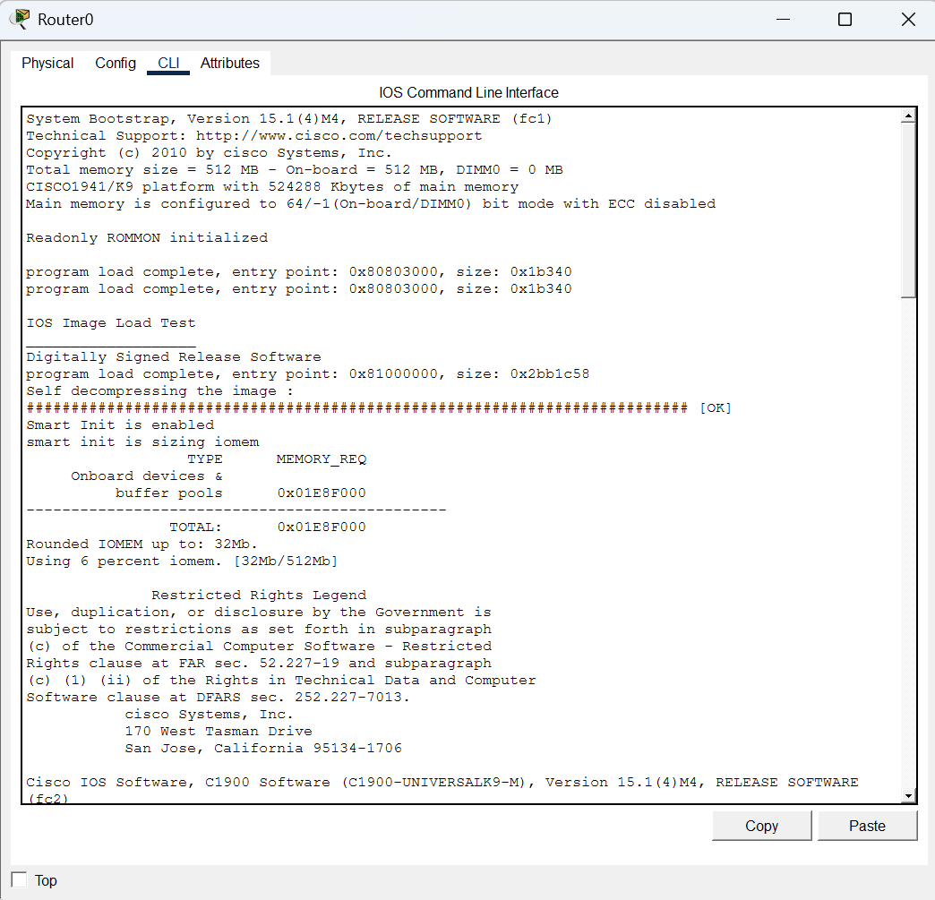
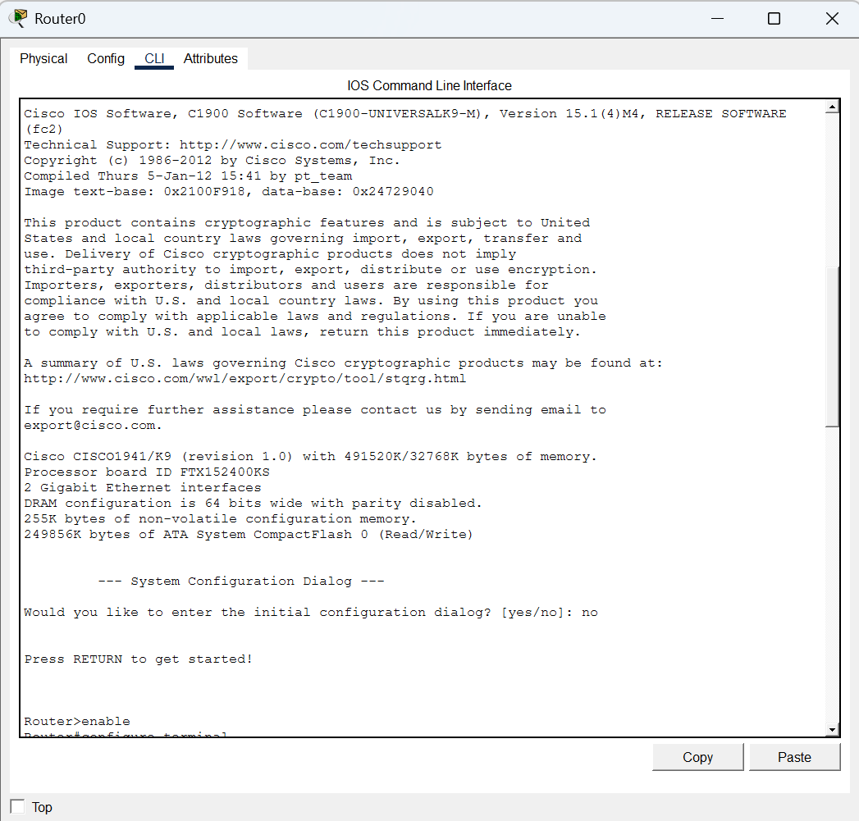
Step 2: Enter Modes, Set passwords and Encrypt passwords
Router> enable
Router# configure terminal
Router(config)#
Router(config)# enable password 123
Router(config)# enable secret 456
If both exist → enable secret overrides password
Router(config)# service password-encryption
This converts visible passwords into encrypted form
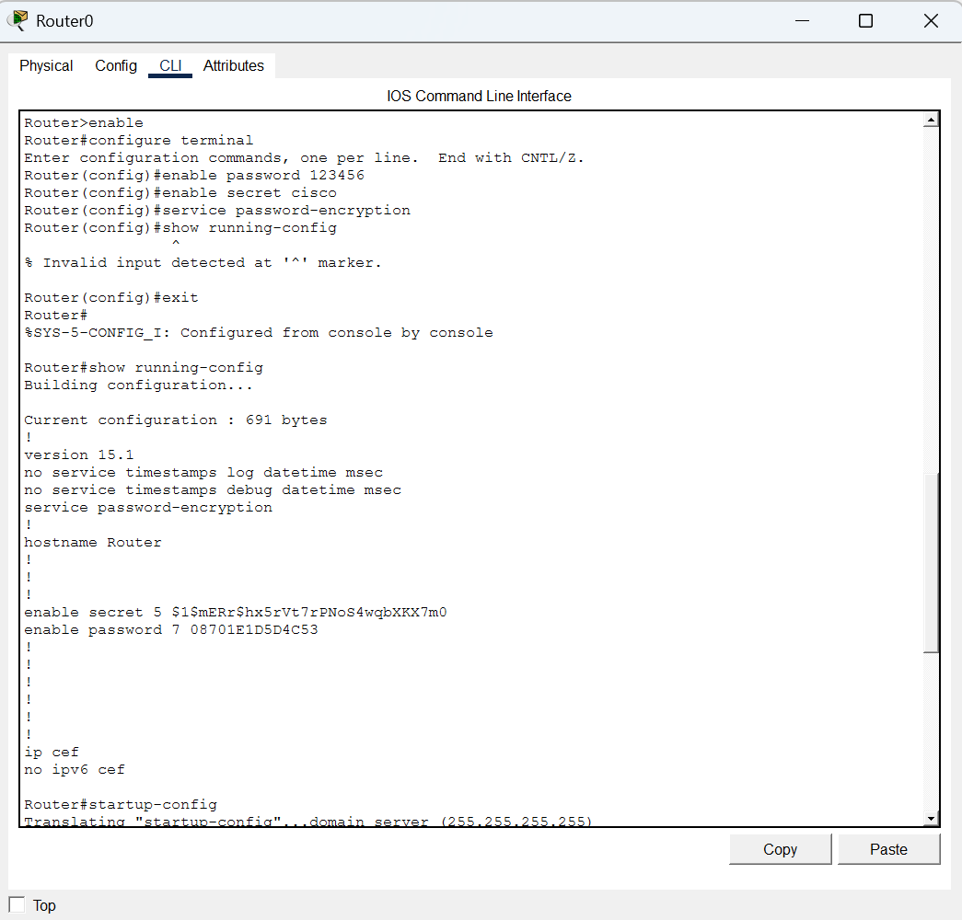

Step 3: Check configurations
Router# show running-config
Router# show startup-config
