

The University of Azad Jammu and Kashmir,
Muzaffarabad

Name | Kamal Ali Akmal
Course Name | Computer Networks
Submitted to | Engr. Dr. Asma Javaid
Semester | 4th
Session | 2024-2028
Roll No | 2024-SE-38
Lab No | 04
Submission date | 28 March 2026

Create and Test a Simple LAN in Cisco Packet Tracer
Step 01: Open Cisco Packet Tracer and take one switch and four PCs.
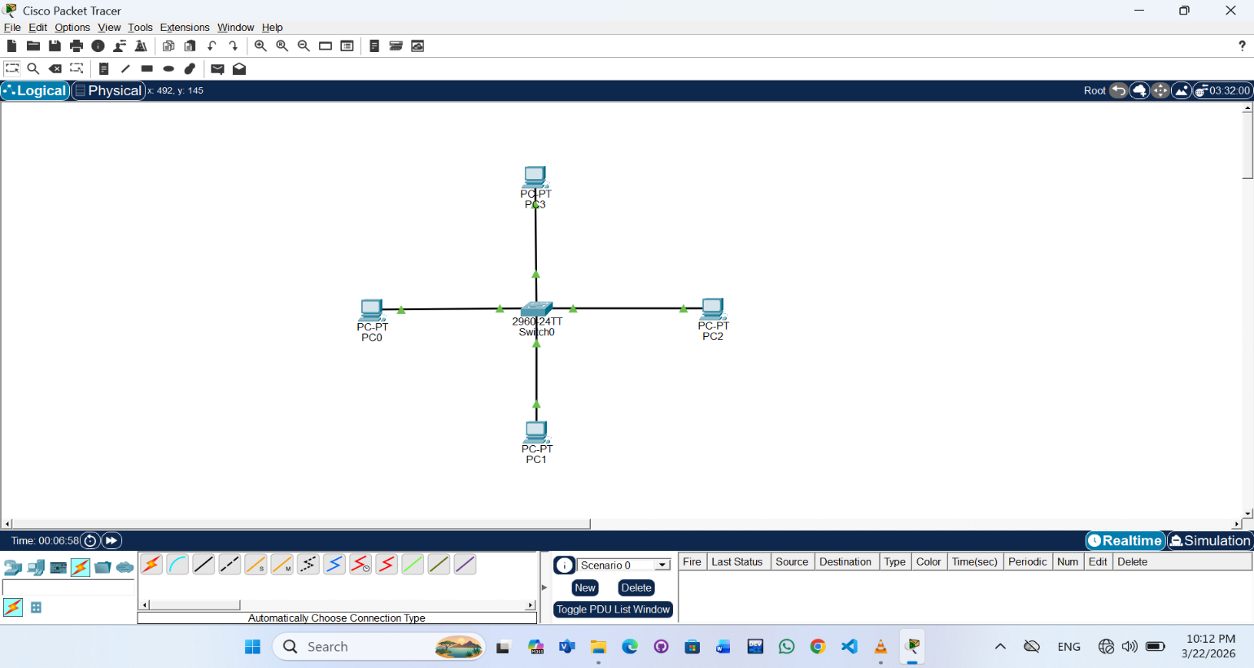
Step 02: Click on the PC. Go to the Desktop tab. Click on IP Configuration. Enter the IP Address and Subnet Mask as instructed.
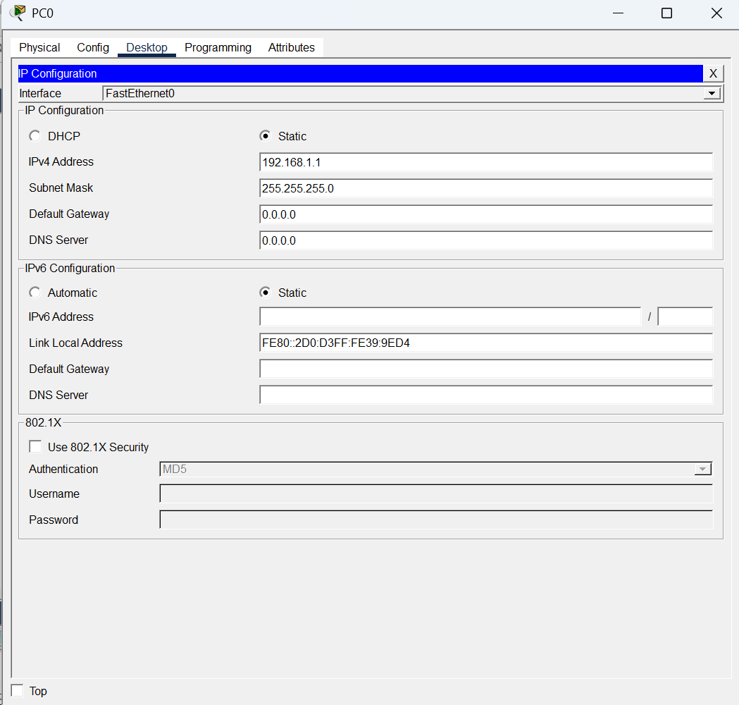
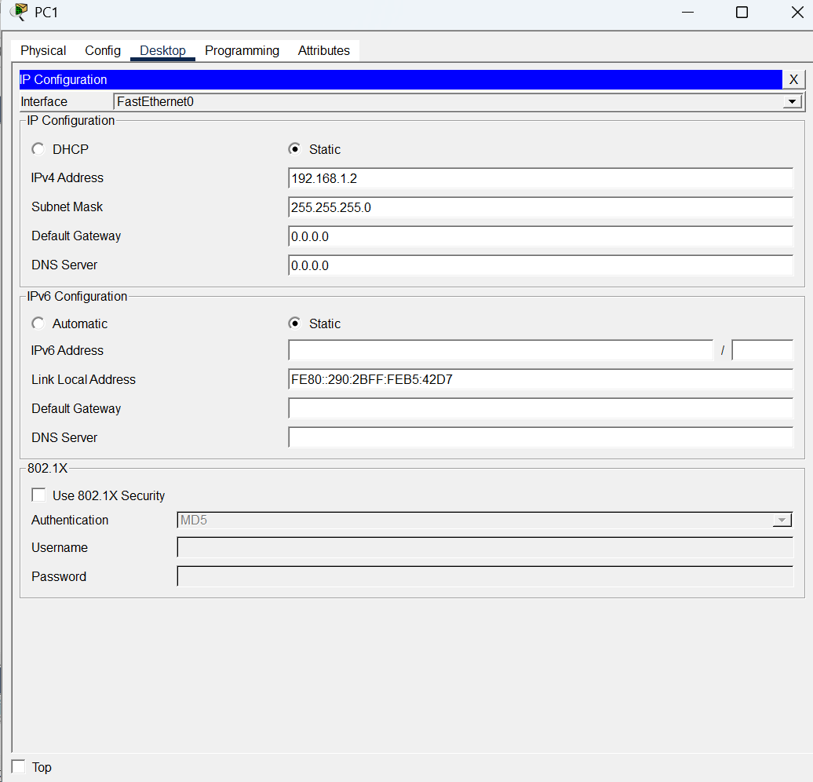
Step 03: Packet has been given to each PC and start simulation.
