

The University of Azad Jammu and Kashmir,
Muzaffarabad

Lab Title: Switching and ARP (MAC Address Learning)
Course Name: Computer Networks
Lab No: 07
Course Code: CS-2203
Submitted to: Engr. Dr. Asma Javaid

Student Name: Kamal Ali Akmal
Roll No: 2024-SE-38
Session: 2024-2028
Semester: 4th
Submission date: 17 May 2026

Switching and ARP (MAC Address Learning)
Objective
The objective of this lab is to understand the working of network switches and the ARP (Address Resolution Protocol). The lab also aims to study how switches learn MAC addresses dynamically and store them in the MAC address table for frame forwarding.
Introduction
A network switch is a Layer 2 networking device used to connect multiple devices in a Local Area Network (LAN). A switch forwards frames based on MAC addresses instead of broadcasting data to every device. When a switch receives a frame and does not know the destination MAC address, it floods the frame to all ports except the source port.
ARP (Address Resolution Protocol) is used to map an IP address to a MAC address before communication occurs between devices in a network. During communication, the switch learns the MAC addresses of connected devices and stores them in the MAC address table, also called the CAM table.
Task
Step 1: Create network topology.
- 2 PCs
- 1 Switch
- Straight-through cables
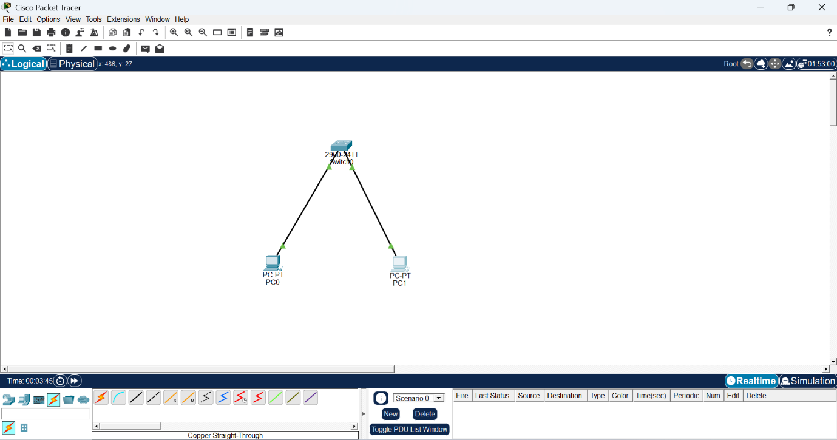
Step 2: IP Configuration
IP addresses were assigned to both PCs in the same network.
- PC0 → 192.168.1.1
- PC1 → 192.168.1.2
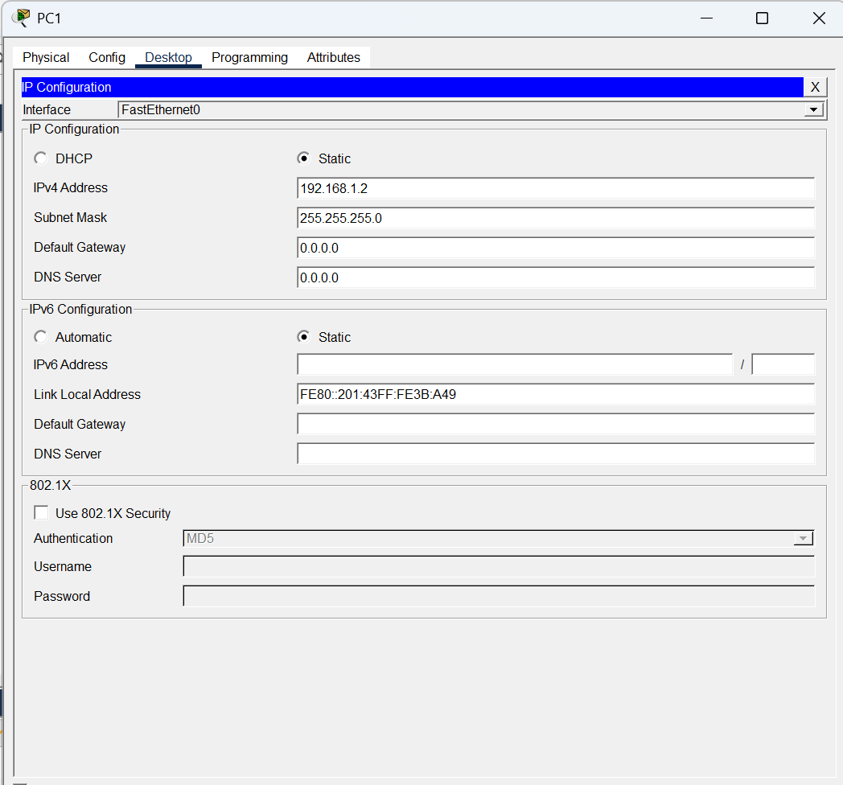
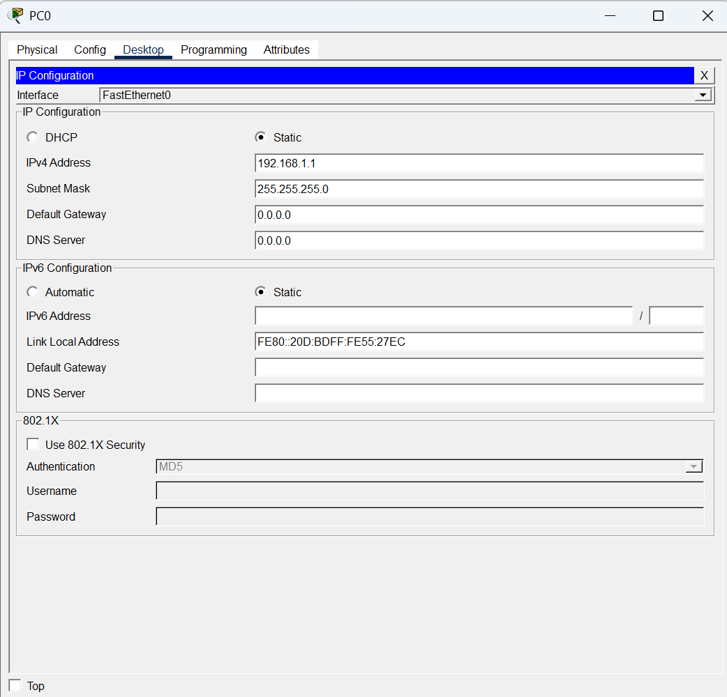
Step 3: Checking MAC Address Table Before Communication
The switch CLI was opened, and the following command was executed:
show mac address-table
Initially, the MAC address table was empty or contained limited entries because communication had not started yet.
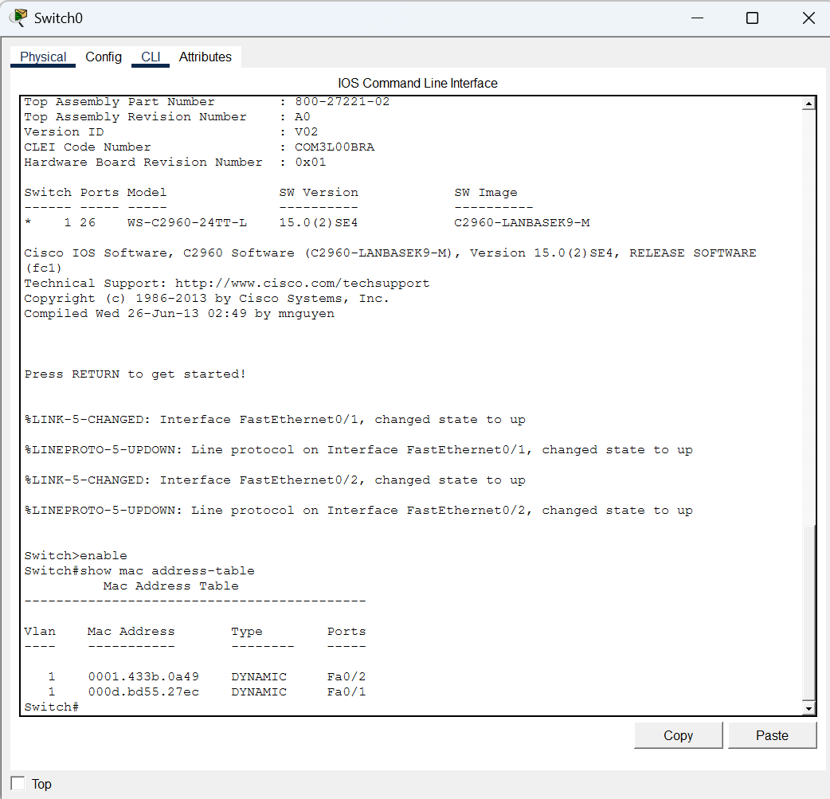
Step 4: Ping Communication
A ping request was sent from PC0 to PC1 using the following command:
ping 192.168.1.2
During this process, ARP was used to resolve the destination MAC address.
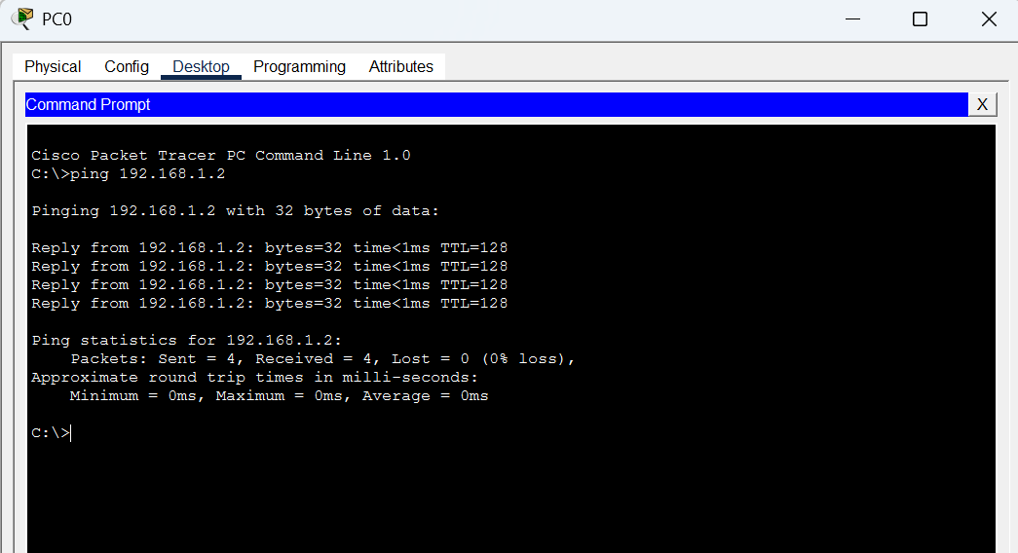
Step 5: Verifying MAC Address Table After Communication
After successful communication, the switch learned the MAC addresses dynamically. The MAC table was checked again using:
show mac address-table
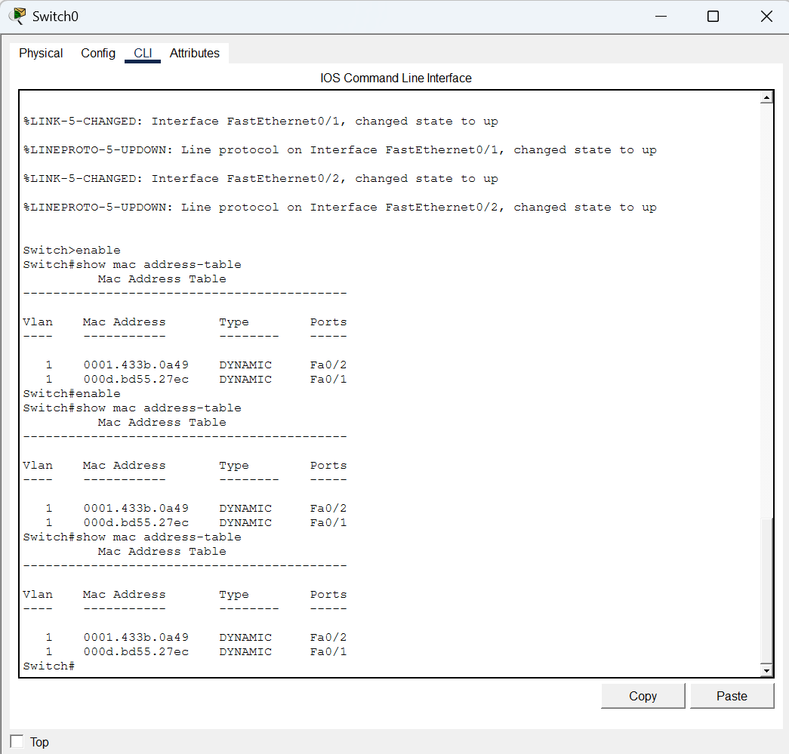
The learned MAC addresses of both PCs were displayed in the table.
Step 6: Clearing MAC Address Table
The dynamic MAC entries were cleared using:
clear mac address-table dynamic
The table was verified again using:
show mac address-table
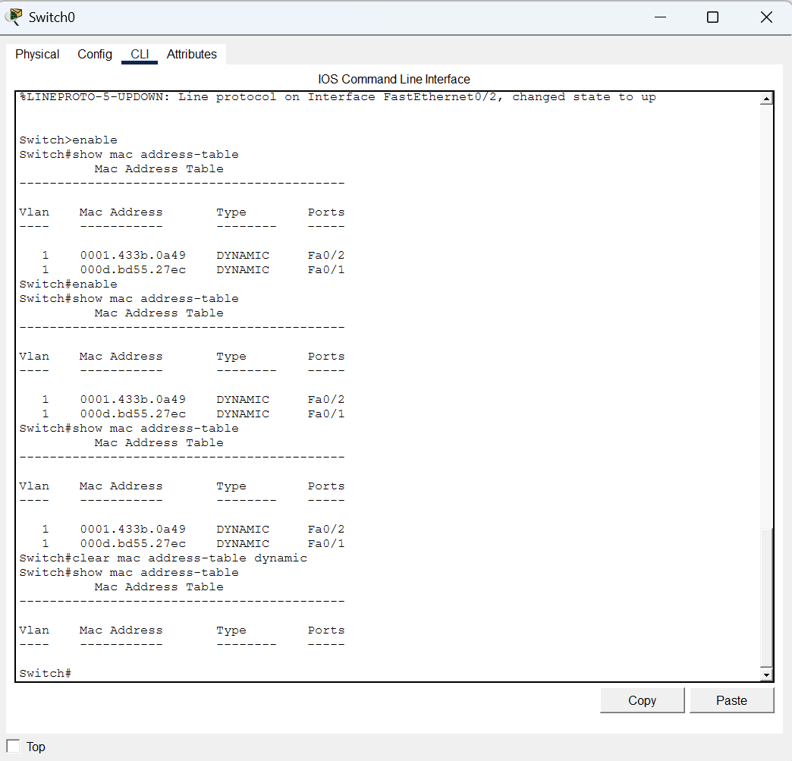

Observations
- Initially, the switch MAC address table was empty.
- During the first ping, ARP requests were broadcasted in the network.
- The switch dynamically learned the MAC addresses of connected devices.
- After communication, the MAC address table contained MAC entries of both PCs.
- Clearing the table removed all dynamically learned entries.

Result
The lab was performed successfully. The working of switching, ARP communication, and MAC address learning was observed practically using Cisco Packet Tracer. The switch successfully learned MAC addresses dynamically and stored them in the MAC address table.

Conclusion
This lab provided practical understanding of switching and ARP operations in a LAN environment. It demonstrated how switches use MAC addresses to forward frames efficiently and how ARP resolves IP addresses into MAC addresses before communication. The behavior of the MAC address table was also studied, including learning and clearing MAC entries. The experiment improved understanding of Layer 2 communication and switching behavior in computer networks.

