

The University of Azad Jammu and Kashmir,
Muzaffarabad

Name | Kamal Ali Akmal
Course Name | Computer Networks
Submitted to | Engr. Dr. Asma Javaid
Semester | 4th
Session | 2024-2028
Roll No | 2024-SE-38
Lab No | 01
Submission date | 05 March 2026

Installation of Cisco Packet Tracer

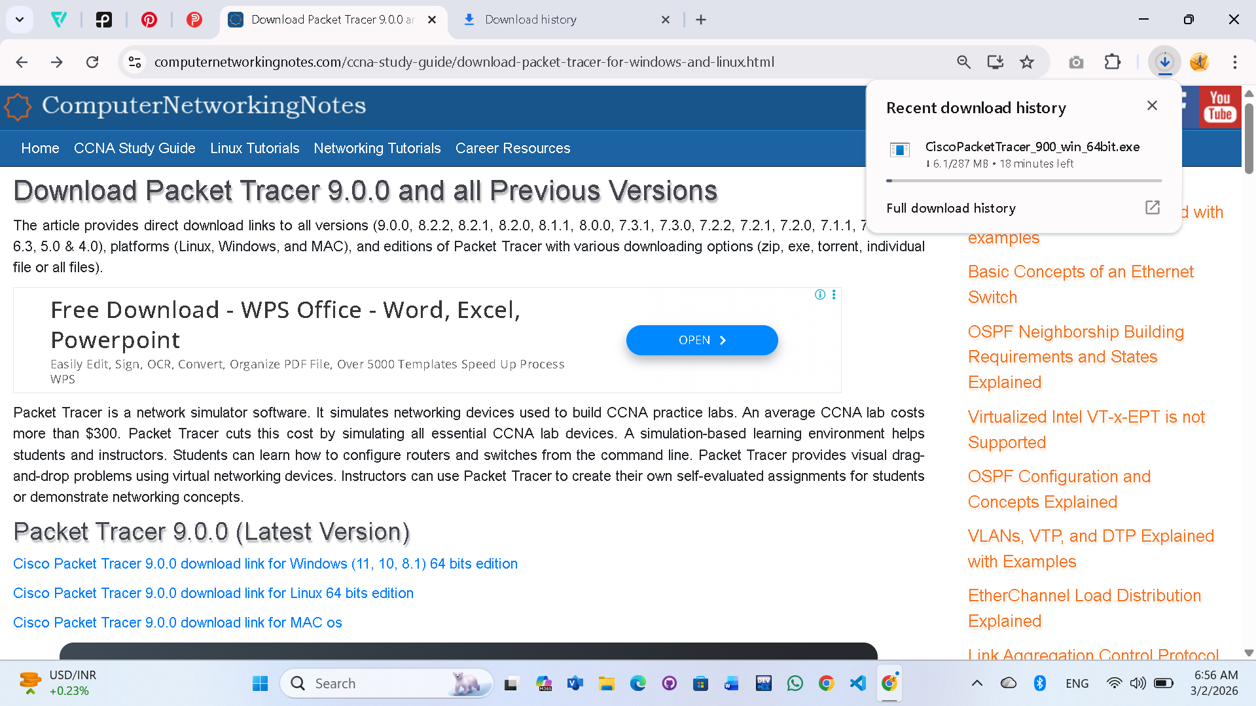
Step 01: Search for the cisco packet tracer on google and click on download.
Step 02: Accept the license agreement.
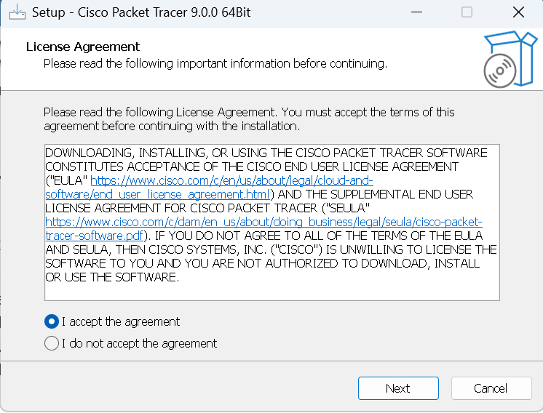
Step 03: Choose a path where you want to download it on PC.
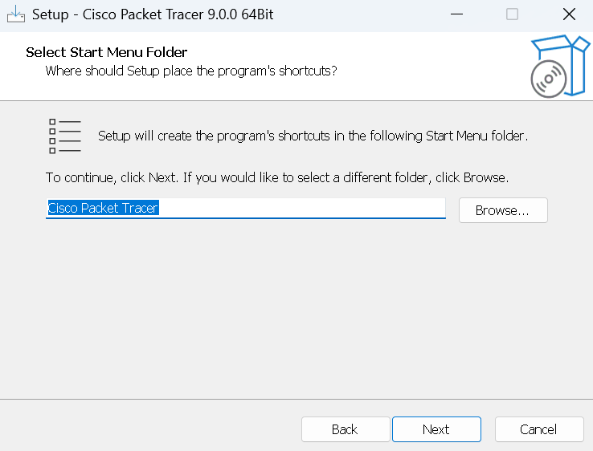
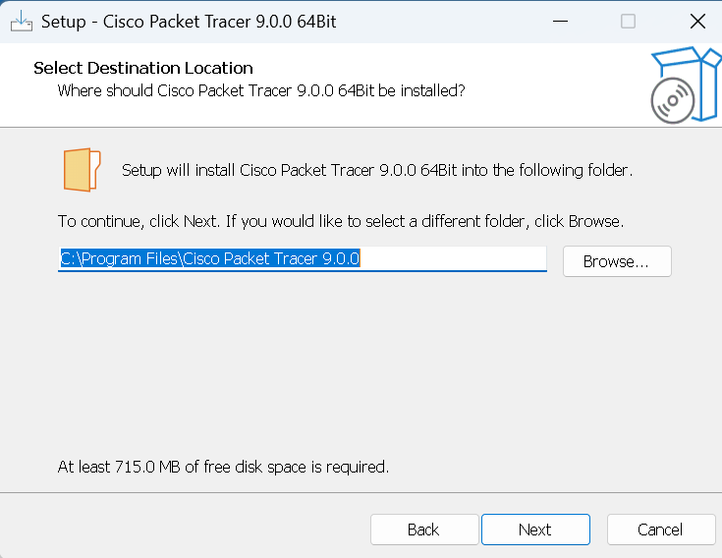

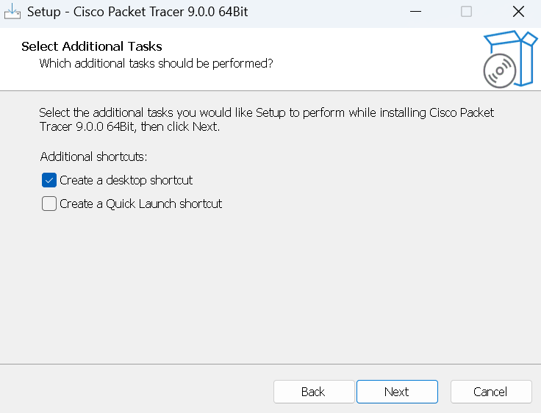
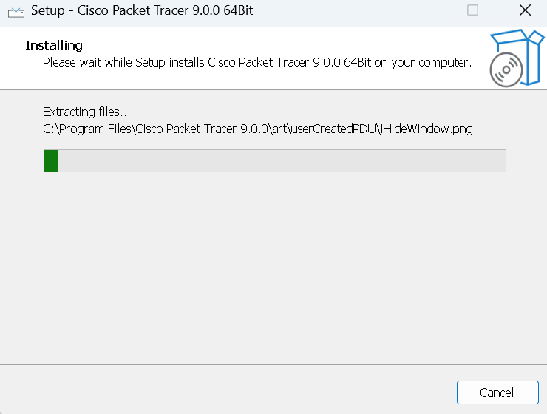
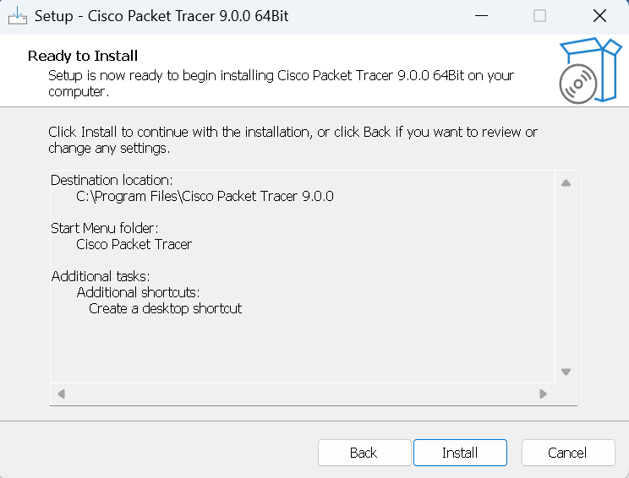
Step 04: Click on Install.
Step 05: Click on Finish.
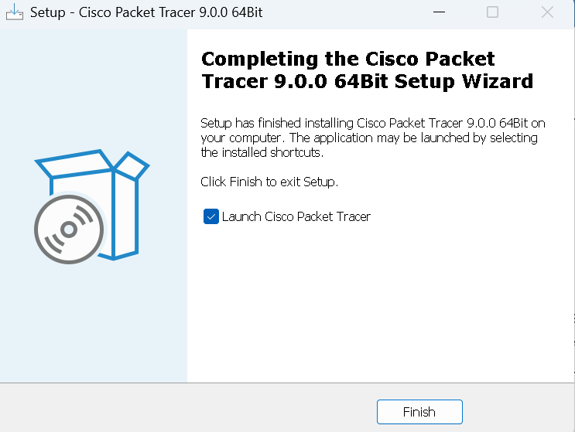
Step 06: Interface of Cisco Packet Tracer shown.
