

The University of Azad Jammu and Kashmir,
Muzaffarabad

Name | Kamal Ali Akmal
Course Name | Computer Networks
Submitted to | Engr. Dr. Asma Javaid
Semester | 4th
Session | 2024-2028
Roll No | 2024-SE-38
Lab No | 02
Submission date | 12 March 2026

Create and Test a Simple LAN in Cisco Packet Tracer
Step 01: Open Cisco Packet Tracer and take one switch and two PCs.
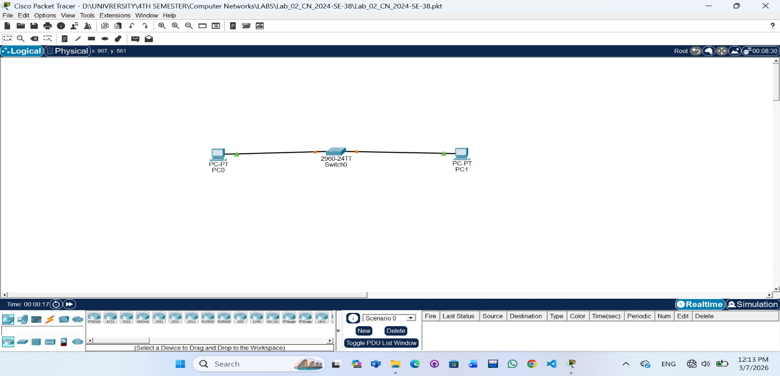
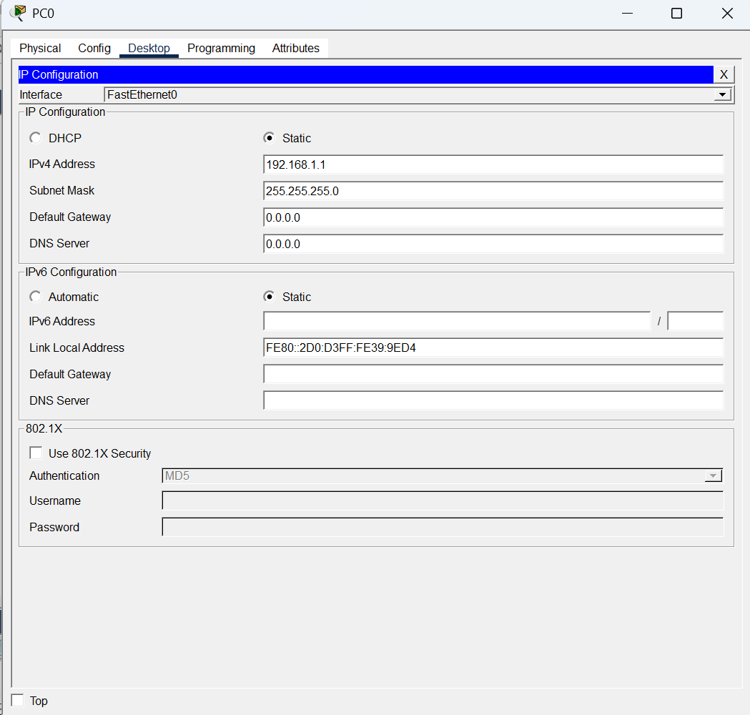
Step 02: Click on the PC. Go to the Desktop tab. Click on IP Configuration. Enter the IP Address and Subnet Mask as instructed.
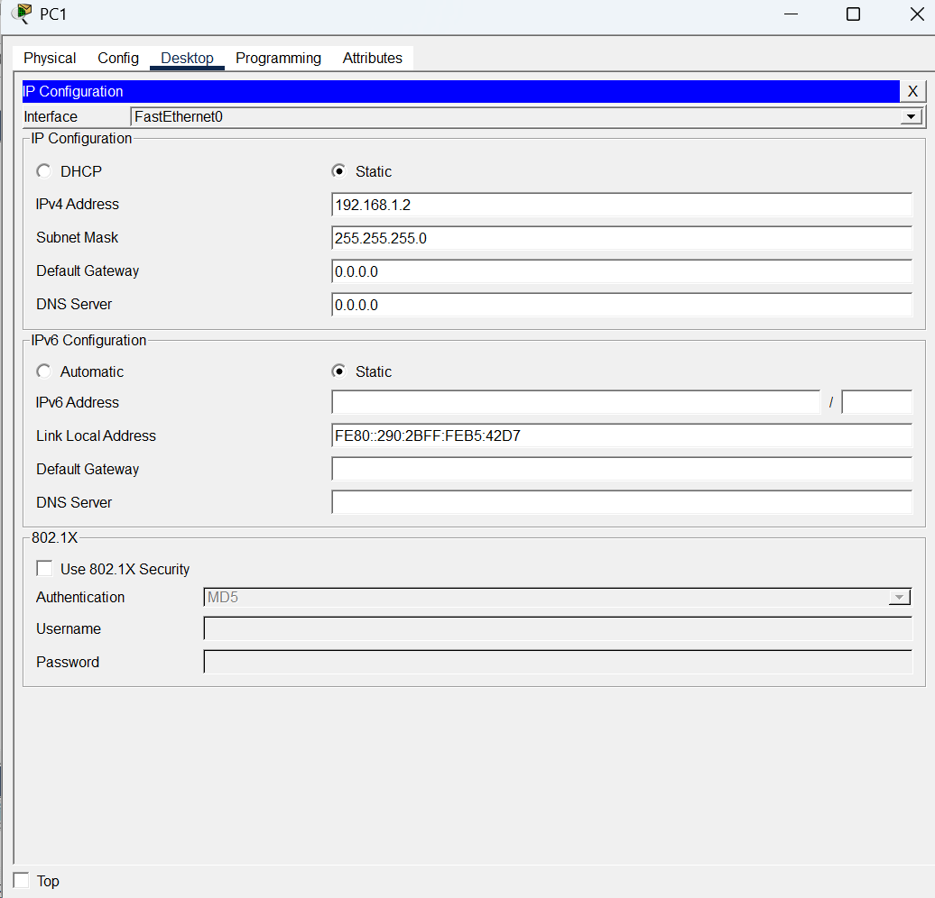
Step 03: 1. ipconfig
Displays the current IP address configuration of the PC.
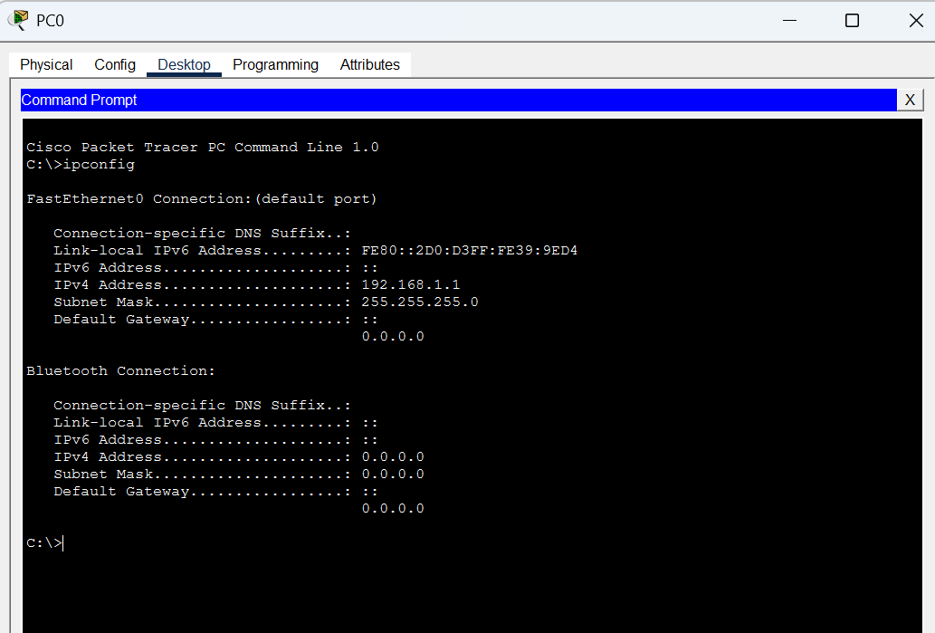
Step 04: 2. ping
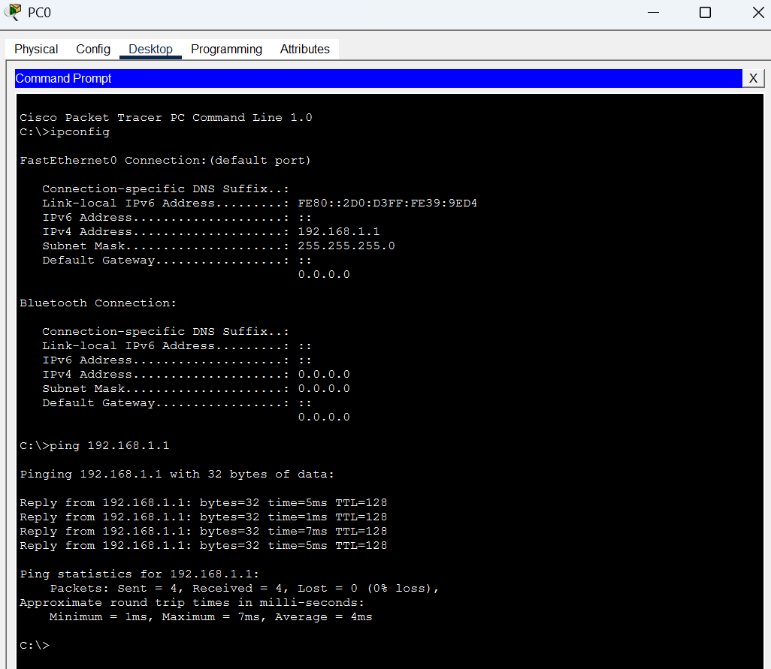
Tests connectivity between two network devices.

Step 05: 3. tracert
Shows the path taken by packets to reach the destination.
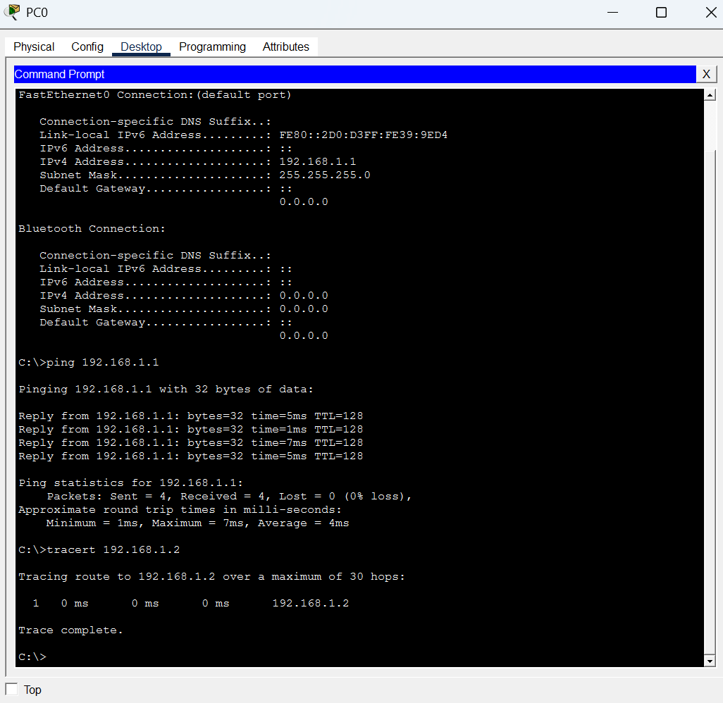

Step 06: 4. arp -a
Displays the ARP table (IP to MAC address mapping).
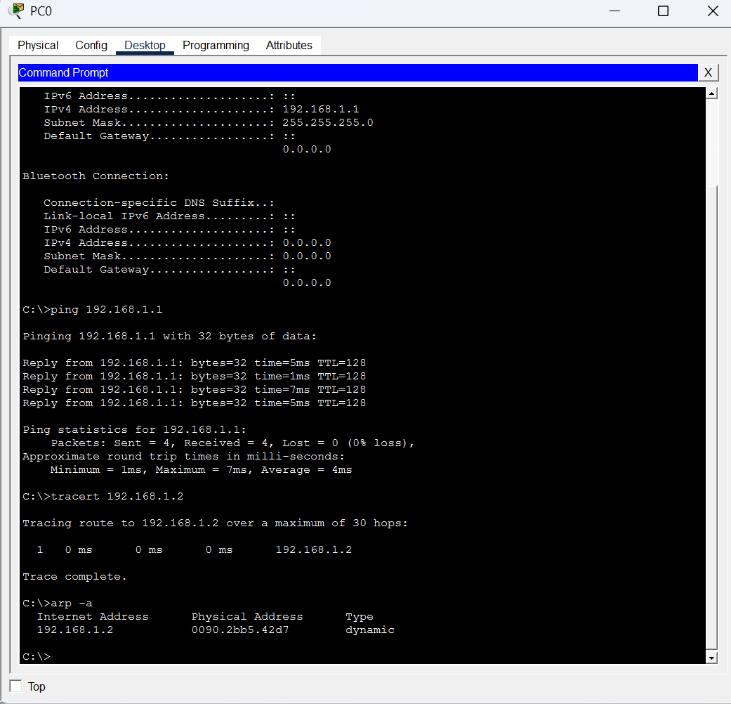
Step 07: 5. netstat
Displays active network connections and statistics.
