

**The University of Azad Jammu and Kashmir,**

**Muzaffarabad**

|  |  |
| --- | --- |
| Name | Kamal Ali Akmal |
| Course Name | Data Structure & Algorithm |
| Submitted to | Engr. Sidra Rafique |
| Semester | 3rd |
| Session | 2024-2028 |
| Roll No | 2024-SE-38 |
| Lab No | 01 |
| Submission date | 23 October 2025 |

**Question:**

***Write a program that reads 5 numbers using array, finds sum and maximum as well.***

**Answer:**

**Code**

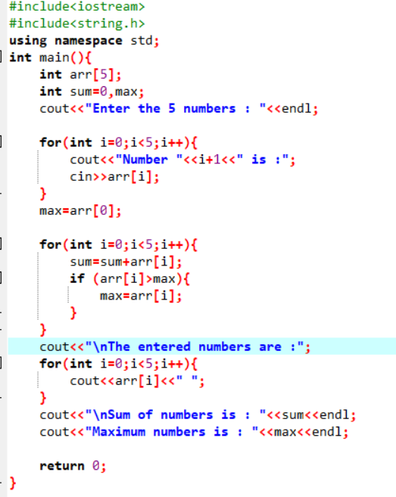

**Output**

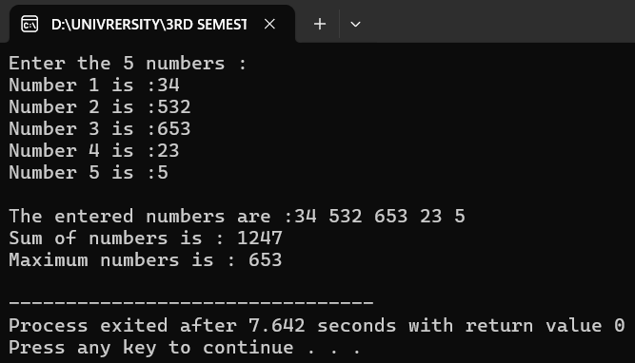

# Explanation

1) #include <iostream>

* This line tells the compiler to include the input/output library so we can use cin, cout, and other IO features.

2) Using namespace std;

* Lets us use names from the standard library (like cout, cin) without writing std:: every time.

3) int main() { ... }

* The main function is where program execution starts. The program runs the statements inside this block.

4) int numbers[5];

* Declares an array named numbers that can hold 5 integers.
* Arrays are zero-indexed, so valid indices are 0 through 4.

5) int sum = 0, max;

* Declares two integer variables:
  + sum is initialized to 0 and will accumulate the sum of all array elements.
  + max is declared but not initialized here — we initialize it later using the first array element.

6) cout << "Enter 5 numbers: " << endl;

* Prints a message prompting the user to enter five numbers.

7) Input loop

for (int i = 0; i < 5; i++) {

cout << "Number " << i + 1 << ": ";

cin >> numbers[i];

}

* This for loop runs 5 times (i = 0,1,2,3,4).
* For each iteration:
  + It prints Number 1:, Number 2:, etc.
  + Reads a value from the user into numbers[i].
* After this loop, the array numbers contains the five entered values.

8) max = numbers[0];

* We set max to the first element of the array.
* This is a safe and common approach: start with the first element and compare other elements against it, so max will end up as the largest of the set.
* Important: this assumes that the array has at least one element (true here because size is 5).

9) Sum and maximum loop

for (int i = 0; i < 5; i++) {

sum += numbers[i];

if (numbers[i] > max)

max = numbers[i];

}

* This loop also runs 5 times and does two things for each array element:
  + Adds the current element to sum (sum += numbers[i];).
  + Checks if the current element is greater than max; if yes, updates max.
* After the loop:
  + sum holds the total of all 5 numbers.
  + max is the largest number among them.

10) Displaying the entered numbers

* Prints the array elements in order so the user sees what they entered.

11) Print sum and maximum

* Shows the calculated sum and max values on the screen.

12) return 0;

Ends main and returns 0 to the operating system