

**The University of Azad Jammu and Kashmir,**

**Muzaffarabad**

|  |  |
| --- | --- |
| Name | Kamal Ali Akmal |
| Course Name | Data Structure & Algorithm |
| Submitted to | Engr. Sidra Rafique |
| Semester | 3rd |
| Session | 2024-2028 |
| Roll No | 2024-SE-38 |
| Lab No | 02 |
| Submission date | 24 October 2025 |

**Question:**

***Write a program that reads 5 numbers using array pointers, finds sum and maximum as well.***

**Answer: Code**

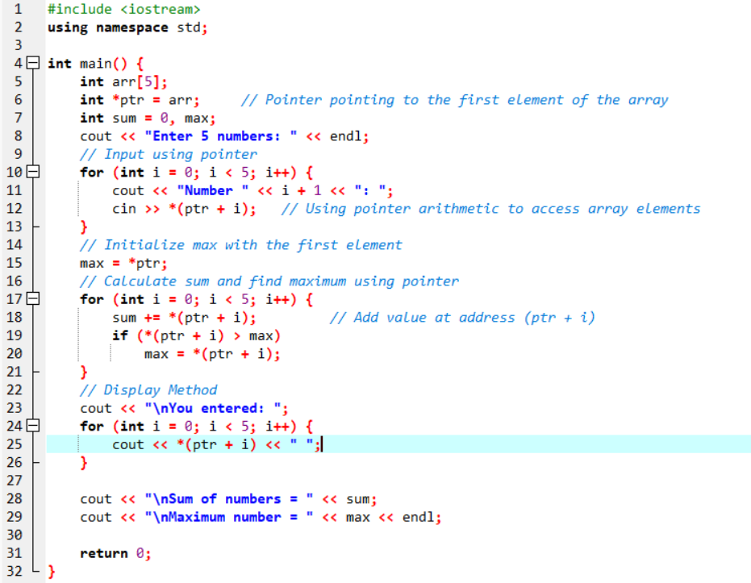

**Output**

# Explanation

1️⃣ int arr[5];

Creates an integer array that holds 5 elements in continuous memory.

2️⃣ int *ptr = arr;

The variable ptr is a pointer to an integer.

The name of the array numbers represents the address of its first element, so this line makes ptr point to the first element.

3️⃣ Input loop

cin >> *(ptr + i);

(ptr + i) moves the pointer to the i-th element of the array.

*(ptr + i) accesses the value stored at that position.

So, we’re filling the array using pointer arithmetic.

4️⃣ Initialize max

max = *ptr;

Dereferences ptr (the first element’s value) and stores it as the initial maximum.

5️⃣ Sum and maximum loop

sum += *(ptr + i);

if (*(ptr + i) > max)

max = *(ptr + i);

Adds each value to sum.

Compares and updates max if a larger number is found.

6️⃣ Display loop

cout << *(ptr + i) << " ";

Uses the pointer again to print each element from memory.