

The University of Azad Jammu and Kashmir,
Muzaffarabad

Name | Kamal Ali Akmal
Course Name | Data Structure & Algorithm
Submitted to | Engr. Sidra Rafique
Semester | 3rd
Session | 2024-2028
Roll No | 2024-SE-38
Lab No | 04
Submission date | 04 November 2025

Doubly Linked List
- Each node points to both the next and previous nodes.
- A Doubly Linked List is like a singly linked list, but each node has an additional pointer, typically called “prev”, which points to the previous node in the sequence. This allows for efficient traversal in both forward and backward directions.
Code
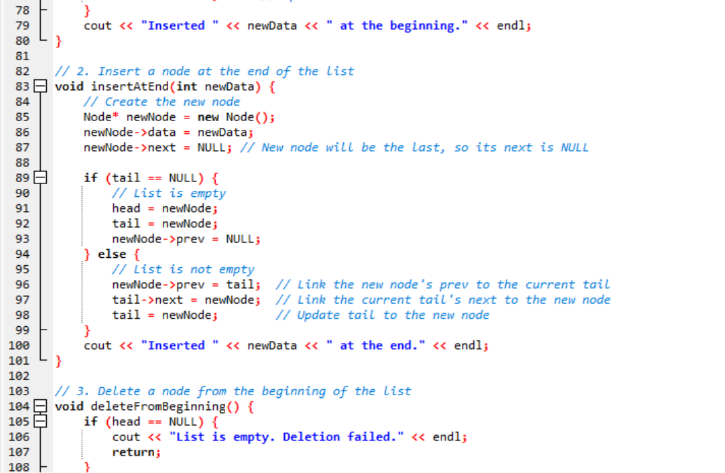
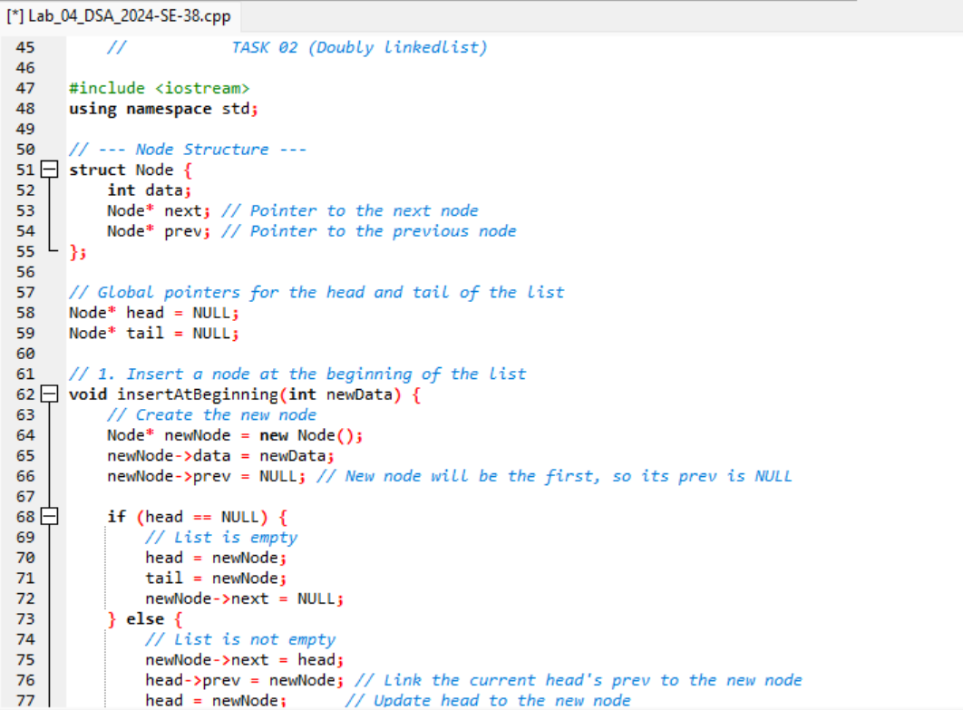

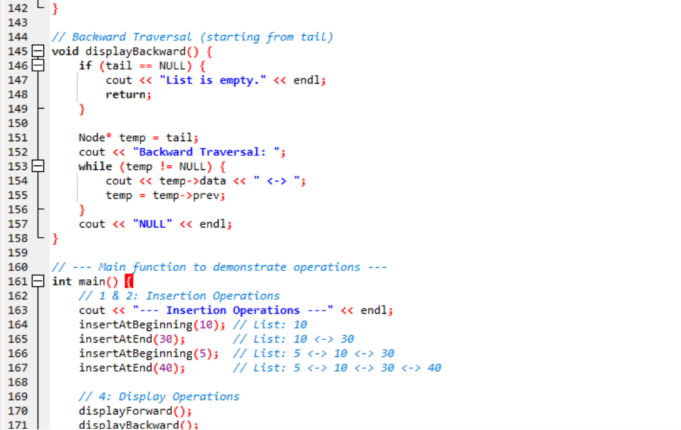
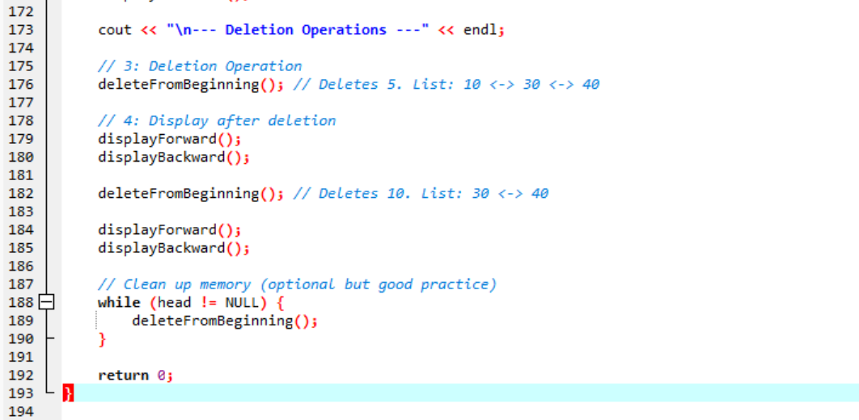
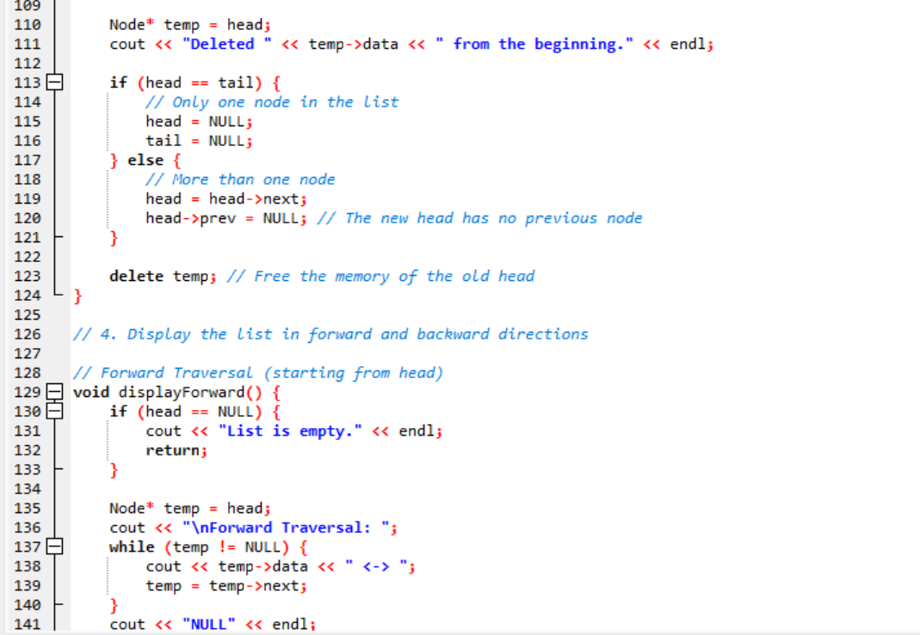
Output

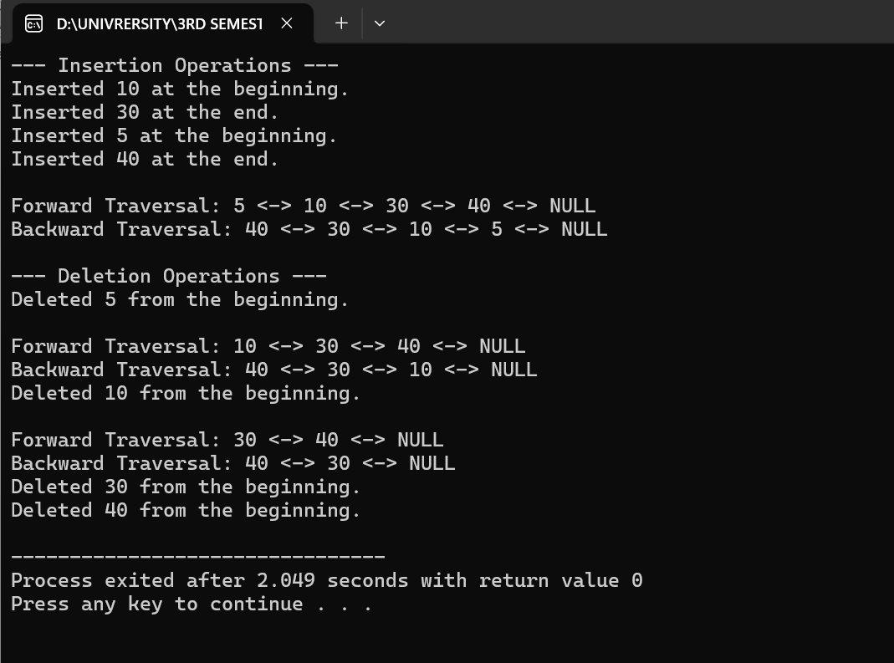

Key Concepts
- Node Structure: Each Node contains data, a pointer to the next node, and a pointer to the previous node (prev).
- Head and Tail: We use two global pointers, head and tail, to keep track of the first and last nodes, respectively.
- Insertion Logic: Insertion requires updating two pointers (the next and prev) for the new node and potentially for the adjacent existing nodes. For example, when inserting at the beginning, you link the new node's next to the old head and the old head's prev back to the new node.
- Deletion Logic: Deletion also involves updating adjacent nodes' pointers to bypass the deleted node and freeing the memory.

