

The University of Azad Jammu and Kashmir,
Muzaffarabad

Name | Kamal Ali Akmal
Course Name | Data Structure & Algorithm
Submitted to | Engr. Asma Javaid
Semester | 3rd
Session | 2024-2028
Roll No | 2024-SE-38
Lab No | 07
Submission date | 08 January 2026

What is a Queue?
A Queue is a linear data structure that follows the FIFO (First In, First Out) principle. This means the first element added to the queue will be the first one to be removed, similar to a real-world queue (like a line of people waiting at a ticket counter).
Linear Queue (Array-Based)
- Uses a fixed-size array to store elements.
- Maintains two pointers:
  - front: points to the first element
  - rear: points to the last element
- Drawback: Once the rear reaches the end of the array, no more elements can be added, even if space is available at the front (due to dequeued elements). This is called "memory wastage".
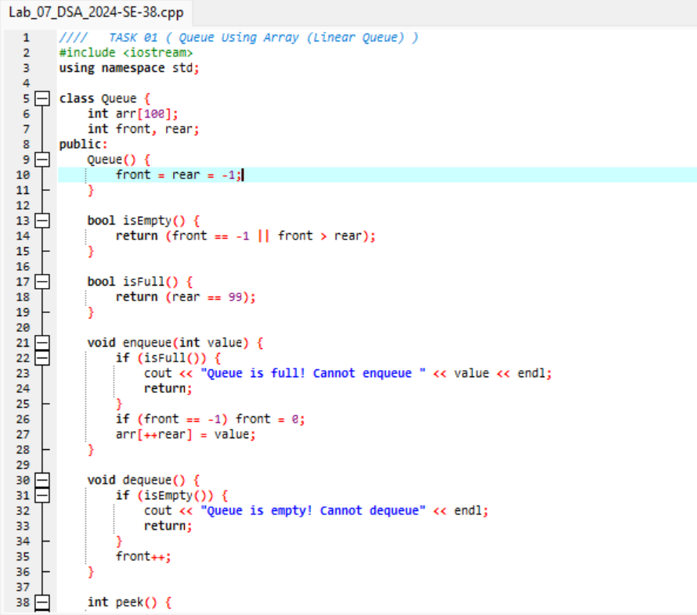
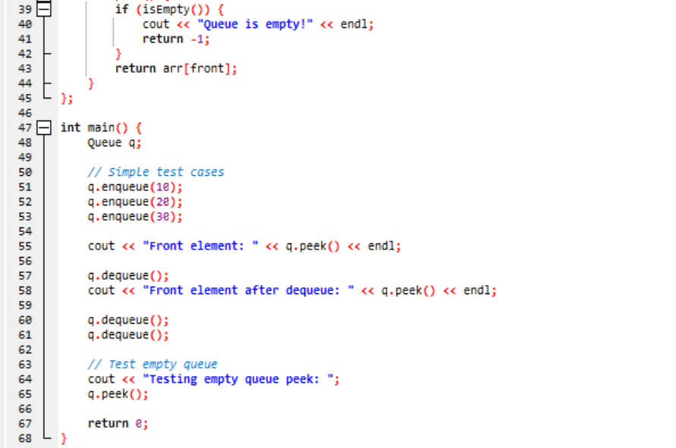
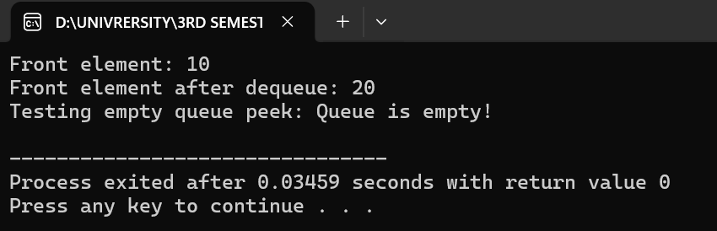
Circular Queue
- Also uses a fixed-size array, but treats it as a circular buffer.
- When the rear pointer reaches the end, it wraps around to the beginning if space is available.
- Benefit: Eliminates the memory wastage problem of linear queues.
- Uses modulo arithmetic for pointer updates:
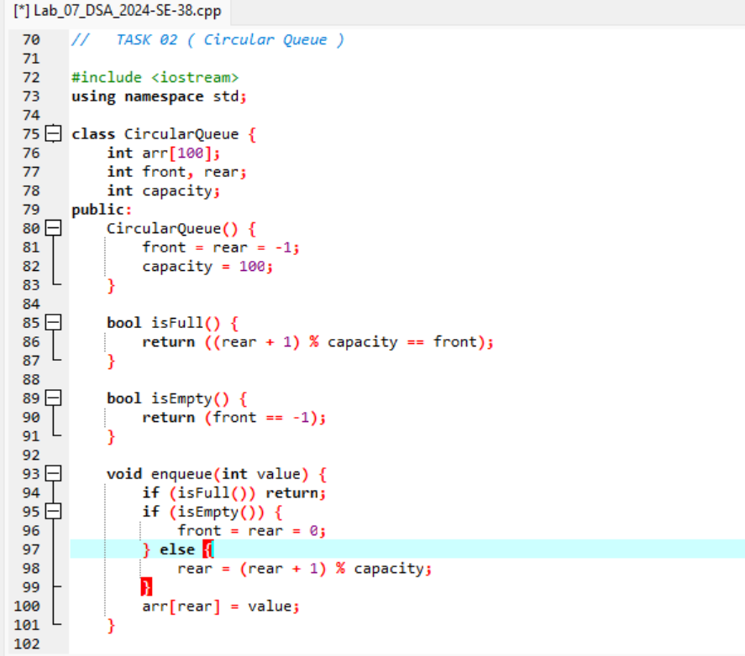
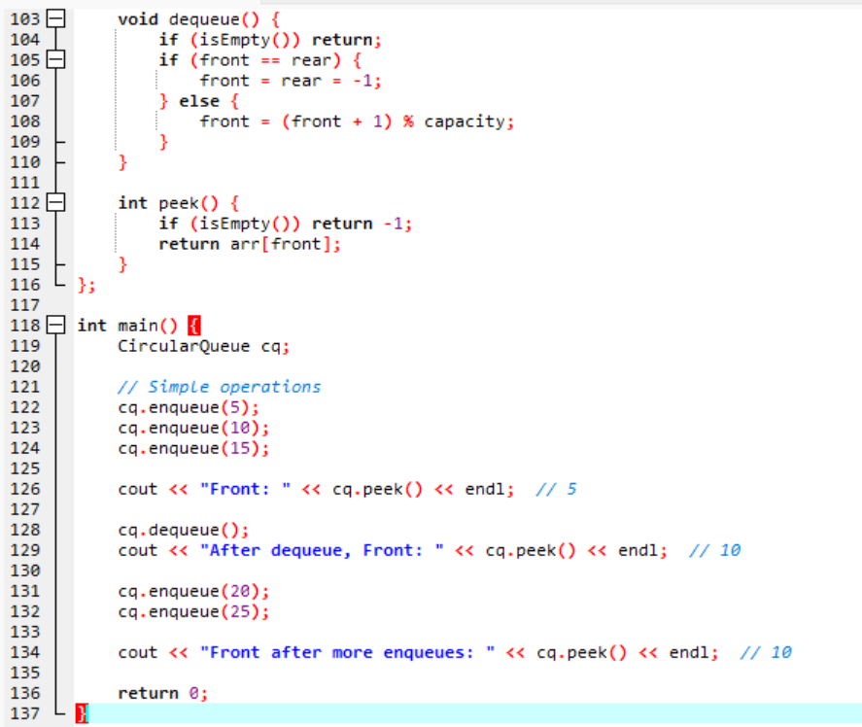
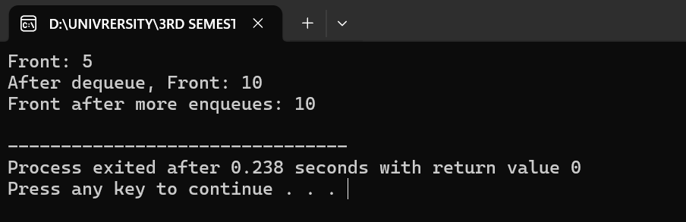

Queue Using Linked List
- Uses dynamic memory allocation (nodes) to store elements.
- Each node contains:
  - data: the element value
  - next: pointer to the next node
- Front pointer points to the first node, Rear pointer points to the last node.
- Advantages:
  - No fixed size limit
  - Efficient memory usage (allocates only what’s needed)
- Disadvantages:
  - Extra memory for storing pointers
  - Slightly slower due to dynamic allocation
