

The University of Azad Jammu and Kashmir,
Muzaffarabad

Name | Kamal Ali Akmal
Course Name | Data Structure & Algorithm
Submitted to | Engr. Asma Javaid
Semester | 3rd
Session | 2024-2028
Roll No | 2024-SE-38
Lab No | 08
Submission date | 08 January 2026

1. What is a Stack?
A Stack is a linear data structure that follows the LIFO (Last In, First Out) principle. This means the last element added to the stack will be the first one to be removed. Think of it like a stack of plates – you add plates to the top and remove them from the top.

2. Key Operations in a Stack
Operation | Description
Push | Adds an element to the top of the stack.
Pop | Removes the top element from the stack.
Peek / Top | Returns the top element without removing it.
isEmpty | Checks if the stack contains no elements.
isFull | Checks if the stack has reached its maximum capacity (for fixed-size implementations).

3. Types of Stack Implementations
A. Stack Using Array (Static Implementation)
- Uses a fixed-size array to store elements.
- Maintains a top pointer (or index) that tracks the topmost element.
- Advantages:
  - Simple to implement
  - Memory efficient (no pointer overhead)
- Disadvantages:
  - Fixed size (cannot grow beyond initial capacity)
  - Can lead to stack overflow if capacity is exceeded

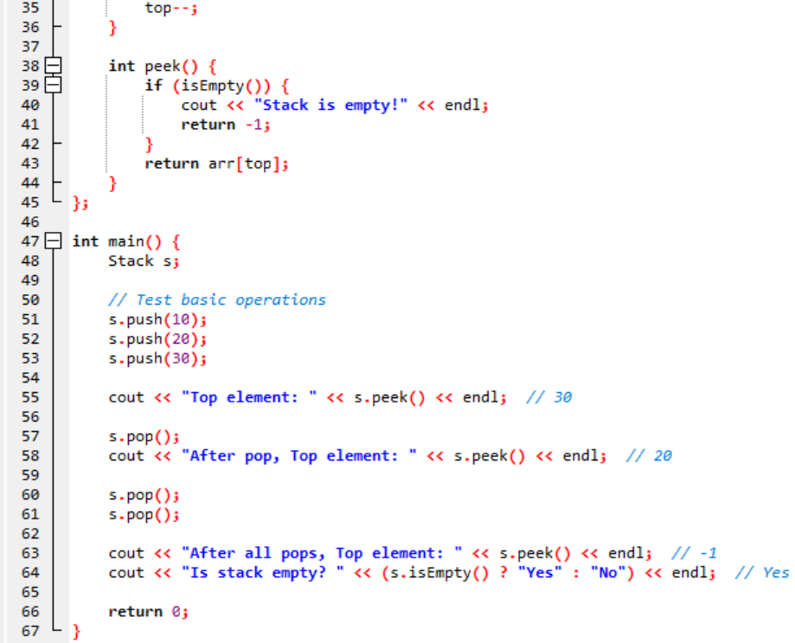
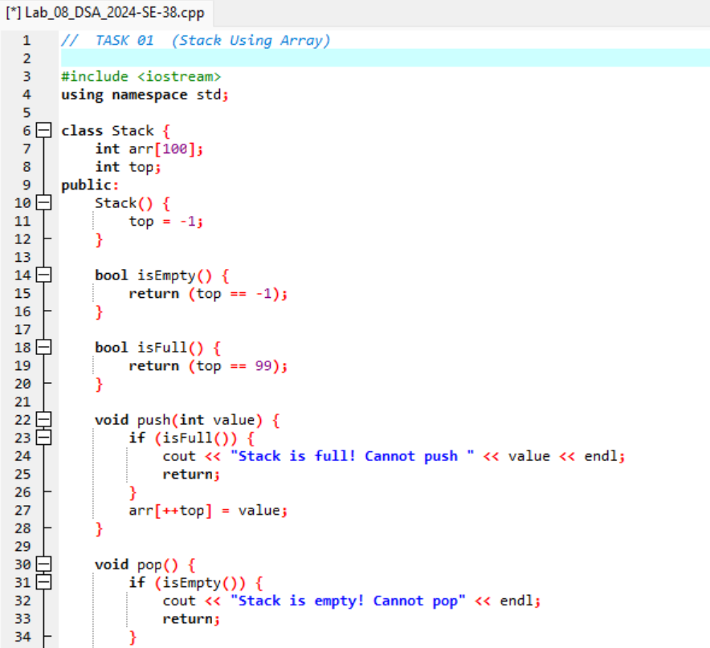

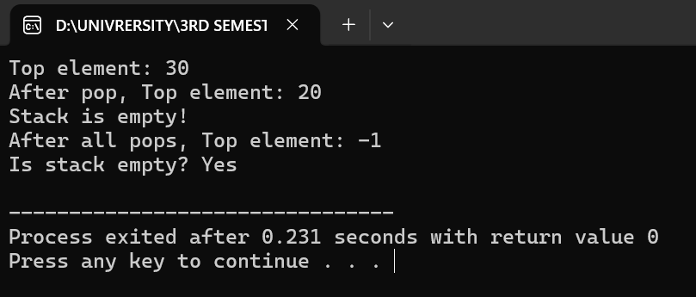

B. Stack Using Linked List (Dynamic Implementation)
- Uses dynamic memory allocation (nodes) to store elements.
- Each node contains:
  - data: the element value
  - next: pointer to the next node
- The top pointer points to the first node (head of the list).
- Advantages:
  - No fixed size limit
  - Can grow and shrink as needed
- Disadvantages:
  - Extra memory for storing pointers
  - Slightly slower due to dynamic allocation

