

The University of Azad Jammu and Kashmir,
Muzaffarabad

Name | Kamal Ali Akmal
Course Name | Data Structure & Algorithm
Submitted to | Engr. Asma Javaid
Semester | 3rd
Session | 2024-2028
Roll No | 2024-SE-38
Lab No | 09
Submission date | 09 January 2026

Tree Data Structure
What is a Tree?
A Tree is a non-linear data structure used to store data in hierarchical form. It starts from a root node, and every node can have child nodes.
Task No 01:
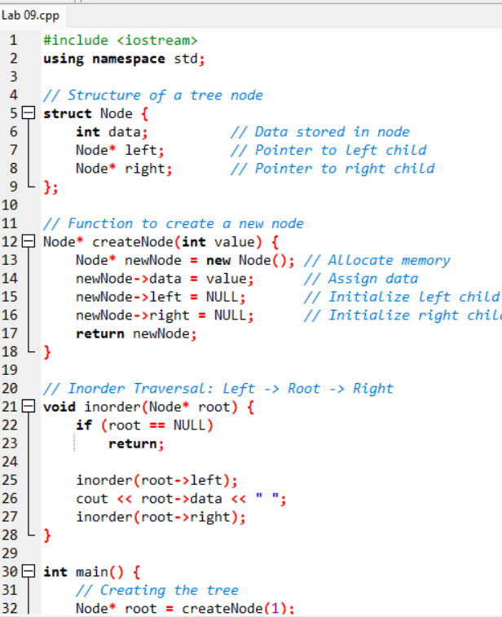

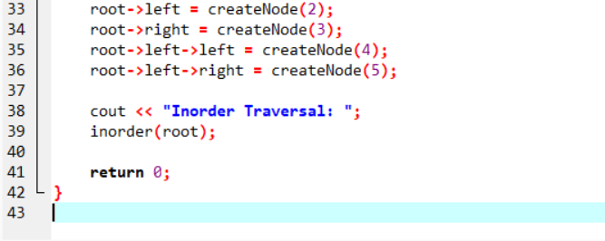

Output:
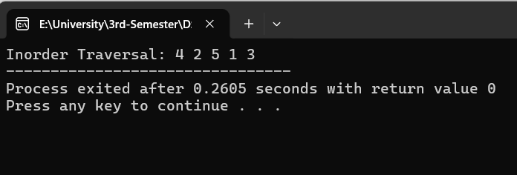

Tree Traversals:
- Inorder Traversal: Left → Root → Right
- Preorder Traversal: Root → Left → Right
- Postorder Traversal: Left → Right → Root

