

The University of Azad Jammu and Kashmir,
Muzaffarabad

Name | Kamal Ali Akmal
Course Name | Data Structure & Algorithm
Submitted to | Engr. Asma Javaid
Semester | 3rd
Session | 2024-2028
Roll No | 2024-SE-38
Lab | Open Ended Lab
Submission date | 16 January 2026

Graphs in DSA Using C++
1.Graph
A graph is a non-linear data structure consisting of a set of vertices (nodes) and a set of edges that connect pairs of vertices.
Mathematically:
A graph is represented as: G= (V, E)
Where:
- V = set of vertices
- E = set of edges

2.Basic Graph Terminology
Term | Description
Vertex | A node in a graph
Edge | A connection between two vertices
Degree | Number of edges connected to a vertex
Path | A sequence of connected vertices
Cycle | A path that starts and ends at the same vertex
Connected Graph | Every vertex is reachable

3.Types of Graphs
a) Directed Graph
Edges have a direction (A → B).
b) Undirected Graph
Edges have no direction (A — B).
c) Weighted Graph
Edges have weights (cost, distance, etc.).
4.Graph Representations
a) Adjacency Matrix
A 2D array where rows and columns represent vertices.
b) Adjacency List
An array of linked lists where each vertex stores its adjacent vertices.

5.Graph Traversal Algorithms
- BFS (Breadth First Search) – Uses a queue.
- DFS (Depth First Search) – Uses recursion or stack.

Implementation Tasks (C++)
Program 1: Graph Representation Using Adjacency Matrix
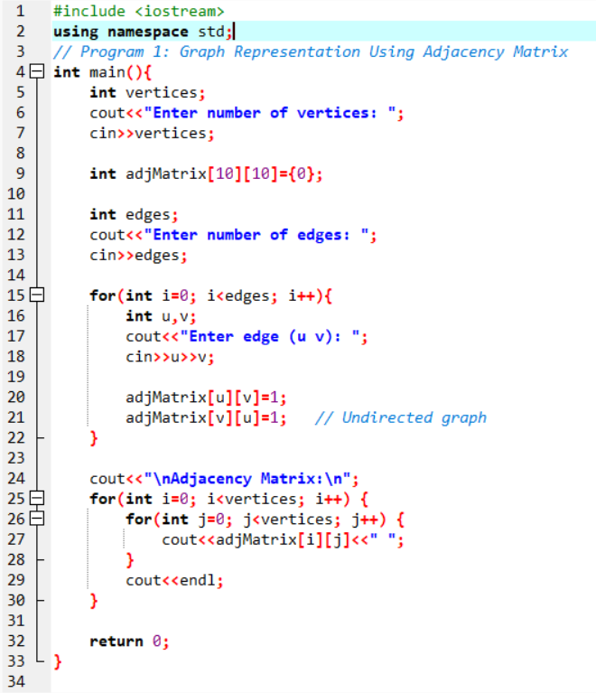

Output:
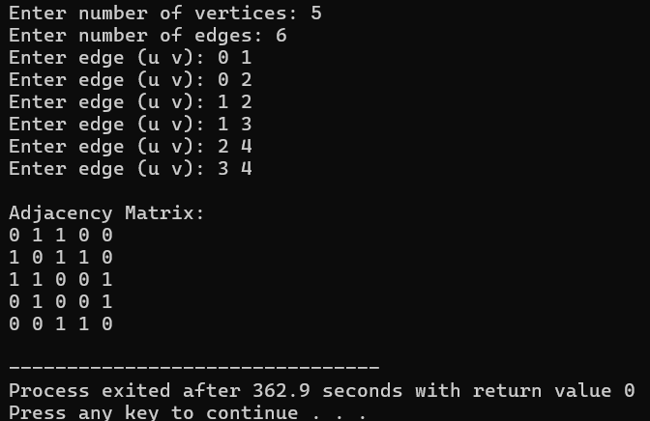

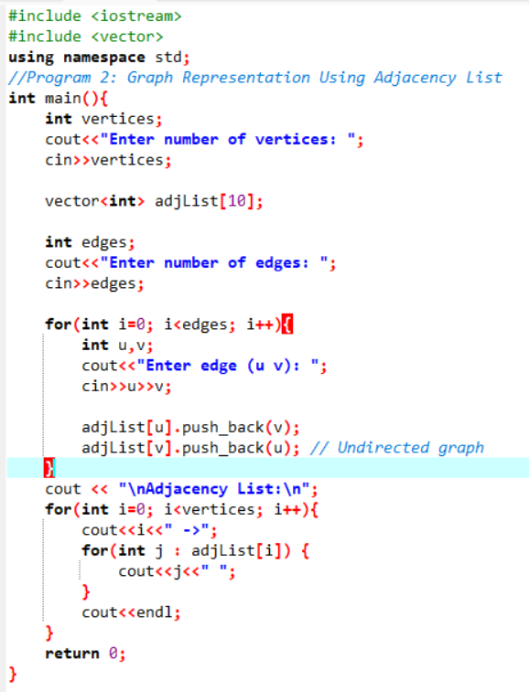
Program 2: Graph Representation Using Adjacency List
Output:
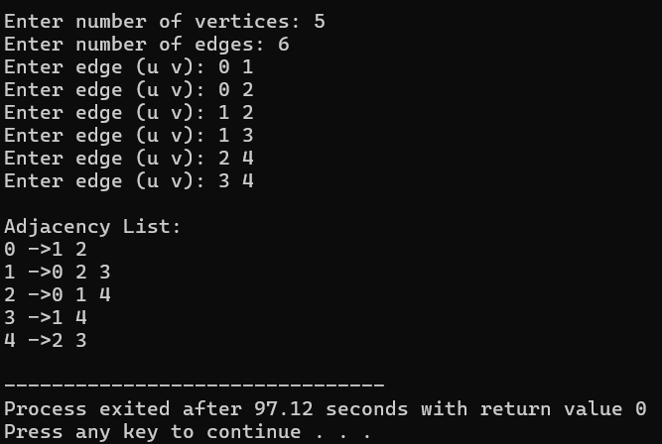

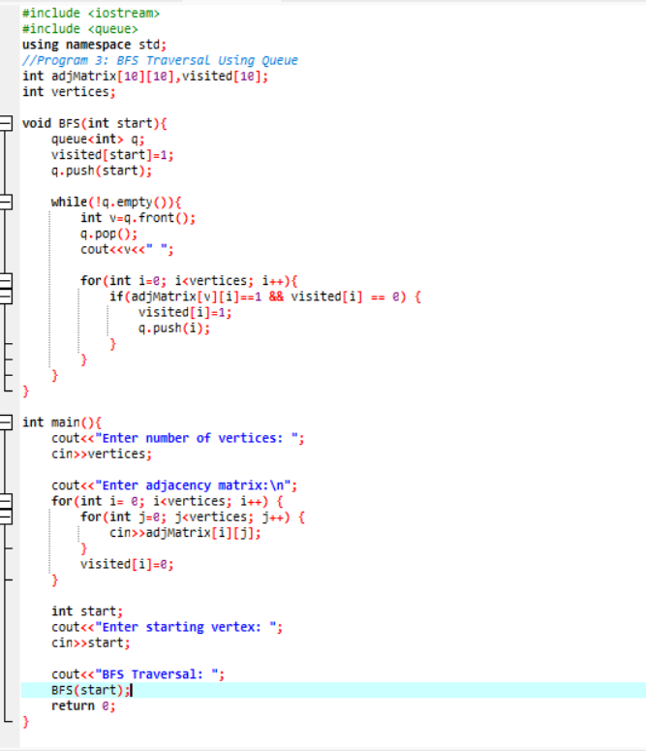
Program 3: BFS Traversal Using Queue
Output:

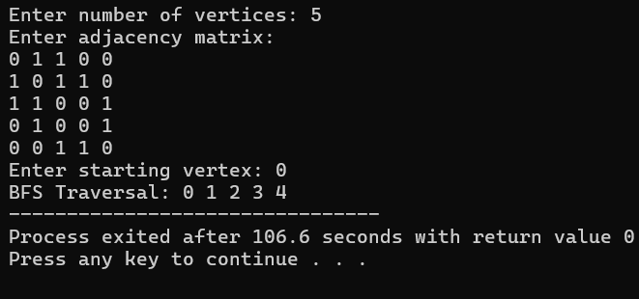

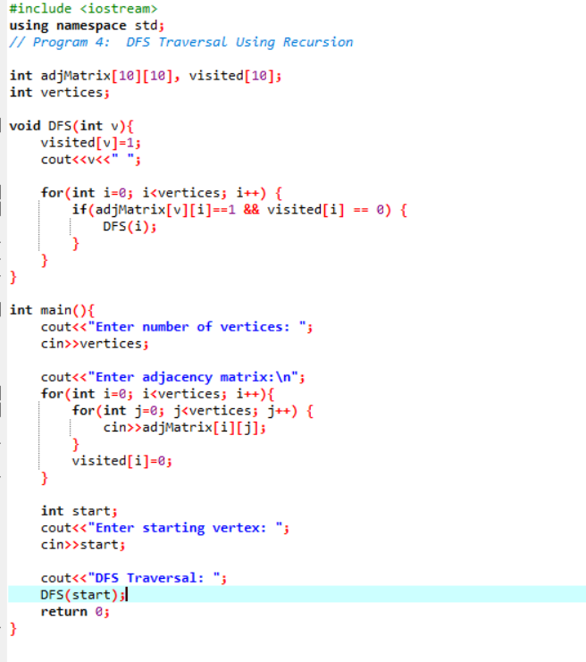
Program 4: DFS Traversal Using Recursion
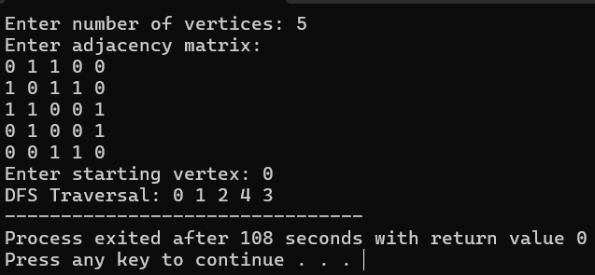
Output:

