

The University of Azad Jammu and Kashmir,
Muzaffarabad

Name | Kamal Ali Akmal
Course Name | Data Structure & Algorithm
Submitted to | Engr. Sidra Rafique
Semester | 3rd
Session | 2024-2028
Roll No | 2024-SE-38
Lab No | 05
Submission date | 12 December 2025

Doubly Circular Linked List
In a Doubly Circular Linked List, each node contains three parts: data, pointer to the next node, and pointer to the previous node. The list is circular in both directions, allowing traversal from any node forward or backward.
Diagram
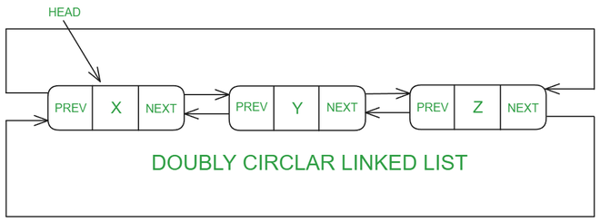
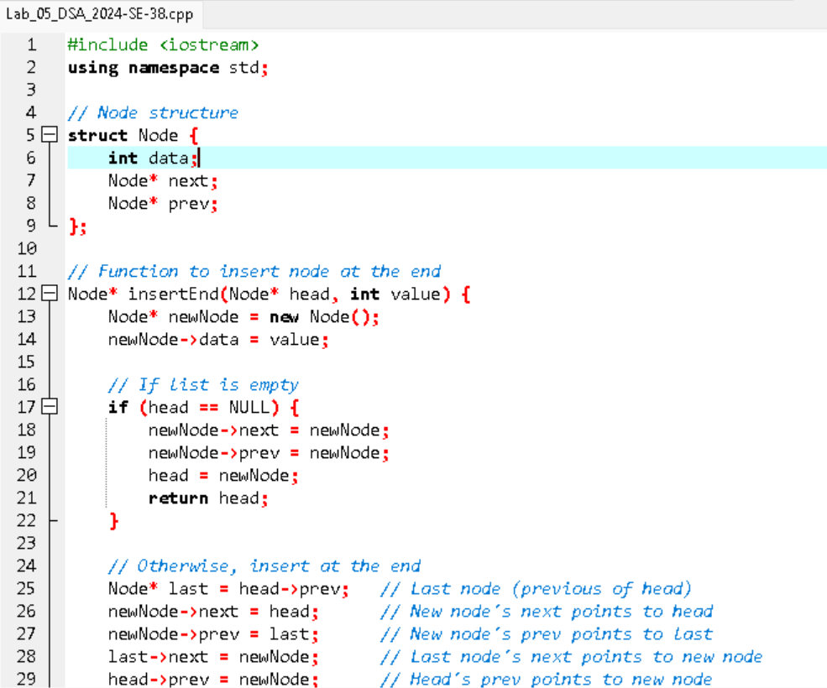
Code
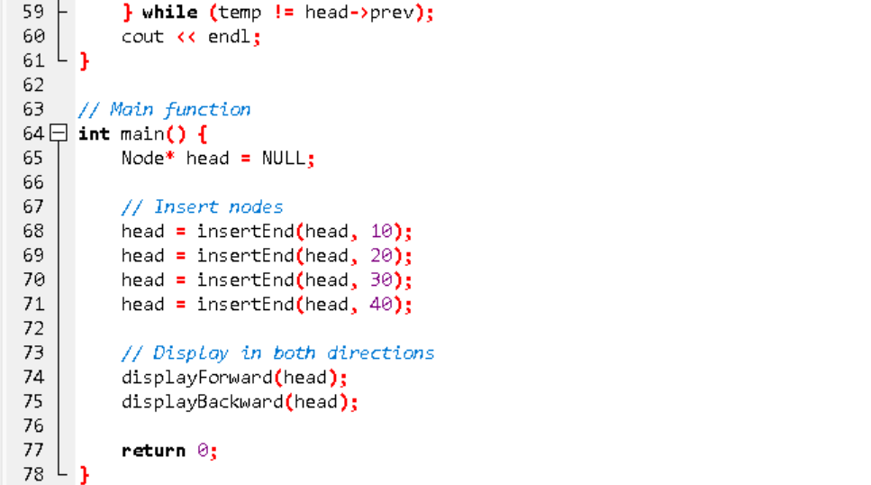
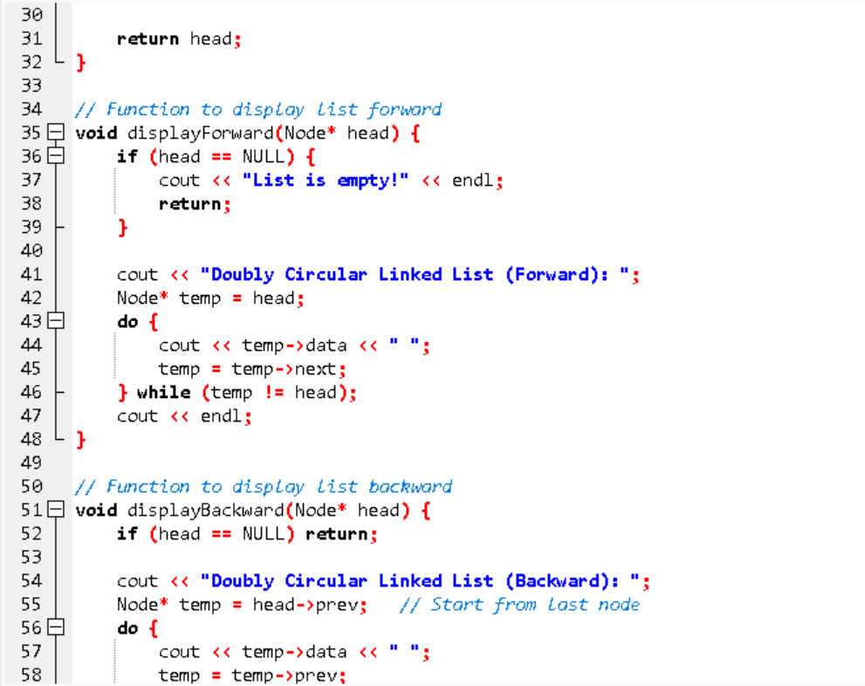

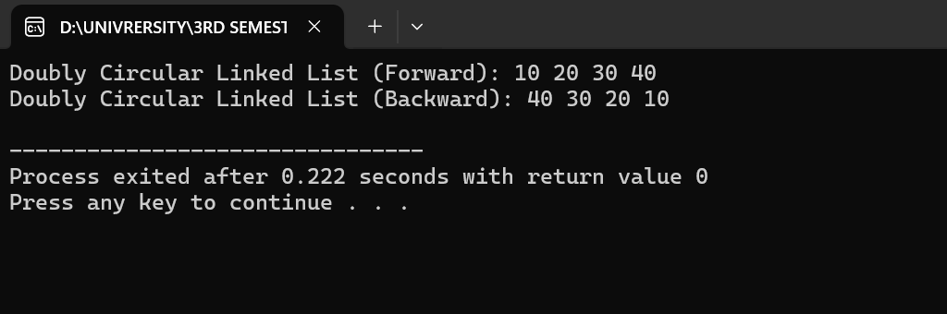
Output
Explanation: -
Structure
Each node has:
- data: stores the value
- next: points to the next node
- Prev: points to the previous node
Circular Behavior
- The last node points back to the first node (via next).
- The first node points back to the last node (via prev).
So the list is circular in both directions.
Insert Logic
- If list is empty → new node points to itself in both directions.
- Otherwise:
  - Find the last node (head->prev)
  - Adjust four pointers:
    - newNode->next = head
    - newNode->prev = last
    - last->next = newNode
    - head->prev = newNode
Traversal
- Forward: Start from head, follow next until you reach head again.
Backward: Start from head->prev, follow prev until you reach that node again.

