

**The University of Azad Jammu and Kashmir,**

**Muzaffarabad**

|  |  |
| --- | --- |
| Name | Kamal Ali Akmal |
| Course Name | Operating System |
| Submitted to | Engr. Sidra Rafique |
| Semester | 3rd |
| Session | 2024-2028 |
| Roll No | 2024-SE-38 |
| Lab No | 02 |
| Submission date | 27 October 2025 |

**Title: Familiarization of Windows Command Prompt**

**Objective:**

To familiarize students with the Windows Command Prompt environment by executing common CMD commands, analyzing their outputs, and documenting results with screenshots.

**Command 1: dir**

**Description:** Lists all files and folders in the current directory.

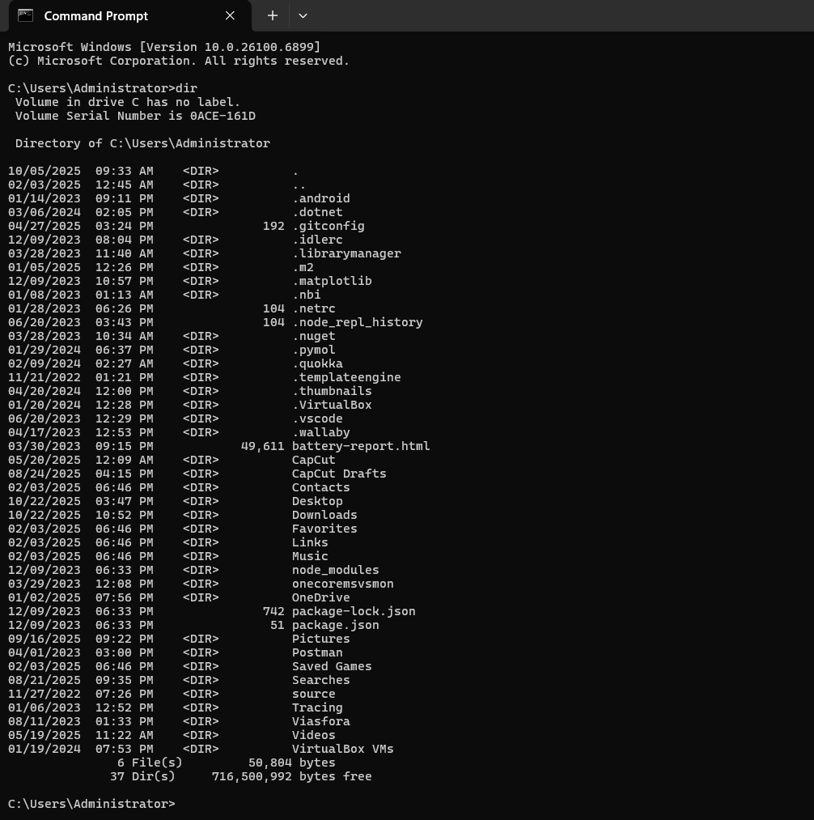  
**Explanation of Output:** Displays a table showing the names, sizes, and modification dates of files/folders.

**Command 2: cd**

**Description:** Changes the current directory.

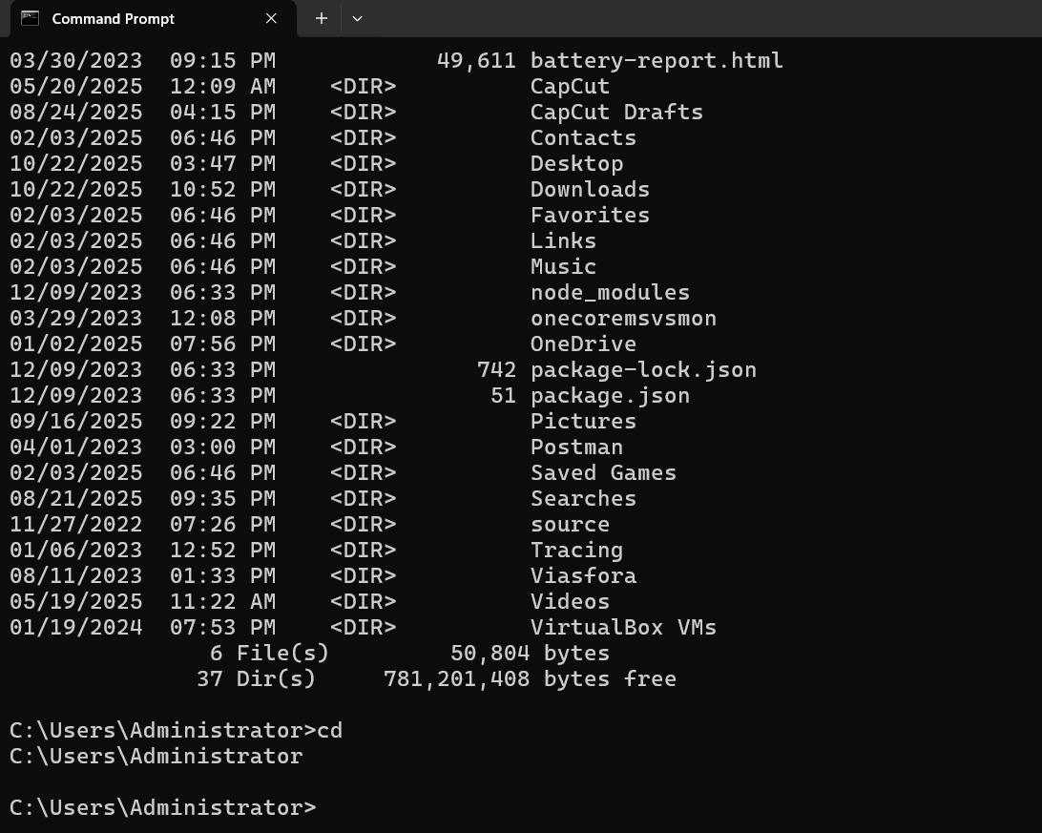  
**Explanation of Output:** After entering a folder name, CMD navigates to that folder’s path.

**Command 3: cls**

**Description:** Clears all previous text from the CMD window.

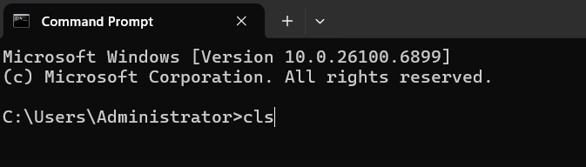

After pressing enter key the above data will be removed as:

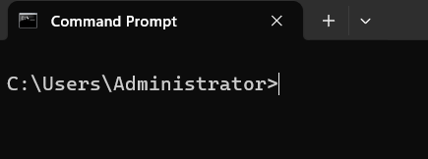  
**Explanation of Output:** The CMD screen becomes blank, showing only the current directory cpath.

**Command 4: ipconfig**

**Description:** Displays network configuration details.

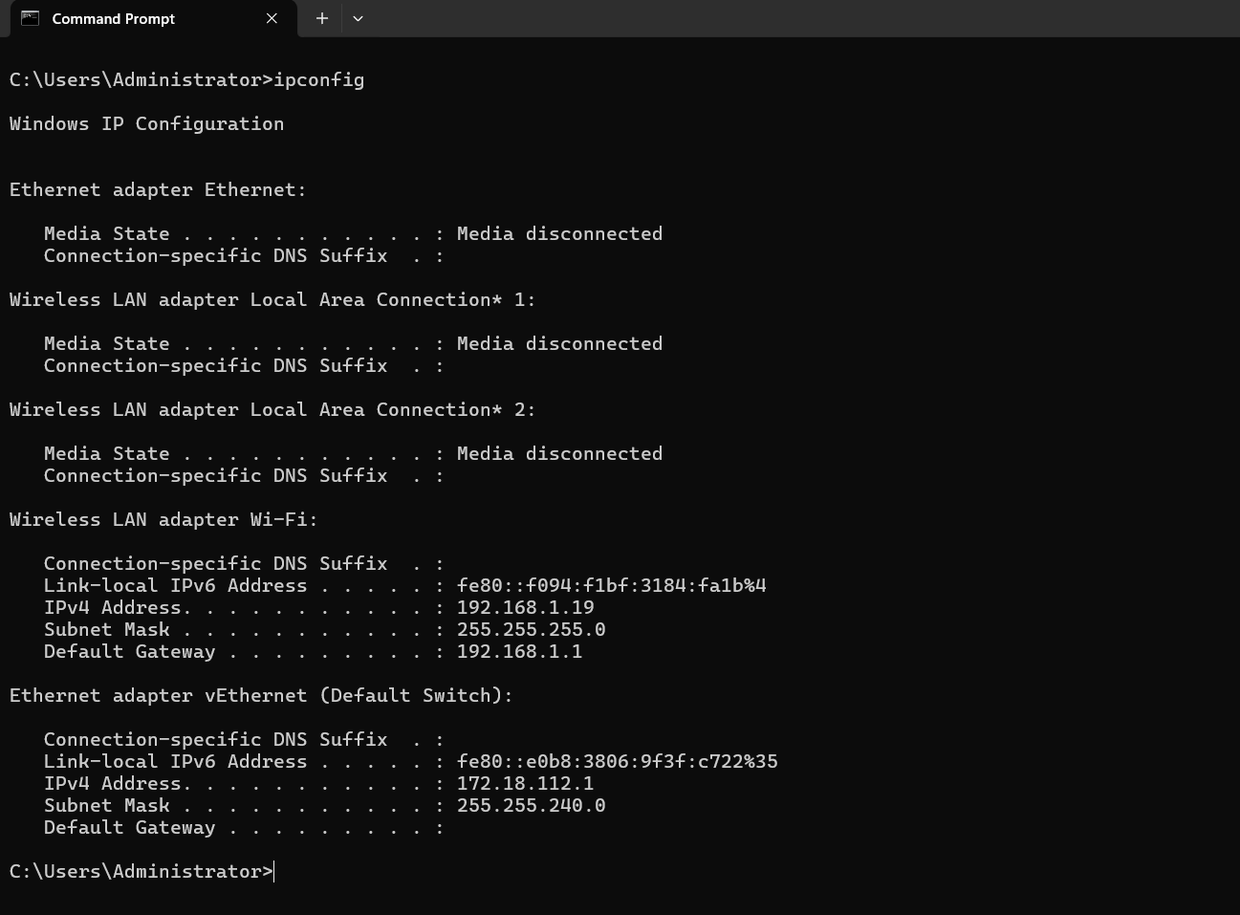  
**Explanation of Output:** Shows IP address, subnet mask, and default gateway for each network adapter.

**Command 5: ping**

**Description:** Tests connectivity to another network device or website.

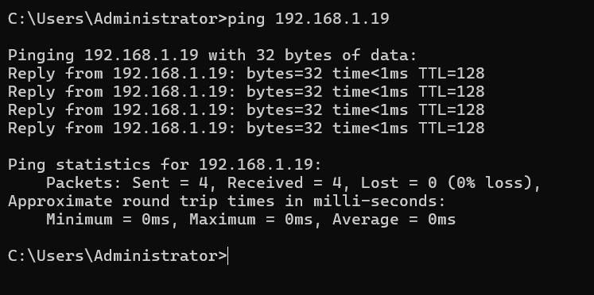  
**Explanation of Output:** Displays response times (in ms) showing whether the target host is reachable.

**Command 6: systeminfo**

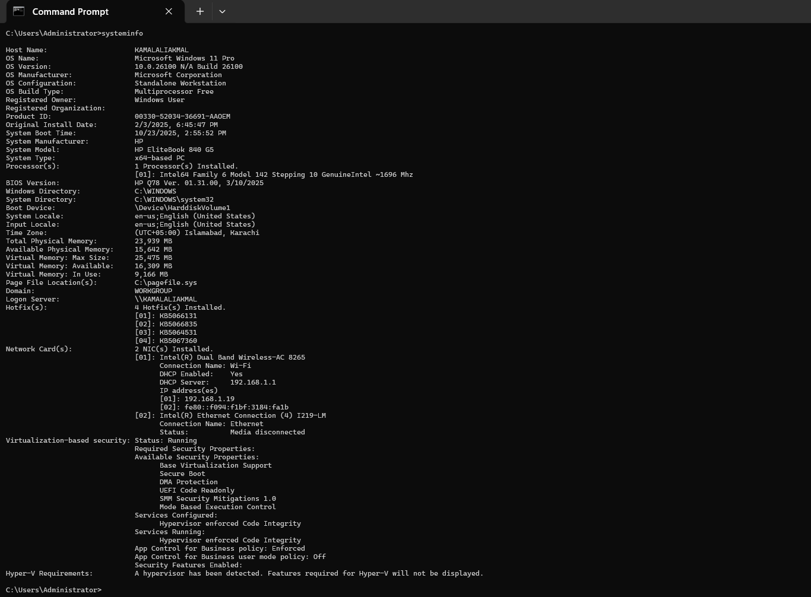**Description:** Displays detailed system configuration information.

**Explanation of Output:** Lists OS name, version, system manufacturer, processor, and RAM details.

**Command 7: tasklist**

**Description:** Lists all running processes on the computer.

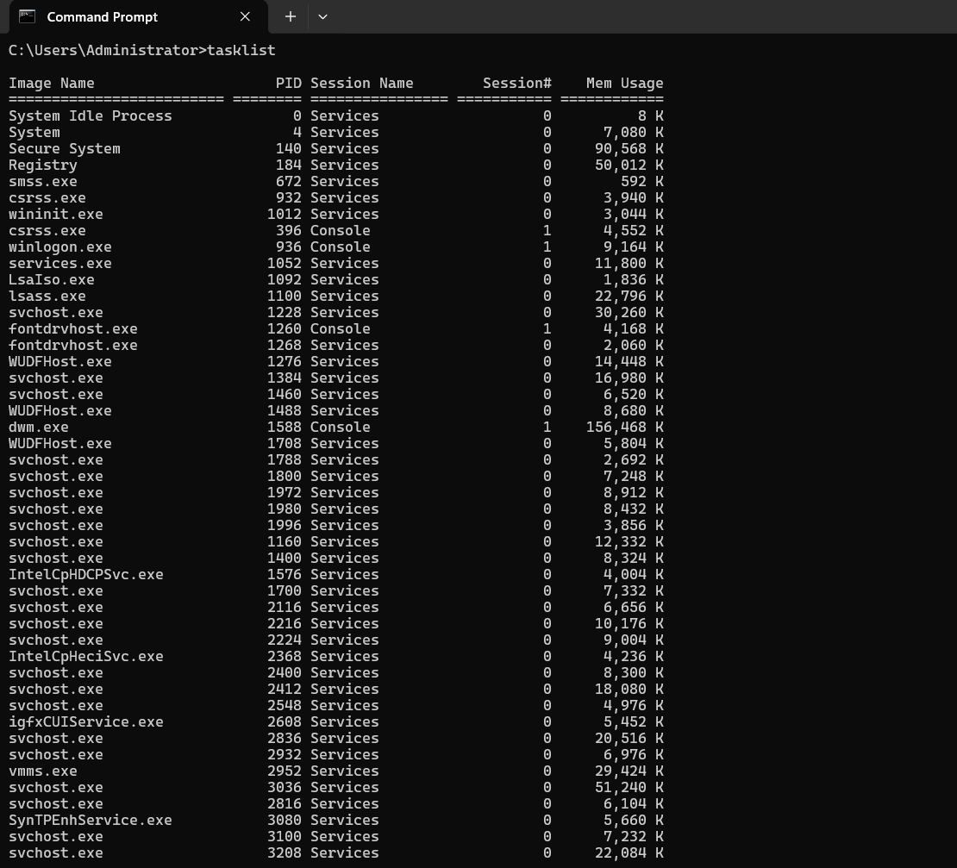  
**Explanation of Output:** Shows process name, PID (Process ID), and memory usage.

**Command 8: netstat**

**Description:** Displays active network connections and listening ports.

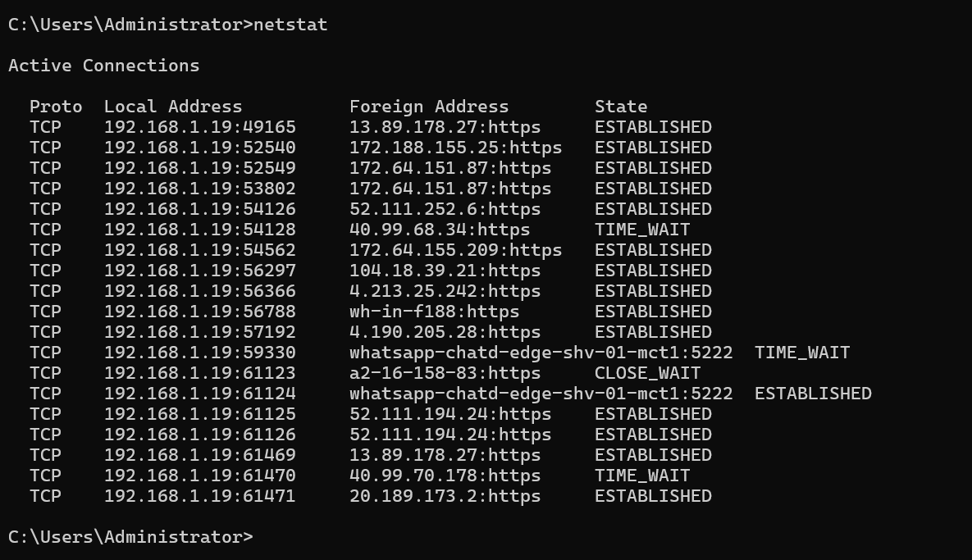  
**Explanation of Output:** Shows protocol type (TCP/UDP), local and foreign addresses, and connection states.

**Command 9: whoami**

**Description:** Displays the current logged-in username.

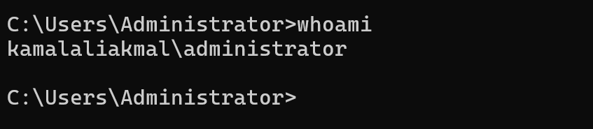  
**Explanation of Output:** Shows your Windows account name and domain.

**Command 10: ver**

**Description:** Displays the Windows version currently running.

**Explanation of Output:** Shows the OS build and version number (e.g., Microsoft Windows [Version 10.0.26100.6899]).

**Answer the Following Questions**

**1) What is the purpose of Command Prompt in Windows?**

The Command Prompt allows users to interact with the operating system using text-based commands. It helps with performing administrative tasks, troubleshooting, file management, and running scripts efficiently.

**2) Describe the steps to open Command Prompt as an Administrator.**

1. Click **Start Menu → Search “cmd”**.
2. Right-click **Command Prompt**.
3. Select **Run as administrator**.
4. Click **Yes** on the User Account Control (UAC) prompt.

**3) Explain the function of ten commands you executed.**

**DIR** – Displays a list of files and folders in the current directory. It helps users see what content is available in a specific location.

**CD** – Changes the current working directory. It is used to navigate through different folders in the file system.

**CLS** – Clears all previous commands and output from the Command Prompt screen, making it clean for new commands.

**IPCONFIG** – Shows detailed network configuration information such as IP address, subnet mask, and default gateway of the system.

**PING** – Tests connectivity between your computer and another network device or website by sending data packets and measuring response time.

**SYSTEMINFO** – Displays detailed system configuration, including operating system version, hardware details, and memory information.

**TASKLIST** – Lists all currently running programs and background processes along with their Process IDs (PIDs).

**NETSTAT** – Displays all active network connections, open ports, and network statistics. It’s useful for monitoring network activity.

**WHOAMI** – Shows the username of the currently logged-in user. It confirms which account is being used in the Command Prompt.

**VER** – Displays the version number of the Windows operating system currently running on the computer.

**4) Which command is used to list active network connections and their ports?**

**Command:** netstat  
**Explanation:** It displays all active network connections, listening ports, and connection states.

**5) What information does the whoami /all command display?**

**Answer:**  
It shows detailed information about the current user, including:

* Username and domain
* Security Identifier (SID)
* Group membership
* Privileges assigned to the user account

**6) How can you check your Windows version using CMD?**

**Command:** ver  
**Explanation:**  
This command outputs the current Windows version and build number installed on the system.

**7) What precautions should be taken when running commands with administrative privileges?**

* Always **understand the command** before executing it.
* Avoid deleting or modifying system files.
* Run as administrator **only when necessary**.
* Never execute commands from **unknown sources**.
* Double-check commands that modify **registry or boot settings**.