

The University of Azad Jammu and Kashmir,
Muzaffarabad

Name | Kamal Ali Akmal
Course Name | Operating System
Submitted to | Engr. Sidra Rafique
Semester | 3rd
Session | 2024-2028
Roll No | 2024-SE-38
Lab No | 04
Submission date | 01 November 2025

-: Code:-
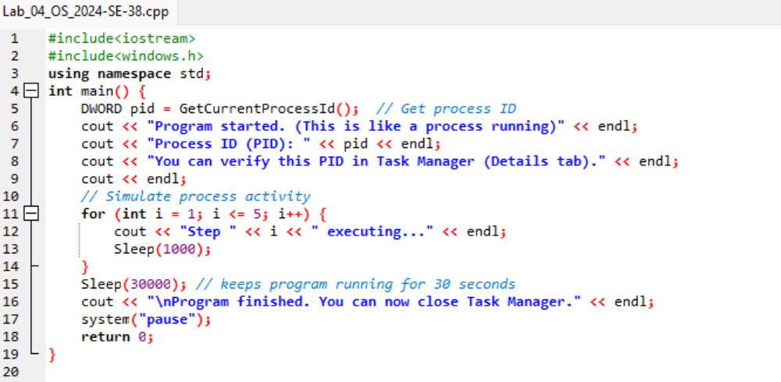
-: Output: -
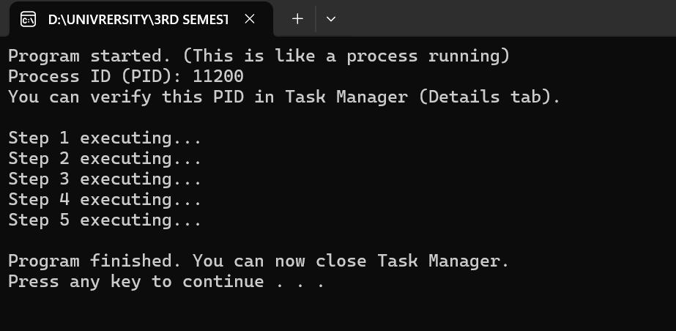

-: Task Manager: -
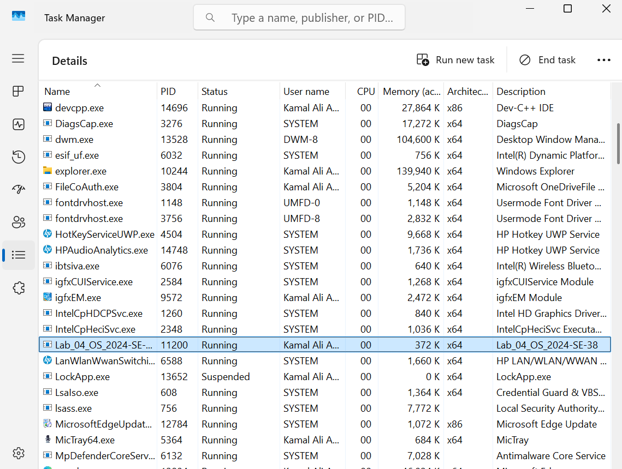
-: Flowchart: -
