

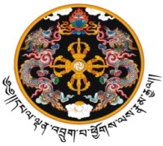

**༄༅།  །  བརྡ་དོན་དང་བརྒྱུད་འབྲེལ་ལྷན་ཁག།**

**Ministry of Information &Communications**

**Thimphu : Bhutan**

***_____________________________________***

**National Website Competition (2017-18)**

***(Evaluated* *from August 31st, 2017- April 28th, 2018)***

***This certificate is awarded to***

***Mr/Ms. ______________, bearing CID # ___________on***

***behalf of ____________________________________ in***

***recognition of their website which was ranked _____ out***

***of 135 websites evaluated***

***_____________________________________***

(Lyonpo DN Dhungyel)

Minister, MoIC





**༄༅།  །  བརྡ་དོན་དང་བརྒྱུད་འབྲེལ་ལྷན་ཁག།**

**Ministry of Information & Communications**

**Thimphu : Bhutan**

***_____________________________________***

**National Website Competition (2017-18)**

***(Evaluated* *from August 31st, 2017- April 28th, 2018)***

***This certificate is awarded to***

***________________________________***

***in recognition of their website***

***which was ranked _____ out of 135websites evaluated***

***____________________________________***



(Lyonpo DN Dhungyel)

Minister, MoIC